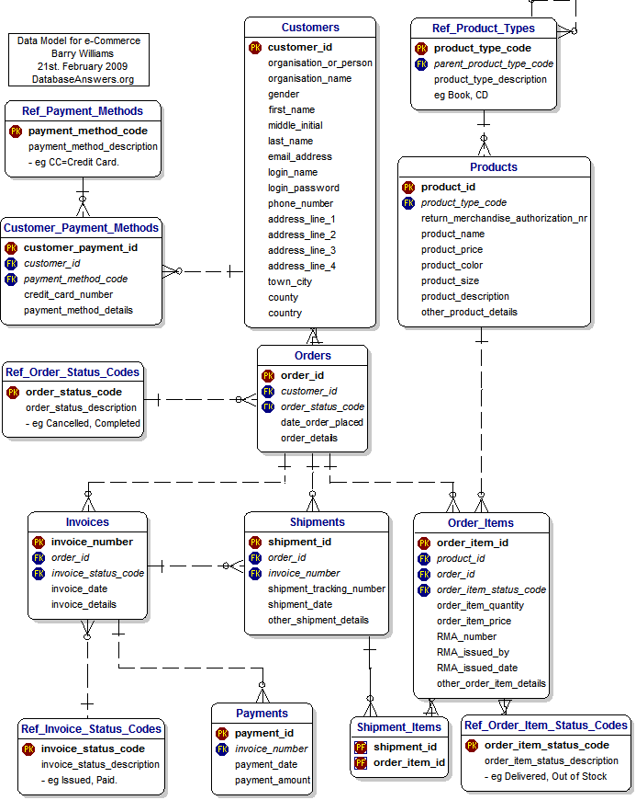

1. Database Schema for SQLite prepared
2. API Design for Services
3. UI Design Considerations

API Design for Services