Abha Art Studio
LEARN • DRAW • GROW
CERTIFICATE
~~~~~~~OF PARTICIPATION~~~~~~~
This Certificate is Proudly Presented To
<<NAME>>
for successfully participating in the
THREE-DAY DRAWING WORKSHOP
held from <<FROM_DATE>> to <<TO_DATE>>
~~~~~~~~~~~~~~~~~~~~~~~{}~~~~~~~~~~~~~~~~~~~~~
Your creativity, enthusiasm, and dedication throughout the workshop have been truly inspiring.
Keep creating and inspiring through your art.
Certificate No.: <<CERTIFICATE_NO>>

Abha Patel | Abha Art Studio
Instructor Signature | 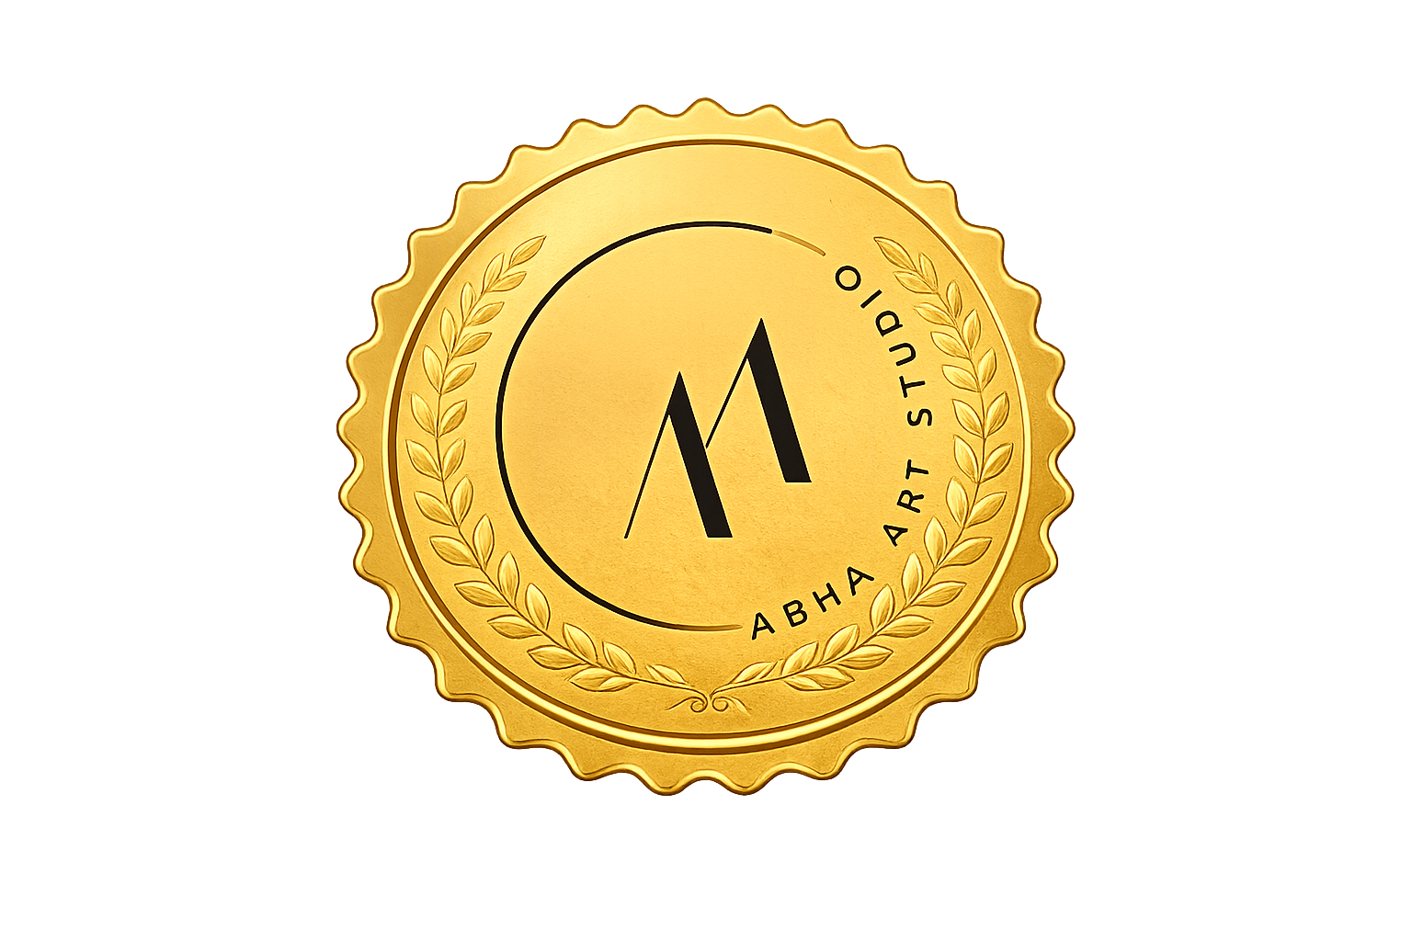  Organizer Signature

