Section A -Traceability and Architectural Validation of Artifact 3
This appendix provides supporting evidence for Artifact 3. It shows how healthcare requirements were translated into recurring control patterns, consolidated into a layered BC--SSI architecture, and comparatively validated through heterogeneous proof-of-concept implementations.

Requirement Foundations: Core requirements with diagrams
This appendix summarizes the requirement-driven analysis underlying Artifact 1. It presents the core healthcare requirements (R1-R16), selected structural and behavioral models for architecturally significant requirements, and their mapping to architectural components used in Artifact 3. The following requirements are shown in greater detail because they directly shaped the layered architecture and recurring runtime control flows identified in the comparative evaluation.
R1- Full access to Health Records (Structural and Behavioral View)

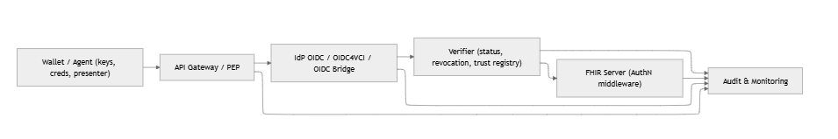
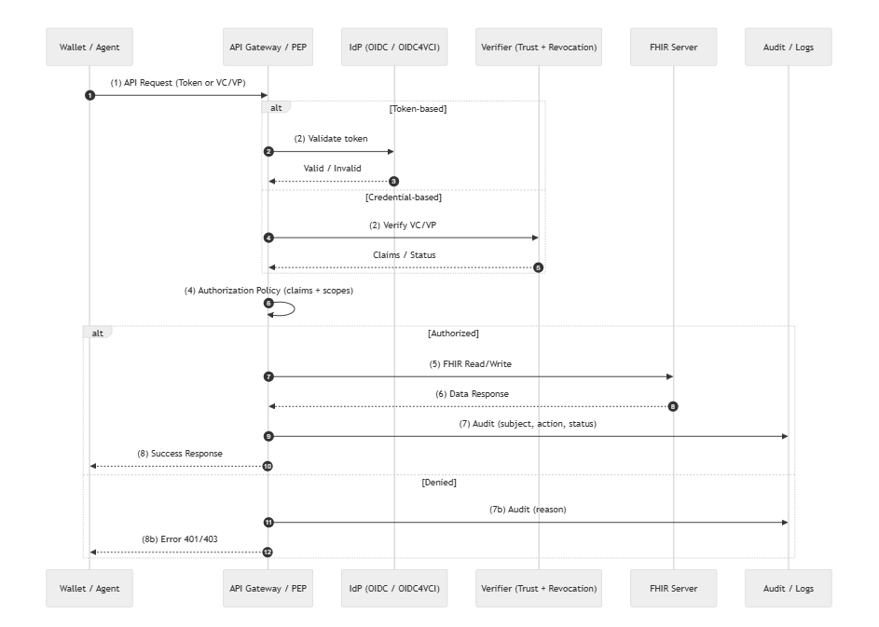
The access-control flow begins when the wallet or agent sends an API request to the API Gateway/PEP using either a bearer token or a verifiable credential/presentation (VC/VP). The gateway first validates the request: if token-based authentication is used, the IdP checks the token’s signature and expiry; if credential-based access is used, the gateway forwards the VC/VP to the Verifier service, which validates the issuer's trust, the schema, the signature, and the revocation status. The verified claims (e.g., subject ID, purpose, attributes) are then returned to the gateway. Using these claims together with predefined scopes, the gateway evaluates the authorization policy to determine whether the request is permitted. If authorized, the gateway forwards a scoped read/write request to the FHIR server, retrieves the resulting resource bundle, and returns it to the client. Simultaneously, an audit event is logged, capturing subject, action, and decision. If the request is denied due to an invalid token, failing credential verification, or insufficient scopes, the gateway returns a 401/403 error and records the denial reason in the audit log.

R2 Consent and Access
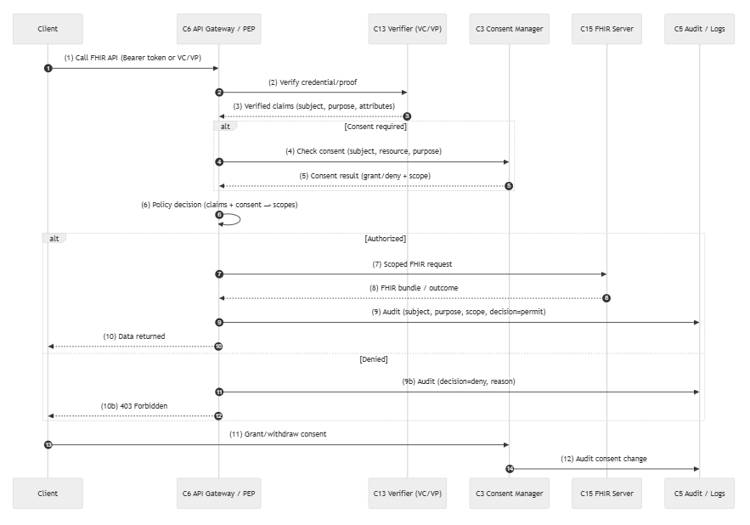
This consent flow begins when the client (e.g., a wallet or app) calls the FHIR API through the API Gateway/PEP. The gateway first verifies the credentials or proof by communicating with the Verifier, which returns the authenticated subject, purpose, and other relevant claims. If the requested operation requires consent, the gateway queries the Consent Manager to check whether a valid consent grant exists for the specific subject, resource type, and purpose of use. The gateway then combines the verified credential claims with the consent status to make a final policy decision on whether access is permitted and what FHIR scopes should be applied. If authorized, the gateway forwards a scoped request to the FHIR Server and returns the resulting resource bundle to the client, while logging the access in the audit service. If consent is missing or invalid, the request is denied and the denial reason is recorded in the audit log. Additionally, the client may at any time grant or revoke consent, and each consent change is also recorded for traceability.

R3 – Standardized interoperable exchange
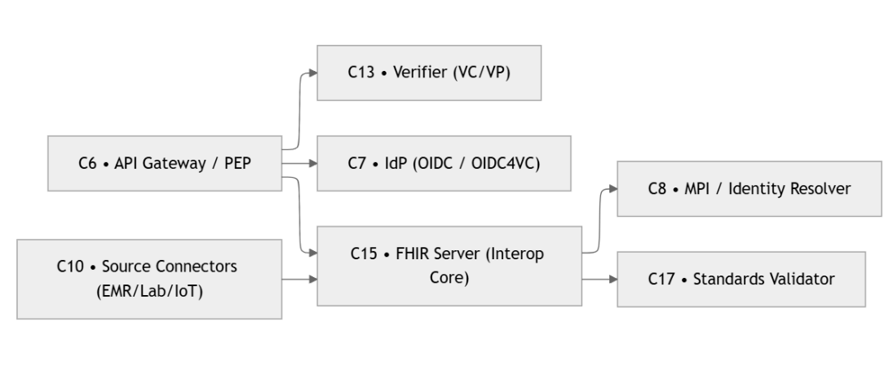

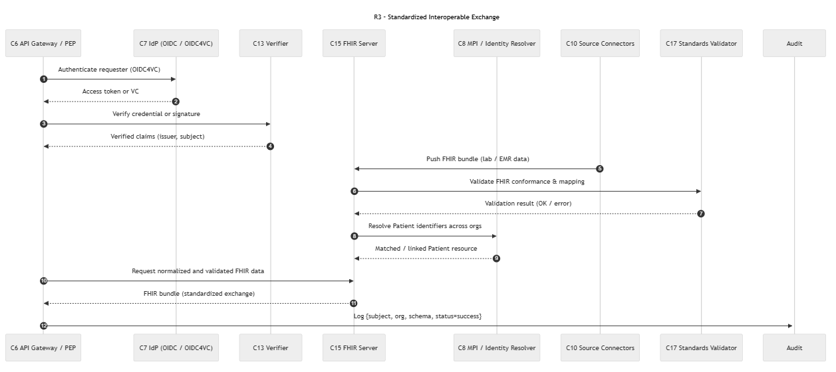

The R3 standardized exchange flow begins with the API Gateway authenticating the requester using either an OIDC token or a VC/VP. After the IdP or Verifier validates signatures, issuer trust, and subject identity, the gateway forwards the request to the FHIR server with verified claims. The FHIR server then performs two parallel checks: a FHIR conformance and schema validation to ensure the bundle adheres to required profiles, and an identity-resolution step that matches patient identifiers across organizational sources. Once both validations succeed, the server stores or exchanges the normalized FHIR bundle via the appropriate source connectors. Throughout the process, each major event, including authentication, verification, mapping, and exchange, is captured in the audit log to provide full traceability. This ensures that only authenticated, verified, and standards-compliant data participates in cross-system healthcare exchange.

R4- Cross-organisational Acceptance
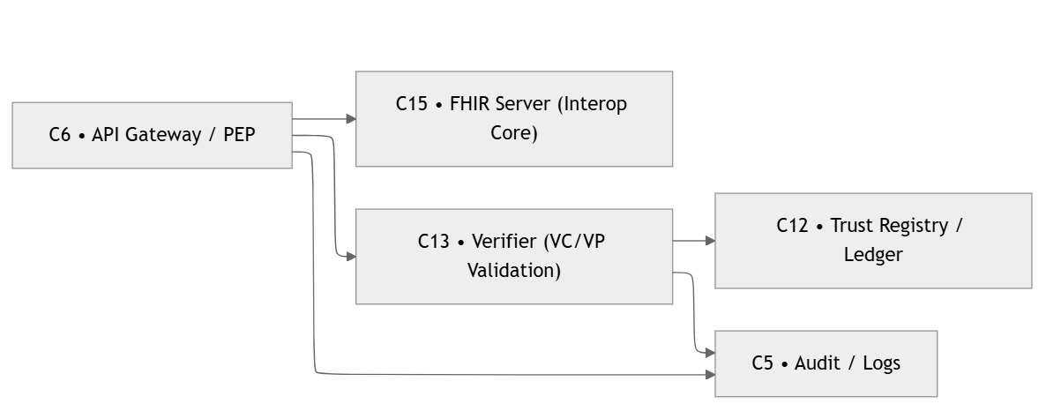
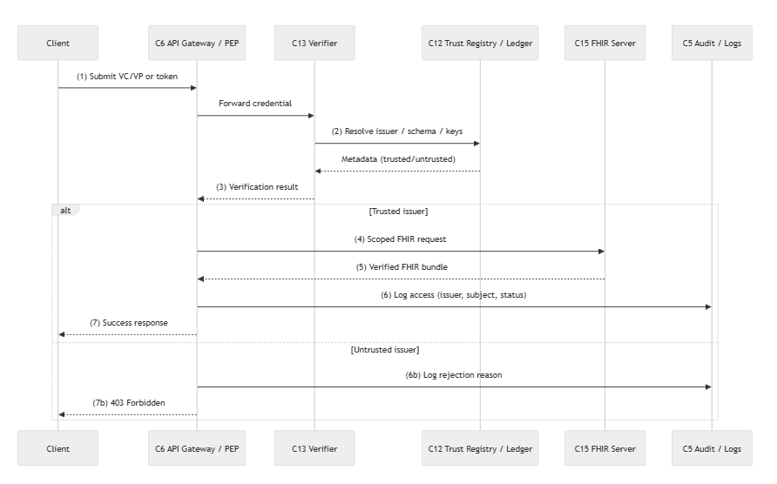
This flow illustrates the cross-organizational verification process used to ensure that a submitted VC/VP (or access token) originates from a trusted issuer before any FHIR data can be accessed. When the request arrives at the API Gateway, it is forwarded to the Verifier, which resolves the issuer’s DID, credential schema, and public keys using a local trust cache when possible or querying the trust registry or ledger if needed. The Verifier evaluates the credential’s authenticity, the issuer's trustworthiness, and its revocation or expiry status. If verification succeeds, the request proceeds to the FHIR server, which returns the normalized FHIR bundle per policy. All verification outcomes, including correlation IDs and trust decisions, are logged for auditability. If the issuer is untrusted, the metadata is stale, or verification fails, the system records the rejection in the audit log and returns a 403 error to the client. This ensures that only credentials from valid, trusted issuers can trigger cross-organization data exchange.
R5-Validity and Integrity checks
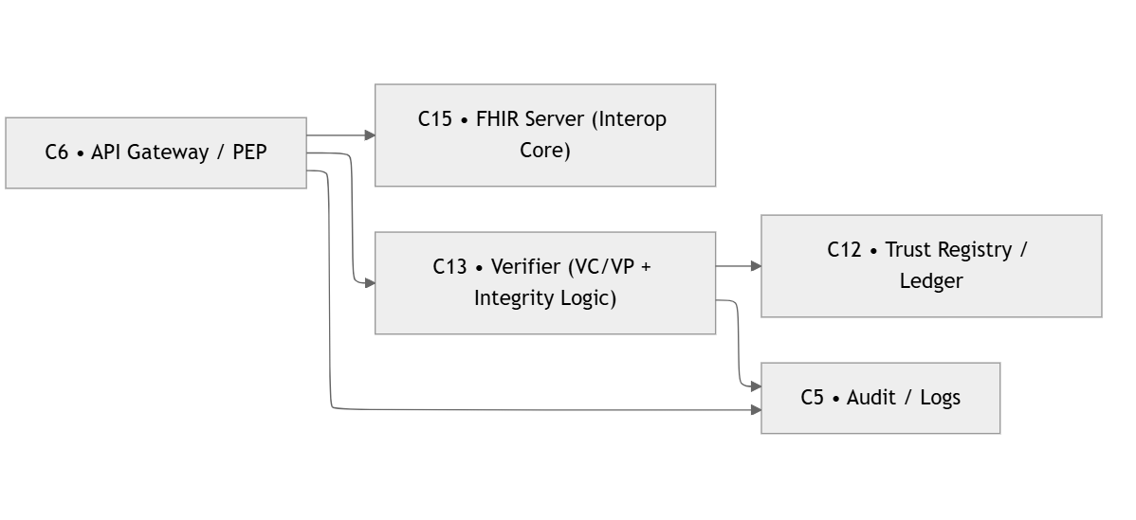
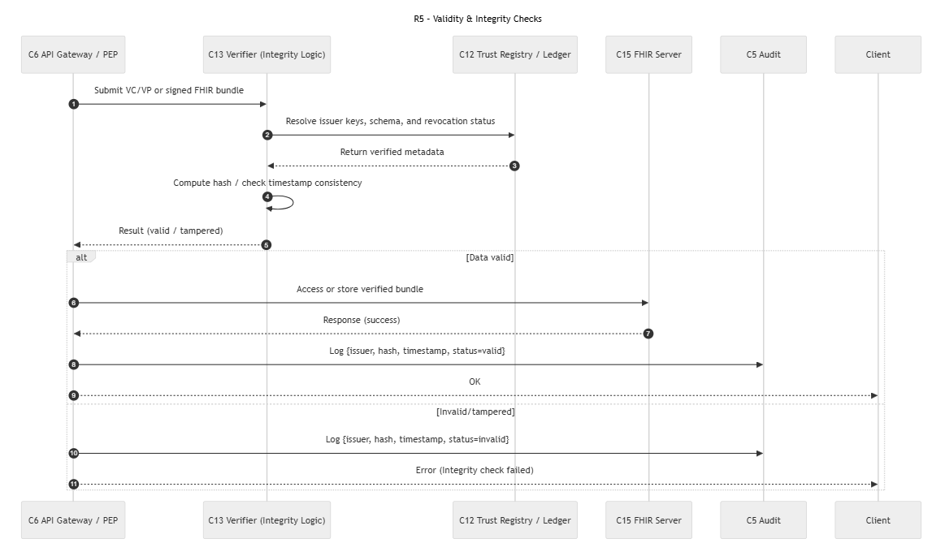
The flow begins when the API Gateway/PEP receives a VC/VP or a signed FHIR bundle from the client and forwards it to the Verifier. The Verifier resolves the issuer’s keys, schema, and revocation status using the Trust Registry/Ledger, then returns the verified metadata. With this information, the Verifier computes a hash of the received bundle and checks timestamp consistency to detect tampering or replay attacks. The Verifier then returns a result indicating whether the data is valid or has been altered.
If the integrity check succeeds, the verified FHIR bundle is accessed or stored in the FHIR Server, and a normal success response is returned to the client. An audit entry is logged containing issuer identity, hash, timestamp, and a “valid” status. If the integrity check fails, the system logs an “invalid/tampered” audit entry and returns an integrity-error response to the client. This ensures that only trustworthy, unmodified data flows into the healthcare system, while all verification outcomes are captured for traceability and compliance.

R6- Authenticity and patient record binding

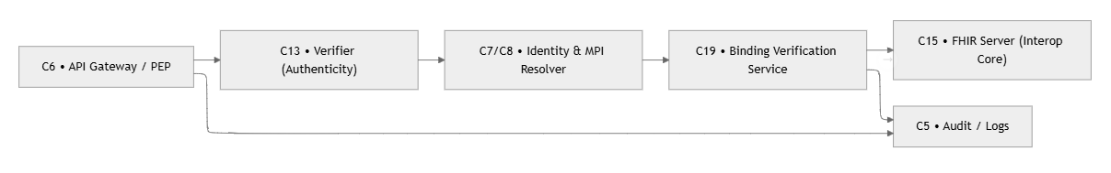
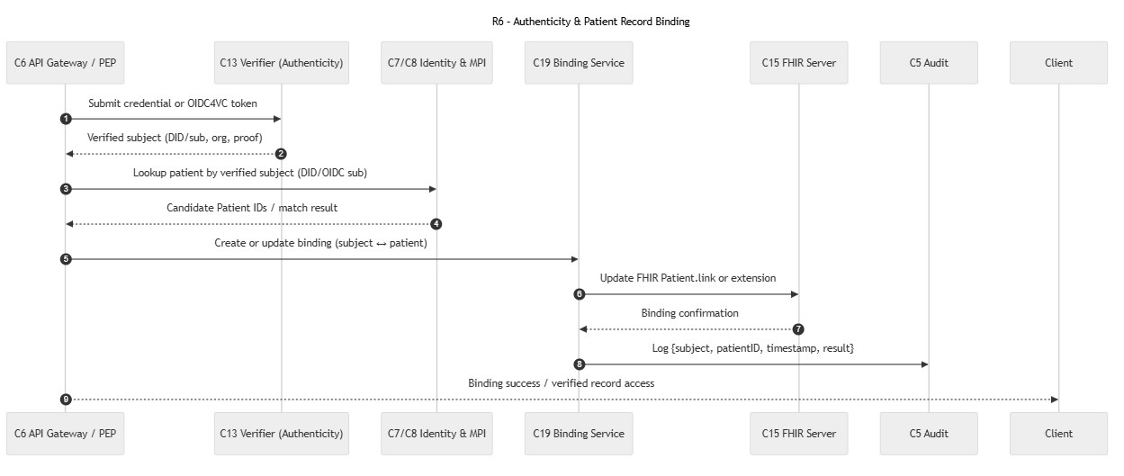
The process begins when the API Gateway/PEP receives a credential or OIDC4VC token from the client and forwards it to the Verifier. The Verifier validates the credential or proof and extracts the verified subject identifiers (e.g., DID, OIDC sub, or organizational metadata). Using this verified subject, the Identity/MPI service is queried to locate existing patient records that may correspond to the authenticated user. The MPI returns candidate patient IDs, which are then assessed for a deterministic or probabilistic match.
If a match is confirmed, the Binding Service creates or updates the binding relationship between the digital identity (DID or OIDC sub) and the corresponding FHIR Patient resource. This binding is materialized in the FHIR Server using a Patient.link, extension, or dedicated identifier entry. Once the binding is successfully updated, a confirmation is returned, and an audit event is recorded documenting the subject, patient ID, timestamp, and binding outcome.
The flow concludes with the system granting the client verified access to the bound patient record. This ensures that all FHIR interactions occur only after a trustworthy linkage has been established between a digital identity and the correct patient entity, preventing impersonation and ensuring accurate record attribution.

R7- Need-to-know
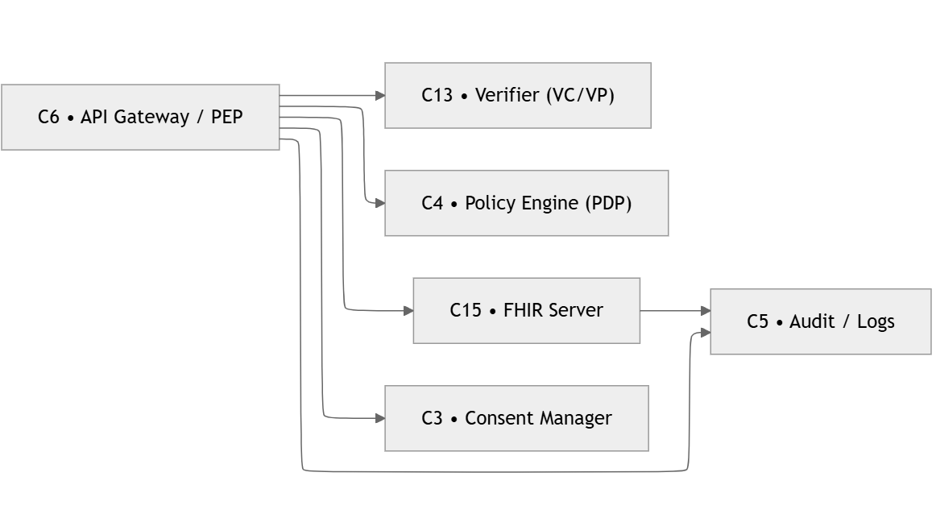
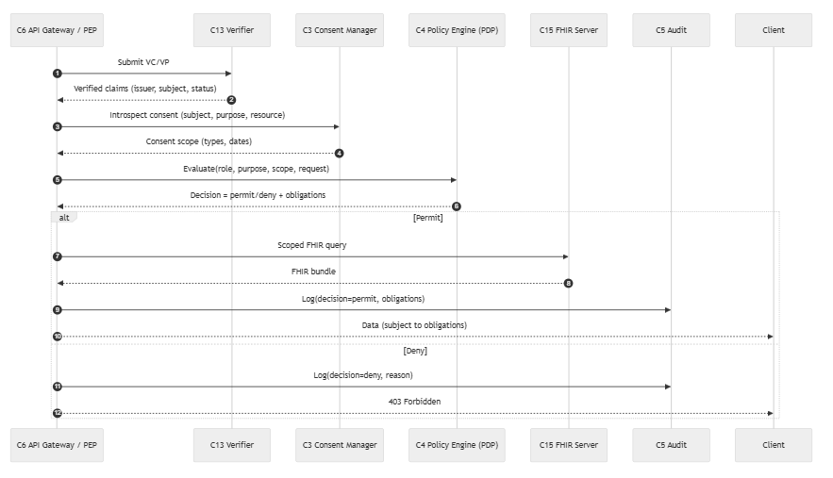
The R7 flow enforces need-to-know access by combining credential verification, consent evaluation, and policy-based authorization. First, the API Gateway/PEP receives a request containing either a VC/VP or a token. It sends it to the Verifier, which returns validated claims such as the issuer, subject, and credential status. The PEP then queries the Consent Manager to retrieve the patient’s consent scope, including permissible data types, access purposes, and valid time ranges. These claims and consent constraints are forwarded to the Policy Engine (PDP), which evaluates the access request and returns a decision—permit or deny—along with any obligations that must be enforced (e.g., masking fields or limiting date ranges). If access is permitted, the PEP issues a scoped FHIR query, returns the filtered FHIR bundle to the client, and logs the permitted action. If denied, the PEP logs the denial and returns a 403 error. This ensures that data access always respects both verified identity and patient-defined consent.
R8 – Data Minimisation
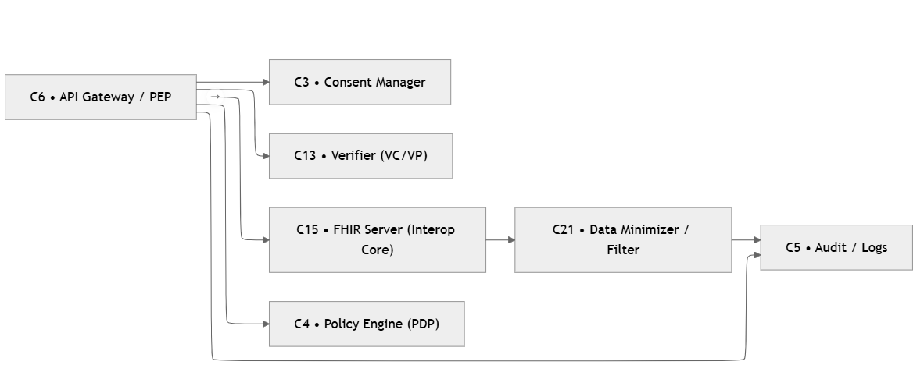
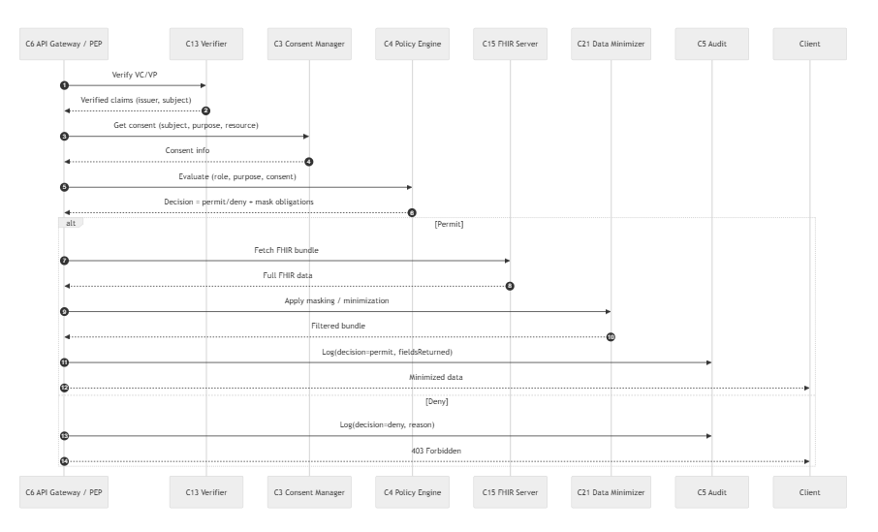

R10- Cross system integration
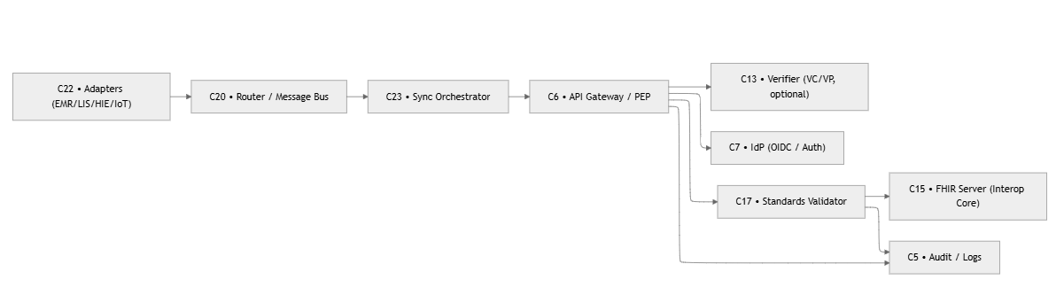
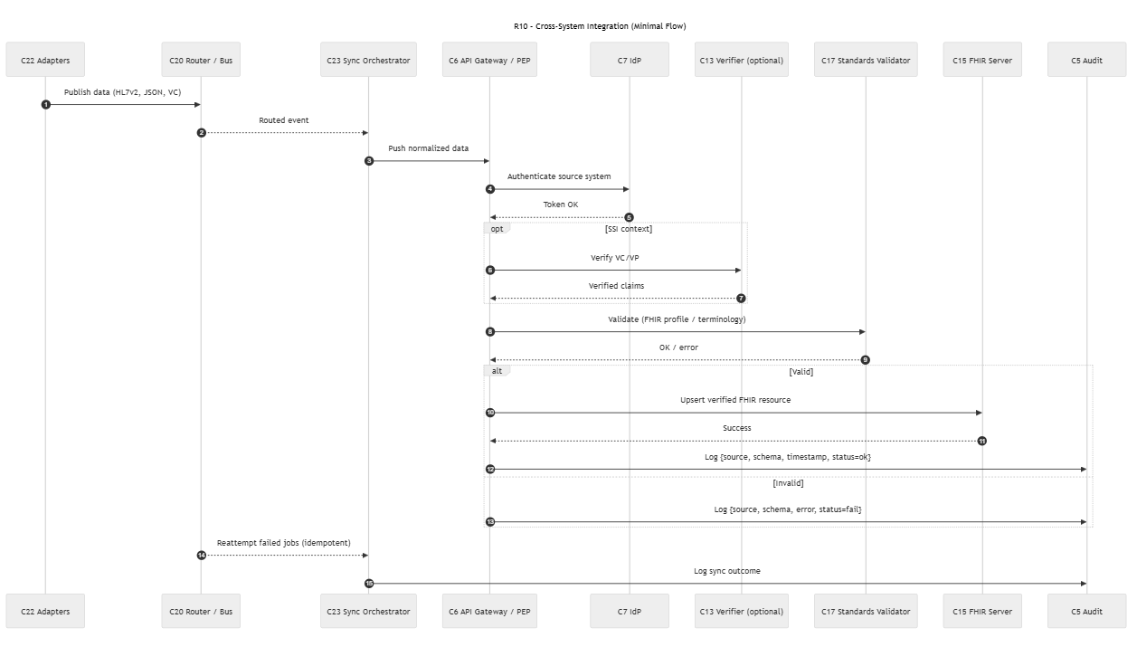

The R10 flow describes how external healthcare systems—such as Electronic Medical Records (EMRs), laboratory systems, or national registries—send data into the shared FHIR-based ecosystem in a standardized and secure manner. The process begins when a source adapter transforms system-specific data (HL7v2, JSON, VC, etc.) into a normalized event and publishes it to a router or message bus. The message bus delivers this event to a Sync Orchestrator, which prepares the cleaned and normalized payload for ingestion.
Before the data is accepted, the Sync Orchestrator authenticates itself through the API Gateway via OAuth2 or an SSI-based credential. If SSI context is present, the system verifies the VC/VP to confirm the source, integrity, and trustworthiness of the incoming data. Regardless of the authentication mechanism, the next step is content validation: the Standards Validator checks that the resource complies with required FHIR profiles, terminologies, and value sets.
If validation succeeds, the payload is written (upserted) into the FHIR Server and logged as a successful synchronization event, including metadata such as source system, schema, timestamp, and status. If validation fails, the error is logged and no write is performed. The Sync Orchestrator then logs the final outcome and may automatically retry failed jobs in an idempotent manner, ensuring consistency across system boundaries. Through this flow, R10 enables robust, secure, standards-based data ingestion from heterogeneous external systems.

R16- Support, recovery and exception handling
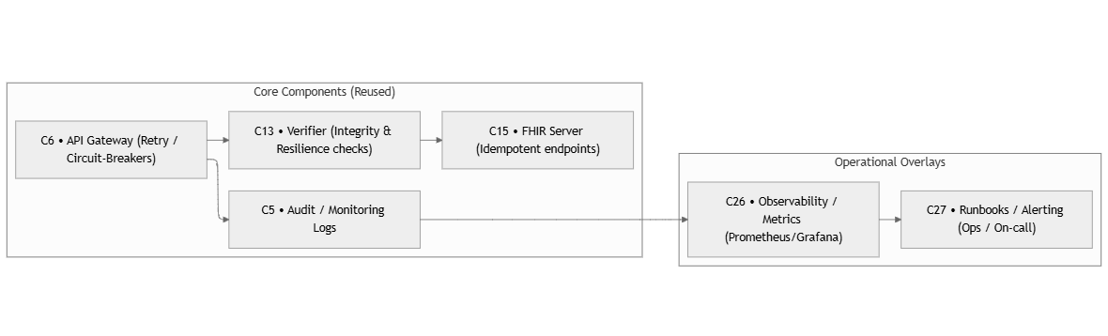
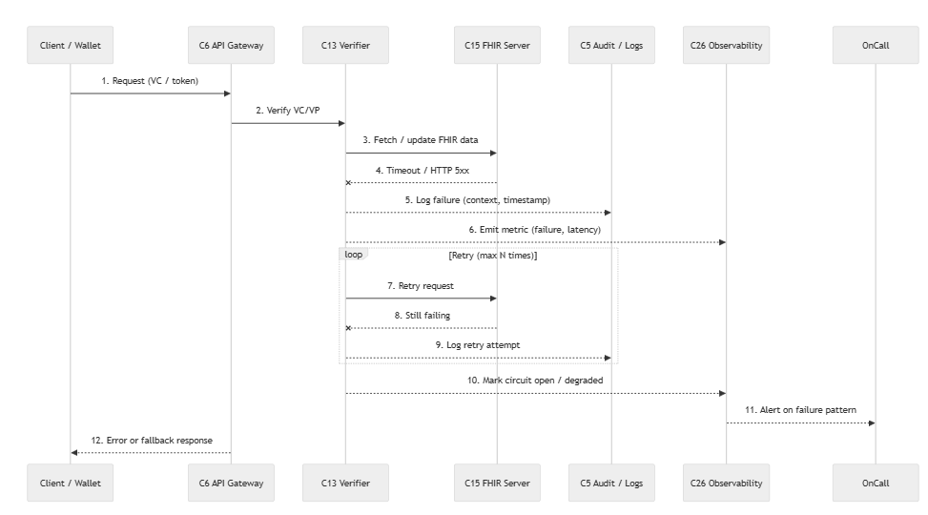
This flow describes how the system maintains reliability and operational stability when errors, timeouts, or verification failures occur. The client sends a request using a token or VC/VP, and the API Gateway attempts to verify the credentials and fetch FHIR data. If verification or data access fails, the Gateway immediately logs the failure, including context and timestamp, and emits operational metrics such as error counters and latency.
For transient or retriable failures, the system automatically performs up to three retry attempts using exponential backoff, recording each retry trace for later debugging. If repeated failures occur, the system enters a circuit-breaker mode, marking the service as temporarily unavailable to prevent overload. This circuit-open state is logged, and an alert signal is emitted to the observability platform.
The observability system correlates the incident with other logs and metrics, then notifies on-call personnel or triggers an automated runbook. Meanwhile, the API Gateway returns a safe fallback or error message to the client, ensuring the user interface remains responsive even when backend components are degraded.
Overall, R16 ensures the system is resilient, observable, and recoverable by combining logging, metrics, retries, circuit breakers, alerting, and on-call escalation to sustain operational continuity.

Requirement Foundations: Supporting requirements
While all requirements (R1-R16) contribute to the architecture, they do not all appear as primary drivers in every runtime flow. Core requirements directly shape component interactions and control paths, whereas supporting requirements act as cross-cutting, contextual, or governance constraints. They are summarized in tabular form because they do not introduce distinct runtime patterns beyond those already captured in the core requirements.
Req | Meaning | Primary Components
R9 | Standards conformance | C17, C15
R11 | Regulatory alignment | C12, C24
R12 | Federation | C6, C15
R13 | Open protocols | C7, C13
R14 | Simplicity | C6, C1
R15 | Multi-device | C1, C6

This appendix provides traceability evidence for Artifact 3. Two complementary tables are included: (i) an analytical requirement-to-runtime mapping that explains how requirements are operationalized through recurring control flows, and (ii) a consolidated requirement-to-component mapping that summarizes the final architectural capability model.

Section B- Requirement Operationalization and Runtime Patterns

Table A. Extended Requirement Operationalization and Representative Runtime Flows
Based on the structural and behavioral modeling of all requirements (R1–R16), and after merging dropped components into their parent services, this table presents the final requirement-to-component mapping, organized by the three master flows that emerged from the cross-framework analysis. Representative runtime flows for the core requirements are summarized in the Master Flow diagrams and detailed traceability matrices.
Yosur Requirement | What It Corresponds To in the Architecture & Overlays (answers technical building block fulfill this requirement) | Primary Control Domain | Coverage / Notes | Runtime flow
R1 – Full Access to Health Records | C1 Wallet/UI, C6 Gateway/PEP, C7 IdP, C13 Verifier, C15 FHIR, C5 Audit | Access & Trust | Supports two patterns: (1) live FHIR API access after identity verification, or (2) FHIR-as-VC payload (credentialized snapshot model).  Auth (OIDC/OIDC4VC), token verify, proof verify, FHIR access, full audit trail. | Standard Access Flow: C1 → C7 → C1 presents VP → C6 → C13 (verify proofs) → C13 checks C12 (trust) → C6 enforces → C15 (FHIR access) → C5 (audit)
R2 – Consent & Access Management | C4 Policy Engine (consent/purpose), C14 Issuer (consent VC), C6 Gateway (enforcement), C5 Audit | Privacy & Policy | No standalone C3: consent UI in C1/C16, consent VC via C14, decisions via C4, enforcement at C6/C15. | Consent Flow: Patient uses C1/C16 to set consent → C14 issues Consent VC → C6 receives access request → C6 queries C4 (PDP) with purpose → C4 evaluates Consent VC + policies → C6 enforces decision → C5 logs
R3 – Standardized Interoperable Exchange | C10 Source Connectors (mapping/normalization), C6 Gateway, C7, C13, C15, C5 | Access & Trust (+ Validation & Integration) | C10 performs HL7/CSV→FHIR mapping; optionally gate with C17 ($validate) if required. | Ingestion Flow: Source system → C10 (transform HL7/CSV→FHIR) → [optional C17 validate] → C6 (authZ check) → C15 (store) → C5 (audit)
R4 – Cross-Organizational Acceptance | C12 Trust Registry/Resolver, C13 Verifier, C6 Gateway, C15, C5 | Access & Trust | Federated issuer & schema trust via C12; verification in C13. | Federation Flow: External issuer presents VC → C13 verifies → C13 resolves issuer DID via C12 (trust registry) → C12 checks federated trust list → C6 enforces → C15 access → C5 logs
R5 – Validity & Integrity Checks | C13 Verifier (crypto/integrity), C12 Trust/Status, C6, C5 | Access & Trust | Proofs, status/revocation, timestamps where applicable; log outcomes. | Verification Flow: C6 receives VP → C13 cryptographically verifies (signatures, timestamps) → C13 checks C12 for revocation status → C6 acts on result → C5 logs verification outcome
R6 – Authenticity & Patient Record Binding | C19 Binding Service, C13 Verifier, C14 Issuer (binding VC), C15, C6, C5 | Access & Trust | Deterministic DID↔Patient link; persisted in FHIR (e.g., Patient.link). | Binding Flow: C1 authenticates → C19 creates deterministic DID↔Patient link → C14 issues Binding VC → C15 stores in Patient.link → Subsequent access: C13 verifies Binding VC → C6 allows
R7 – “Need-to-know” Policy Enforcement | C4 Policy Engine (PDP), C6 Gateway (PEP), C15 FHIR (authZ filter), C13, C5 | Privacy & Policy | Central OPA returns permit/deny + obligations; enforced at edge and data layer. | Policy Enforcement Flow: C6 intercepts request → C4 PDP evaluates (subject, resource, action, purpose) → C4 returns permit/deny + obligations → C6 applies obligations (filter/mask) → C15 applies FHIR security labels → C5 logs
R8 – Data Minimization | C6 Gateway plugins (masking/filter), C4 policies (obligations), C15, C13, C5 | Privacy & Policy | No separate C21: implement minimization at C6 using OPA obligations. | Minimization Flow: C4 returns obligations (e.g., "mask SSN", "date range only") → C6 plugin applies field-level masking → C15 returns filtered Bundle → C5 logs what was redacted
R9 – Common Open Data Standards | C15 FHIR, C6 Gateway, C5 Audit | Validation & Integration | Optionally use C17 Standards Validator for strict profile/terminology checks. | Standards Flow: Data access/ingestion → [optional C17 $validate for strict profiles] → C15 serves FHIR R4 → C6 ensures conformance → C5 logs validation result
R10 – Cross-System Integration Capabilities | C10 Source Connectors, C23 Queue/Event Bus, C25 Orchestrator/Scheduler, C6, C15, C5 | Validation & Integration | Replaces C22/C20/C2: mapping in C10, async via C23, retries/cron via C25. | Integration Flow: Source → C10 (map) → C23 (queue) → C25 (orchestrate retries/scheduling) → C6 (authZ) → C15 (store) → C5 (audit); Async pattern with dead letter handling
R11 – Institutional & Regulatory Alignment | C12 Trust, C13 Verifier, C6 Gateway, C15, C5 | Access & Trust (+ Validation & Integration) | Add C24 Compliance Registry and/or C5.2 Blockchain Anchor only if mandated. | Compliance Flow: C12 maintains accredited issuer lists → C24 (if present) checks regulatory compliance → C13 verifies against trusted schema → C6 enforces institutional policies → C5 immutable audit
R12 – Elimination of Centralized Repositories | C6, C7, C13, C15, C5 | Access & Trust | Achieved by federated/API-based access; no extra component. | Federated Access Flow: C6 routes to appropriate C15 instance by patient ID hash → No central MPI; C7 federated IdP → C13 verifies without central registry → C5 distributed audit
R13 – Building upon Open Protocols | C6 (REST/FHIR), C7 (OIDC/OIDC4VC), C13 (VC/VP), C12 (trust), C15, C5 | Access & Trust | Bridge only if you must mix DIDComm with OIDC; otherwise stick to OIDC4VC+FHIR. | Protocol Flow: Standard OIDC4VP for auth, W3C VC Data Model 2.0, HL7 FHIR R4, IHE profiles → No custom protocols → Interoperable by design
R14 – Low Complexity & Task Simplicity | C6 Gateway (aggregated endpoints/SDKs), C1 Wallet/UI, C15, C5 | Access & Trust | Fewer hops; provide summary endpoints behind C6. | Simplified Flow: C1 uses SDK → Single C6 endpoint handles authZ + routing → Summary endpoints (Patient/$everything) → Reduced hops for common tasks
R15 – Multidevice & Cross-Platform Accessibility | C1, C6, C7/C13, C15, C5 | Access & Trust  C25 Orchestrator if you need cross-device state/sync | Replaces C2; only add scheduled sync if truly needed. | Multi-device Flow: C1 (web/mobile) → Same C7/C13 auth → C6 stateless → C15 consistent → [optional C25 for cross-device sync] → C5 logs device fingerprint
R16 – Support, Recovery & Exception Handling | C23 Queue, C25 Orchestrator, C6, C13, C15, C5 | Data Integration & Validation flow  Ops runbooks/guardrails | Retries/backoff, idempotency, circuit breakers; observability via C5. | Resilience Flow: C23 queues failed requests → C25 retry with backoff → Circuit breaker on C15 failure → Dead letter queue for manual review → C5 alerts + observability

Table C: Agnostic Runtime Flow
Table C abstracts the PoC findings into framework-agnostic runtime flows, showing how each requirement can be realized through reusable architectural capabilities rather than vendor-specific technologies. Across requirements, recurring control loops involve authentication (C7), proof verification and trust resolution (C13/C12), policy decision and enforcement (C4/C6), data access or transformation (C15/C10/C17), and auditing (C5). Different SSI frameworks may implement these roles using varying protocols (e.g., OIDC, VC, JWT, AnonCreds, FHIR REST), while preserving the same logical control structure.
Req | Capability Goal (Agnostic) | Primary Control Domain | Framework-Agnostic Runtime Flow
R1 | User obtains authorized access to health data (live access or signed snapshot). | Access & Trust | AuthN: C1→C7 → Verify assertion: C1→C13(+C12) → Decide: C4 → Enforce: C6 → Access: C15 (live) or consume signed snapshot (VC/JWT doc) → Audit: C5
R2 | Capture and enforce consent/purpose constraints over access. | Privacy & Policy | Capture consent: C1→(consent UI) → Record consent: C14 or policy store → Request access: C1→C6 → Decide (purpose): C6→C4 → Enforce: C6/C15 → Audit: C5
R3 | Ingest/serve standardized interoperable clinical data. | Validation & Integration | Ingest: Source→C10 → Validate: C17 → Authorize/Enforce: C6(+C4) → Store/Serve: C15 → Audit: C5
R4 | Accept credentials/assertions across organizations based on federated trust. | Access & Trust | Present assertion: C1→C13 → Resolve trust: C13→C12 → Verify: C13 → Decide/Enforce: C4/C6 → Audit: C5 (C15 optional if data access follows)
R5 | Validate integrity, issuer authenticity, and status (where supported). | Access & Trust | Receive assertion: C6/C13 → Crypto verify: C13 → Trust resolve: C13→C12 → Status/revocation (if applicable): via status list/ledger/issuer endpoint → Enforce: C6 → Audit: C5
R6 | Bind identity to patient record deterministically and re-use it. | Access & Trust | AuthN: C1→C7 → Bind: C19 creates/maintains link → Store binding: C15 (or registry) → Verify binding on access: C13(+C12) → Enforce: C6 → Audit: C5
R7 | Enforce “need-to-know” decisions with obligations (mask/filter). | Privacy & Policy | Intercept: C6 → Decide: C6→C4 (subject/resource/action/purpose) → Return decision+obligations: C4→C6 → Enforce: C6 (mask/filter) + C15 (labels/filters) → Audit: C5
R8 | Minimize data shared (credential-layer and/or API-layer). | Privacy & Policy | Credential-layer: C1 reveals minimal claims → C13 verifies → C6 allows → C5 audits. API-layer: C6→C4 obligations → C6 filters/masks → C15 returns reduced data → C5 audits redactions
R9 | Ensure use of open data standards and conformance checks. | Validation & Integration | Validate: C17 (profiles/terminology) on ingest and/or response → Serve: C15 → Enforce: C6 (reject nonconformant) → Audit: C5
R10 | Integrate across systems with async workflows, retries, and scheduling. | Validation & Integration | Ingest: Source→C10 → Queue: C23 → Orchestrate: C25 (retries/cron) → Authorize/Enforce: C6(+C4) → Store/Serve: C15 → Audit: C5
R11 | Align with institutional/regulatory governance (accreditation, compliance evidence). | Access & Trust + Validation | Trust policy: C12 maintains allowed issuers/schemas → Compliance checks (optional): C24 → Verify: C13 → Enforce: C6 → Audit/immutable logs: C5
R12 | Avoid centralized repositories; support federation and decentralized exchange. | Access & Trust | Present/verify without central store: C1→C13(+C12) → Route to data holder (federation): C6 → Access: C15 (distributed) → Audit: C5
R13 | Build on open protocols; no proprietary lock-in. | Access & Trust | AuthN: OAuth2/OIDC/SAML/mTLS → Assertions: VC/JWT/SAML → Data: FHIR/REST → Trust: PKI/ledger/registry → Audit: C5 (protocol-agnostic)
R14 | Reduce complexity for common tasks via aggregation/SDKs. | Access & Trust | Single entrypoint: C1→C6 (aggregated APIs/SDK) → Verify/Decide: C13/C4 → Access: C15 (summary endpoints) → Audit: C5
R15 | Support multi-device and cross-platform clients. | Access & Trust | Any client: C1 (web/mobile/desktop) → AuthN/Verify: C7/C13 → Stateless edge: C6 → Data: C15 → Audit: C5 (optional C25 for sync/state)
R16 | Provide resilience: retries, DLQ, circuit breakers, observability. | Validation & Integration | Queue failures: C23 → Retry/orchestrate: C25 → Circuit-break at C6/C15 → DLQ/manual review → Audit/alerts: C5

Section C- Synthesized Master Flows and Layered Control Domains
Master Flow Diagrams:
The comparative evaluation of requirements (R1-R16) revealed recurring runtime control patterns that were independent of the underlying SSI framework. These recurring patterns were consolidated into three master flows corresponding to the layered architecture proposed in Artifact 3: (i) Access & Trust, (ii) Privacy & Policy, and (iii) Validation & Integration. The following diagrams summarize these technology-agnostic control loops.

Master flow 1: Access and Trust (R1, R3, R4, R5, R6, R11, R12, R13, R14, R15)
This flow governs identity assurance, credential verification, trust resolution, patient binding, and authorized access to distributed health records.
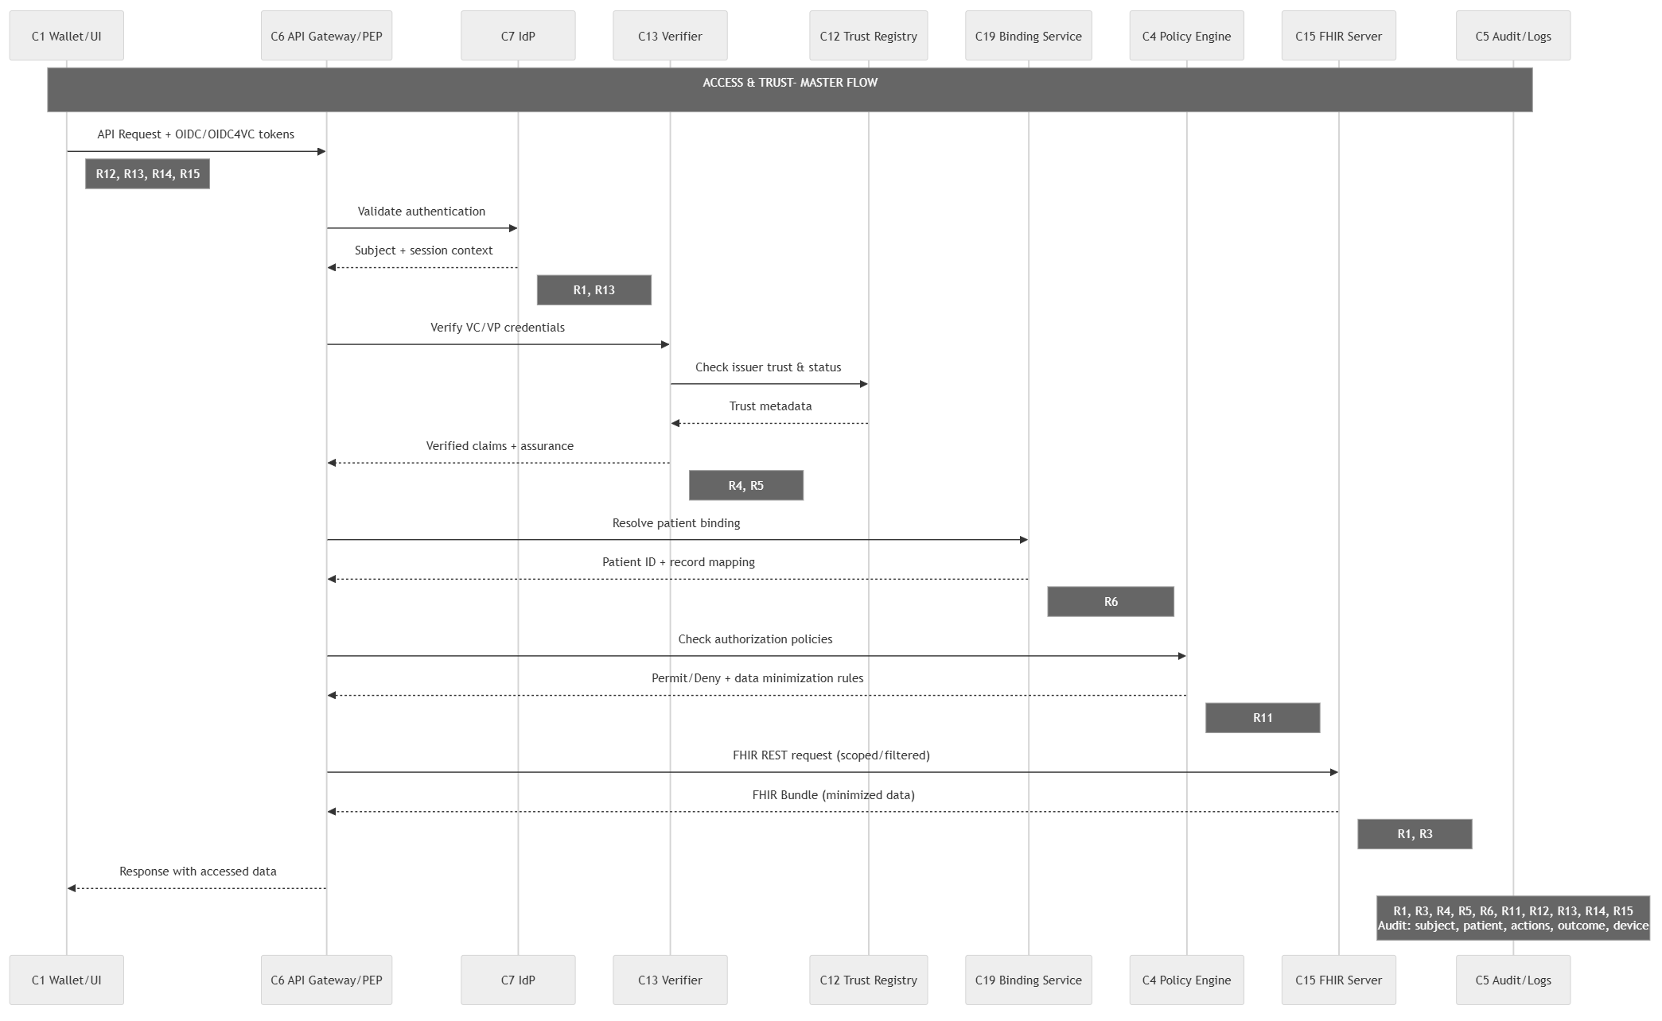
Masterflow 2: (R2,R7,R8)
This flow governs consent evaluation, purpose limitation, need-to-know decisions, and data minimization before information is disclosed.
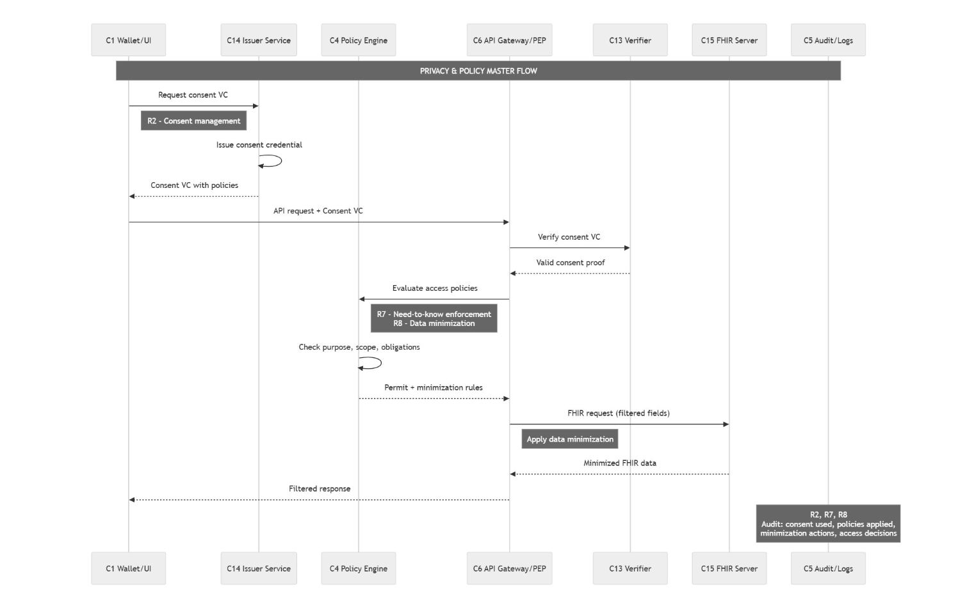

Masterflow 3 (R3, R9, R10, R11, R16)
This flow governs standards conformance, external system ingestion, orchestration, resilience, and interoperable exchange across heterogeneous healthcare systems.
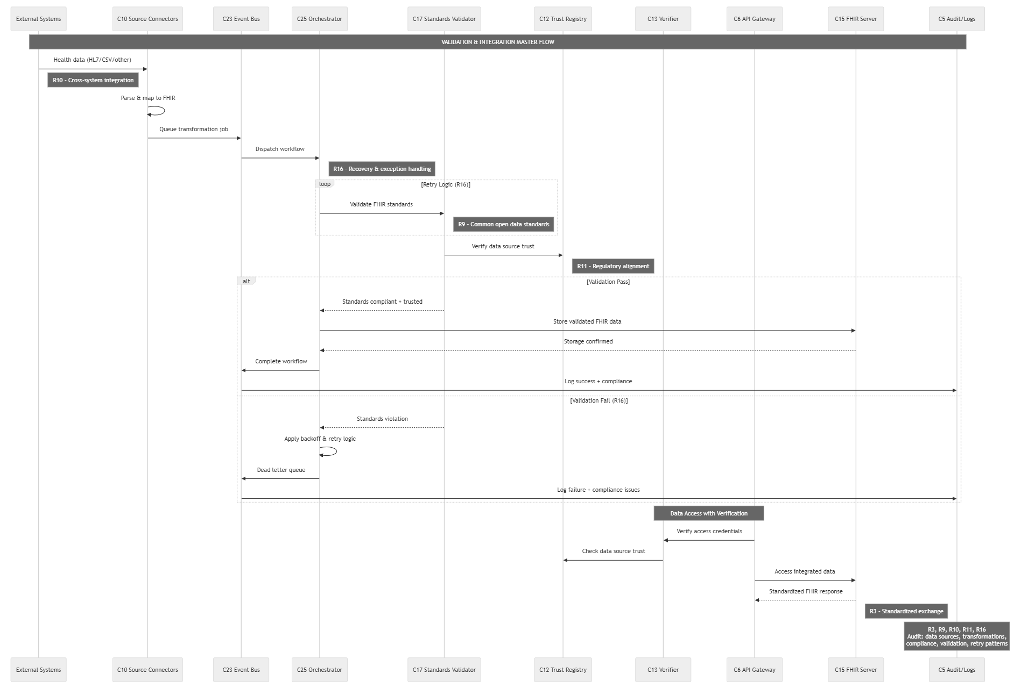

Section D- Final Requirement-to-Architecture Mapping
Table B. Consolidated Requirement-to-Architecture Component Mapping
This table presents the final requirement-to-component mapping after architectural consolidation, reflecting the refined structure used in Artifact 3.
The architecture has been simplified by removing several redundant components (C2, C3, C8, C11, C17, C18, C20, C21, C22) and consolidating their responsibilities into core services. Key mergers include: the API Gateway (C6) now handles policy enforcement and integration; the Policy Engine (C4) manages consent; the Binding Service (C19) and FHIR Server (C15) handle patient indexing; and the Orchestrator (C25) and Event Bus (C23) manage synchronization. This leaner design maintains all required functionality with reduced complexity.

Req | Required Components (core + reused) | Optional / Conditional | Notes
R1 – Full access to health records | C1 Wallet/UI, C6 Gateway/PEP, C7 IdP (OIDC/OIDC4VC), C13 Verifier, C15 FHIR Server, C5 Audit | – | Baseline Access & Trust path for all requirements.
R2 – Consent & access management | C4 Policy Engine (PDP), C14 Issuer (Consent VC), C6 Gateway (enforcement), C5 Audit | – | No standalone C3: consent UX in C1, VC via C14, PDP via C4, enforced at C6/C15.
R3 – Standardized interoperable exchange | C10 Source Connectors (mapping/normalization), C6 Gateway, C7, C13, C15, C5 | C17 Standards Validator (if validating transforms) | Adds normalization + identity resolution; may call C17 during mapping.
R4 – Cross-organizational acceptance | C12 Trust Registry/Resolver, C13 Verifier, C6 Gateway, C15, C5 | – | Trust issuers/orgs before using shared data.
R5 – Validity & integrity checks | C13 Verifier (crypto/integrity), C12 Trust/Status, C6, C15, C5 | – | Proofs, status/revocation, timestamps; logged via C5.
R6 – Authenticity & patient record binding | C19 Binding Service, C13 Verifier, C14 Issuer (Binding VC), C7 IdP, C15, C6, C5 | – | Deterministic DID - Patient.id binding, persisted in FHIR (Patient.link).
R7 – “Need-to-know” policy enforcement | C4 Policy Engine (PDP), C6 Gateway (PEP), C15 FHIR (authZ filter), C13, C5 | – | Central OPA returns permit/deny + obligations; enforced at Gateway/FHIR layer.
R8 – Data minimization | C6 Gateway (mask/filter plugin), C4 Policy (obligations), C15, C13, C5 | – | No separate C21: use OPA obligations + masking middleware.
R9 – Common open data standards | C6 Gateway, C17 Standards Validator, C15 FHIR, C5 | C13 Verifier (if SSI context present) | Use FHIR $validate / $expand; 422 on fail.
R10 – Cross-system integration capabilities | C10 Source Connectors, C23 Queue/Event Bus, C25 Orchestrator/Scheduler, C6 Gateway, C17 Validator, C15, C5 | C13 Verifier (if upstream uses VC/VP), C7 IdP (for source auth) | Replaces C22/C20/C2; mapping via C10, async via C23, retries via C25.
R11 – Institutional & regulatory alignment | C6 Gateway, C13 Verifier, C12 Trust Registry, C24 Compliance Registry, C15, C5 | – | Adds compliance templates & optional blockchain anchoring.
R12 – Elimination of centralized repositories | C6 Gateway, C7 IdP, C13 Verifier, C15, C5 | – | Achieved via federated, API-based access.
R13 – Building upon open protocols | C6 (REST/FHIR), C7 (OIDC/OIDC4VC), C13 (VC/VP), C12 (Trust), C15, C5 | C25 Bridge (only if bridging OIDC- DIDComm) | Conformance to OIDC4VC, FHIR, JSON-LD/DID; part of Access & Trust overlay.
R14 – Low complexity & task simplicity | C6 Gateway (simplified endpoints/SDKs), C1 Wallet/UI, C15, C5 | C7/C13 (as baseline) | Aggregate endpoints; fewer hops.
R15 – Multidevice & cross-platform accessibility | C1 Wallet/UI, C6 Gateway, C7/C13, C15, C5 | C25 Orchestrator (for sync/state) | Same Access & Trust path; optional state sync across devices.
R16 – Support, recovery & exception handling | C23 Queue/Event Bus, C25 Orchestrator, C6 Gateway, C13 Verifier, C15, C5 | – | Retries/backoff, idempotency, circuit breakers, observability via C5.

Layer Tables:
Component Mapping - ACCESS & TRUST LAYER
Component | Walt.id | Credo | Status
C1 - Wallet/ UI | waltid-wallet-api + Next.js frontend | React Native + Credo | Both offered- Different tech
C6 - Gateway/ PEP | Express in issuer-verifier-frontend | Express in backend | Neither has policy enforcement- partial
C7 - IdP | Signicat (OIDC) | Signicat + @credo-ts/openid4vc | Both use Signicat-offered
C12 - Trust Registry | Ethereum smart contracts | Indy von-network | Different approaches
C13 - Verifier | waltid-verifier-api | Custom Credo verifier | Both functional-offered
C14 - Issuer | waltid-issuer-api | Custom Credo issuer | Both functional-offered
C19 - Binding | Manual DID Patient | Manual DID | Not automated- no

PRIVACY & POLICY LAYER
Component | Walt.id | Credo | Status
C4 – Policy engine | Hardcoded rules | Hardcoded rules | Gap - No OPA
C6 - Gateway/ PEP | No enforcement | No enforcement | Gap

VALIDATION & INTEGRATION LAYER
Component | Walt.id | Credo | Status
C10 - Connectors | Not implemented | Not implemented | Gap
C15 - FHIR | FHIR resources as VC payload (examplecredentials/fhir/) fhirclient + SMART on FHIR Both implement differently | fhirclient + SMART on FHIR Both implement differently | Both implement differently- external
C17 - Validator | fhir.schema.json exists but not enforced Not implemented Partial | Not implemented | Partial
C23 - Queue | Not implemented | Not implemented | Gap
C25 - Orchestrator | Not implemented | Not implemented | Gap

Section E- Comparative Proof-of-Concept Validation
The following matrices document how the two proof-of-concept implementations realize the derived requirements. They support the comparative evaluation by indicating whether requirements are fully, partially, or not covered.
Walt.id Matrix
- Coverage legend: fully supported;  partially supported or externally dependent; x not supported.
 | Requirement | Components Used | Runtime Flow in PoC | Req
R1 | Full Access to Health Records | C1, C7, C14, C15 (HAPI-FHIR), C13, C12, C6 | C6 → C15 (HAPI-FHIR fetch) → C14 (wrap FHIR as VC) → C1 (store) → C1 presents VP → C13 verifies → C12 checks issuer trust → Record displayed | - Credentialized snapshot model (not live API access)
R2 | Consent & Access Management | C1 (UI selective disclosure) | C1 Wallet prompts allow selective claim disclosure via SD-JWT; no policy engine or consent registry | X No policy-driven consent management
R3 | Standardized Interoperable Exchange | C14, C15, C17 (schema file) | FHIR R4 resource embedded in VC; schema present but not enforced | Format standardized; no integration layer
R4 | Cross-Organizational Acceptance | C14, C13, C12 | C1 presents VP → C13 verifies → C13 queries C12 → Only trusted issuers accepted |  Trust registry enforced
R5 | Validity & Integrity Checks | C13, C12 | C13 verifies signature → C12 confirms issuer trust status | 
R6 | Authenticity & Patient Binding | C1, C14, C19 (manual) | DID linked manually to patient reference in FHIR payload; no deterministic binding service |  No automated binding service
R7 | Need-to-Know Policy Enforcement | C6 (routing only) | C6 (Caddy) routes requests; no PDP, no attribute-based authorization, no FHIR-layer filtering | x
R8 | Data Minimization | C1, C14, C13 (SD-JWT) | C14 issues SD-JWT VC → C1 selectively discloses claims → C13 verifies disclosed claims only | - Credential-layer minimization
R9 | Common Open Data Standards | C15, C14 | FHIR R4 payload + VC format used; no runtime profile validation (C17 not enforced) | - Validation not runtime-enforced
R10 | Cross-System Integration Capabilities | — | No connectors (C10), no HL7 mapping, no async integration | x
R11 | Institutional & Regulatory Alignment | C12, C13 | Trusted issuer registry enforced; no compliance governance registry (C24 absent) | 
R12 | Elimination of Centralized Repositories | C1, C14, C13 | Credentials exchanged wallet-to-verifier; vc-repo used for demo only | - Decentralized model demonstrated
R13 | Building upon Open Protocols | C7, C13, C14, C15 | OIDC login + VC APIs + FHIR R4 format | 
R14 | Low Complexity & Task Simplicity | C6, C1 | Single ingress via Caddy; multiple services behind | 
R15 | Multidevice & Cross-Platform Accessibility | C1, C6 | Web-based wallet and verifier accessible via browser (cross-device capable) | 
R16 | Support, Recovery & Exception Handling | — | No queue (C23), no orchestration (C25), no retry/circuit breaker | x

Hyperledger Aries/Indy Matrix:
Req | Requirement | Components Used | Runtime Flow in PoC | Coverage
R1 | Full Access to Health Records | C7, C13, C15 | C7 → C13 (Verify Identity VC) → C15 (smart fetch FHIR) | - Live SMART retrieval demonstrated; identity verified by credo, FHIR access acheived
R2 | Consent & Access Management | C1 (credential selection only) | C1 (user chooses which credential to present); no PDP/consent registry | x No policy-driven consent management
R3 | Standardized Interoperable Exchange | C6, C10, C15, C13, C1 | C6/C10 (FHIR client) → C15 (SMART/FHIR REST) → C6 (mapping to claims) → C13 (issue VC) → C1 | - Standardized APIs used; no ingestion/orchestration layer
R4 | Cross-Organizational Acceptance | C12 (Indy Ledger), C13 | C13 (verify) → C12 (Indy ledger resolve issuer DID / credential metadata) → decision | - Ledger-anchored trust enforced
R5 | Validity & Integrity Checks | C13 (Verifier Agent), C12 | C13 (AnonCreds proof verification) → C12 (ledger trust anchor for verification metadata) | - AnonCreds proof validation
R6 | Authenticity & Patient Binding | C1, C13, C15 | C1 presents identity/credential → C6 maps to patient context → C15 accessed via SMART session (binding handled in app logic) | - Manual/application-level binding
R7 | Need-to-Know Policy Enforcement | C6 (Backend), C15 (SMART scopes) | Access limited by SMART OAuth scopes; no centralized PDP or ABAC enforcement | - Scope-based restriction only
R8 | Data Minimization | C1 (Proof presentation), C13 | C13 requests “Prescription” credential → C1 selects credential → C13 verifies VP (no attribute-level minimization demonstrated in request) |  Credential selection shown; attribute-level selective disclosure not demonstrated
R9 | Common Open Data Standards | C7, C15, C13, C12 | C7 (OID4VC transport) + C15 (FHIR R4 via SMART) + C12 (Indy trust) | - Standards used; no runtime profile validation (C17 missing)
R10 | Cross-System Integration | C10 (FHIR client), C6 | C6/C10 integrates only with C15; no C23/C25 pipelines, no external ingestion | - Limited to SMART integration
R11 | Institutional & Regulatory Alignment | C12 (Indy Ledger) | C13 verifies → C12 provides trust anchor; no compliance registry (C24) | - Trust anchored, governance external
R12 | Elimination of Centralized Repositories | C1, C13, C12 | C1 stores credentials locally → C13 verifies without central repo → C12 ledger anchors DIDs/metadata | - Decentralized exchange model
R13 | Building upon Open Protocols | C7 , C13, C15, C12 | OID4VCI/OID4VP (C7 layer) + SMART/FHIR (C15) + Indy trust (C12) | 
R14 | Low Complexity & Task Simplicity | C1, C6 | Multiple moving parts: C1 ↔ C6 ↔ C13 ↔ C12 plus C15 | - Moderate architectural complexity
R15 | Multidevice & Cross-Platform Accessibility | C1 (React Native wallet), C6 | C1 (mobile wallet) ↔ C6 (backend services) | 
R16 | Support, Recovery & Exception Handling | - | No C23 queue, no C25 orchestration, retry, or resilience layer | x

