R1- Full access to Health Records (Structural and Behavioral View)

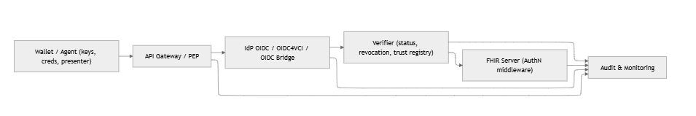

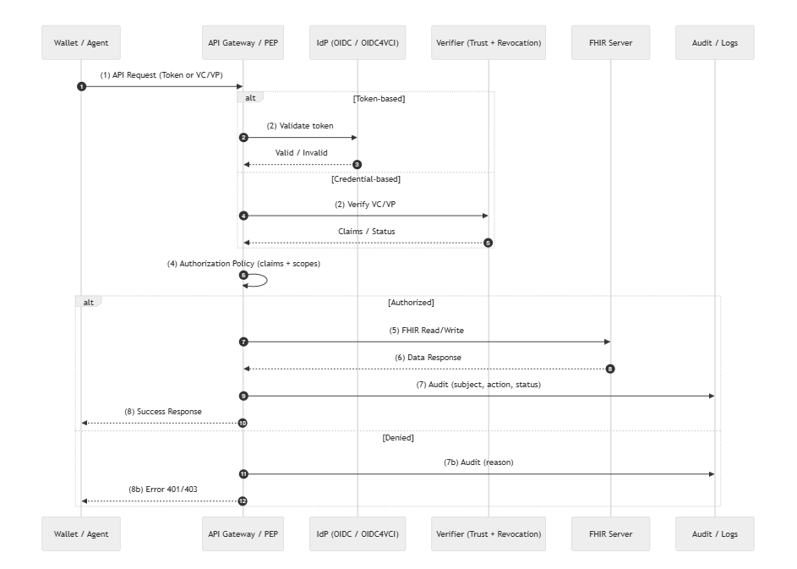
The access-control flow begins when the wallet or agent sends an API request to the API Gateway/PEP using either a bearer token or a verifiable credential/presentation (VC/VP). The gateway first validates the request: if token-based authentication is used, the IdP checks the token’s signature and expiry; if credential-based access is used, the gateway forwards the VC/VP to the Verifier service, which validates the issuer's trust, the schema, the signature, and the revocation status. The verified claims (e.g., subject ID, purpose, attributes) are then returned to the gateway. Using these claims together with predefined scopes, the gateway evaluates the authorization policy to determine whether the request is permitted. If authorized, the gateway forwards a scoped read/write request to the FHIR server, retrieves the resulting resource bundle, and returns it to the client. Simultaneously, an audit event is logged, capturing subject, action, and decision. If the request is denied due to an invalid token, failing credential verification, or insufficient scopes, the gateway returns a 401/403 error and records the denial reason in the audit log.

R2 Consent and Access
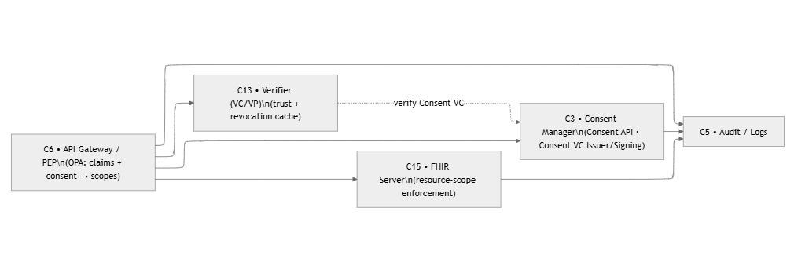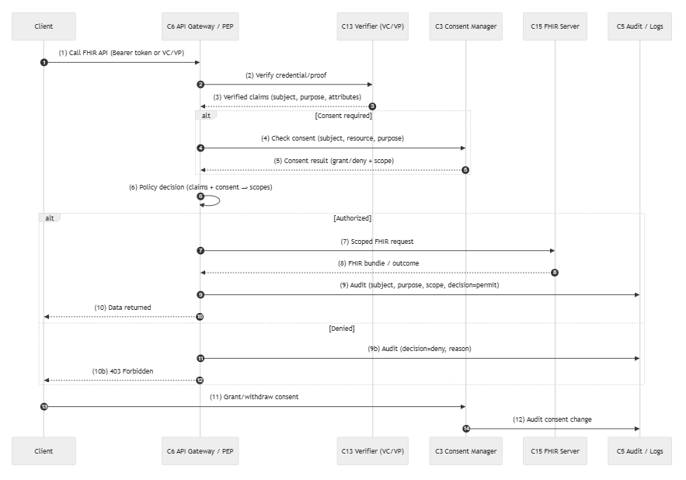
This consent flow begins when the client (e.g., a wallet or app) calls the FHIR API through the API Gateway/PEP. The gateway first verifies the credentials or proof by communicating with the Verifier, which returns the authenticated subject, purpose, and other relevant claims. If the requested operation requires consent, the gateway queries the Consent Manager to check whether a valid consent grant exists for the specific subject, resource type, and purpose of use. The gateway then combines the verified credential claims with the consent status to make a final policy decision on whether access is permitted and what FHIR scopes should be applied. If authorized, the gateway forwards a scoped request to the FHIR Server and returns the resulting resource bundle to the client, while logging the access in the audit service. If consent is missing or invalid, the request is denied and the denial reason is recorded in the audit log. Additionally, the client may at any time grant or revoke consent, and each consent change is also recorded for traceability.

R3 – Standardized interoperable exchange
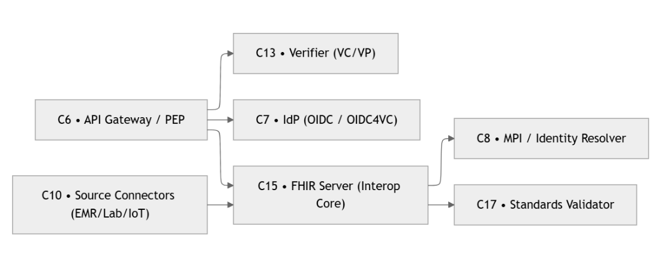

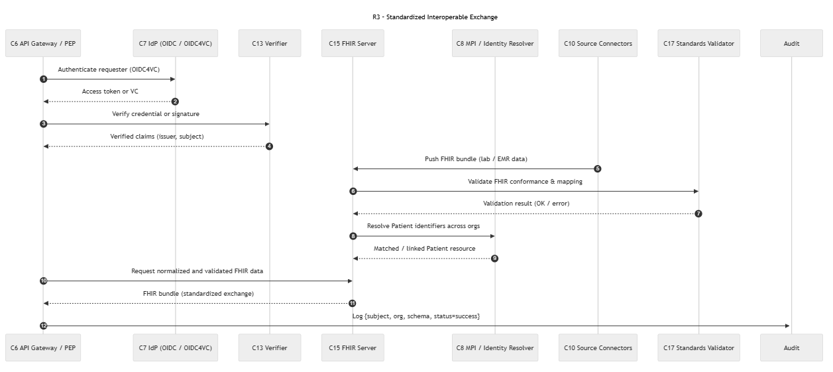

The R3 standardized exchange flow begins with the API Gateway authenticating the requester using either an OIDC token or a VC/VP. After the IdP or Verifier validates signatures, issuer trust, and subject identity, the gateway forwards the request to the FHIR server with verified claims. The FHIR server then performs two parallel checks: a FHIR conformance and schema validation to ensure the bundle adheres to required profiles, and an identity-resolution step that matches patient identifiers across organizational sources. Once both validations succeed, the server stores or exchanges the normalized FHIR bundle via the appropriate source connectors. Throughout the process, each major event, including authentication, verification, mapping, and exchange, is captured in the audit log to provide full traceability. This ensures that only authenticated, verified, and standards-compliant data participates in cross-system healthcare exchange.

R4- Cross-organisational Acceptance
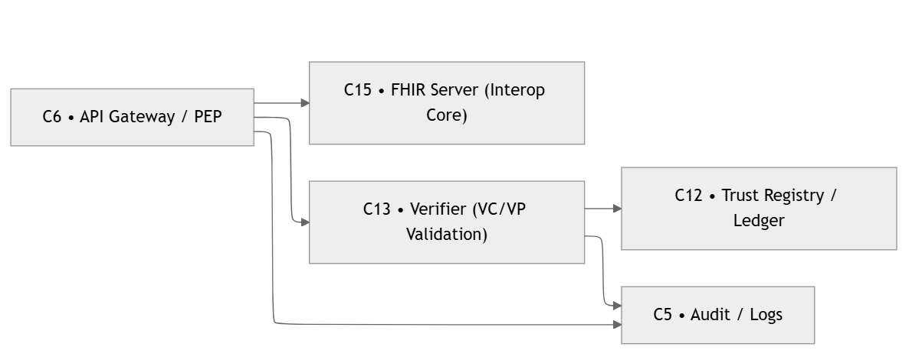
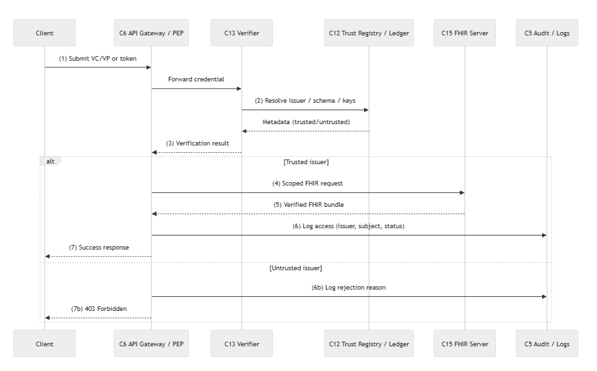
This flow illustrates the cross-organizational verification process used to ensure that a submitted VC/VP (or access token) originates from a trusted issuer before any FHIR data can be accessed. When the request arrives at the API Gateway, it is forwarded to the Verifier, which resolves the issuer’s DID, credential schema, and public keys using a local trust cache when possible or querying the trust registry or ledger if needed. The Verifier evaluates the credential’s authenticity, the issuer's trustworthiness, and its revocation or expiry status. If verification succeeds, the request proceeds to the FHIR server, which returns the normalized FHIR bundle per policy. All verification outcomes, including correlation IDs and trust decisions, are logged for auditability. If the issuer is untrusted, the metadata is stale, or verification fails, the system records the rejection in the audit log and returns a 403 error to the client. This ensures that only credentials from valid, trusted issuers can trigger cross-organization data exchange.

R5-Validity and Integrity checks
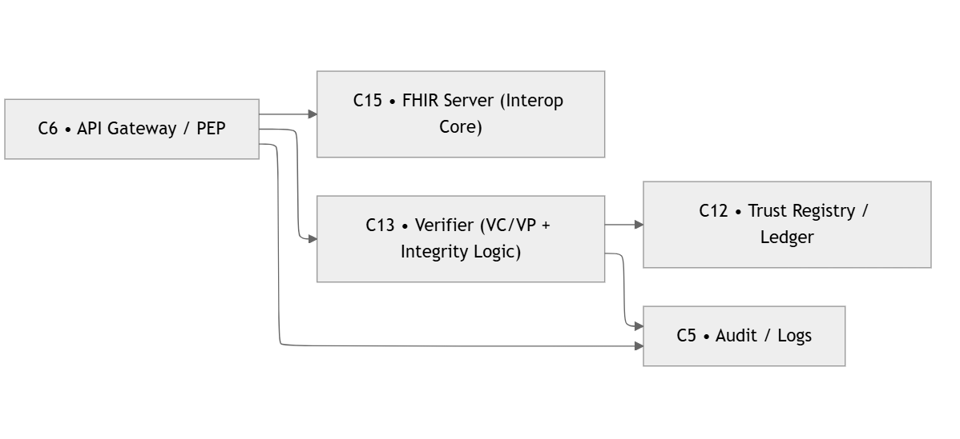
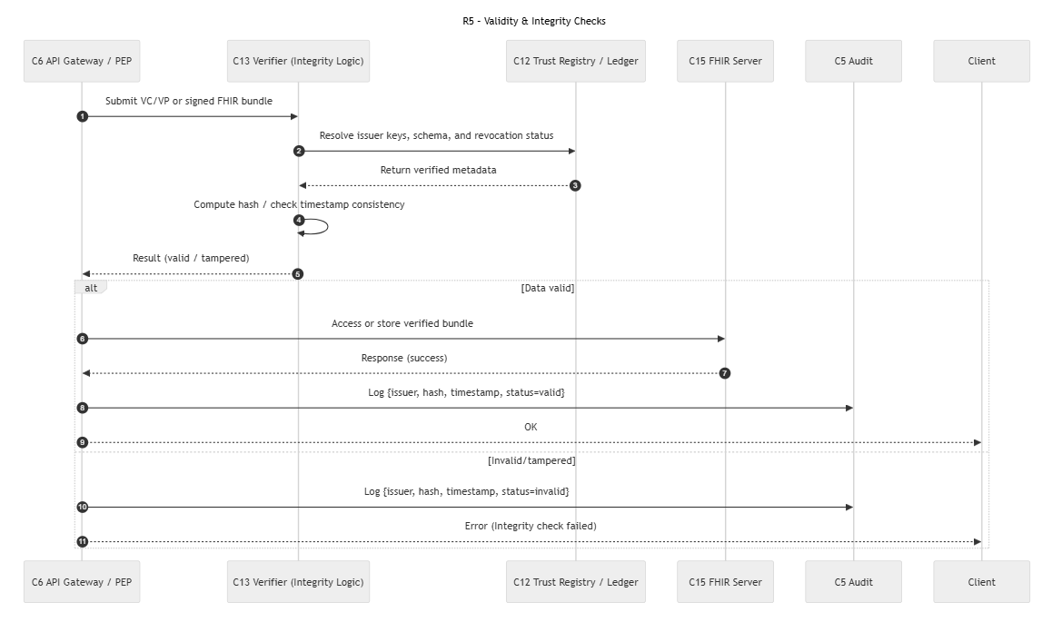
The flow begins when the API Gateway/PEP receives a VC/VP or a signed FHIR bundle from the client and forwards it to the Verifier. The Verifier resolves the issuer’s keys, schema, and revocation status using the Trust Registry/Ledger, then returns the verified metadata. With this information, the Verifier computes a hash of the received bundle and checks timestamp consistency to detect tampering or replay attacks. The Verifier then returns a result indicating whether the data is valid or has been altered.
If the integrity check succeeds, the verified FHIR bundle is accessed or stored in the FHIR Server, and a normal success response is returned to the client. An audit entry is logged containing issuer identity, hash, timestamp, and a “valid” status. If the integrity check fails, the system logs an “invalid/tampered” audit entry and returns an integrity-error response to the client. This ensures that only trustworthy, unmodified data flows into the healthcare system, while all verification outcomes are captured for traceability and compliance.

R6- Authenticity and patient record binding

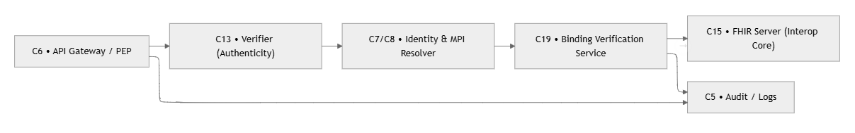
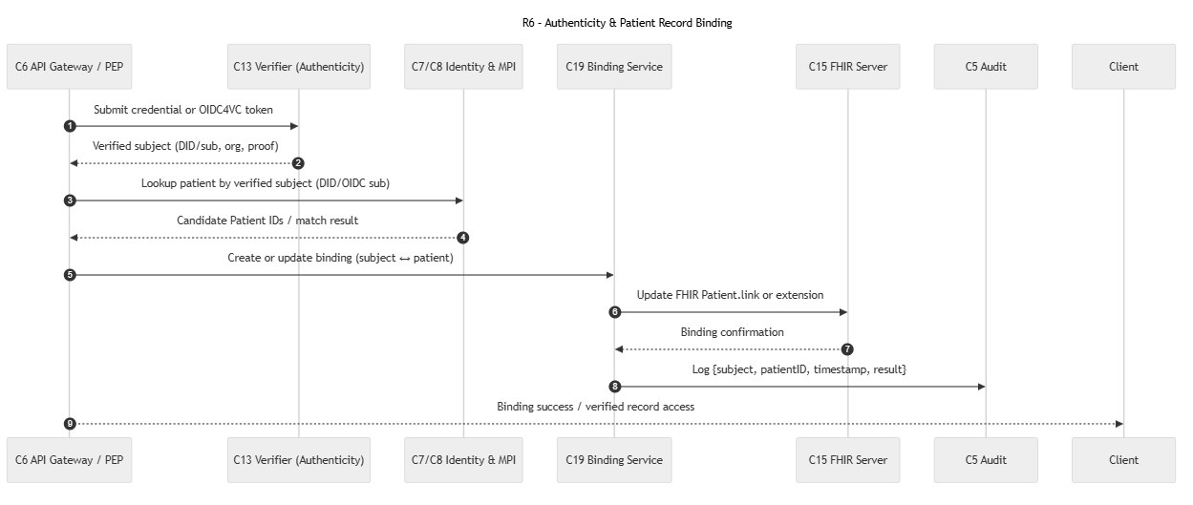
The process begins when the API Gateway/PEP receives a credential or OIDC4VC token from the client and forwards it to the Verifier. The Verifier validates the credential or proof and extracts the verified subject identifiers (e.g., DID, OIDC sub, or organizational metadata). Using this verified subject, the Identity/MPI service is queried to locate existing patient records that may correspond to the authenticated user. The MPI returns candidate patient IDs, which are then assessed for a deterministic or probabilistic match.
If a match is confirmed, the Binding Service creates or updates the binding relationship between the digital identity (DID or OIDC sub) and the corresponding FHIR Patient resource. This binding is materialized in the FHIR Server using a Patient.link, extension, or dedicated identifier entry. Once the binding is successfully updated, a confirmation is returned, and an audit event is recorded documenting the subject, patient ID, timestamp, and binding outcome.
The flow concludes with the system granting the client verified access to the bound patient record. This ensures that all FHIR interactions occur only after a trustworthy linkage has been established between a digital identity and the correct patient entity, preventing impersonation and ensuring accurate record attribution.

R7- Need-to-know
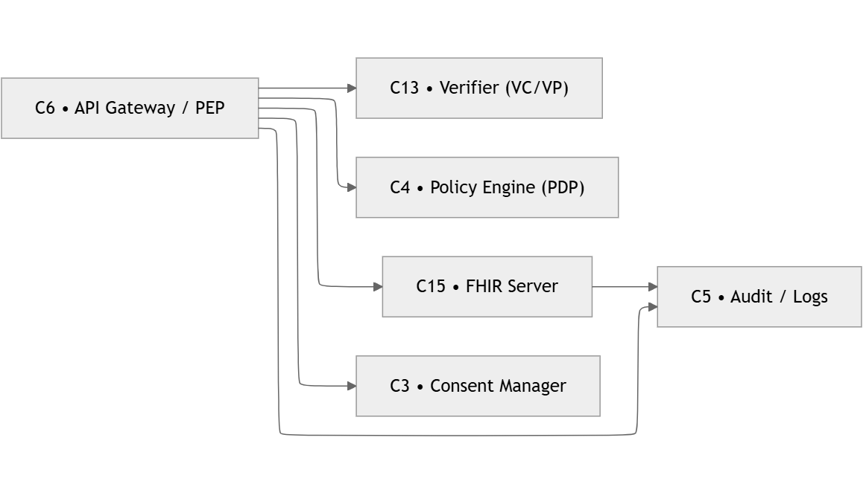
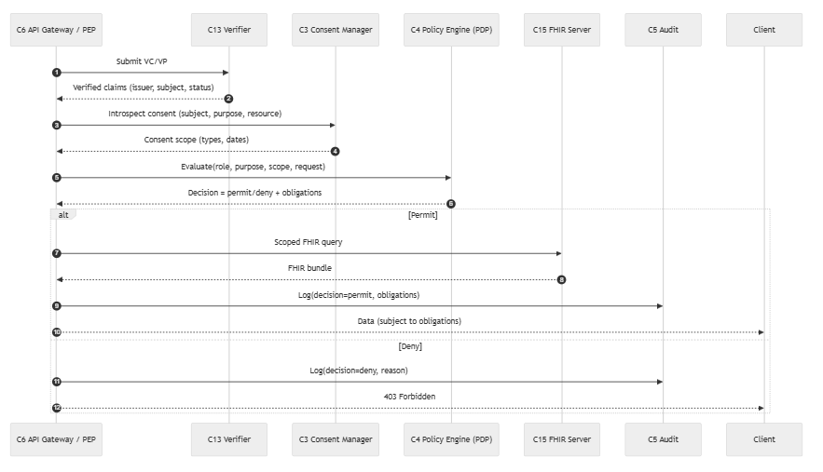
The R7 flow enforces need-to-know access by combining credential verification, consent evaluation, and policy-based authorization. First, the API Gateway/PEP receives a request containing either a VC/VP or a token. It sends it to the Verifier, which returns validated claims such as the issuer, subject, and credential status. The PEP then queries the Consent Manager to retrieve the patient’s consent scope, including permissible data types, access purposes, and valid time ranges. These claims and consent constraints are forwarded to the Policy Engine (PDP), which evaluates the access request and returns a decision—permit or deny—along with any obligations that must be enforced (e.g., masking fields or limiting date ranges). If access is permitted, the PEP issues a scoped FHIR query, returns the filtered FHIR bundle to the client, and logs the permitted action. If denied, the PEP logs the denial and returns a 403 error. This ensures that data access always respects both verified identity and patient-defined consent.

R8 – Data Minimisation
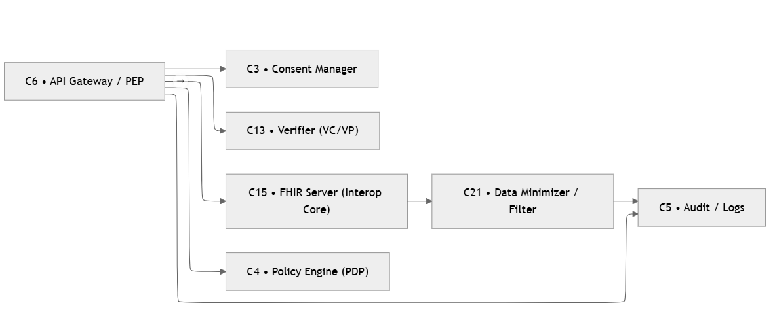
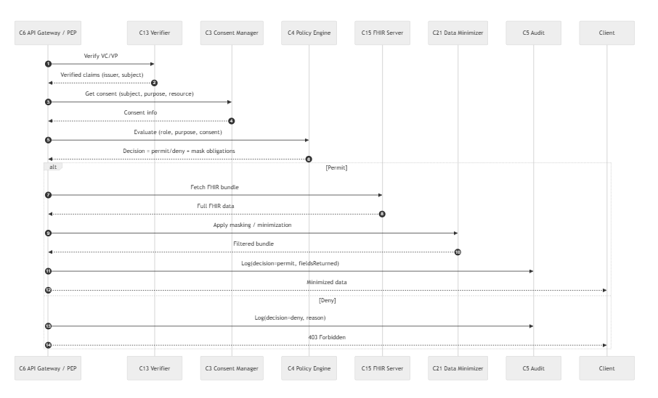

In this flow, the API Gateway first verifies the requester’s identity and credential via the Verifier, ensuring the issuer, subject, and status are trustworthy. It then retrieves the user’s consent from the Consent Manager to determine what data, for which purpose, may be accessed. The Policy Engine evaluates the request against consent, role, and purpose, returning either a permit or deny decision along with any minimization obligations (e.g., masking or removing certain FHIR fields).
If permitted, the gateway fetches the full FHIR data from the FHIR server and applies the minimization rules through the Data Minimizer, producing a filtered dataset that is logged and returned to the client. If the request is denied, the system logs the decision and returns a standard 403 Forbidden response. The result is a privacy-preserving data exchange where only the minimum necessary health information is released.

R9- Common open data standards
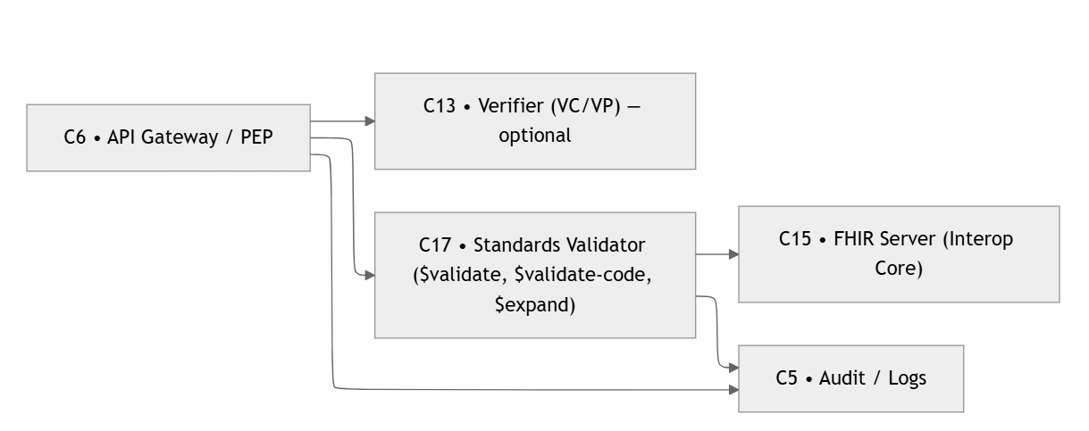
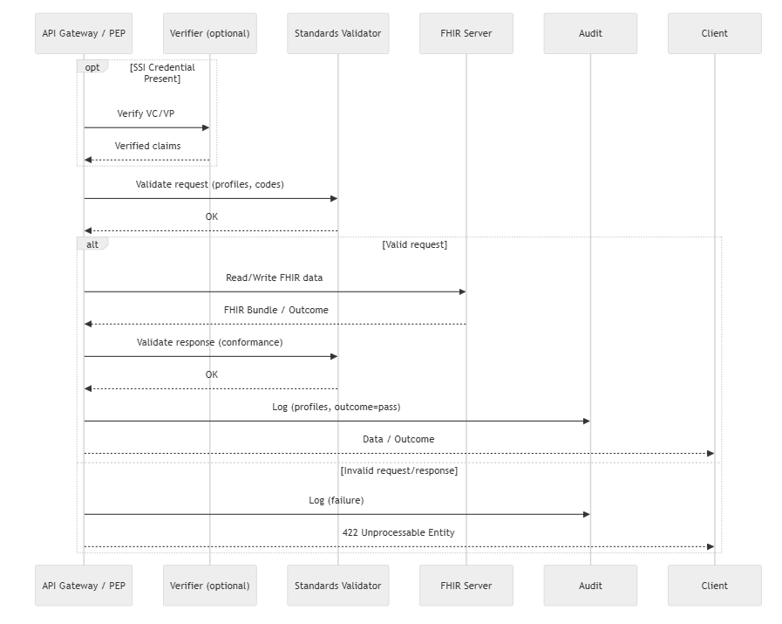

The R9 flow ensures that all data exchanged through the system complies with established healthcare data standards, such as HL7 FHIR profiles, value sets, and coding systems. When a request arrives at the API Gateway, it may optionally include an SSI-based credential, which can be verified to confirm the requester’s identity and authorization context. The Gateway then forwards the request to the Standards Validator to check whether the requested resources, parameters, profiles, or codes conform to the expected FHIR standards.
If the request is valid, the Gateway proceeds to read or write data from the FHIR Server. The resulting FHIR bundle or OperationOutcome is then validated again for standards conformance. Successful validations are logged, and the correct data is returned to the client. If either the initial request or the final response fails validation—for example, due to incorrect profiles, mismatched value sets, or invalid codes—the system logs the error and returns a 422 Unprocessable Entity, ensuring that only syntactically and semantically correct data flows through the healthcare exchange.

R10- Cross system integration
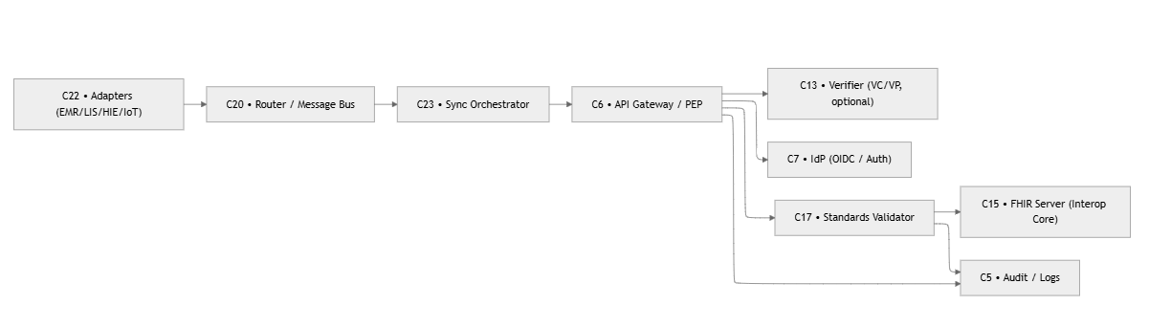
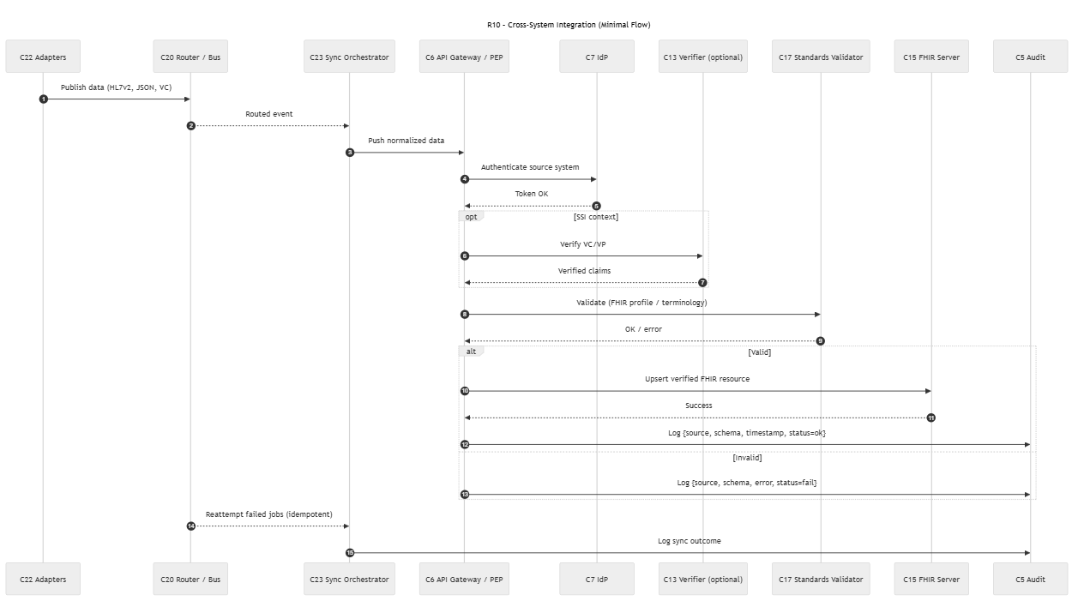

The R10 flow describes how external healthcare systems—such as Electronic Medical Records (EMRs), laboratory systems, or national registries—send data into the shared FHIR-based ecosystem in a standardized and secure manner. The process begins when a source adapter transforms system-specific data (HL7v2, JSON, VC, etc.) into a normalized event and publishes it to a router or message bus. The message bus delivers this event to a Sync Orchestrator, which prepares the cleaned and normalized payload for ingestion.
Before the data is accepted, the Sync Orchestrator authenticates itself through the API Gateway via OAuth2 or an SSI-based credential. If SSI context is present, the system verifies the VC/VP to confirm the source, integrity, and trustworthiness of the incoming data. Regardless of the authentication mechanism, the next step is content validation: the Standards Validator checks that the resource complies with required FHIR profiles, terminologies, and value sets.
If validation succeeds, the payload is written (upserted) into the FHIR Server and logged as a successful synchronization event, including metadata such as source system, schema, timestamp, and status. If validation fails, the error is logged and no write is performed. The Sync Orchestrator then logs the final outcome and may automatically retry failed jobs in an idempotent manner, ensuring consistency across system boundaries. Through this flow, R10 enables robust, secure, standards-based data ingestion from heterogeneous external systems.

R11- Institutional and regulatory alignment
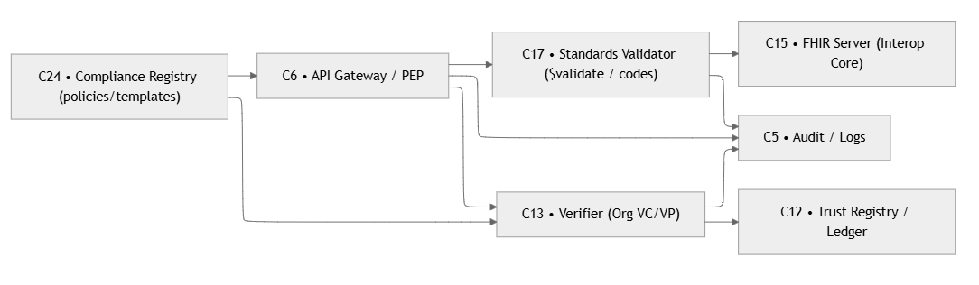
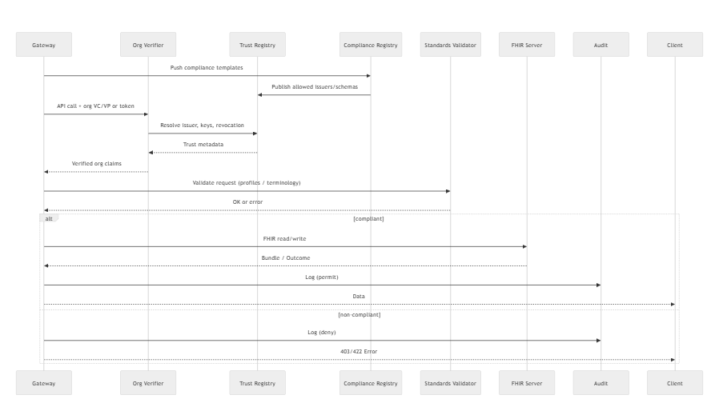
The R11 flow ensures that any organization interacting with the health information exchange is both trusted and compliant with regulatory requirements. First, regulatory policies—such as retention rules, accreditation requirements, or allowed issuer lists—are distributed from the Compliance Registry to the Trust Registry, where they are applied as runtime configuration. When an organization makes an API request, it submits an organizational VC/VP or token. The Org Verifier checks the credential by resolving the issuer’s DID, keys, and revocation status in the Trust Registry. Once validated, organizational claims such as accreditation or permitted roles are returned. Next, the API Gateway validates the request and its payload against mandatory data standards using the Standards Validator (profiles, terminology, codes). If both the trust check and compliance check succeed, the Gateway forwards the request to the FHIR Server, which performs the read/write and returns the outcome. A success entry is logged for auditing. If the organization fails trust validation or the payload violates a regulatory rule or FHIR conformance profile, the request is denied, the reason is logged, and an appropriate 403/422 error is returned. Through this flow, the system enforces institutional accreditation, regulatory alignment, and data-standard compliance before granting access to health data.

R12- Eliminate centralized repositories

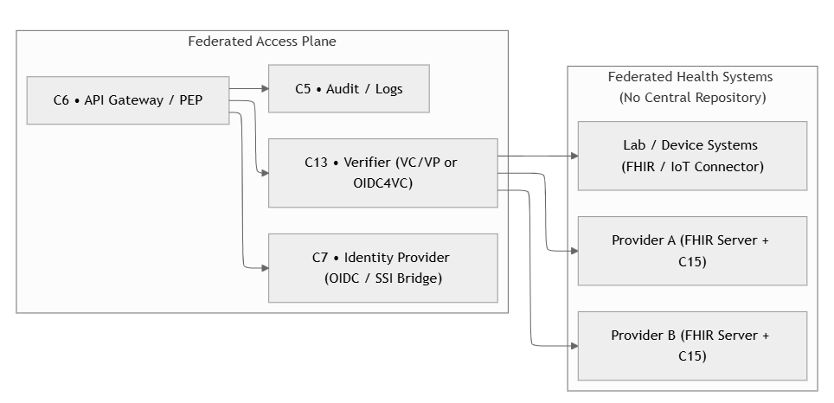
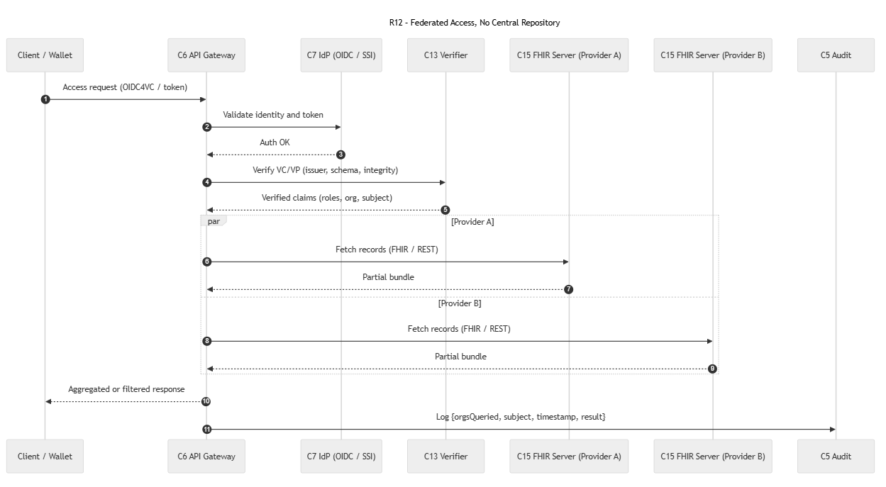
R12 demonstrates a federated health-record access model in which no central data repository exists. Instead, patient data remains distributed across multiple healthcare providers, and the system aggregates results on demand. The flow begins when the client (patient wallet or application) submits an access request, either using a traditional OIDC token or a verifiable credential. The API Gateway validates the identity and token, and the Verifier checks the VC/VP to ensure issuer trust, schema correctness, and integrity. Once the subject and organizational claims are validated (e.g., roles, affiliations, authorization scope), Gateway fetches the patient’s records in parallel from multiple FHIR servers belonging to different providers.
Each provider (e.g., Provider A and Provider B) returns a partial FHIR bundle containing the subset of the patient’s data stored within its own system. These bundles are streamed back independently to the Gateway. After receiving all partial responses, Gateway aggregates, merges, or filters the data according to the policy or request type (e.g., full record consolidation, type-specific query, or date-based subset). The final combined result is returned to the client.
All access operations including which organizations were queried, the subject involved, timestamps, and the success or failure of each provider query are logged to the Audit service to ensure traceability and regulatory compliance. Through this flow, the system provides unified access to distributed clinical data while preserving the decentralized nature of health-record storage.

R13- Build upon open protocols

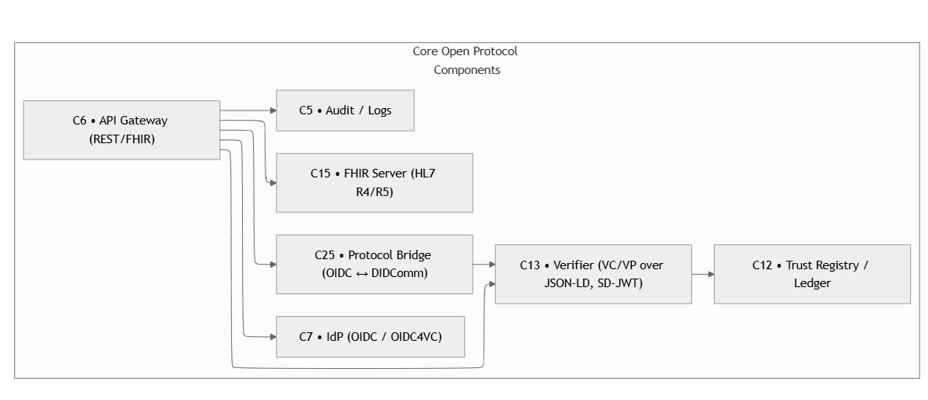
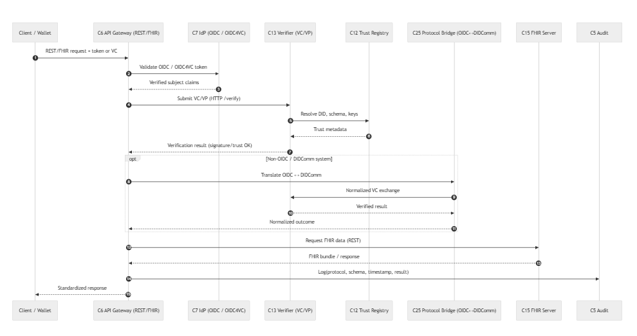

This flow shows how the system supports multiple open identity and credential protocols-OIDC, OIDC4VC, and DIDComm, while keeping a single, unified verification and trust layer. A client sends a standard REST/FHIR API request, including either an OIDC token or a verifiable credential (VC/VP). The API Gateway first authenticates the requester by validating the token against the IdP, then forwards any attached VC/VP to the Verifier. The Verifier resolves issuer keys, schemas, and revocation status through the Trust Registry and returns a signed verification result.
If the requester uses a different protocol, such as DIDComm, a Protocol Bridge translates between OIDC and DIDComm so all systems share the same trust and metadata resolution process. After successful verification, Gateway retrieves the requested data from the FHIR server using standard REST calls. Finally, the Gateway logs protocol details, schema used, timestamps, and verification outcomes into the audit system before returning a standardized FHIR response back to the client. In essence, R13 demonstrates that the system can absorb multiple identity protocols, normalize them through a unified trust layer, and still deliver consistent, secure access to healthcare data via standard FHIR APIs.

R14- Low Complexity and task simplicity
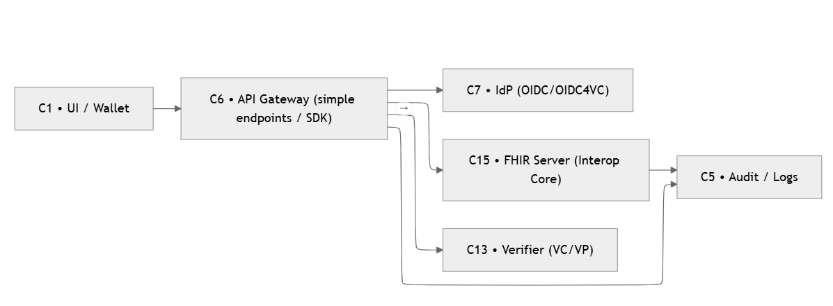
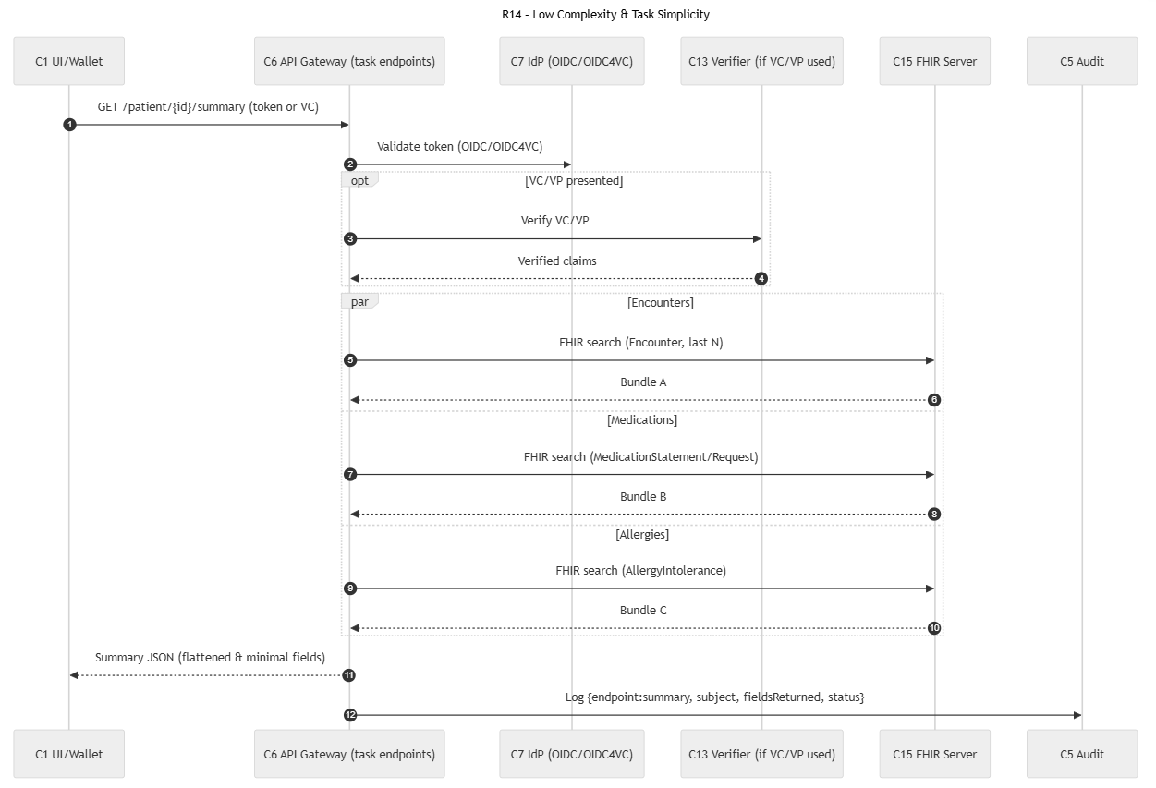
This flow demonstrates how the system supports simple, low-effort tasks like retrieving a patient summary without exposing unnecessary data or requiring complex interactions. The user (from a wallet or UI) calls a dedicated summary endpoint (e.g., /patient/{id}/summary) with either a normal OIDC token or a VC/VP. The API Gateway authenticates the request; if a VC/VP is present, the Verifier checks its issuer, subject, and claims before returning verified metadata.
Once authentication is complete, the Gateway performs multiple FHIR searches in parallel, each returning only the minimal fields needed for a simple summary. For example: Encounters (last N), Medications and Allergies.
Each FHIR query returns a small FHIR bundle with only the required elements. The Gateway then aggregates the results, flattens them into a compact summary JSON, and returns this lightweight representation to the client. Finally, the system logs the request, including the endpoint used, the subject, the fields returned, and the decision status, ensuring full auditability.
In essence, R14 ensures that users can get a quick, simple overview of essential health information with minimal data exposure, minimal FHIR complexity, optional SSI-based verification, and efficient parallel retrieval. This supports usability and performance while maintaining strong authentication and audit control.

R15- Multidevice and cross-platform

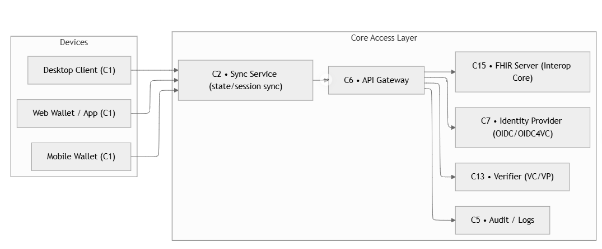
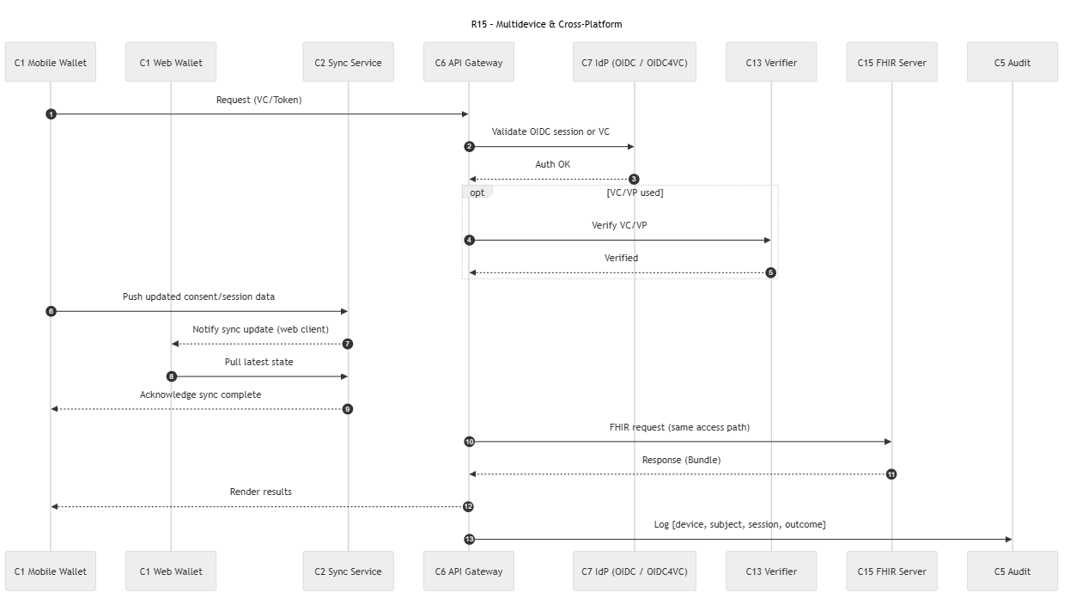
This flow demonstrates how the system maintains a consistent and synchronized user experience across multiple devices, such as a mobile wallet and a web wallet, while ensuring secure authentication and verifiable access.
A user begins by making a request from one of their devices (mobile or web) using either a standard OIDC token or a verifiable credential/presentation. The API Gateway validates this session or VC, and if a VC/VP is provided, the Verifier checks its authenticity, issuer trust, and subject integrity before returning verified claims. Once authenticated, the Gateway performs the required FHIR request and retrieves the data bundle from the FHIR server.
After the mobile wallet obtains updated data or consent information, it pushes the new session state to the Sync Service, which acts as a lightweight coordination layer for multi-device consistency. The Sync Service then notifies the user’s other device (e.g., the web wallet) that the updated state is available. The receiving wallet pulls the latest state, acknowledges synchronization, and updates its local view so both devices display consistent information.
Finally, the Gateway logs the interaction, including the device ID, subject, and session outcome, for auditability and traceability. In summary, R15 ensures that state, consent, and data views remain consistent across all user devices by using secure sessions or VC/VP authentication, a dedicated synchronization service, FHIR-based retrieval of updated data, and event-driven notifications across devices. This supports seamless cross-platform use while maintaining strong identity, consistency, and auditability.

R16- Support, recovery and exception handling
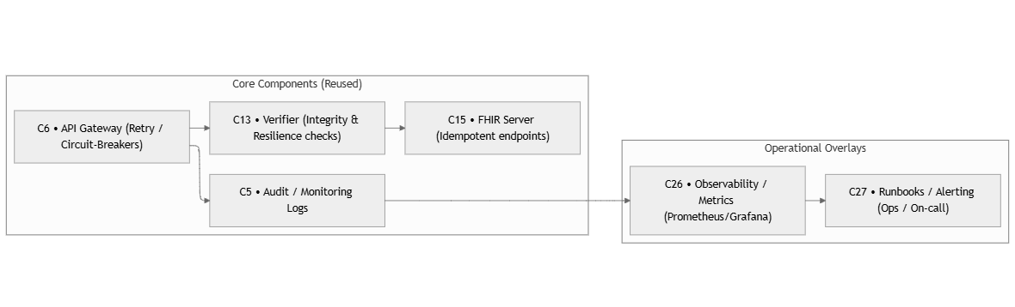
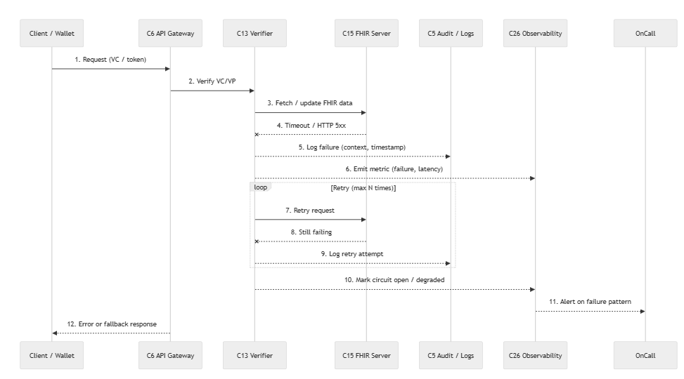
This flow describes how the system maintains reliability and operational stability when errors, timeouts, or verification failures occur. The client sends a request using a token or VC/VP, and the API Gateway attempts to verify the credentials and fetch FHIR data. If verification or data access fails, the Gateway immediately logs the failure, including context and timestamp, and emits operational metrics such as error counters and latency.
For transient or retriable failures, the system automatically performs up to three retry attempts using exponential backoff, recording each retry trace for later debugging. If repeated failures occur, the system enters a circuit-breaker mode, marking the service as temporarily unavailable to prevent overload. This circuit-open state is logged, and an alert signal is emitted to the observability platform.
The observability system correlates the incident with other logs and metrics, then notifies on-call personnel or triggers an automated runbook. Meanwhile, the API Gateway returns a safe fallback or error message to the client, ensuring the user interface remains responsive even when backend components are degraded.
Overall, R16 ensures the system is resilient, observable, and recoverable by combining logging, metrics, retries, circuit breakers, alerting, and on-call escalation to sustain operational continuity.

Mapping Components Across Requirements (R1–R16)
The table below maps each healthcare requirement (R1–R16) to the architectural components (C) needed to fulfill it. It highlights the core services and reused services, as well as optional components that apply only in specific scenarios. This provides a clear overview of which capabilities are essential, which require custom extensions, and how each requirement is supported within the BC–SSI architecture.
Req | Required components (core + reused) | Optional / conditional | Notes
R1 – Full access to health records | C1 UI/Wallet, C6 Gateway/PEP, C7 IdP (OIDC/OIDC4VC), C13 Verifier, C15 FHIR Server, C5 Audit | - | Baseline Access & Trust path for all other requirements.
R2 – Consent & access management | C6 Gateway/PEP, C13 Verifier, C3 Consent Manager, C15 FHIR (for resource scoping), C5 Audit | - | Consent grant/revoke/introspect + audit.
R3 – Standardized interoperable exchange | C6 Gateway, C7 IdP, C13 Verifier, C15 FHIR, C8 MPI/Identity, (or) C10 Source Connectors | C17 Standards Validator (if validating transforms) | Adds normalization + identity resolution; may call C17 during mapping.
R4 – Cross-organizational acceptance | C6 Gateway, C13 Verifier, C12 Trust Registry, C15 FHIR, C5 Audit | - | Trust issuers/orgs before using shared data.
R5 – Validity & integrity checks | C6 Gateway, C13 Verifier (with integrity logic), C12 Trust Registry, C15 FHIR, C5 Audit | - | Hash/timestamp checks live inside C13 (no new box).
R6 – Authenticity & patient record binding | C6 Gateway, C13 Verifier, C7/C8 Identity & MPI, C19 Binding Service, C15 FHIR, C5 Audit | - | Deterministic Subject↔Patient binding, persisted (e.g., Patient.link).
R7 – “Need-to-know” policy enforcement | C6 Gateway/PEP, C13 Verifier, C3 Consent, C4 Policy Engine (PDP), C15 FHIR, C5 Audit | - | PDP returns permit/deny + obligations.
R8 – Data minimization | C6 Gateway, C13 Verifier, C3 Consent, C4 Policy, C21 Data Minimizer, C15 FHIR, C5 Audit | - | Apply FHIRPath/masking per obligations; log fields returned.
R9 – Common open data standards | C6 Gateway, C17 Standards Validator, C15 FHIR, C5 Audit | C13 Verifier (if SSI context present) | Use $validate / $validate-code / $expand; 422 with OperationOutcome on fail.
R10 – Cross-system integration | C22 Adapters, C20 Router/Bus, C23 Sync Orchestrator, C6 Gateway, C17 Standards Validator, C15 FHIR, C5 Aud it | C13 Verifier (when upstream requires VC/VP), C7 IdP (for source auth) | Schedules, retries, idempotency; C17 gate before writes.
R11 – Institutional & regulatory alignment | C6 Gateway, C13 Verifier, C12 Trust Registry, C24 Compliance Registry, C17 Validator (for conformance gates), C15 FHIR, C5 Audit | - | Org credentials + compliance templates applied at gateway.
R12 – Eliminate centralized repositories | C6 Gateway, C7 IdP, C13 Verifier, C15 FHIR, C5 Audit | - | Architectural principle: federated access; no extra component needed.
R13 – Build upon open protocols | C6 Gateway (REST/FHIR), C7 IdP (OIDC/OIDC4VC), C13 Verifier (VC/VP), C12 Trust, C15 FHIR, C5 Audit | C25 Protocol Bridge (only if bridging OIDC- DIDComm) | Conformance to OIDC4VC, FHIR, JSON-LD/DID; avoid proprietary links.
R14 – Low complexity & task simplicity | C6 Gateway (simplified endpoints/SDKs), C1 UI/Wallet, C15 FHIR, C5 Audit | C7/C13 (as used in baseline) | Aggregate endpoints (e.g., patient summary); fewer hops for common tasks.
R15 – Multidevice & cross-platform | C1 UI/Wallet, C6 Gateway, C7/C13 Auth/Verify, C15 FHIR, C5 Audit | C2 Sync Service (for multi-device wallet/app state) | Same Access & Trust path; C2 provides state/session sync across devices.
R16 – Support, recovery & exception handling | C6 Gateway, C13 Verifier, C15 FHIR, C5 Audit | Ops guardrails (retry/backoff, circuit-breakers, idempotency), runbooks | Operational overlays on the same path; no new functional components.

Refined Architecture: Component-to-Requirements Mapping
The architecture has been simplified by removing several redundant components (C2, C3, C8, C11, C17, C18, C20, C21, C22) and consolidating their responsibilities into core services. Key mergers include: the API Gateway (C6) now handles policy enforcement and integration; the Policy Engine (C4) manages consent; the Binding Service (C19) and FHIR Server (C15) handle patient indexing; and the Orchestrator (C25) and Event Bus (C23) manage synchronization. This leaner design maintains all required functionality with reduced complexity.
Req | Required Components (core + reused) | Optional / Conditional | Notes
R1 – Full access to health records | C1 Wallet/UI, C6 Gateway/PEP, C7 IdP (OIDC/OIDC4VC), C13 Verifier, C15 FHIR Server, C5 Audit | – | Baseline Access & Trust path for all requirements.
R2 – Consent & access management | C4 Policy Engine (PDP), C14 Issuer (Consent VC), C6 Gateway (enforcement), C5 Audit | – | No standalone C3: consent UX in C1, VC via C14, PDP via C4, enforced at C6/C15.
R3 – Standardized interoperable exchange | C10 Source Connectors (mapping/normalization), C6 Gateway, C7, C13, C15, C5 | C17 Standards Validator (if validating transforms) | Adds normalization + identity resolution; may call C17 during mapping.
R4 – Cross-organizational acceptance | C12 Trust Registry/Resolver, C13 Verifier, C6 Gateway, C15, C5 | – | Trust issuers/orgs before using shared data.
R5 – Validity & integrity checks | C13 Verifier (crypto/integrity), C12 Trust/Status, C6, C15, C5 | – | Proofs, status/revocation, timestamps; logged via C5.
R6 – Authenticity & patient record binding | C19 Binding Service, C13 Verifier, C14 Issuer (Binding VC), C7 IdP, C15, C6, C5 | – | Deterministic DID - Patient.id binding, persisted in FHIR (Patient.link).
R7 – “Need-to-know” policy enforcement | C4 Policy Engine (PDP), C6 Gateway (PEP), C15 FHIR (authZ filter), C13, C5 | – | Central OPA returns permit/deny + obligations; enforced at Gateway/FHIR layer.
R8 – Data minimization | C6 Gateway (mask/filter plugin), C4 Policy (obligations), C15, C13, C5 | – | No separate C21: use OPA obligations + masking middleware.
R9 – Common open data standards | C6 Gateway, C17 Standards Validator, C15 FHIR, C5 | C13 Verifier (if SSI context present) | Use FHIR $validate / $expand; 422 on fail.
R10 – Cross-system integration capabilities | C10 Source Connectors, C23 Queue/Event Bus, C25 Orchestrator/Scheduler, C6 Gateway, C17 Validator, C15, C5 | C13 Verifier (if upstream uses VC/VP), C7 IdP (for source auth) | Replaces C22/C20/C2; mapping via C10, async via C23, retries via C25.
R11 – Institutional & regulatory alignment | C6 Gateway, C13 Verifier, C12 Trust Registry, C24 Compliance Registry, C15, C5 | – | Adds compliance templates & optional blockchain anchoring.
R12 – Elimination of centralized repositories | C6 Gateway, C7 IdP, C13 Verifier, C15, C5 | – | Achieved via federated, API-based access.
R13 – Building upon open protocols | C6 (REST/FHIR), C7 (OIDC/OIDC4VC), C13 (VC/VP), C12 (Trust), C15, C5 | C25 Bridge (only if bridging OIDC- DIDComm) | Conformance to OIDC4VC, FHIR, JSON-LD/DID; part of Access & Trust overlay.
R14 – Low complexity & task simplicity | C6 Gateway (simplified endpoints/SDKs), C1 Wallet/UI, C15, C5 | C7/C13 (as baseline) | Aggregate endpoints; fewer hops.
R15 – Multidevice & cross-platform accessibility | C1 Wallet/UI, C6 Gateway, C7/C13, C15, C5 | C25 Orchestrator (for sync/state) | Same Access & Trust path; optional state sync across devices.
R16 – Support, recovery & exception handling | C23 Queue/Event Bus, C25 Orchestrator, C6 Gateway, C13 Verifier, C15, C5 | – | Retries/backoff, idempotency, circuit breakers, observability via C5.

Framework Capability Comparison: Subcomponent Implementation Analysis for Walt.id and Aries/Credo
The table systematically shows, for each subcomponent, whether it's offered natively (O), requires custom development (C), or requires external integration (E) in each framework.
ID | Component | Key Subcomponents | Walt.id | Aries / Credo (Indy) | Summary / DevOps Role
C1 | Patient Wallet (Web / Mobile) | C1.1 Web Wallet UI; C1.2 Mobile Wallet/ Agent ; C1.3 Local Credential Store; C1.4 OIDC4VC Client / Bridge | •C1.1 (O) -offer a featured web wallet, •C1.2 (C) -does not provide a mobile wallet, must be custom-built  •C1.3 (O)- Local persistence handled in web wallet (vc, metadata, and key(where applicable), encrypted in browser storage  •C1.4 (O)- supports natively OIDC4VC flows | •C1.1 (C)- doesnot provide webwallet, frontend must built manually  •C1.2 (O)- Credo-Ts/Aries frameworks support mobile and Edge agents  •C1.3(O)- Agent stores Anoncreds locally  •C1.4 (C)- OIDC4VC is not native, requires external bridge (keycloak or Idp) | User-facing wallet to hold VCs and issue presentations. Walt.id supports web wallets and OIDC4VC natively but lacks a mobile wallet. Aries/Indy provides strong mobile/edge agents with native credential storage, but does not provide a web wallet or OIDC4VC, and therefore requires a custom OIDC bridge.
C4 | Policy Engine (OPA) | C4.1 Policy Evaluator (OPA); C4.2 Policy Registry; C4.3 Decision API; C4.4 Obligation handler | •C4.1 –C4.4 (C)  Walt.id doesn’t include a build in Policy decision point (PDP), OPA must be built or integrated externally and integrated with Gateway and Verifier | •C4.1–C4.4 (C) -likewise walt.id needed to be integrated externally | Acts as the central Policy Decision Point (PDP) for authorization, ABAC, consent, and minimization rules. Returns permit/deny decisions and obligations. Queried by C6 (Gateway) and optionally by C13 (Verifier). Enables consistent cross-system policy enforcement.
C5 | Audit / Observability | C5.1 Event Logger; C5.2 Blockchain Anchor (opt); C5.3 ELK Exporter; C5.4 Alert Hooks | •C5.1(O)- Basic JSON logs provided; •C5.2 (C)- optional Ethereum/IPFS anchoring,  •C5.3 (E)- ELK/Prometheus external; •C5.4 (C)- Custom alerting via gateway/OPA hooks | •C5.1 (O)- Built-in agent/controller logs,  •C5.2 (partial- Indy ledger contains credential status events, not application audit logs),  •C5.3 (E)- requires ELK/Prometheus external  •C5.4 (C)- custom notifications | Centralized audit layer for all system events (auth, verification, FHIR access). Supports export to ELK/Grafana for dashboards, optional blockchain anchoring for tamper-evidence.
C6 | API Gateway / PEP (front door) | C6.1 Auth Layer; C6.2 Policy Plugin (OPA); C6.3 Router; C6.4 Rate Limiter; C6.5 Audit Hook; C6.6 Data Minimizer Plugin | •C6.1–C6.2 (C)- Requires custom OIDC4VC +OPA integration;  •C6.3-C6.4 (O/E)- via standard reverse proxy (KGNIX, ENVOY) to route traffic to verifier, issuer, works seamlessly with walt.id APIs | C6.1–C6(C)- External OIDC+ OPA integration, C6.3–C6.4 (O)- with NGNIX/Envoy proxying for aries/agent controller and agent APIs,  •C6.5-C6.6 (C)- audit and data minimization implemented manually | Unified ingress for all services, enforces authentication, authorization, consent policies. Field minimization and auditing. Acts as system policy enforcement point
C7 | Identity Provider (IdP) | C7.1 OIDC4VC Provider; C7.2 Token Issuer; C7.3 AuthN Module; C7.4 DID Resolver | •C7.1 (O) –C7.4 (O)  OIDC and OIDC4VC flows, Token issuance (JWT, SD-JWT/VC-bound tokens), DID resolution (DID: key, web, custom DID methods), wallet authentication | •C7.1-C7.2 (C)- requires external OIDC bridge to convert VP to OAuth2 token ;  •C7.3–C7.4 (O)- agent provides DID resolution and auth primitives | Issues tokens and supports wallet/app authentication, bridges SSI to web APIs, resolves DID to keys, and trusts metadata. Required by the Gateway and Verifier.
C10 | Source Connectors (EMR / Lab / IoT) | C10.1 Ingestion API; C10.2 Parser / Mapper (HL7 to FHIR); C10.3 Queue Buffer; C10.4 Retry Handler | •C10.1–C10.4 (C) -Walt.id provides no clinical data ingestion tools, so all connectors must be built externally.  •C10.1: Custom REST/FHIR ingestion API required.  •C10.2: Mapping via external libraries (HAPI HL7, Mirth, FHIR converters).  •C10.3: Integrates cleanly with Kafka/NATS/Redis for buffering.  •C10.4: Retry logic implemented via C25 (Orchestrator). | •C10.1–C10.4 (C)- Same pattern as Walt.id since Aries provides identity and credential workflows, not clinical ETL.  • C10.1: Requires external ingestion layer for EMR/Lab systems.  • C10.2: HL7/FHIR transformation done through external ETL tools (Mirth, FHIR mapping engines).  • C10.3: Integrates via agent webhooks or message buses (Kafka, RabbitMQ).  • C10.4: Retry/backoff handled in the event bus or orchestrator. | Pulls external health data, converts it into standardized FHIR, and hands it to C15 (FHIR Server) using async queueing and retries; essential for integrating EMRs, labs, and IoT outside the SSI framework.
C12 | Trust Registry / Resolver | C12.1 Issuer Registry; C12.2 Schema Store; C12.3 DID Resolver; C12.4 Status List / Hash Anchor | C12.1- C12.2 (C)- Walt.id provides templates for trust registries but you must host and populate the registry yourself (DB/GitHub/JSON).  • C12.3 (O)- Built-in DID resolver for did:key / did:web / did:jwk.  • C12.4 (C)- Supports StatusList2021 revocation and optional hash anchoring (blockchain/IPFS), but configuration is manual per deployment. | C12.1–C12.4 (O) - Aries/Indy provides a native decentralized trust layer:  • Issuer registry is stored on the ledger (public Indy network).  • Schema definitions and credential definitions stored directly on ledger.  • DID resolution is native to the VON/Indy network.  • Revocation registries also live on the ledger (cryptographic accumulators). | Federated trust anchor that is required for credential verification, including trusted issuers, VC schemas, and DID resolution and revocation checking- used by C13 and C14 to validate proofs
C13 | Verifier Service | C13.1 Proof Validator; C13.2 Signature Verifier; C13.3 Credential Parser; C13.4 VC Policy Evaluator (delegate to C4) | •C13.1–C13.3 (O)-Walt.id provides a complete verifier API that performs cryptographic proof checks, signature validation, schema lookups, trust resolution and StatusList revocation checks.  •C13.4 (C)- walt.id Verifier can call external OPA (C4) for policy decisions (purpose, scope). Not built-in. | •C13.1–C13.3 (O) - Aries/Indy verifier functionality is provided natively via the agent (ACA-Py/Credo TS), including cryptographic proof validation, schema/cred-def resolution from the ledger, and revocation registry checks.  •C13.4 (C)- Like Walt.id, Aries/Indy agents do not include a policy engine; the controller typically calls an external OPA (C4) after proofs are verified. | Performs cryptographic validation of VC/VPs, verifies issuer trust and revocation status, resolves schema metadata, and delegates policy evaluation to C4; acts as a critical verification and trust enforcement component integrated with the Gateway (C6) and Audit (C5).
C14 | Issuer Service | C14.1 Credential Issuer API; C14.2 Schema Manager; C14.3 Signature Engine; C14.4 Revocation List / Status | C14.1- C14.4 (O) - Fully provided by Walt.id’s issuer module, including API endpoints for issuing VCs, built-in schema management, JSON-LD/JWT signing, and StatusList2021-based revocation. | C14.1- C14.4 (O)- Fully supported via Aries/Credo issuer agents, which manage schemas, credential definitions, signature operations, and Indy-ledger-based revocation registries. | Issues identity, consent, prescription, or binding credentials; handles schema registration, secure signing, and revocation/status updates; integrated tightly with the Trust Registry/ledger for validation.
C15 | FHIR Server (Interop Core) | C15.1 FHIR REST API; C15.2 Database Layer; C15.3 Bundle Normalizer; C15.4 Auth Filter (JWT + OPA claims) | • C15.1-C15.2 (E)- Walt.id does not ship with a FHIR server; implementations typically use HAPI FHIR, Blaze, or Smile CDR.  • C15.3–C15.4 (C)- Developers must add middleware to convert VC-derived data into valid FHIR bundles (C15.3) and attach authentication/authorization interceptors such as HAPI Interceptors or SMART-on-FHIR filters (C15.4) | • C15.1-C15.2 (E)- Aries/Indy also does not store or manage FHIR resources; external servers like HAPI/Blaze are required.  • C15.3–C15.4 (C) - Data mapped from verified proofs must be normalized manually, and authorization is enforced in the controller layer using JWT/VC claims and policy responses. | Acts as the secure, standards-based clinical data store; exposes FHIR APIs, normalizes incoming data from credentials, enforces authentication, authorization, and purpose-of-use rules, and provides the canonical interface for healthcare applications.
C16 | Provider / Verifier Portal | C16.1 Web UI; C16.2 Verifier API Client; C16.3 OIDC Bridge; C16.4 FHIR Fetcher | • C16.1–C16.4 (C) - Walt.id provides example verifier UIs (React demos), but production portals must be custom-built. Integrates with the Verifier API (C13), logs in via the IdP (C7), and retrieves verified FHIR data through the Gateway (C6). | • C16.1–C16.4 (C)- Requires custom web portal built on Aries controller APIs or Credo SDKs. OIDC login is optional and added externally. Fetches FHIR data after proof verification using Gateway/agent controllers. | Web-facing application used by providers to request credential proofs and view verified patient data; acts as a thin UI layer over Verifier (C13), Gateway (C6), and the FHIR server (C15).
C19 | Binding Verification Service | C19.1 Binding Validator; C19.2 DID–Patient Mapper; C19.3 Binding VC Issuer; C19.4 FHIR Updater | •C19.1–C19.4 (C)  •C19.1- Walt.id doesn’t include patient–identity linking; you implement logic that compares a verified DID/OIDC subject with a patient record.  •C19.2- Typically a DB table or FHIR Patient.link extension mapping did:web -> Patient.id.  •C19.3 - Use Walt.id Issuer (C14) to mint a VC proving the verified binding. You define a custom VC type (BindingCredential).  •C19.4- Calls C15 (FHIR Server) to persist verified linkage under Patient.link | •C19.1–C19.4 (C)  •C19.1- Same; agents only verify cryptographic proofs. Binding logic (DID - patient) is built in your app/controller.  •C19.2 - Same; mapping stored in app DB or external service.  •C19.3- Same via Credo/ACA-Py Issuer; issue VC asserting identity–patient link.  C19.4 -Same | Establishes a deterministic link between a user’s decentralised identifier (DID) and their clinical patient record; validates identity binding, issues binding credentials, and updates the FHIR Patient resource to record the verified association.
C23 | Queue / Event Bus | C23.1 Publisher; C23.2 Consumer; C23.3 Retry DLQ; C23.4 Metrics Exporter | C23.1–C23.4 (E) - Walt.id does not include an internal message bus. Kafka, NATS, or Redis Streams must be deployed externally. Publishing and consuming jobs are handled by custom microservices (e.g., Verifier, ETL, Gateway). Dead-letter queues and retry semantics come from the broker. Metrics typically exposed through Prometheus/Grafana. | C23.1–C23.4 (E)- Same model: Aries/Credo relies on external brokers such as Kafka, Redis, or RabbitMQ. Agents integrate via webhooks or controller services, but queueing, retries, and telemetry are handled by the external bus. | Provides asynchronous communication for verification jobs, data ingestion, FHIR updates, and long-running workflows; supports retries, DLQ handling, and system-wide telemetry.
C25 | Orchestrator / Scheduler | C25.1 Retry Queue / DLQ; C25.2 Scheduler / Job Runner; C25.3 Backoff Controller; C25.4 Status Monitor; C25.5 Workflow Dispatcher | C25.1–C25.5 (C) - Implemented as a custom microservice or workflow platform (e.g., Temporal, Argo Workflows, Airflow, or simple Cron-based workers). Manages retries, scheduled jobs, backoff policies, and workflow dispatching. Integrates with Prometheus/Grafana for health and job status monitoring. | C25.1–C25.5 (C)- Same pattern: Aries agents do not include workflow orchestration. Controllers/worker services implement scheduling, retries, and workflow logic externally, using the same orchestration stack as Walt.id. | Coordinates long-running workflows, manages retries and scheduling, and monitors job health; effectively replaces the old Sync Service (C2) by centralizing operational workflow control.

Requirements and Architecture mapping table :
Based on the structural and behavioral modeling of all requirements (R1–R16), and after merging dropped components into their parent services, this table presents the final requirement-to-component mapping, organized by the three master flows that emerged from the cross-framework analysis.
Your Requirement | What It Corresponds To in the Architecture & Overlays | Master Flow Used | Coverage / Notes
R1 – Full Access to Health Records | C1 Wallet/UI, C6 Gateway/PEP, C7 IdP, C13 Verifier, C15 FHIR, C5 Audit | Access & Trust | Auth (OIDC/OIDC4VC), token verify, proof verify, FHIR access, full audit trail.
R2 – Consent & Access Management | C4 Policy Engine (consent/purpose), C14 Issuer (consent VC), C6 Gateway (enforcement), C5 Audit | Privacy & Policy | No standalone C3: consent UI in C1/C16, consent VC via C14, decisions via C4, enforcement at C6/C15.
R3 – Standardized Interoperable Exchange | C10 Source Connectors (mapping/normalization), C6 Gateway, C7, C13, C15, C5 | Access & Trust (+ Validation & Integration) | C10 performs HL7/CSV→FHIR mapping; optionally gate with C17 ($validate) if required.
R4 – Cross-Organizational Acceptance | C12 Trust Registry/Resolver, C13 Verifier, C6 Gateway, C15, C5 | Access & Trust | Federated issuer & schema trust via C12; verification in C13.
R5 – Validity & Integrity Checks | C13 Verifier (crypto/integrity), C12 Trust/Status, C6, C5 | Access & Trust | Proofs, status/revocation, timestamps where applicable; log outcomes.
R6 – Authenticity & Patient Record Binding | C19 Binding Service, C13 Verifier, C14 Issuer (binding VC), C15, C6, C5 | Access & Trust | Deterministic DID↔Patient link; persisted in FHIR (e.g., Patient.link).
R7 – “Need-to-know” Policy Enforcement | C4 Policy Engine (PDP), C6 Gateway (PEP), C15 FHIR (authZ filter), C13, C5 | Privacy & Policy | Central OPA returns permit/deny + obligations; enforced at edge and data layer.
R8 – Data Minimization | C6 Gateway plugins (masking/filter), C4 policies (obligations), C15, C13, C5 | Privacy & Policy | No separate C21: implement minimization at C6 using OPA obligations.
R9 – Common Open Data Standards | C15 FHIR, C6 Gateway, C5 Audit | Validation & Integration | Optionally use C17 Standards Validator for strict profile/terminology checks.
R10 – Cross-System Integration Capabilities | C10 Source Connectors, C23 Queue/Event Bus, C25 Orchestrator/Scheduler, C6, C15, C5 | Validation & Integration | Replaces C22/C20/C2: mapping in C10, async via C23, retries/cron via C25.
R11 – Institutional & Regulatory Alignment | C12 Trust, C13 Verifier, C6 Gateway, C15, C5 | Access & Trust (+ Validation & Integration) | Add C24 Compliance Registry and/or C5.2 Blockchain Anchor only if mandated.
R12 – Elimination of Centralized Repositories | C6, C7, C13, C15, C5 | Access & Trust | Achieved by federated/API-based access; no extra component.
R13 – Building upon Open Protocols | C6 (REST/FHIR), C7 (OIDC/OIDC4VC), C13 (VC/VP), C12 (trust), C15, C5 | Access & Trust | Bridge only if you must mix DIDComm with OIDC; otherwise stick to OIDC4VC+FHIR.
R14 – Low Complexity & Task Simplicity | C6 Gateway (aggregated endpoints/SDKs), C1 Wallet/UI, C15, C5 | Access & Trust | Fewer hops; provide summary endpoints behind C6.
R15 – Multidevice & Cross-Platform Accessibility | C1, C6, C7/C13, C15, C5 | Access & Trust  C25 Orchestrator if you need cross-device state/sync | Replaces C2; only add scheduled sync if truly needed.
R16 – Support, Recovery & Exception Handling | C23 Queue, C25 Orchestrator, C6, C13, C15, C5 | Data Integration & Validation flow  Ops runbooks/guardrails | Retries/backoff, idempotency, circuit breakers; observability via C5.

Master flow 1: Access and Trust (R1, R3, R4, R5, R6, R11, R12, R13, R14, R15)
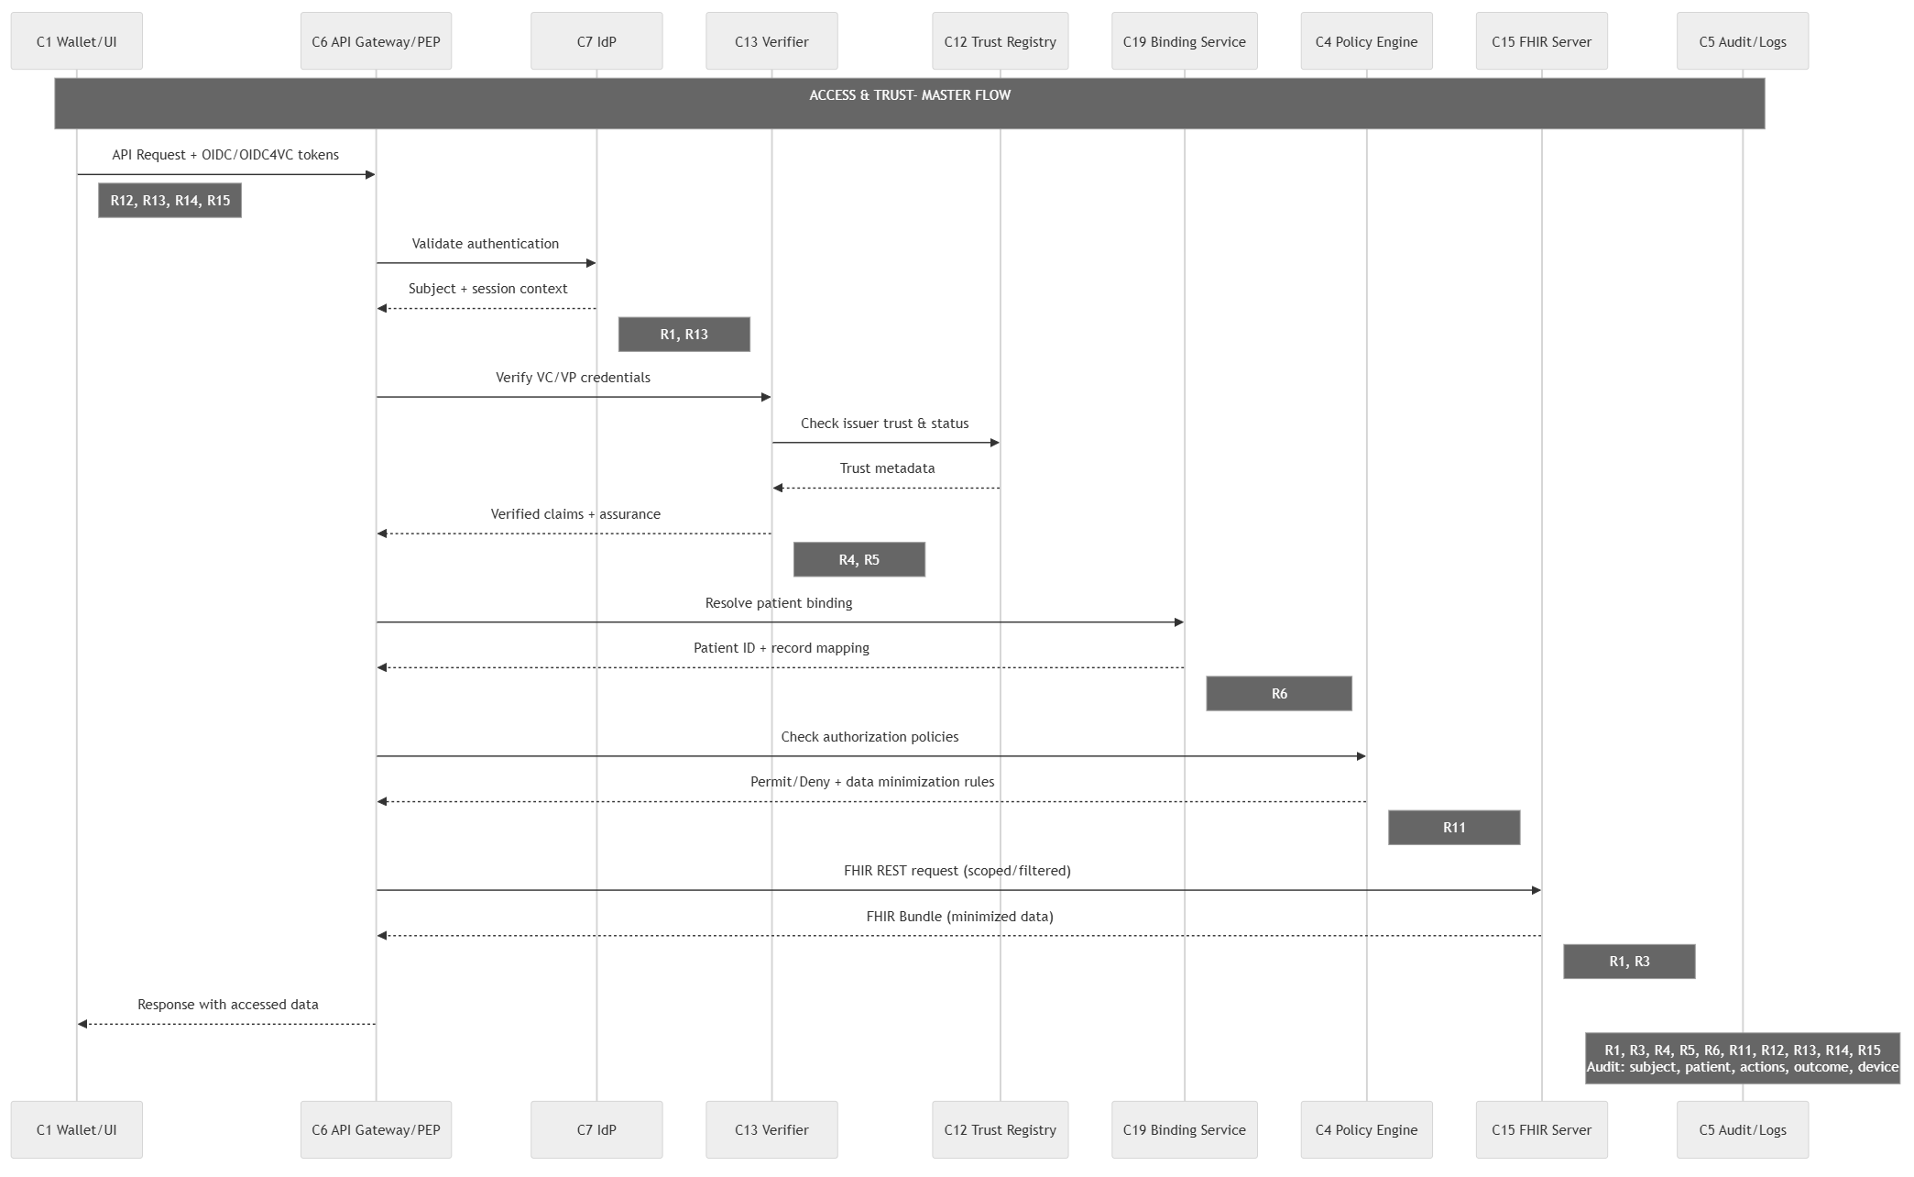

Masterflow 2: (R2,R7,R8)
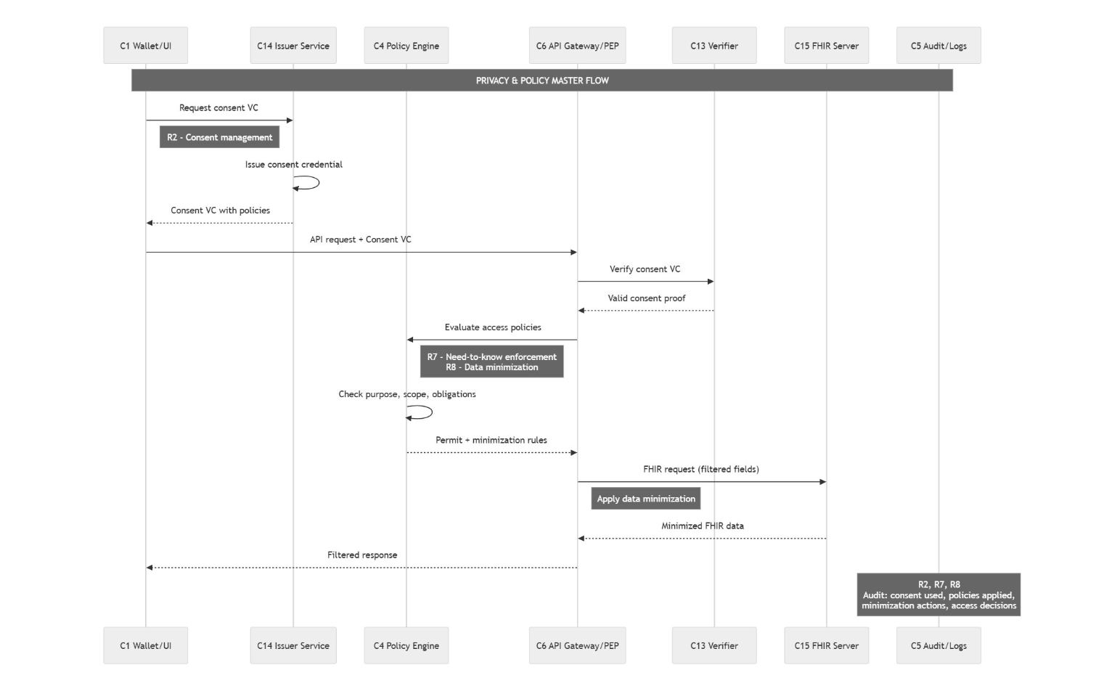

Masterflow 3 (R3, R9, R10, R11, R16)
