WEEK ONE
CYBERSECURITY PROJECT DOCUMENTATION
Kali Linux Virtual Lab Setup & Wireshark SOC Investigation Labs

Prepared by
YUSUFF ABIOLA ABDULLAHI
Cybersecurity Intern
Networkwalks Cybersecurity Internship Program
30 October 2026
Scope: Week One Project Module 1 and Wireshark SOC Extra Project Module

1. Executive Summary
This document presents the practical work completed for Week One of the Networkwalks Cybersecurity Internship Program. The work had two major components: building a controlled cybersecurity laboratory with Oracle VirtualBox and Kali Linux, and completing six browser-based Wireshark SOC investigation labs. The activities focused on safe lab preparation, virtual networking, connectivity validation, packet filtering, TCP stream analysis, clear-text credential exposure, brute-force investigation, and VoIP traffic analysis.
The practical evidence in this report is based on the actual configuration and investigation work performed during the week. Where the live environment differed from the nominal project specification, the observed working configuration is reported rather than replaced with an assumed value.

1.1 Objectives
- Prepare a functional Kali Linux virtual machine for future cybersecurity and ethical-hacking practice.
- Configure a VirtualBox NAT Network and verify that the Kali VM has network and Internet access.
- Enable practical host-to-guest usability features such as shared folders and clipboard/drag-and-drop integration.
- Use Wireshark display filters and packet details to investigate realistic network-security scenarios.
- Identify indicators of scanning, clear-text credential exposure, brute-force activity, hidden application data, and VoIP call traffic.
- Document the work with screenshots and findings suitable for GitHub submission and professional portfolio use.

1.2 Tools and Environment
Host operating system | Windows 11 Pro, 64-bit
Host hardware | Intel Core i5-3437U; 8 GB RAM; approximately 465 GB local storage
Virtualisation platform | Oracle VirtualBox
Guest operating system | Kali Linux 2026.3
Virtual network | NAT Network; 10.0.0.0/24 configured in VirtualBox
Observed Kali address | 10.0.2.15/24 during successful connectivity testing
Packet-analysis environment | Wireshark browser-based SOC labs

2. Kali Linux Virtual Laboratory Setup
The first Week One project required a cybersecurity testing environment using VirtualBox as the base platform and Kali Linux as the security-testing machine. The supplied project module specifies a 10.0.0.0/24 NAT Network, Internet connectivity, shared host downloads, clipboard/file integration, and a VM snapshot after configuration.

2.1 VirtualBox Network Configuration
A custom NAT Network named NatNetwork was created in VirtualBox with the IPv4 prefix 10.0.0.0/24 and DHCP enabled. The Kali VM network adapter was attached to this NAT Network with the virtual cable connected.
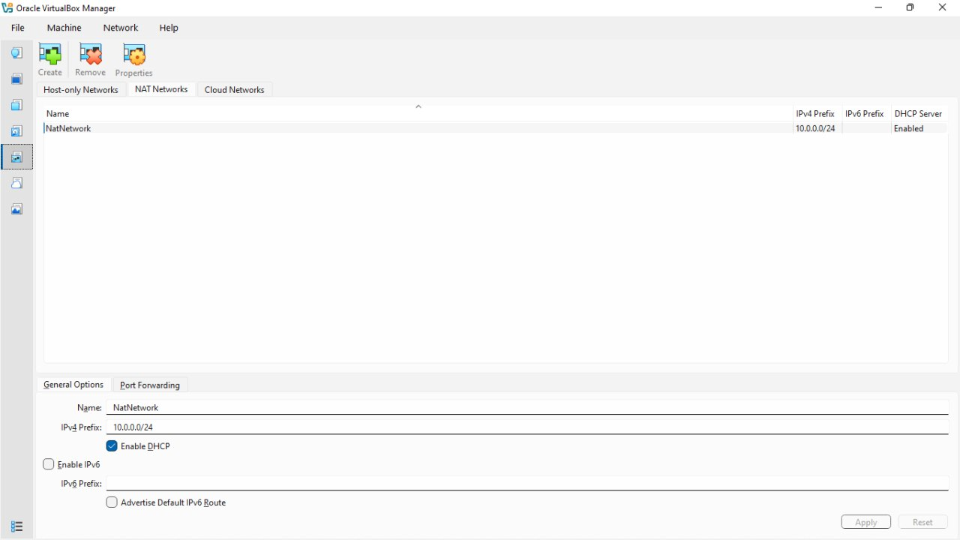
Figure 1. VirtualBox NAT Network configured for the Week One lab.
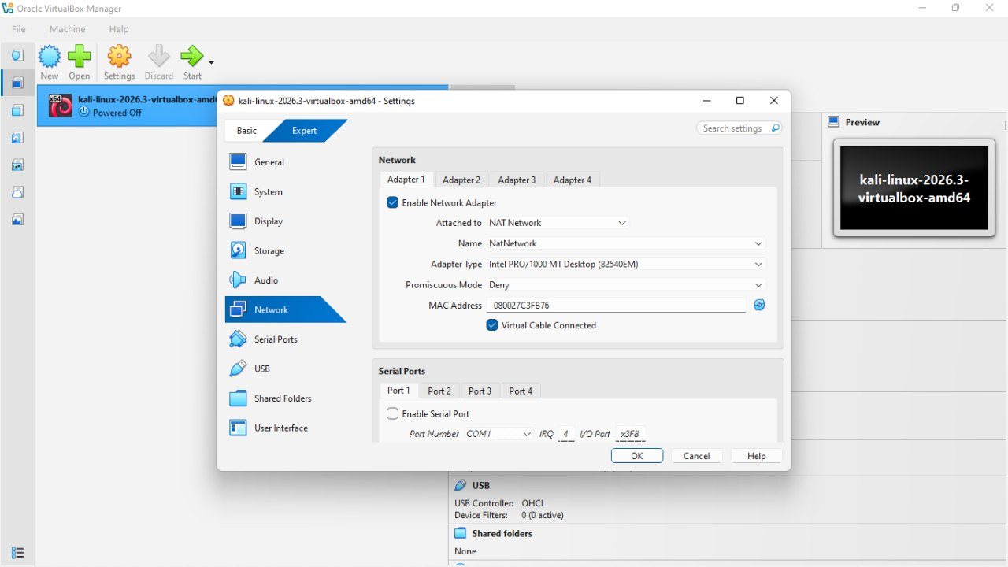
Figure 2. Kali Linux VM attached to the configured NAT Network.

2.2 Kali Linux Deployment and Integration
Kali Linux 2026.3 was imported into VirtualBox and used as the primary security workstation. The VM was configured for practical interaction with the Windows host, including shared Downloads access and bidirectional clipboard/drag-and-drop integration. A clean snapshot named "Yusuff Abiola - Kali Clean Setup" was retained after the environment became stable.
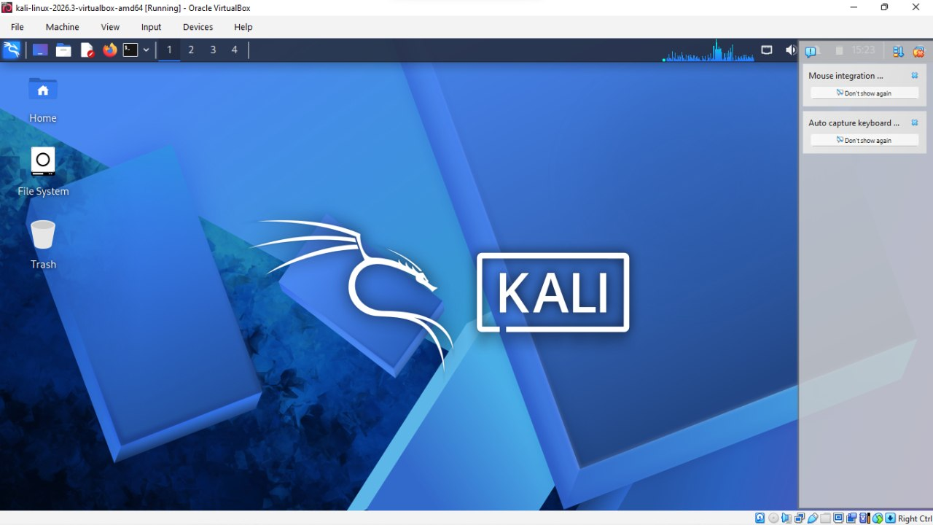
Figure 3. Kali Linux running successfully inside Oracle VirtualBox.
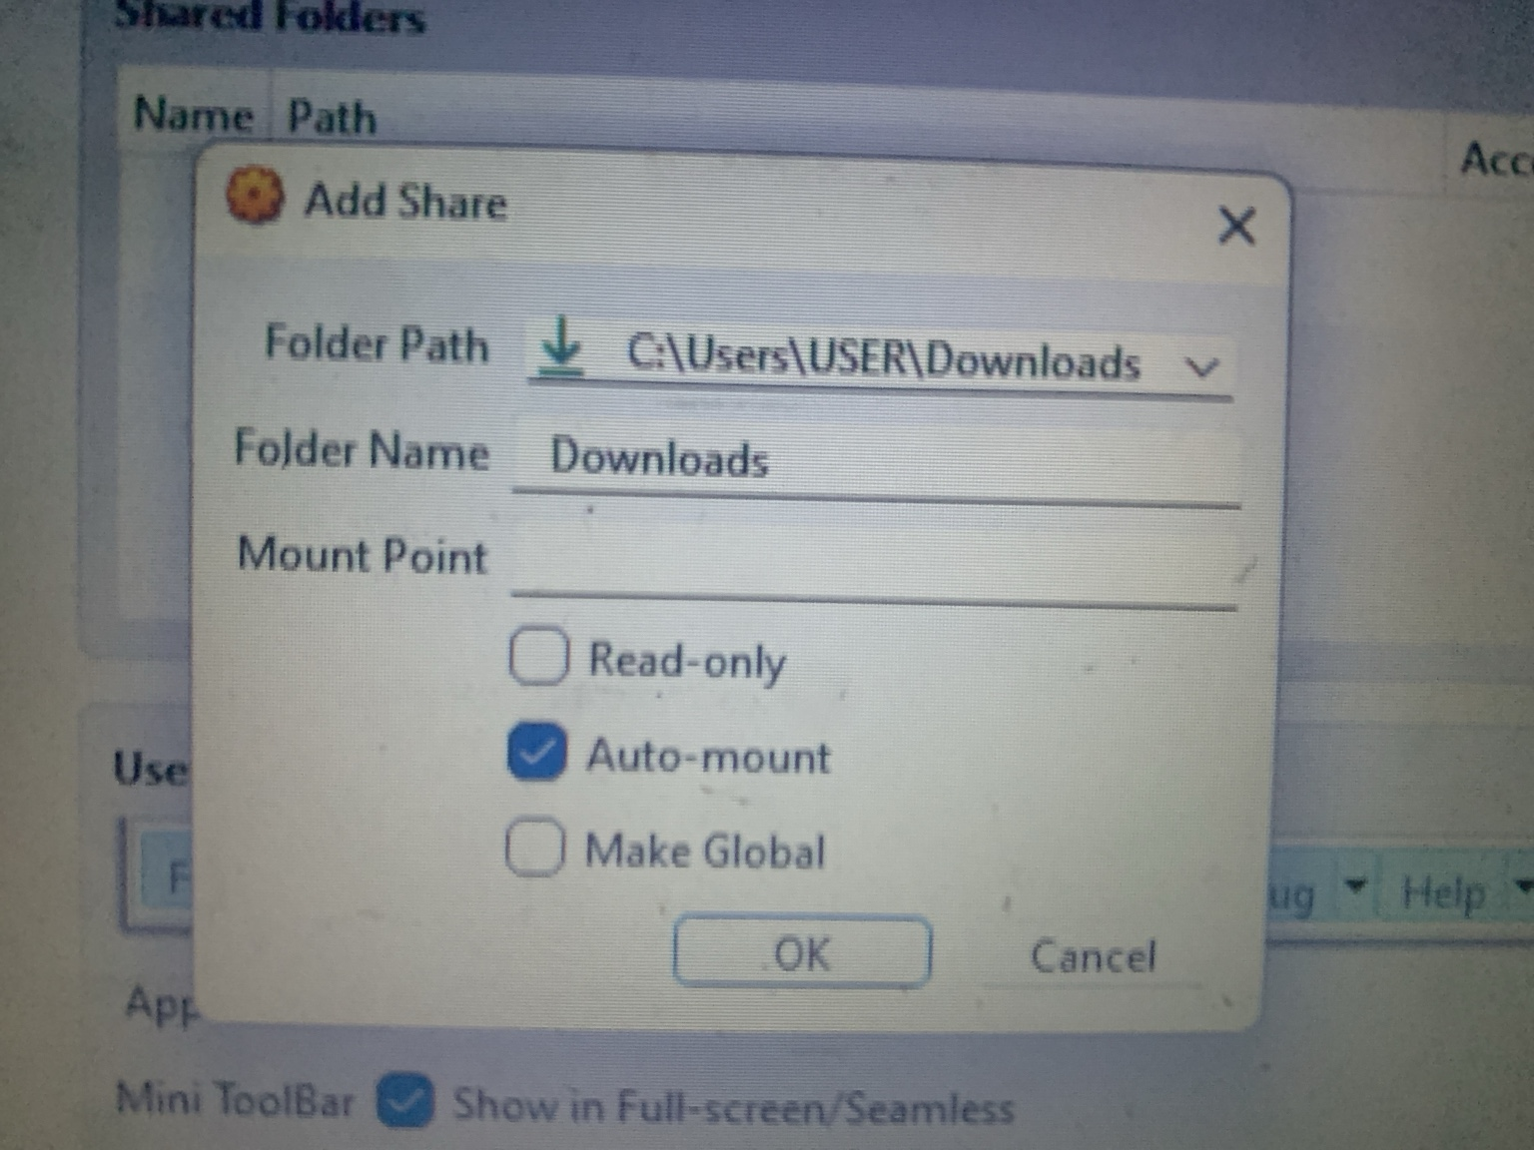
Figure 4. VirtualBox shared-folder configuration used to expose the host Downloads folder to Kali.

2.3 Network and Internet Validation
Connectivity was validated from the Kali terminal. The working VM address observed during the test was 10.0.2.15/24. Successful ICMP replies from 8.8.8.8 confirmed external IP connectivity, while successful replies to google.com also demonstrated DNS resolution. These checks confirmed that the Kali VM could reach the Internet through the virtual network.
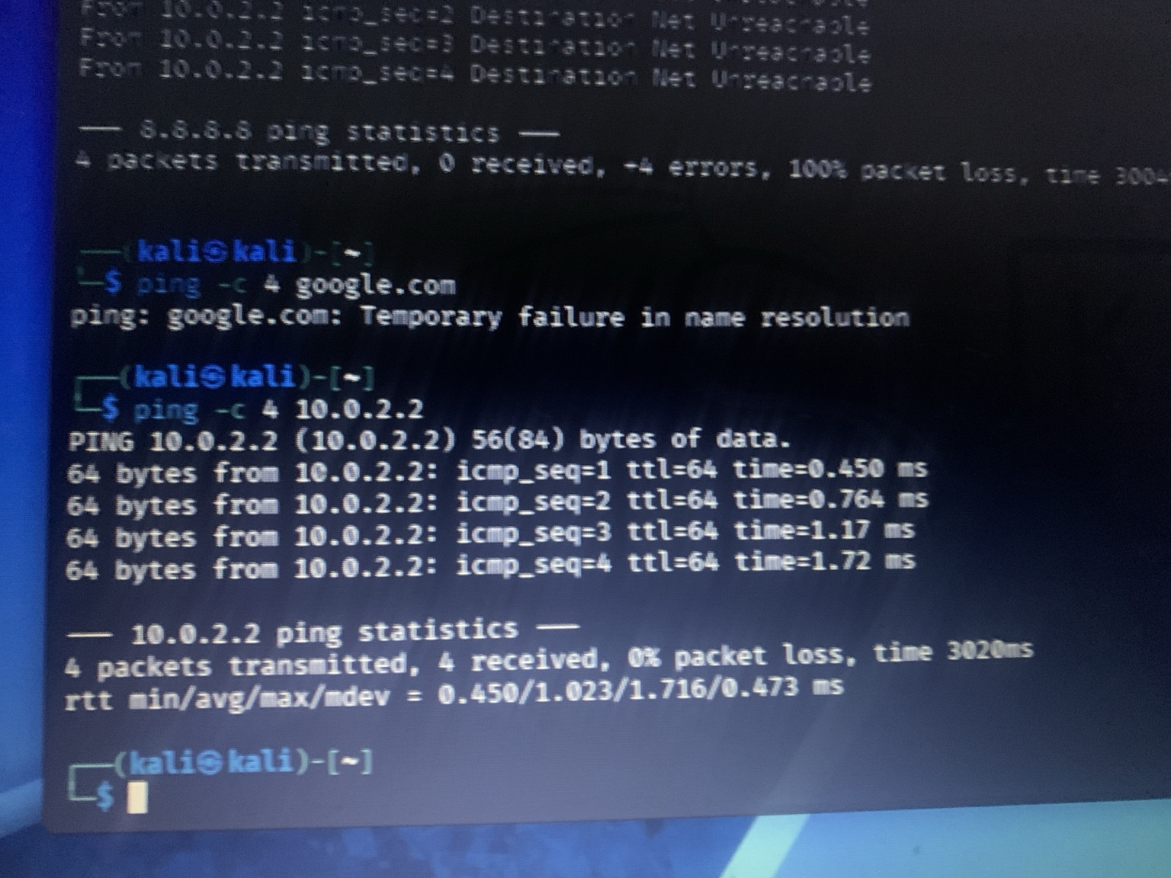
Figure 5. Successful Internet and DNS connectivity tests from the Kali Linux VM.

2.4 Outcome of the Lab Setup
The Week One lab environment was operational and suitable for later cybersecurity exercises. The main outcome was a reusable Kali Linux VM with Internet access, host integration, a dedicated VirtualBox network, and a recoverable clean snapshot. This provides a controlled base for future network-security and ethical-hacking practical work.

3. Wireshark SOC Investigation Labs
The Wireshark extra project module consisted of six live browser labs, each containing ten investigation tasks. The scenarios were designed to practise finding an attacker, following TCP streams, locating hidden data, identifying clear-text credentials, investigating brute-force activity, and analysing VoIP calls.

3.1 Investigation Method
- Captured or opened the traffic provided by each controlled browser lab.
- Applied protocol and field-based display filters to reduce the packet set to relevant evidence.
- Inspected source and destination addresses, TCP flags, ports, HTTP request information, FTP replies, SIP signalling, and RTP payload details.
- Used Follow TCP Stream when application-layer content needed to be reconstructed.
- Correlated packet behaviour with the scenario questions before recording the finding.

3.2 Lab 3 - Identify the Attacker's IP
The capture contained a concentrated sequence of TCP connection attempts from one host. Filtering for initial SYN packets exposed repeated probes from 192.168.10.66 toward 192.168.10.20. The attacker reused source port 52311 while attempting multiple destination ports. Forty destination ports were probed, and SYN/ACK responses showed that ports 22, 80 and 443 were open. The traffic pattern was consistent with a TCP SYN port scan.
Attacker | 192.168.10.66
Target | 192.168.10.20
Repeated source port | 52311
Ports probed | 40
Open ports observed | 22, 80, 443
Technique | TCP SYN port scan
Recorded lab result | 90%
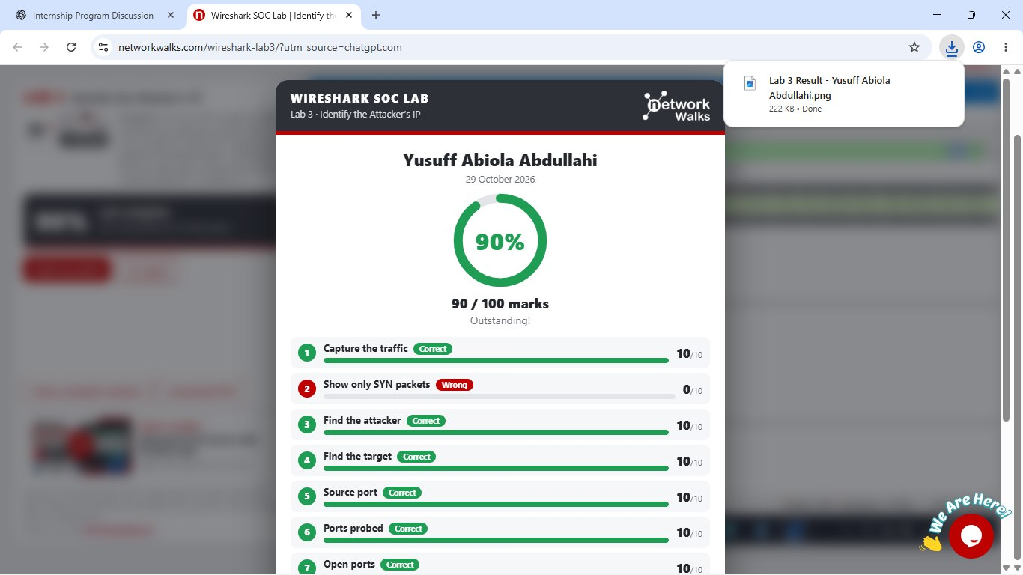
Figure 6. Lab 3 result showing 90% completion with the attacker-identification tasks recorded.

3.3 Labs 4 and 5 - Follow TCP Stream
The TCP-stream exercises demonstrated how a SOC analyst can reconstruct an application conversation from individual packets. In the second stream lab, an HTTP request for /staff.html was traced to its TCP stream. The returned HTML contained a hidden comment with an internal backup-server address and an access-code word. A separate stream also showed a plain-text download request for /download/report.txt and the server's returned report.
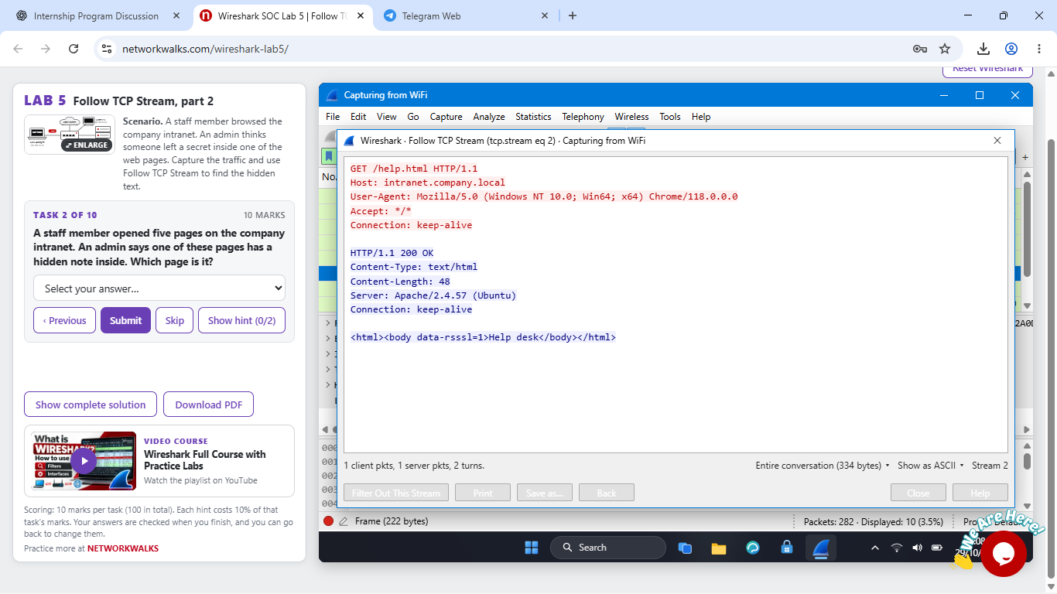
Figure 7. Follow TCP Stream evidence showing the reconstructed HTTP conversation and plain-text report.

3.4 Lab 6 - HTTP Plain-Text Credentials
The HTTP credentials lab showed why login forms should not transmit sensitive data over unencrypted HTTP. Filtering for POST requests revealed sign-in traffic to /login. The request body could be inspected through the HTML Form URL Encoded details, demonstrating that usernames and passwords sent through plain HTTP can be read directly from captured traffic. The appropriate mitigation is to use HTTPS so credentials are protected in transit.
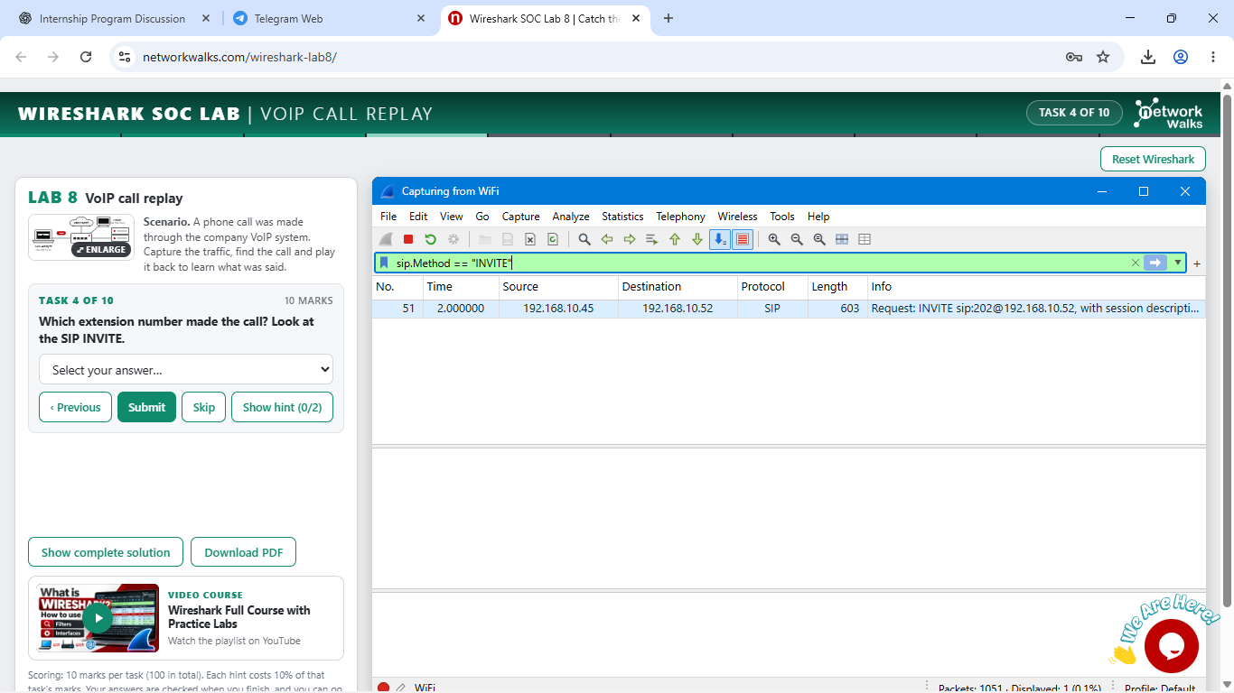
Figure 8. HTTP POST filter isolating sign-in requests to the /login path.

3.5 Lab 7 - Brute Force Catch
The FTP investigation contained many repeated login attempts against an FTP server. The FTP control traffic made the username, password attempts and server reply codes visible. Repeated failed authentication attempts followed by one successful login established the behaviour as a brute-force password attack. This lab was completed with a score of 100/100.
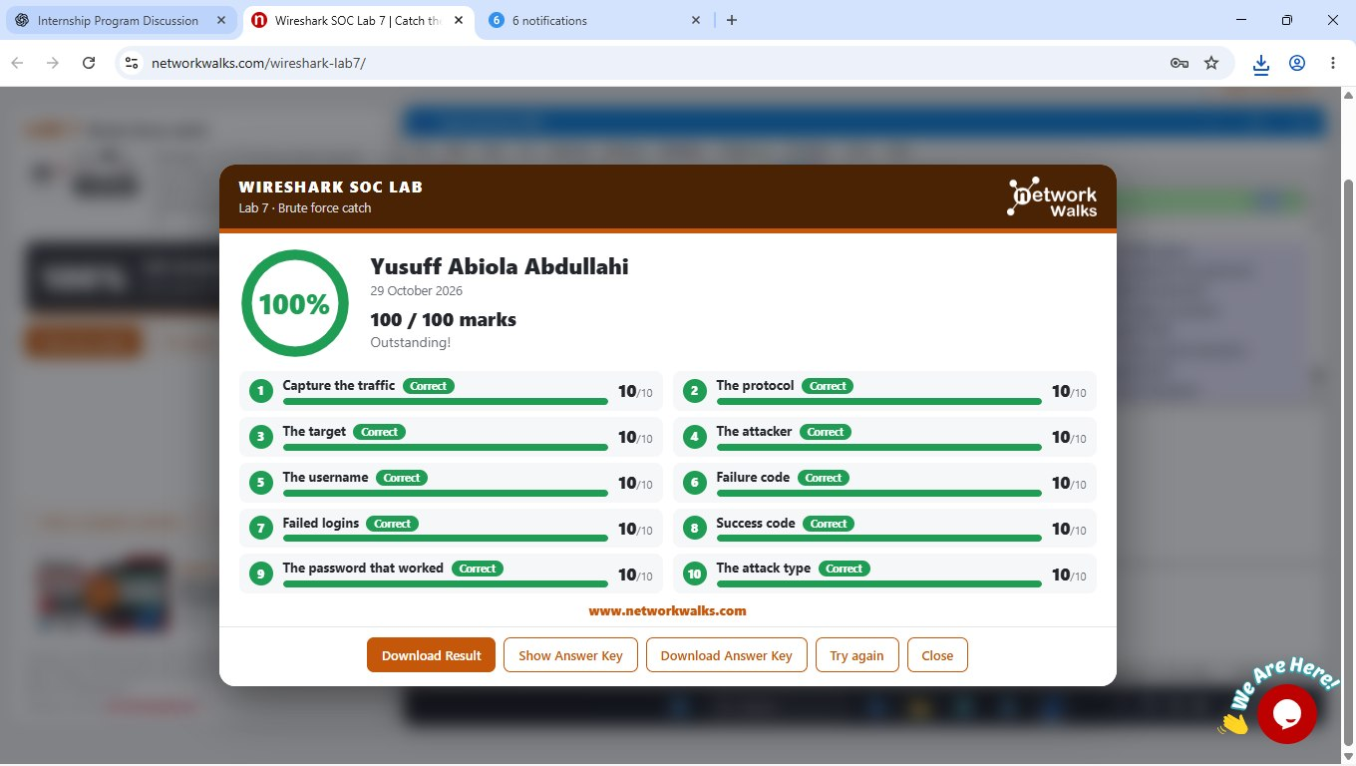
Figure 9. Lab 7 final result: 100/100 for the FTP brute-force investigation.

3.6 Lab 8 - VoIP Call Replay
The final lab focused on a VoIP call. SIP signalling was used to establish the call, while RTP carried the voice media. Filtering for the SIP INVITE identified extension 101 as the caller and extension 202 as the destination. Inspection of an RTP packet showed payload type ITU-T G.711 PCMU. The exercise demonstrated that unencrypted VoIP media can expose call content to someone able to capture the traffic; SRTP is the appropriate control for protecting the voice stream.
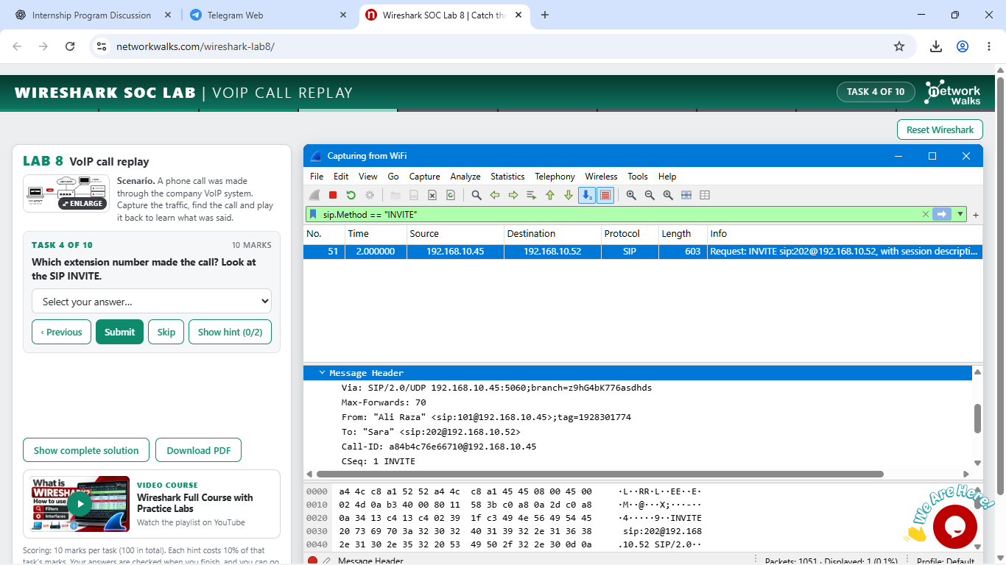
Figure 10. SIP INVITE packet used to identify the calling and called extensions.

4. Key Security Findings and Lessons Learned
TCP scanning is visible in packet behaviour. A long sequence of SYN packets from one source to many destination ports is a strong indicator of reconnaissance. SYN/ACK replies help identify listening services.
Plain HTTP exposes credentials. HTTP form data can be inspected in clear text when transport encryption is absent. HTTPS is required to protect credentials in transit.
FTP authentication is observable and vulnerable to guessing. Repeated USER/PASS attempts and reply codes can reveal brute-force behaviour. Successful authentication can be distinguished from failed attempts through server responses.
TCP stream reconstruction provides application context. Following a TCP stream can reveal complete request/response content that is difficult to understand from isolated packets.
SIP and RTP serve different VoIP roles. SIP handles call signalling while RTP carries the voice media. Unencrypted RTP can expose conversation content, making SRTP important for confidentiality.
Filtering is central to efficient packet investigation. Display filters dramatically reduce noise and allow the analyst to focus on the protocol, host, flag or application action relevant to an investigation.

5. Challenges and Practical Adjustments
The work also required adapting to the actual lab environment. Some controls in the browser-based Wireshark simulation were restricted, so investigations were completed with the filters and packet-detail views available inside the exercise. During the Kali setup, the working address observed during successful connectivity testing was 10.0.2.15/24 even though the supplied project sheet nominally specifies 10.0.0.2/24. The documentation therefore records the actual tested state rather than claiming a configuration that was not observed.
The Wireshark results also reflect the scores actually achieved. Lab 3 was recorded at 90%, while the FTP brute-force lab was completed at 100%. These results are included as evidence of the practical work rather than being altered for presentation.

6. Conclusion
Week One established both the technical environment and the packet-analysis foundation required for the rest of the internship. A working Kali Linux virtual machine was prepared in VirtualBox, network connectivity was validated, and the environment was made reusable through host integration and a clean snapshot. The six Wireshark SOC labs then applied packet analysis to realistic security problems involving reconnaissance, application data, credential exposure, brute-force authentication and VoIP.
The most important outcome was not simply completing the lab questions, but learning how to move from raw packet data to an evidence-based security conclusion. The same workflow - filter, inspect, correlate and document - will be carried into later cybersecurity projects.

7. Submission and Portfolio Notes
This document is intended to accompany the Week One GitHub repository. The repository README will present the project in a shorter portfolio format with the setup steps, investigation highlights, selected screenshots and a link or reference to the full documentation. The GitHub repository will be created and organised as the next step.

Appendix A - Evidence Summary
Kali/VirtualBox evidence | NAT Network, VM network attachment, Kali desktop, shared-folder setup, connectivity test
Wireshark evidence | TCP stream reconstruction, HTTP POST filtering, SIP INVITE analysis
Result evidence | Lab 3: 90%; Lab 7: 100%
Ethical scope | All analysis was performed only inside the authorised internship lab environments.

