The fig.1 below represents a histogram of Time(X-Axis) vs Catch Frequency(Y-axis). We can see from the plot that hours 11-12 am yield the most number of catches. So fishing at those hours will yield more catches, where as fishing in hours 4-5pm have are shown to be the most unproductive.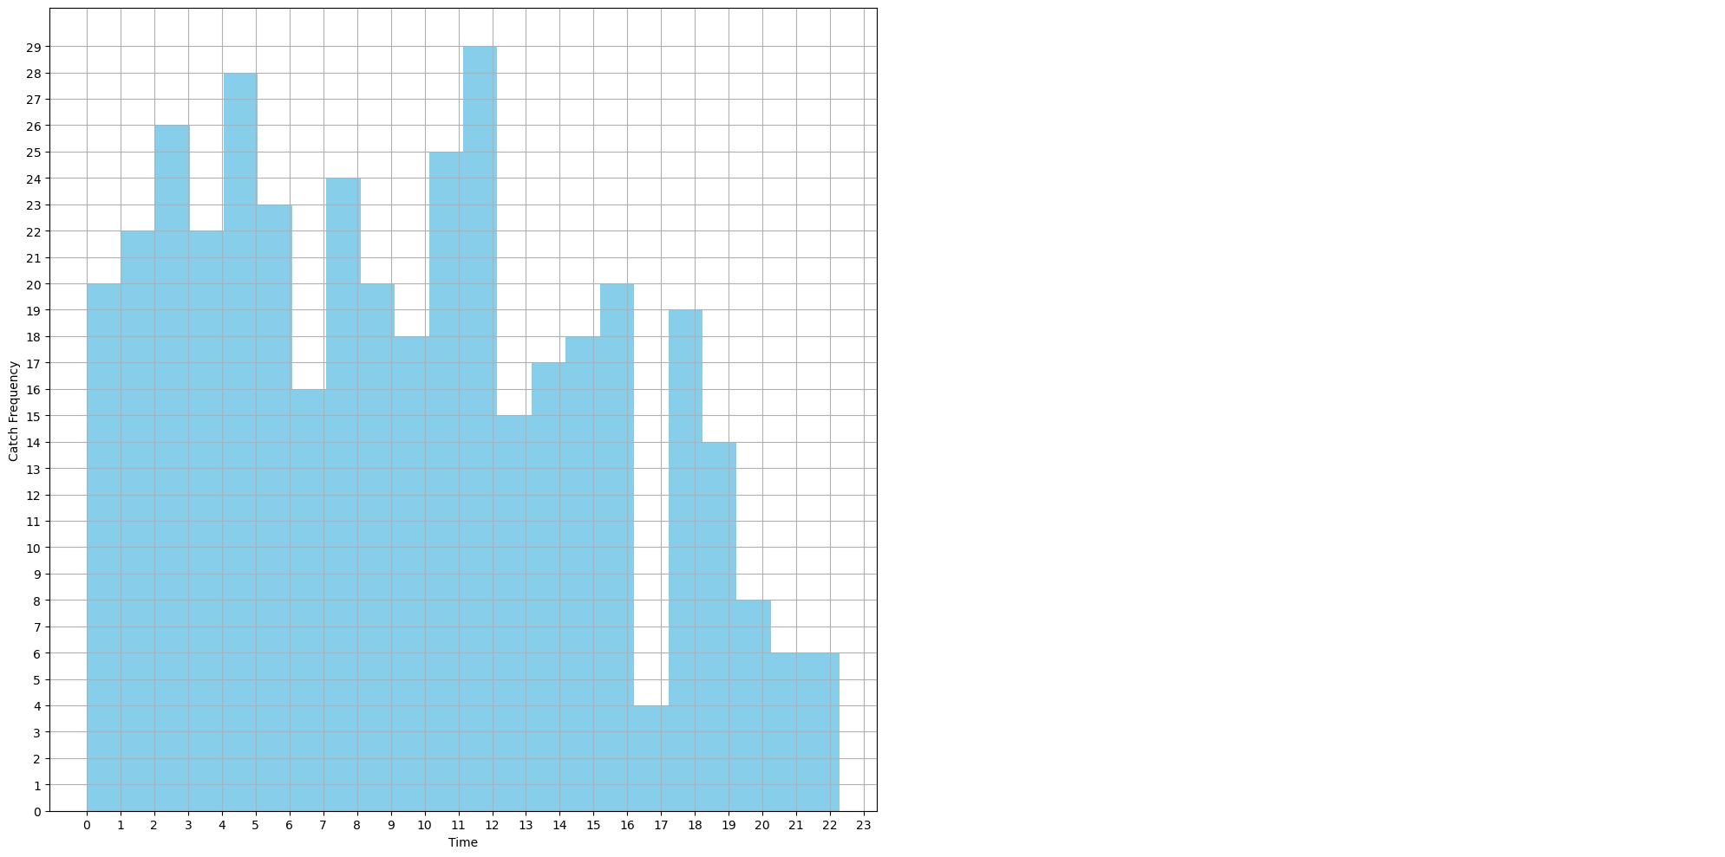

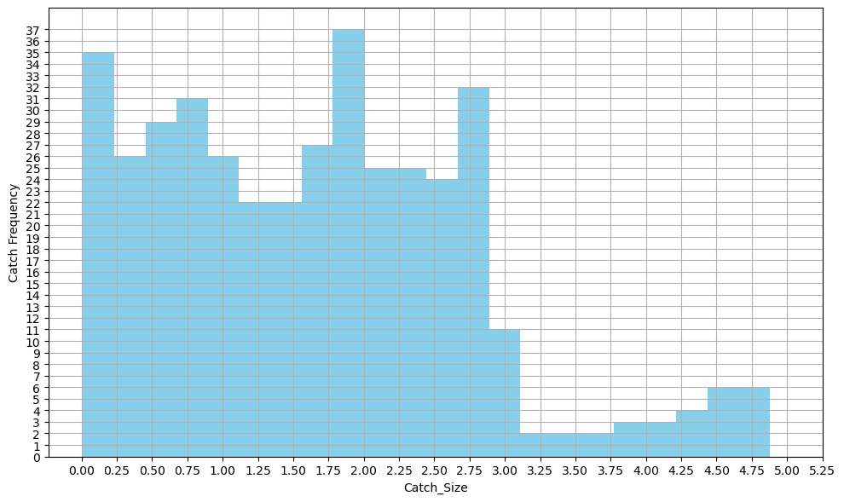

*fig: 1 Histogram of Time vs Catch Frequency fig: 2 Histogram of Catch Size vs Catch Frequency*

fig.2 represents a histogram of Catch size(X-axis) vs Catch Frequency(Y-axis). We can see from the plot that catches of size 1.75 to 2 are the most common. Catches of size 3.125 t0 3.75 are the least common.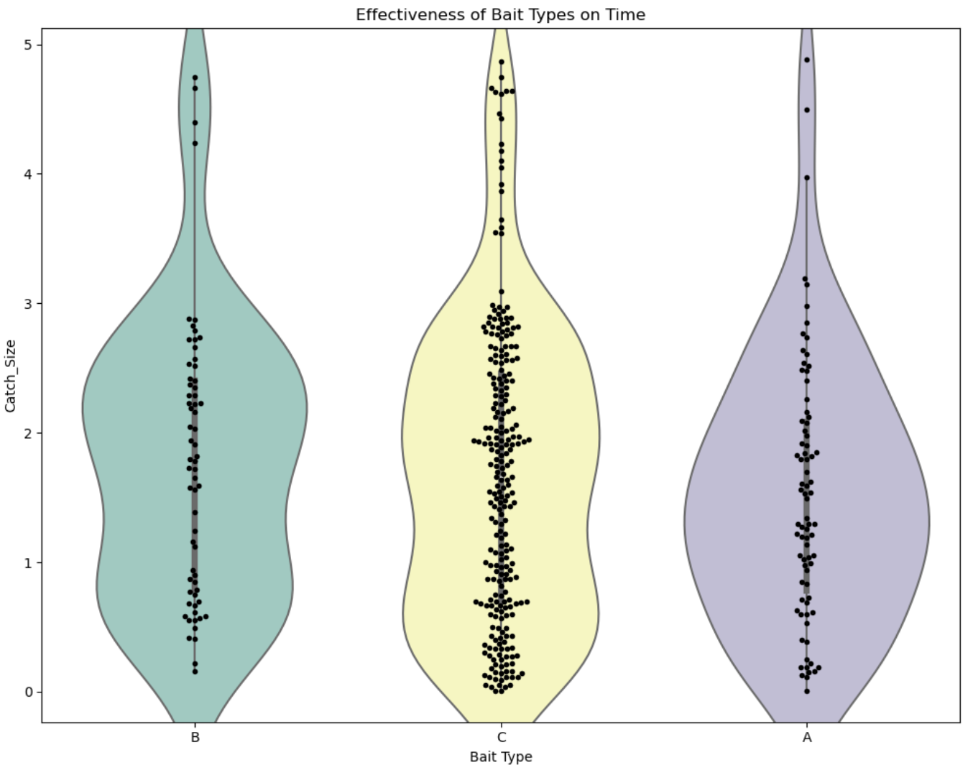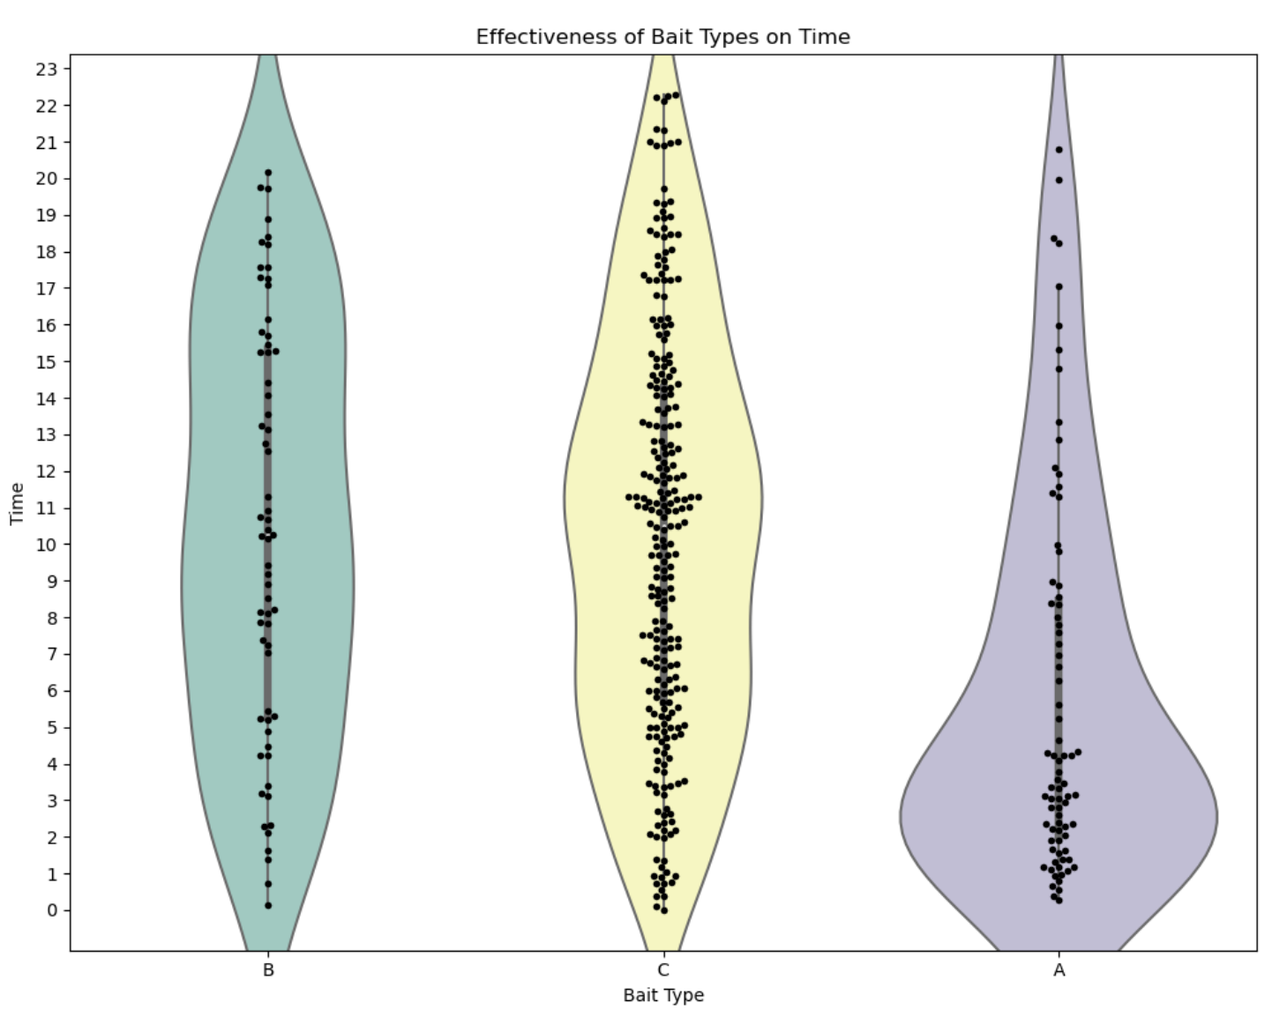

*fig: 3 Violin and Swarm plot for Time of Catch* *fig: 4 Violin and Swarm plot for Size of Catch*

The Violin Plot, in fig.3 represents a Bait Type vs Time plot where we have also a swarm plot on top of it representing the density of that bait-type used every hour, also indirectly representing the density of catches made with a bait type for the hour.

Fig 3 shows that the Bait type ‘C’(yellow) yields the most number of catches. Also, the hour 10-12 are the widest as indicated by the breadth of the violin as well as the swarm plot. So we can conclude that the hours 10-12 yield the most number of catches for Bait ‘C’.  
  
Fig 3 also shows that in the late hours of 21-23 Bait ‘B’ and ‘A’ yield no catches, only bait ‘C’ yields catches in those hours.

Fig 4 has a swarmplot which clearly shows that Bait ‘C’ yields most catches in the size range 2-3.

Fig 5 shows that the Bait type ‘C’ is the one with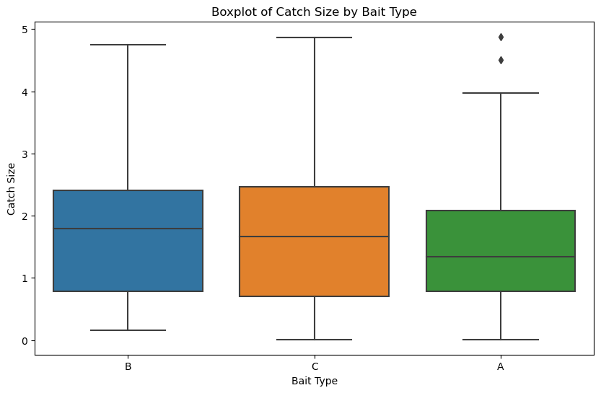 the largest catch size. This seems intuitive as Bait Type ‘C’ is used the most as shown in figure 3. Even though bait ‘C’ is the most frequently used, bait ‘B’ yields the bigger catches on average, this is also shown by the mean line of Bait B.

*fig: 5 - Box plot for Size of Catch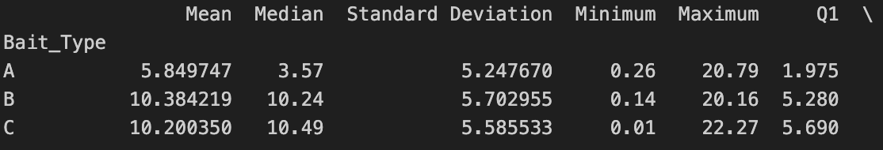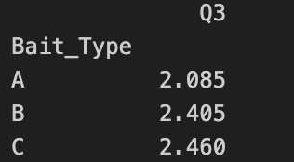*

*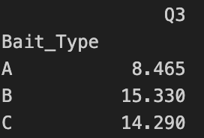*

*fig: 6 - Centrality measures for the Time of Catch*

Figure 6 represents the Centrality measures for the time. As shown, bait ‘A’ is, on average, mostly used at 5 am, where as bait B and C are, on average, used mostly during 10am. From the Maximum column we can figure out that bait C is used in the late hours of up-to 22(10pm) as well, where as A and B are only used till 20(8pm). This can also be related to figure 3 where the swarm-plot indicates this very observation, as there are only data points for Bait ‘C’ after 22(10pm).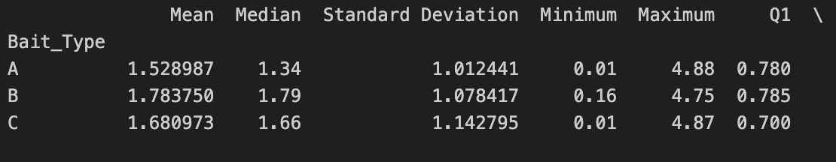

**

*fig: 7 - Centrality measures for the Size of Catch*

Figure 7 represents the Centrality measures for the size of catch. As shown, bait ‘B’, on average, gives the biggest catch sizes. This can also be seen on the Box-Plot in figure 5, where B has the highest mean line. And Bait A has the highest upper limit of 4.88, also shown in the figure 5 with the 2 upper dots.

Bait C has the largest Q3 meaning that 75% of the catches for it lie below 2.46.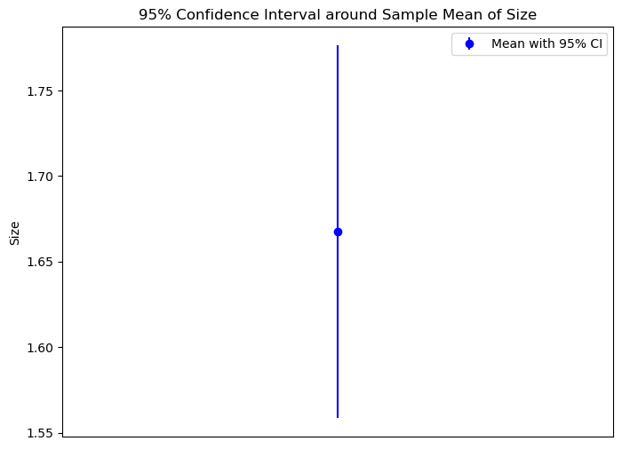



*fig: 8 - 95% Confidence Interval for Size of Catch*  
Figure 8 shows a plot where a plot in the middle represents the mean value for size and the ends represent the edges of the 95% confidence value. The 95% confidence value lies on the line that extends from 1.558 to 1.776. Therefore we can say with 95% confidence that the mean value for the population will lie within the line.



*fig: 9 - 95% Confidence Interval for Time of Catch*

Figure 9 shows a plot where a plot in the middle represents the mean value, which is around 9.3 as seen in the figure. The ends of the line represent the edges of the 95% confidence value. The 95% confidence value lies on the line that extends from 8.8 to 9.8. Therefore we can say with 95% confidence that the mean value for the population will lie within the line.

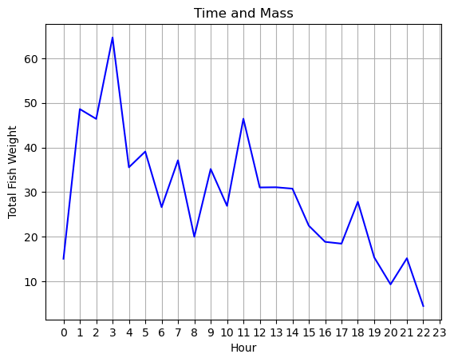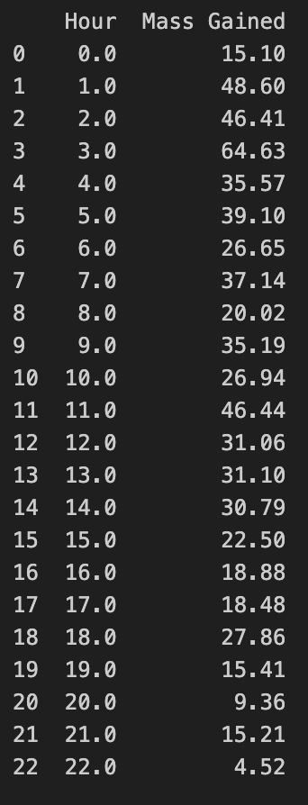

*fig: 10 H*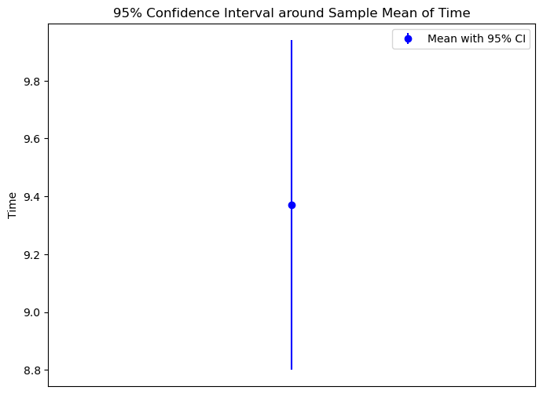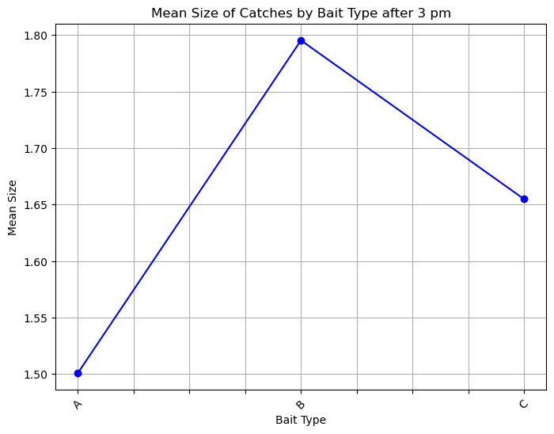*our vs Total Weight*

This graph shows the sum of size of catches(Total Weight) every hour. We can see that 3am yields the maximum weight of 64.63. This is the sum of catches in that hour, and should not be confused with the frequency of catches in that hour. In terms of frequency, the hours 11-12 am yield the most catches as indicated in figure 1.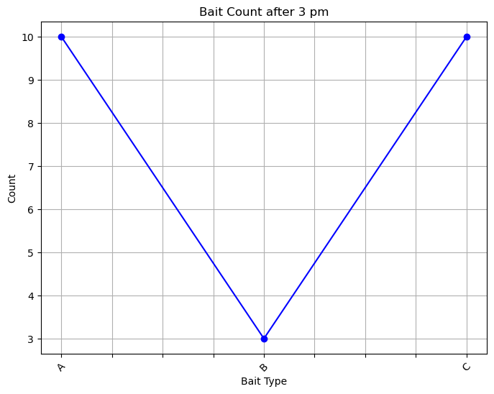

*Fig 11: Bait type vs Mean Size of Catch for 3 pm* *Fig 12: Bait type vs Catch Count for 3 pm*

As observed on the line graph on figure 11 The bait ‘B’ yields the heaviest catches on average at 3pm.  
On figure 12, we can observe that bait B yields the least number of catches at the 3pm hour, where as both ‘A’ and ‘C’ yield equal number of catches.