CUSTOMER SHOPPING BEHAVIOUR
ANALYSIS — PROJECT REPORT

An end-to-end analysis using Python, PostgreSQL (SQL) and an interactive Excel dashboard

Dataset: customer_shopping_behavior.csv | 3,900 customer records | 18 attributes
Tools: Python (pandas) · PostgreSQL · Excel Dashboard

1. Executive Summary
This project analyses the shopping behaviour of 3,900 customers to understand who they are, what they buy, how much they spend, and which factors (subscriptions, discounts, shipping choices, loyalty) drive revenue. The workflow spans three stages: data cleaning and feature engineering in Python, business-question analysis using SQL on a PostgreSQL database, and visual storytelling through an interactive Excel dashboard.
Overall, the store generated $233,081 in total revenue across the dataset. Male customers contribute roughly twice the revenue of female customers, purchase amounts are fairly stable across shipping types and subscription tiers, and the customer base is overwhelmingly ‘Loyal’ (10+ previous purchases). These findings, along with ten targeted SQL queries and a live dashboard, are detailed in the sections below.

2. Project Objective
The goal of this project was to answer key business questions about customer purchasing behaviour in order to support marketing, merchandising and retention decisions. Specifically, the project aims to:
- Clean and structure raw transactional data for analysis.
- Load the data into a relational database (PostgreSQL) and answer business questions using SQL.
- Build an interactive dashboard for stakeholders to explore customer segments, revenue and ratings without writing code.
- Translate the analysis into actionable insights on gender spend, discounting, subscriptions, shipping and customer loyalty.

3. Data Used

3.1 Source & Size
The analysis is based on a single file, customer_shopping_behavior.csv, containing 3,900 rows (one per customer transaction) and 18 raw columns covering demographics, product, transaction and behavioural attributes.

3.2 Key Columns
Column | Description
Customer ID | Unique identifier for each customer
Age / Gender | Customer demographics
Item Purchased / Category | Product bought and its category (Clothing, Footwear, Accessories, Outerwear)
Purchase Amount (USD) | Transaction value, renamed to purchase_amount
Review Rating | Customer's rating for the product (1–5)
Subscription Status | Whether the customer is subscribed (Yes/No)
Shipping Type | Standard, Express, Free Shipping, Next Day Air, 2-Day Shipping, Store Pickup
Discount Applied / Promo Code Used | Whether a discount/promo was used on the order
Previous Purchases | Count of prior purchases — used to build loyalty segments
Frequency of Purchases | How often the customer buys (Weekly, Monthly, etc.)

3.3 Data Quality
The raw file had a small number of missing Review Rating values, which were imputed using the median rating within each product Category. The discount_applied and promo_code_used columns were found to be identical for every record, so promo_code_used was dropped to avoid redundancy. Two engineered features were added: age_group (quartile-based bucket: Young Adult, Adult, Middle-aged, Senior) and purchase_frequency_days (a numeric version of the purchase-frequency label).

4. Methodology & Tools
Stage | Tool | Purpose
Data cleaning & feature engineering | Python (pandas) | Load CSV, handle missing values, standardise columns, engineer age_group and purchase_frequency_days
Storage & analysis | PostgreSQL (SQL) | Host the cleaned data and answer 10 business questions with SQL queries
Visualisation | Excel dashboard | Interactive dashboard with slicers for gender, category, subscription and shipping type

5. Python — Data Cleaning & Preparation
The notebook (customer_shopping_behavior.ipynb) performs the following steps: load the CSV, profile it (head, info, describe, null counts), impute missing ratings, standardise column names, and engineer two new features used throughout the SQL and dashboard analysis.
import pandas as pd

# Load raw data
df = pd.read_csv('customer_shopping_behavior.csv')

df.head()
df.info()
df.describe(include='all')

# Check for missing values
df.isnull().sum()

# Impute missing review ratings with the category median
df['Review Rating'] = df.groupby('Category')['Review Rating']\
.transform(lambda x: x.fillna(x.median()))

# Standardise column names (lowercase, underscores)
df.columns = df.columns.str.lower()
df.columns = df.columns.str.replace(' ', '_')
df = df.rename(columns={'purchase_amount_(usd)': 'purchase_amount'})

# Feature engineering: bucket customers into age groups (quartiles)
labels = ['Young Adult', 'Adult', 'Middle-aged', 'Senior']
df['age_group'] = pd.qcut(df['age'], q=4, labels=labels)

# Feature engineering: convert purchase frequency text into days
frequency_mapping = {
'Fortnightly': 14, 'Weekly': 7, 'Monthly': 30, 'Quarterly': 90,
'Bi-Weekly': 14, 'Annually': 365, 'Every 3 Months': 90
}
df['purchase_frequency_days'] = df['frequency_of_purchases'].map(frequency_mapping)

# discount_applied and promo_code_used were found to be identical columns
(df['discount_applied'] == df['promo_code_used']).all() # -> True
df = df.drop('promo_code_used', axis=1)
Figure 1. Data cleaning and feature engineering script.
After cleaning, the dataframe contains 3,900 rows and 20 columns (18 original + 2 engineered), with zero missing values. This cleaned dataframe was then loaded into a PostgreSQL database using SQLAlchemy:
from sqlalchemy import create_engine

# Connect to PostgreSQL and push the cleaned dataframe to a table
username = 'postgres'
password = '********' # credential omitted from this report
host = 'localhost'
port = '5432'
database = 'customer_shopping_behavior'

engine = create_engine(
f'postgresql+psycopg2://{username}:{password}@{host}:{port}/{database}'
)

df.to_sql('customer', engine, if_exists='replace', index=False)
Figure 2. Loading the cleaned data into PostgreSQL via SQLAlchemy (credential redacted for this report).

6. SQL Analysis (PostgreSQL)
With the cleaned data sitting in a customer table in PostgreSQL, ten business questions were answered with SQL. Each query below is shown alongside the result computed on the dataset and a short business insight.
Q1. What is the total revenue generated by male vs. female customers?
SELECT gender, SUM(purchase_amount) AS revenue
FROM customer
GROUP BY gender;
Result (from dataset):
Gender | Total Revenue
Male | $157,890
Female | $75,191
Insight: Male customers generate roughly 2.1x the revenue of female customers, driven mainly by transaction volume rather than a higher average spend per order.
Q2. Which customers used a discount but still spent more than the average purchase amount?
SELECT customer_id, purchase_amount
FROM customer
WHERE discount_applied = 'Yes'
AND purchase_amount >= (SELECT AVG(purchase_amount) FROM customer);
Result (from dataset):
Metric | Value
Average purchase amount | $59.76
Customers matching criteria | 839
Insight: 839 customers (about 22% of the base) used a discount yet still spent above the store average — discounting does not necessarily mean these are low-value, price-sensitive customers.
Q3. Which are the top 5 products with the highest average review rating?
SELECT item_purchased,
ROUND(AVG(review_rating::numeric),2) AS "Average Product Rating"
FROM customer
GROUP BY item_purchased
ORDER BY AVG(review_rating) DESC
LIMIT 5;
Result (from dataset):
Product | Avg. Rating
Gloves | 3.86
Sandals | 3.84
Boots | 3.82
Hat | 3.80
Skirt | 3.79
Insight: Accessories and footwear items (Gloves, Sandals, Boots) rate the highest, suggesting stronger product-market fit in these lines compared to core apparel.
Q4. Compare the average purchase amount between Standard and Express shipping.
SELECT shipping_type, ROUND(AVG(purchase_amount),2)
FROM customer
WHERE shipping_type IN ('Standard','Express')
GROUP BY shipping_type;
Result (from dataset):
Shipping Type | Avg. Purchase Amount
Express | $60.48
Standard | $58.46
Insight: Customers who choose Express shipping spend marginally more on average ($60.48 vs $58.46) than Standard shipping customers — a ~3.5% premium, but not a dramatic difference.
Q5. Do subscribed customers spend more? Compare average spend and total revenue between subscribers and non-subscribers.
SELECT subscription_status,
COUNT(customer_id) AS total_customers,
ROUND(AVG(purchase_amount),2) AS avg_spend,
ROUND(SUM(purchase_amount),2) AS total_revenue
FROM customer
GROUP BY subscription_status
ORDER BY total_revenue, avg_spend DESC;
Result (from dataset):
Subscribed | Customers | Avg. Spend | Total Revenue
No | 2,847 | $59.87 | $170,436
Yes | 1,053 | $59.49 | $62,645
Insight: Average spend per order is almost identical between subscribers and non-subscribers (~$59.5–59.9). Subscribers drive less total revenue simply because there are fewer of them (27% of customers) — subscription status is not currently a strong lever for order value.
Q6. Which 5 products have the highest percentage of purchases with discounts applied?
SELECT item_purchased,
ROUND(100.0 * SUM(CASE WHEN discount_applied = 'Yes'
THEN 1 ELSE 0 END) / COUNT(*), 2) AS discount_rate
FROM customer
GROUP BY item_purchased
ORDER BY discount_rate DESC
LIMIT 5;
Result (from dataset):
Product | Discount Rate
Hat | 50.00%
Sneakers | 49.66%
Coat | 49.07%
Sweater | 48.17%
Pants | 47.37%
Insight: Hats, Sneakers and Coats are discounted on roughly half of all purchases — the highest reliance on discounting in the catalogue, worth monitoring for margin impact.
Q7. Segment customers into New, Returning, and Loyal based on total previous purchases.
WITH customer_type AS (
SELECT customer_id, previous_purchases,
CASE
WHEN previous_purchases = 1 THEN 'New'
WHEN previous_purchases BETWEEN 2 AND 10 THEN 'Returning'
ELSE 'Loyal'
END AS customer_segment
FROM customer
)
SELECT customer_segment, COUNT(*) AS "Number of Customers"
FROM customer_type
GROUP BY customer_segment;
Result (from dataset):
Segment | Customers
Loyal | 3,116
Returning | 701
New | 83
Insight: 80% of the customer base already falls into the ‘Loyal’ segment (10+ previous purchases), while true ‘New’ customers (only 1 purchase) are just 2% — acquisition of new customers looks like an area to invest in.
Q8. What are the top 3 most purchased products within each category?
WITH item_counts AS (
SELECT category, item_purchased,
COUNT(customer_id) AS total_orders,
ROW_NUMBER() OVER (
PARTITION BY category ORDER BY COUNT(customer_id) DESC
) AS item_rank
FROM customer
GROUP BY category, item_purchased
)
SELECT item_rank, category, item_purchased, total_orders
FROM item_counts
WHERE item_rank <= 3;
Insight: This query uses a window function (ROW_NUMBER partitioned by category) to rank products within each category by order volume, surfacing the top-3 best-sellers per category for merchandising and stock-planning decisions.
Q9. Are repeat buyers (more than 5 previous purchases) also likely to subscribe?
SELECT subscription_status, COUNT(customer_id) AS repeat_buyers
FROM customer
WHERE previous_purchases > 5
GROUP BY subscription_status;
Result (from dataset):
Subscribed | Repeat Buyers
No | 2,518
Yes | 958
Insight: Among repeat buyers, roughly 72% are not subscribed — loyalty (repeat purchasing) and subscription enrolment are largely independent behaviours, so there is an opportunity to convert loyal, non-subscribed customers into subscribers.
Q10. What is the revenue contribution of each age group?
SELECT age_group, SUM(purchase_amount) AS total_revenue
FROM customer
GROUP BY age_group
ORDER BY total_revenue DESC;
Result (from dataset):
Age Group | Total Revenue
Young Adult | $62,143
Middle-aged | $59,197
Adult | $55,978
Senior | $55,763
Insight: Revenue is spread fairly evenly across age groups, with Young Adults contributing slightly more than others — the customer base is not concentrated in a single age bracket, supporting broad, age-agnostic marketing.

7. Interactive Dashboard
An Excel dashboard was built on top of the cleaned dataset to let stakeholders explore the data interactively via slicers for Subscription Status, Gender, Category and Shipping Type. The screenshot below shows the dashboard filtered to Male customers who purchased Clothing with Express shipping.
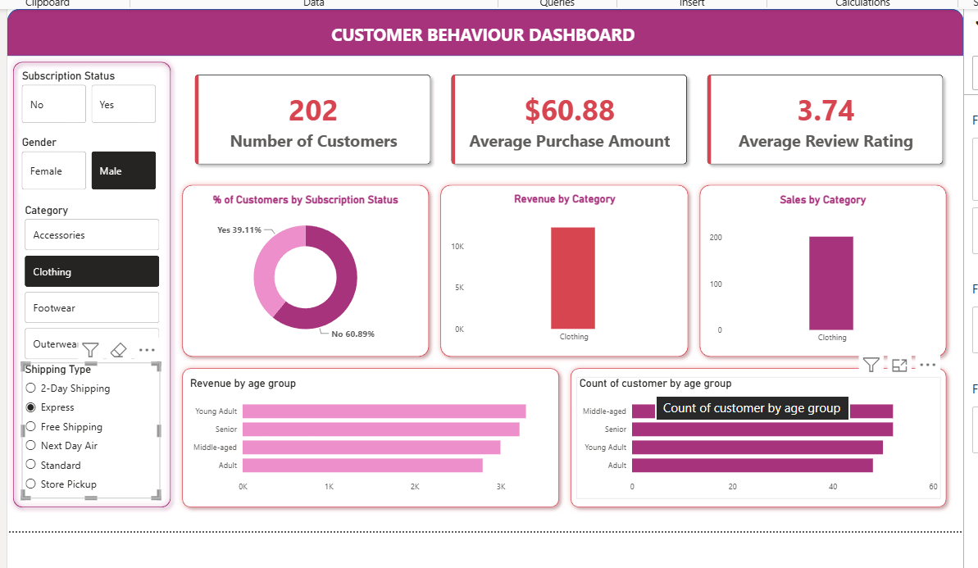
Figure 3. Customer Behaviour Dashboard (filtered view: Male × Clothing × Express Shipping).

7.1 Dashboard Components
- KPI cards: Number of Customers, Average Purchase Amount, Average Review Rating.
- Donut chart: % of customers by Subscription Status.
- Bar charts: Revenue by Category and Sales (order count) by Category.
- Horizontal bar charts: Revenue by Age Group and Count of Customers by Age Group.
- Slicers: Subscription Status, Gender, Category and Shipping Type for interactive filtering.
In the filtered view shown above (Male, Clothing, Express Shipping), the segment contains 202 customers with an average purchase amount of $60.88 and an average review rating of 3.74, with roughly 39% of these customers subscribed. Revenue and customer counts within this segment skew towards the Young Adult and Senior age groups.

8. Key Insights & Recommendations
- Male customers drive about two-thirds of total revenue — consider gender-targeted promotions to grow the female segment.
- Discounting is heavy on Hats, Sneakers and Coats (~50% of orders) — review discount depth on these items to protect margin.
- 80% of customers are already ‘Loyal’ (10+ purchases) but new-customer acquisition (2%) is very low — prioritise top-of-funnel marketing.
- Subscription status barely affects average order value, but most repeat buyers are unsubscribed — there is a clear opportunity to convert loyal customers into subscribers (e.g., via loyalty-linked subscription perks).
- Revenue is evenly spread across age groups and shipping types, indicating a broad, well-diversified customer base rather than dependence on a single segment.

9. Conclusion
This project demonstrates a complete analytics workflow: cleaning and enriching raw customer data in Python, answering targeted business questions in SQL on PostgreSQL, and communicating findings through an interactive Excel dashboard. The combined analysis shows a loyal, evenly-distributed customer base with clear opportunities in new-customer acquisition, subscription conversion, and more disciplined discounting on a handful of high-discount products.

