**CS 301: COMPUTER NETWORKS**

**Assignment 3**

Abhay Singh Patel Student ID: 12040020

**PART 1.1**

1. Start server with the command:

cd Part_1

python3 server.py

2. Run client which pings the server with the command:

python3 client.py

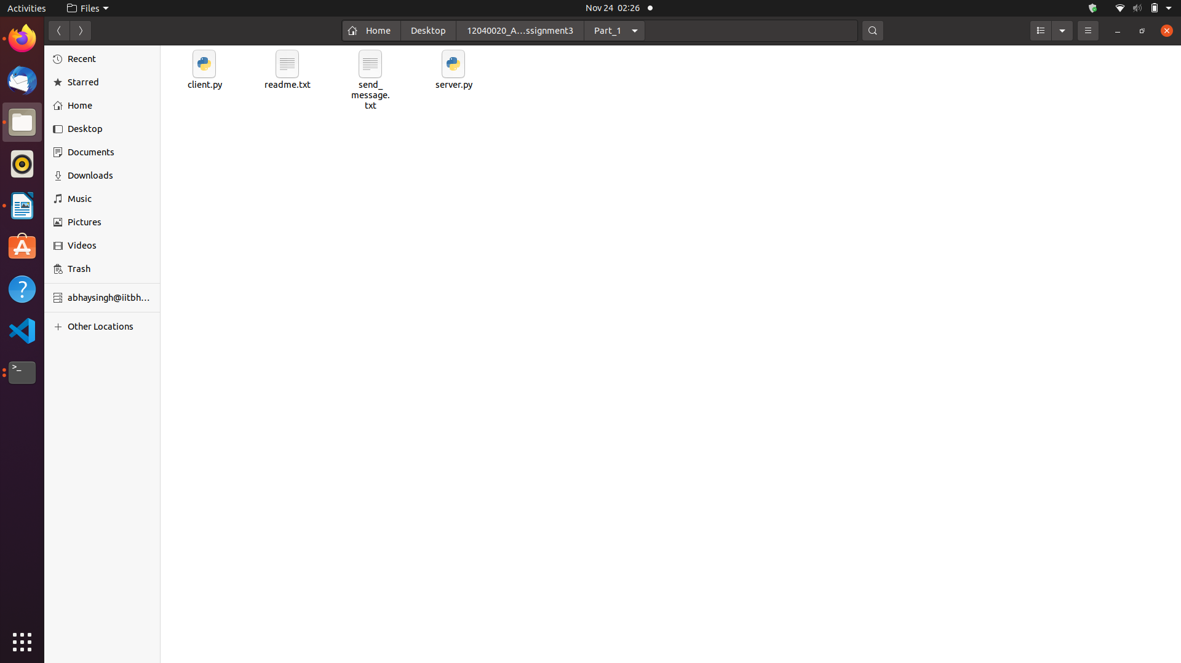.

Screenshot before running code.

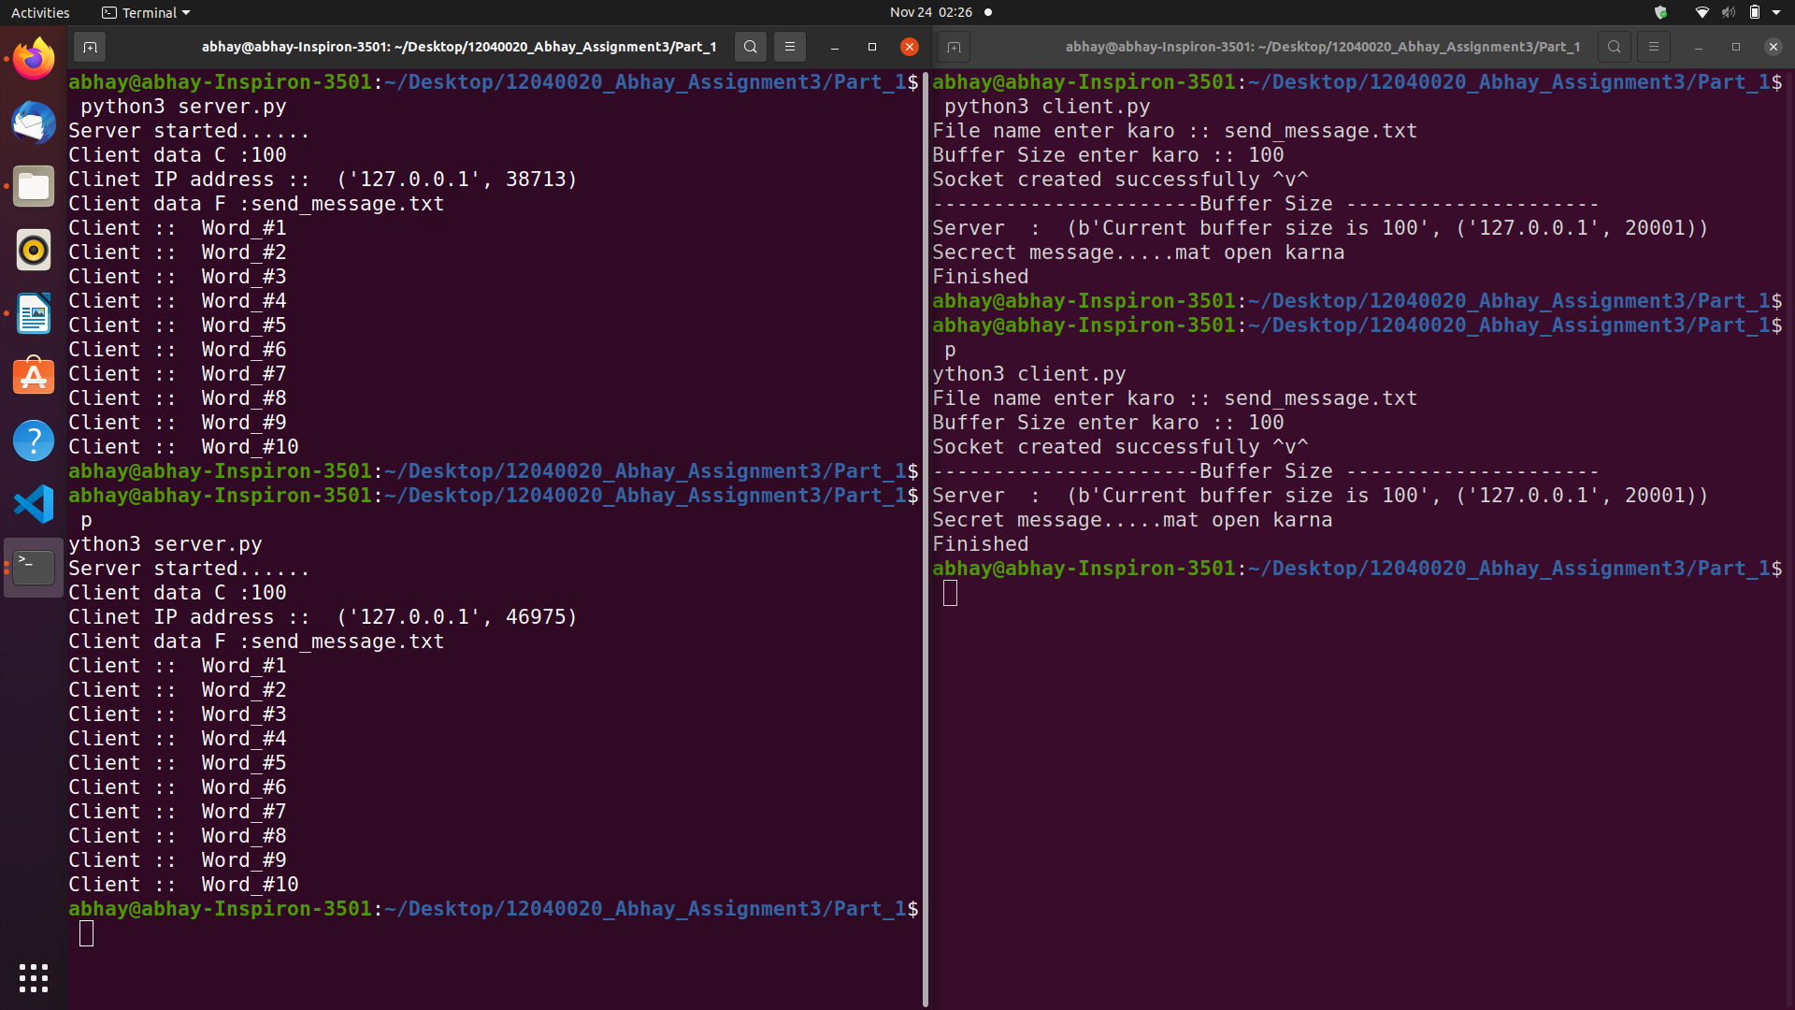.

Screen shot of running code

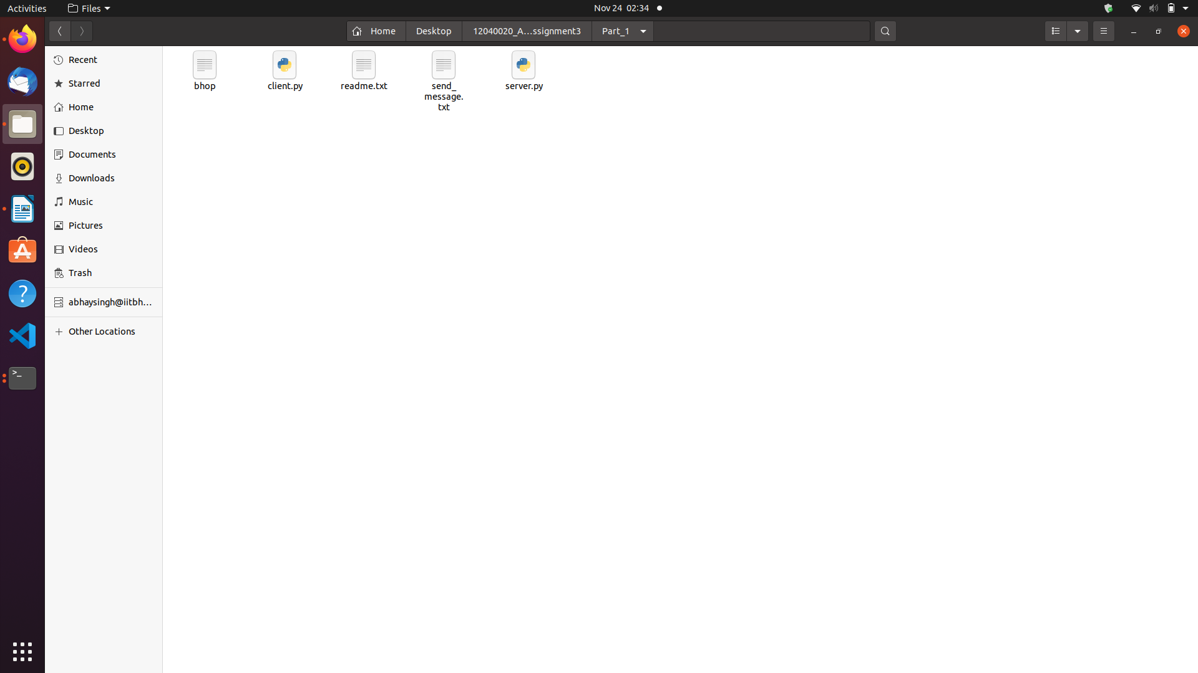

As you can see new file is generated with some random name because I have used random function to generate that name.

**PART 2**

1. Start server with command:

java Server.java

2. Run client which pings the server and plots throughput and delay with the command:

java -cp jfreechart-1.0.19/lib/jfreechart-1.0.19.jar:jfreechart-1.0.19/lib/jcommon-1.0.23.jar Client.java 100 100 1024

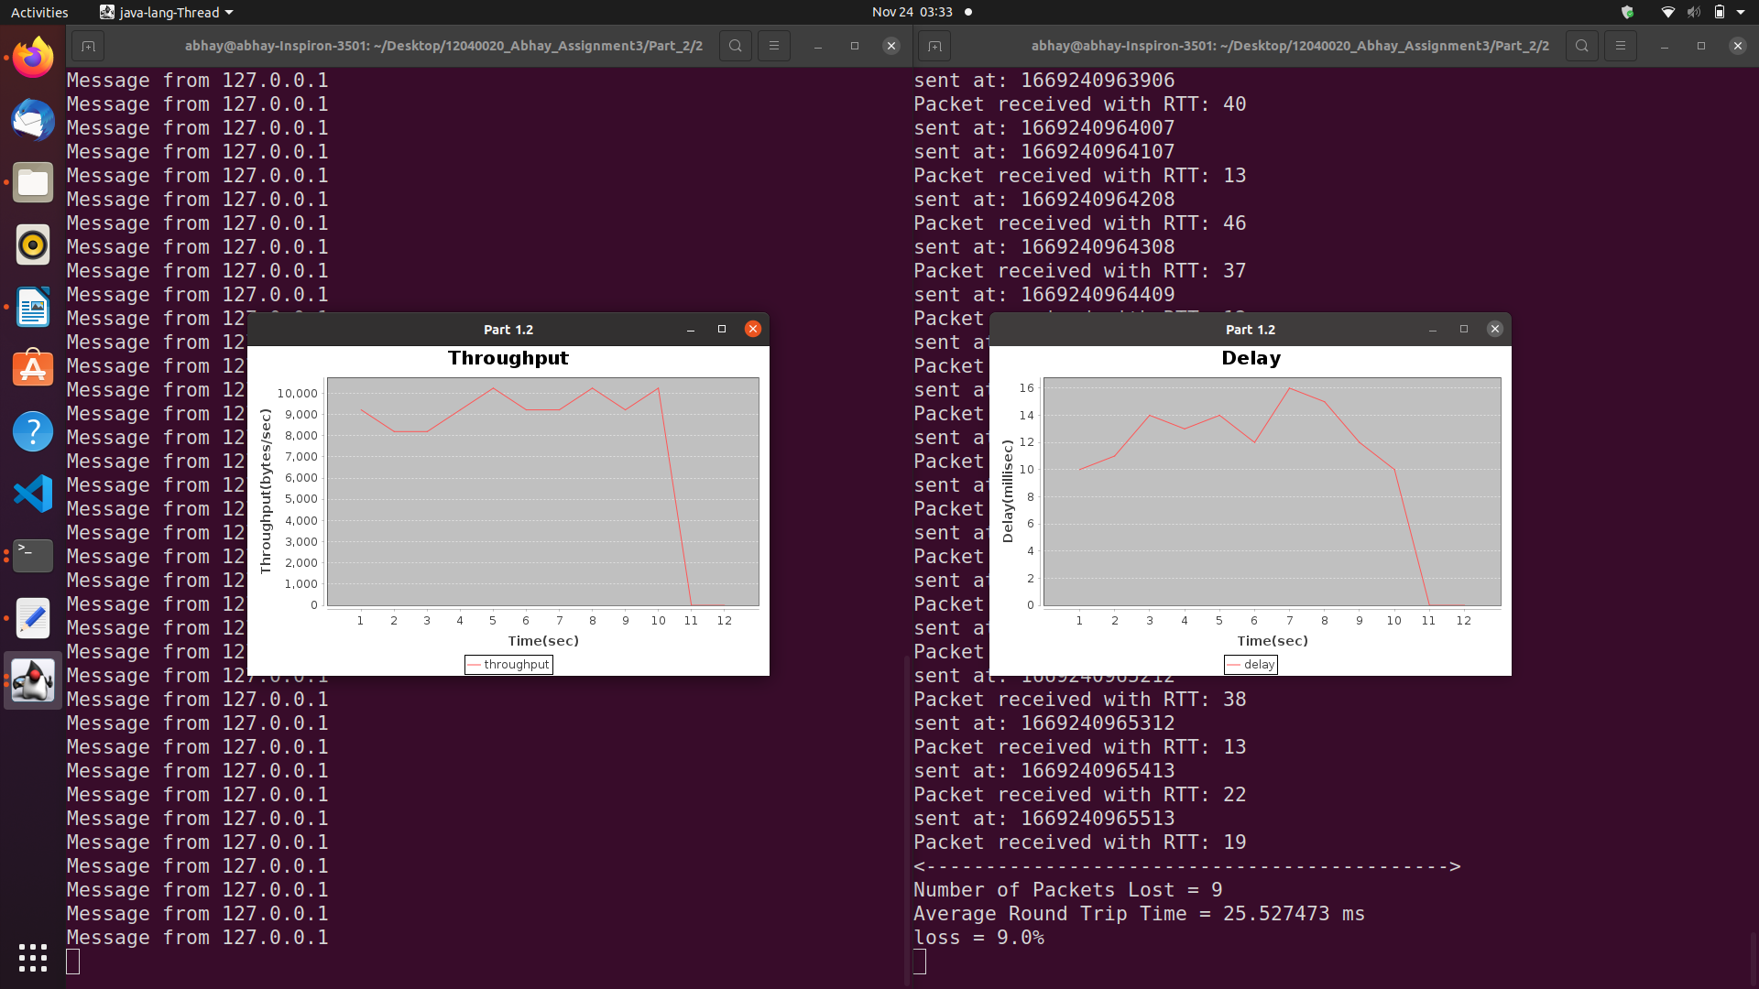

with command passing argument 100(Interval) 100(Number of packets) 1024(Size of packet)

2.a)

Conclusion:-

Total 9 packets are lost

Average Round Trip Time was nearly 25

around 9% packet lost.

RTT is very less because the server and client was on same Computer,even though 9% means around 9 packet lost maybe due to hardware issue or intra network issue.

2.b) Graph show and also present inside folder and also shown below and for plotting purpose we have used jfreechart_1.0.19 java library.

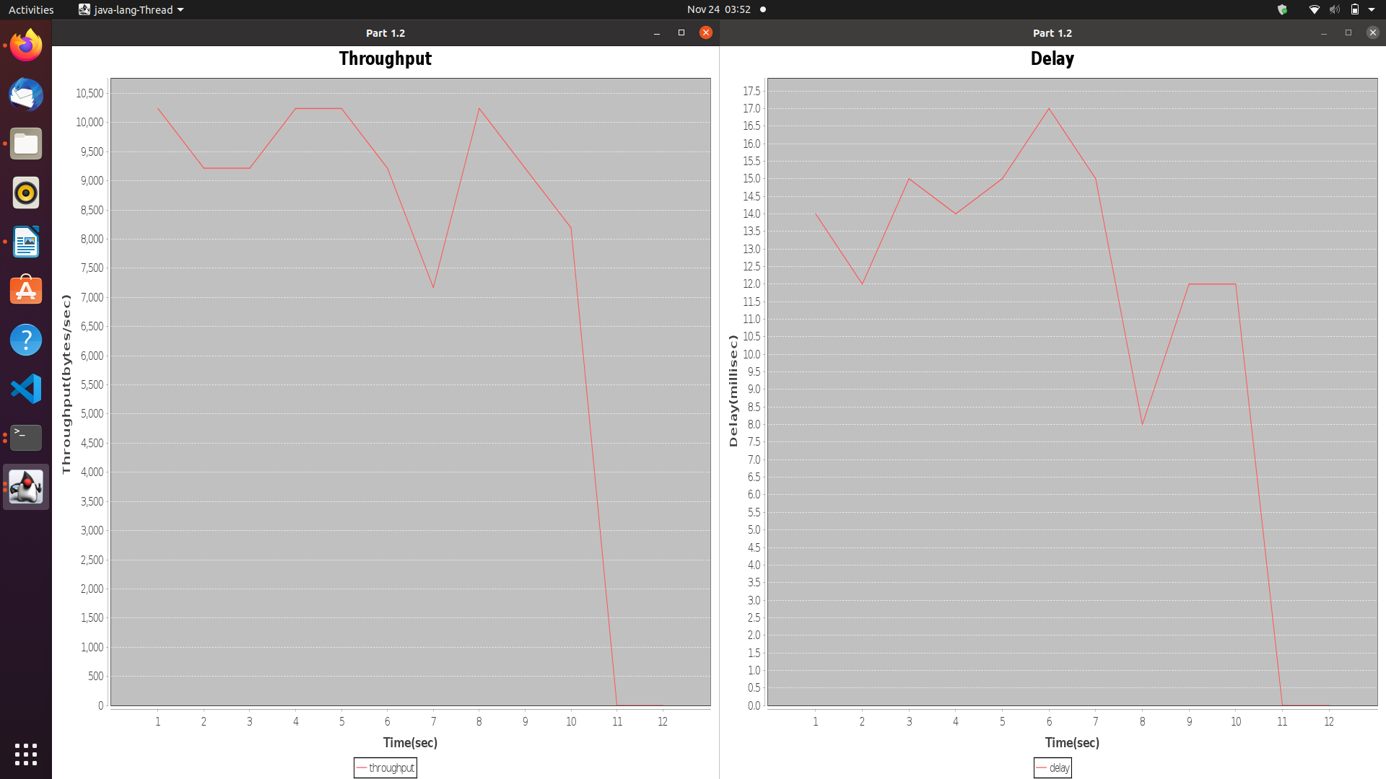**.**

**PART 3**

1. To ipv4 server simply type below command

a) java .\Part3\UDPServer.java localhost

To ipv6 server simply below command

b) java .\Part3\UDPServer.java ::1

2. Run pinging client with the command:

java Client.java <serverAdress> <interval_in_ms> <number_of_packets> <packet_size_in_bytes>

server address maybe localhost or 1 respectively

ex.

java .\Part3\UDPClient.java localhost 1000 5 1024 for ipv4

java .\Part3\UDPClient.java ::1 1000 5 1024 for ipv6

**PART 4**

I have made stone paper scissor game .

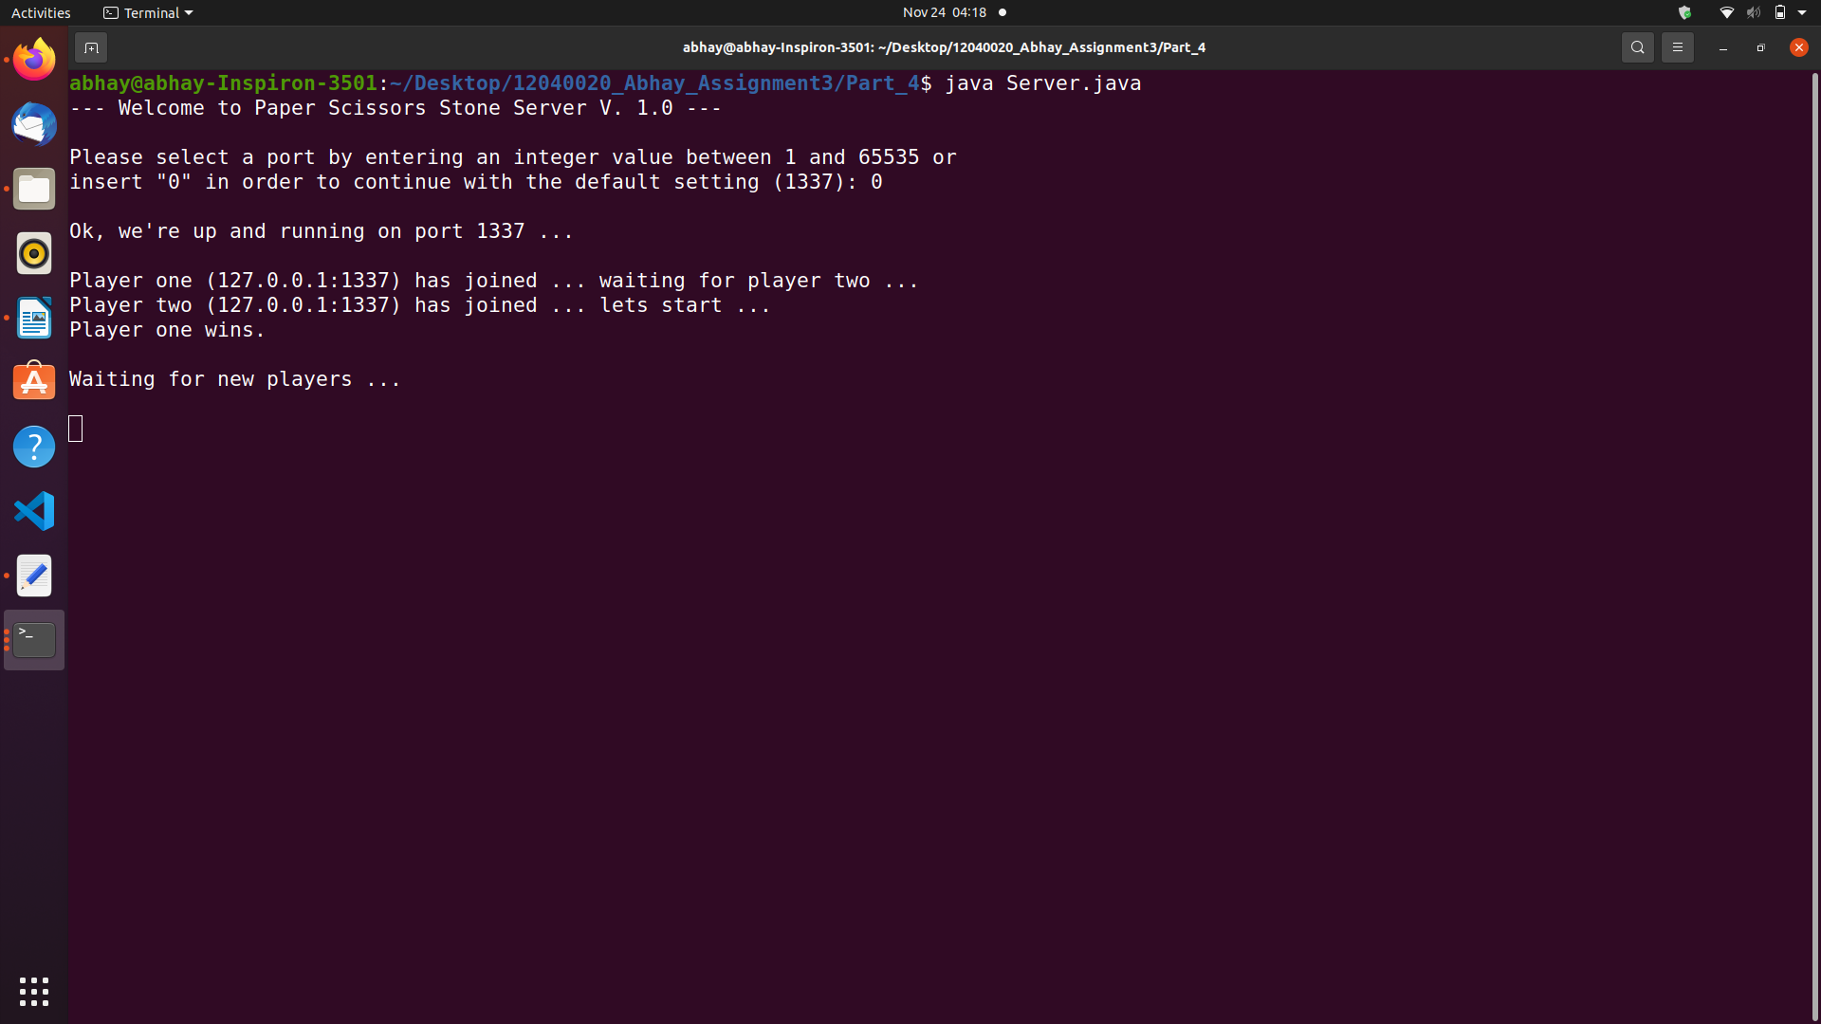.

Server

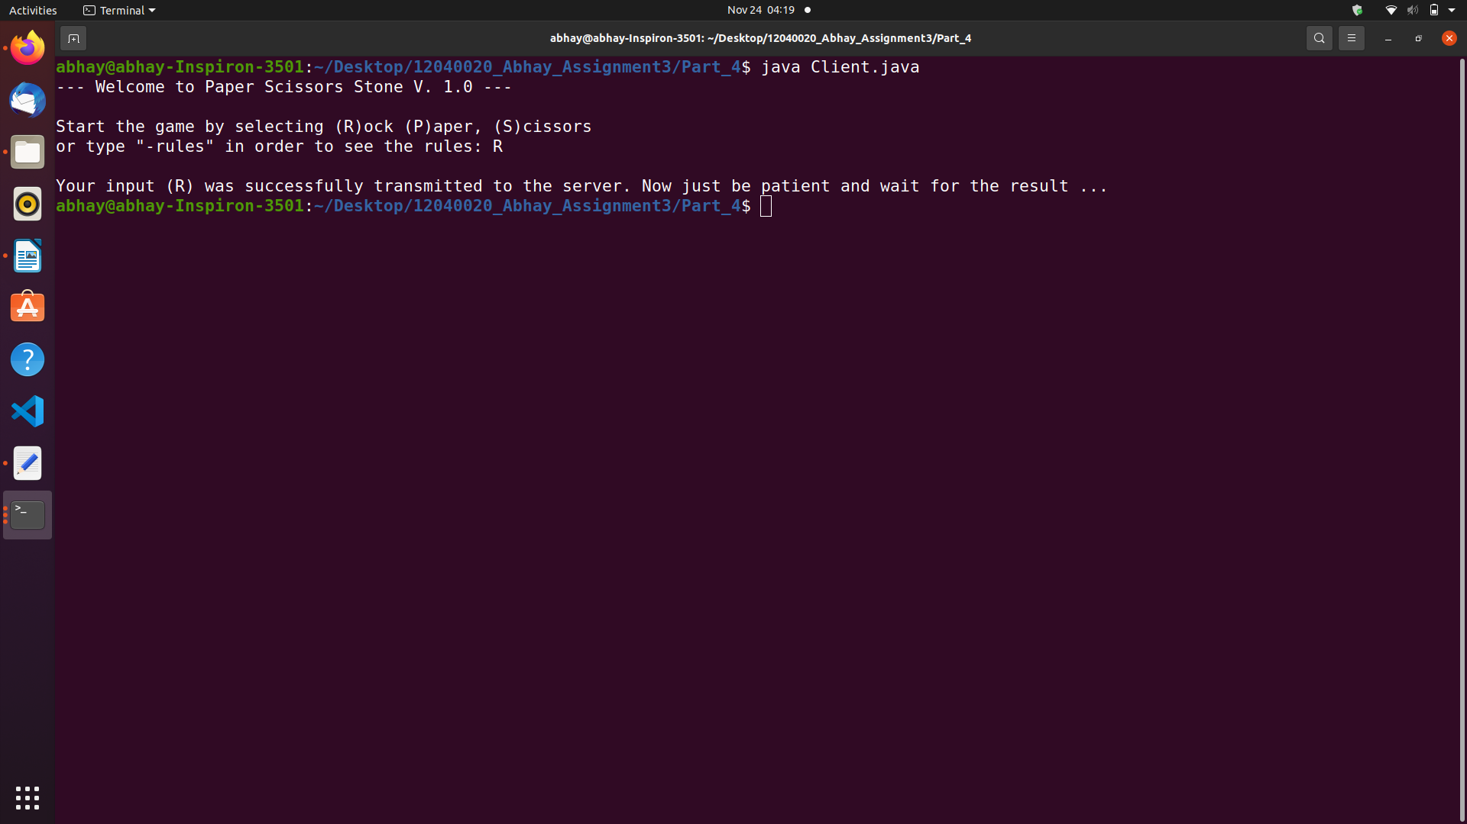

Client 1

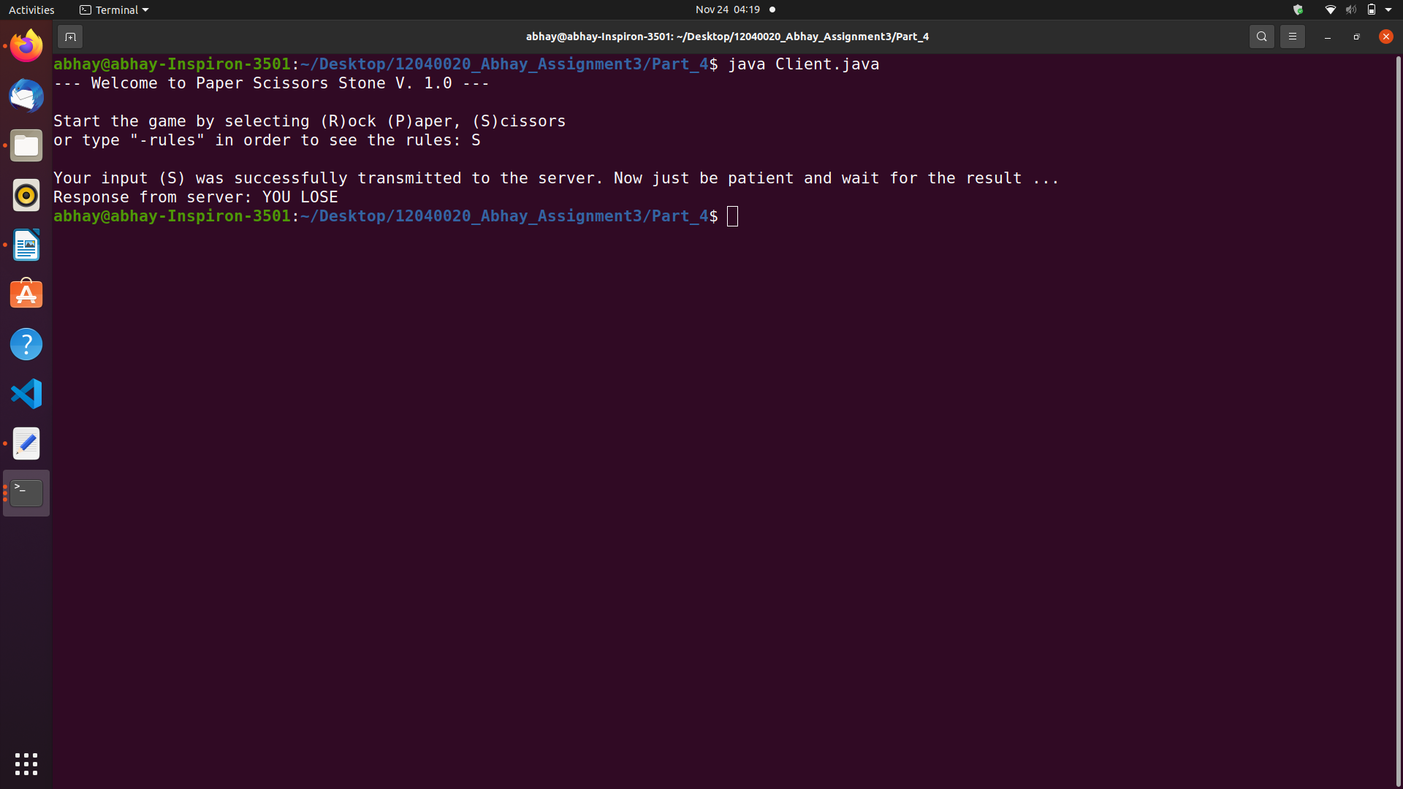

Client 2

After starting server from terminal you have to run again for client 1 and client 2 and accoriding to their interactive reply one client in the game and other loss.

It’s simple stone paper scissor game.

THANK YOU.