Assignment – 2

1)

a) Showing Name

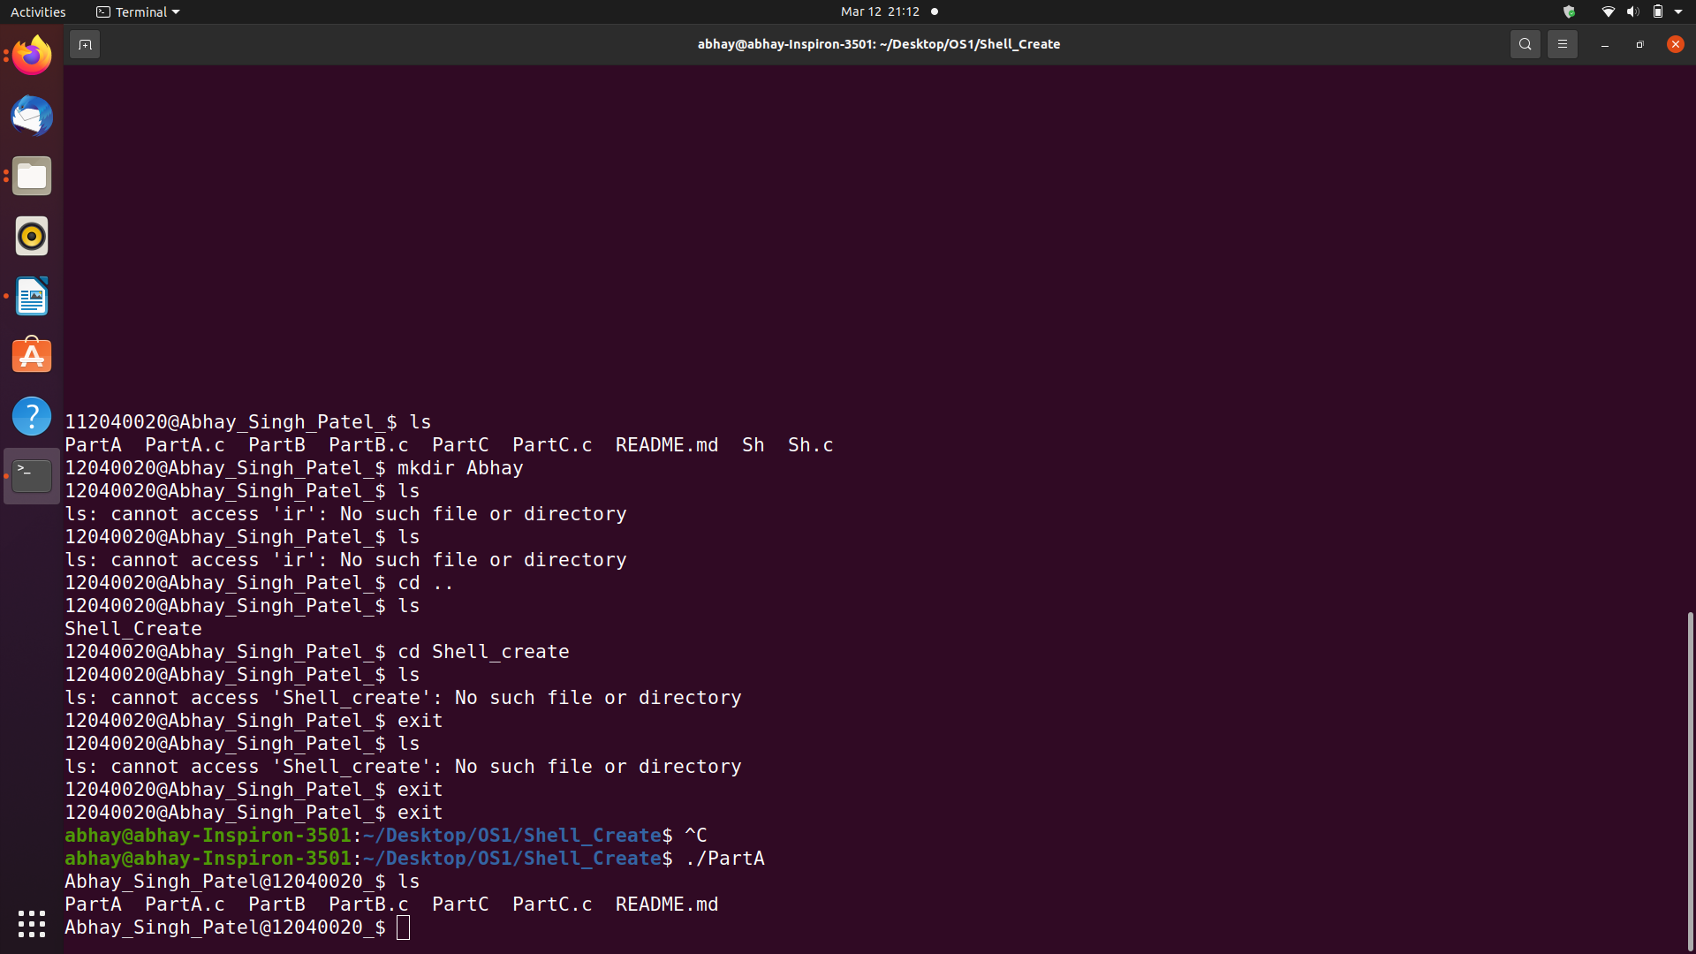

b ) showing ls cmd.



c) ps is working

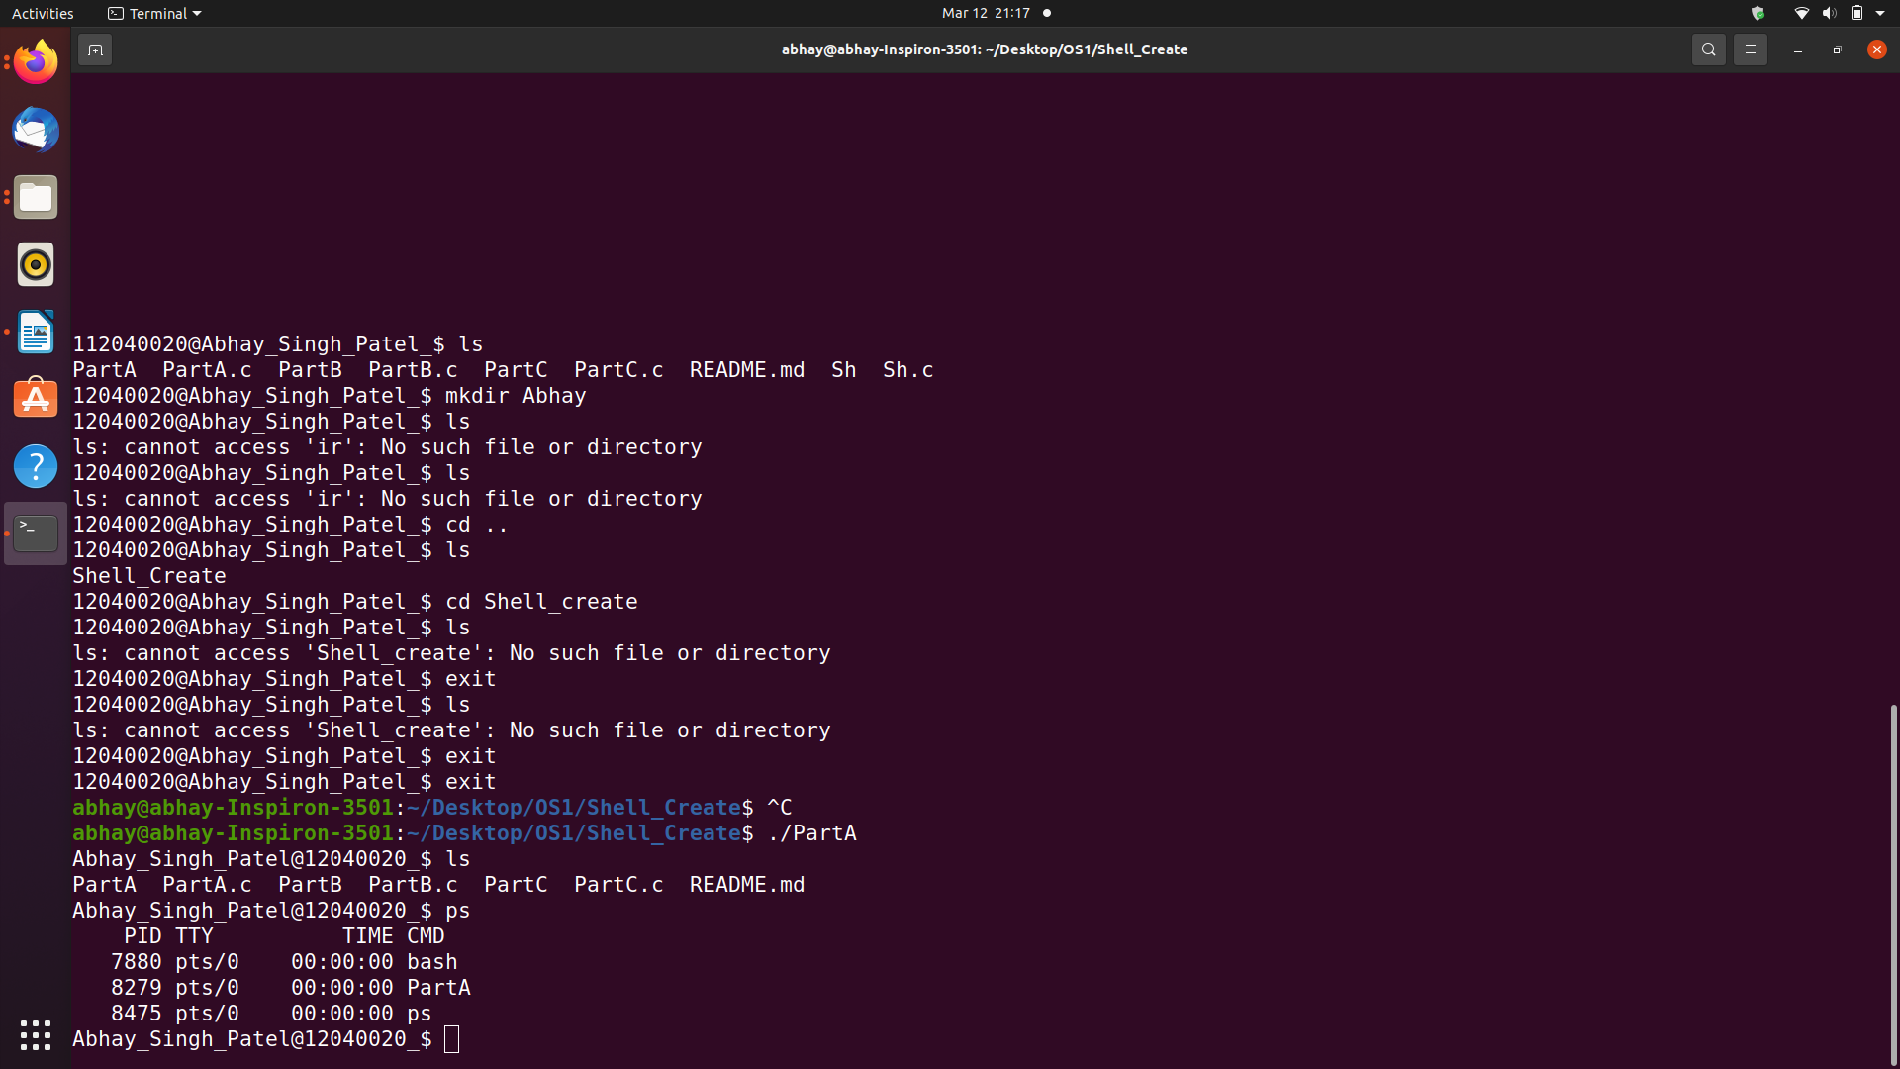

d) netstat is working

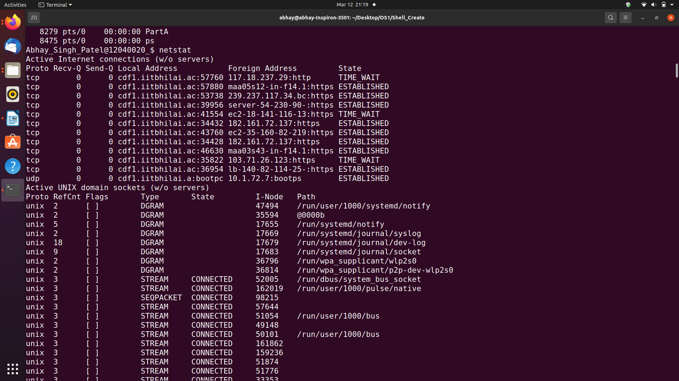

e) Working of exit and ctrl + c command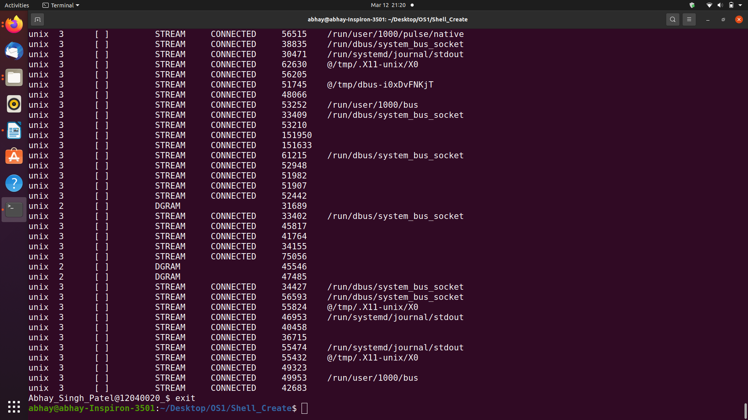

2)

a) Working of pipe

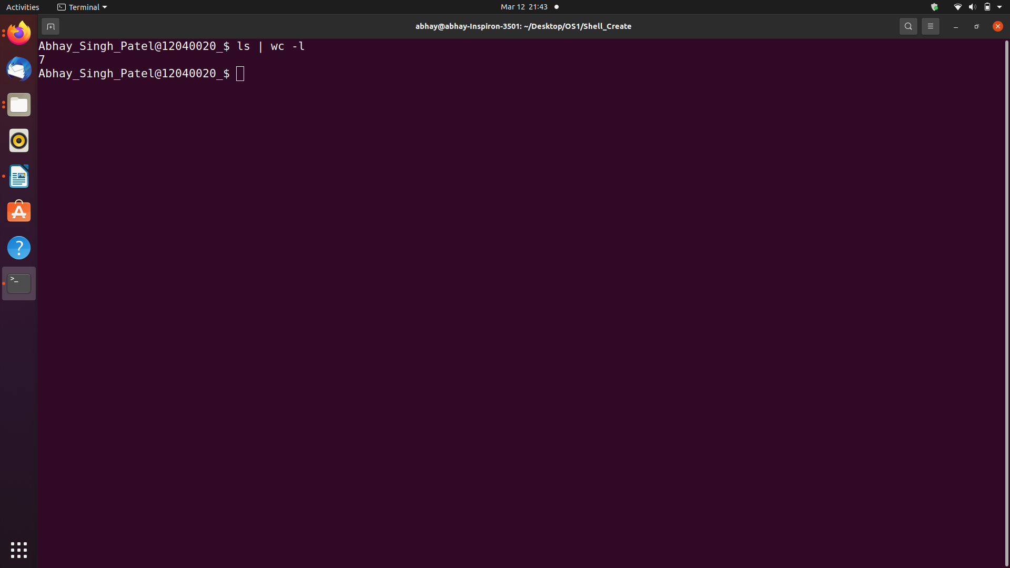

b) Working of grep

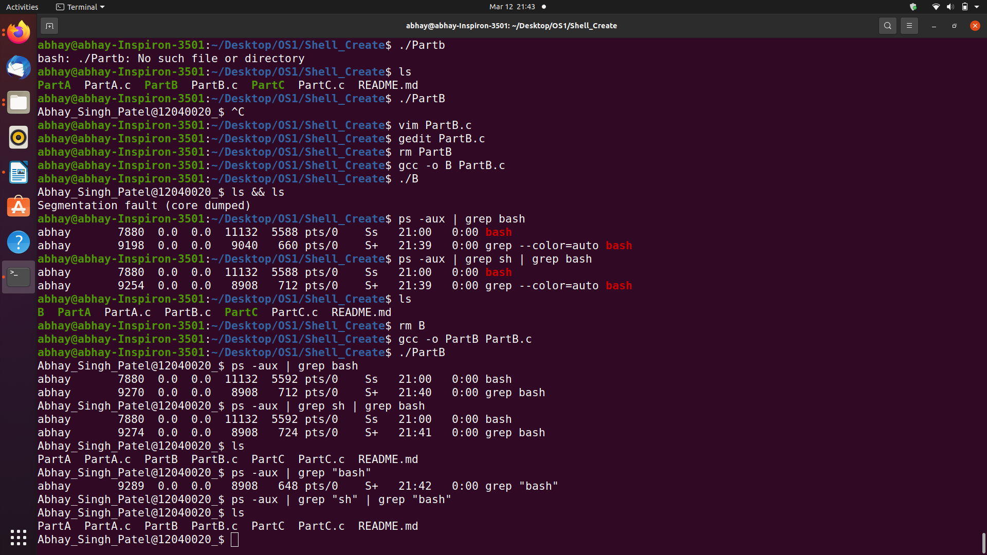

c) Working of && which is not working but sudo apt-update is working

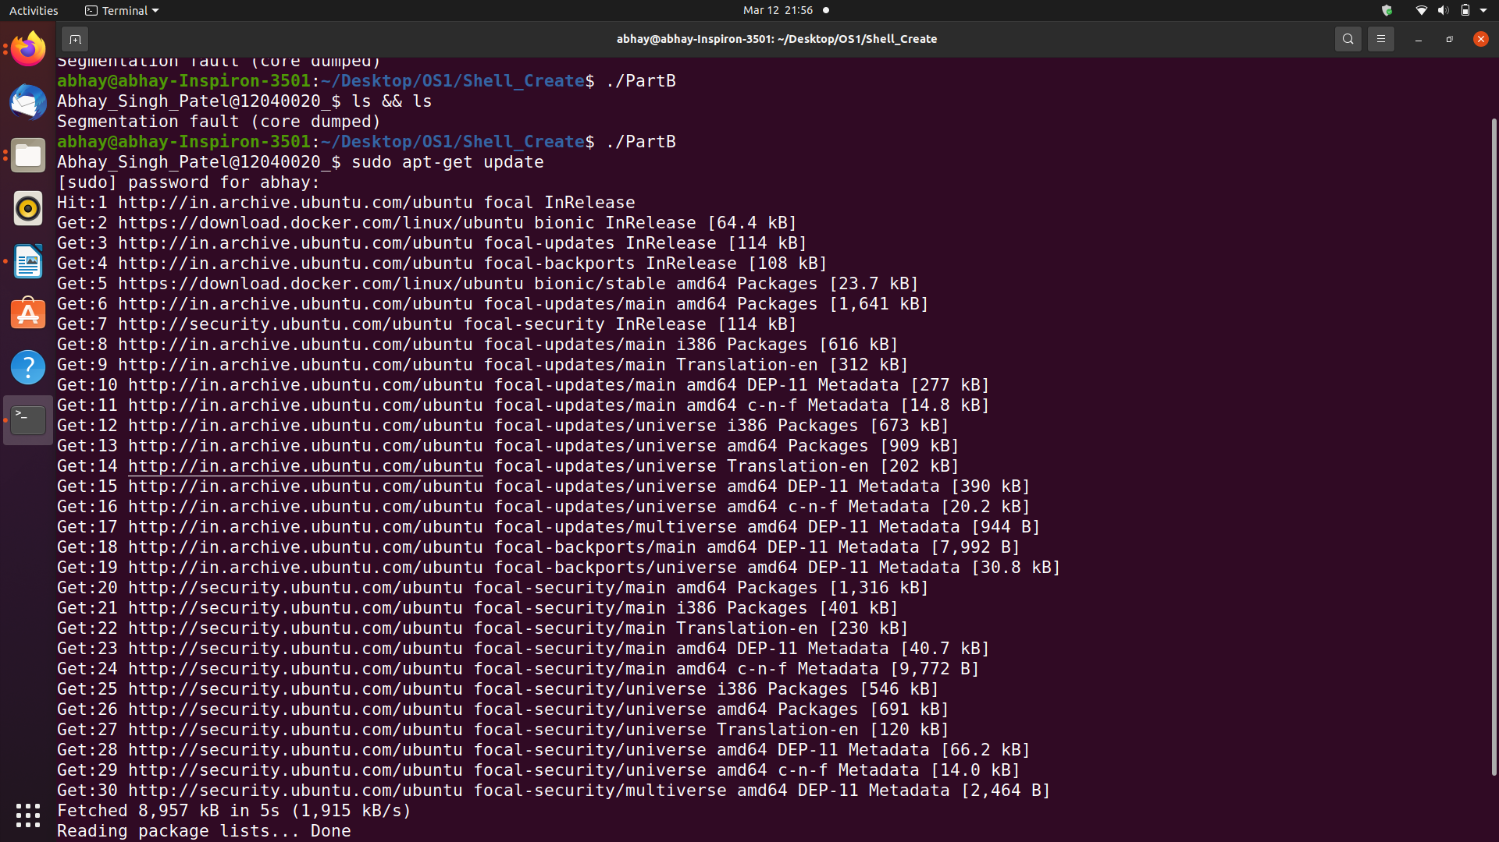.

3)

redirection is working.

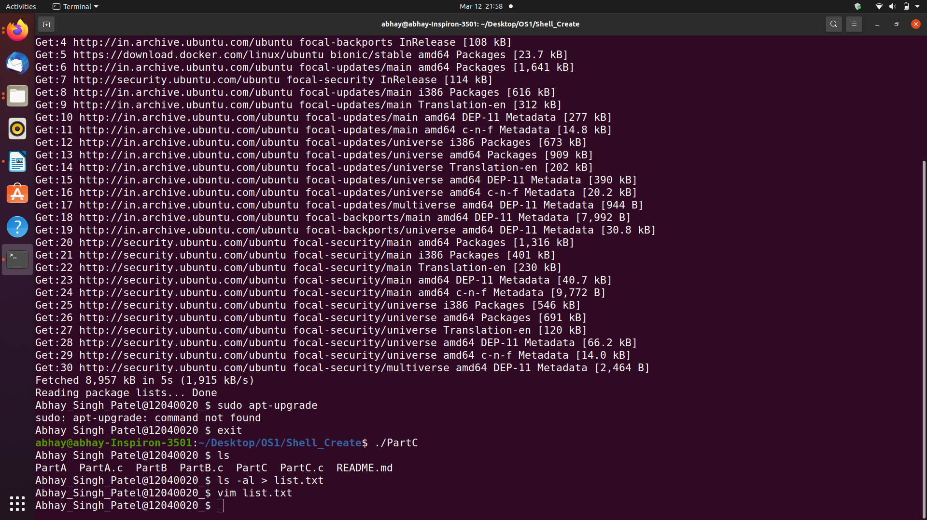.

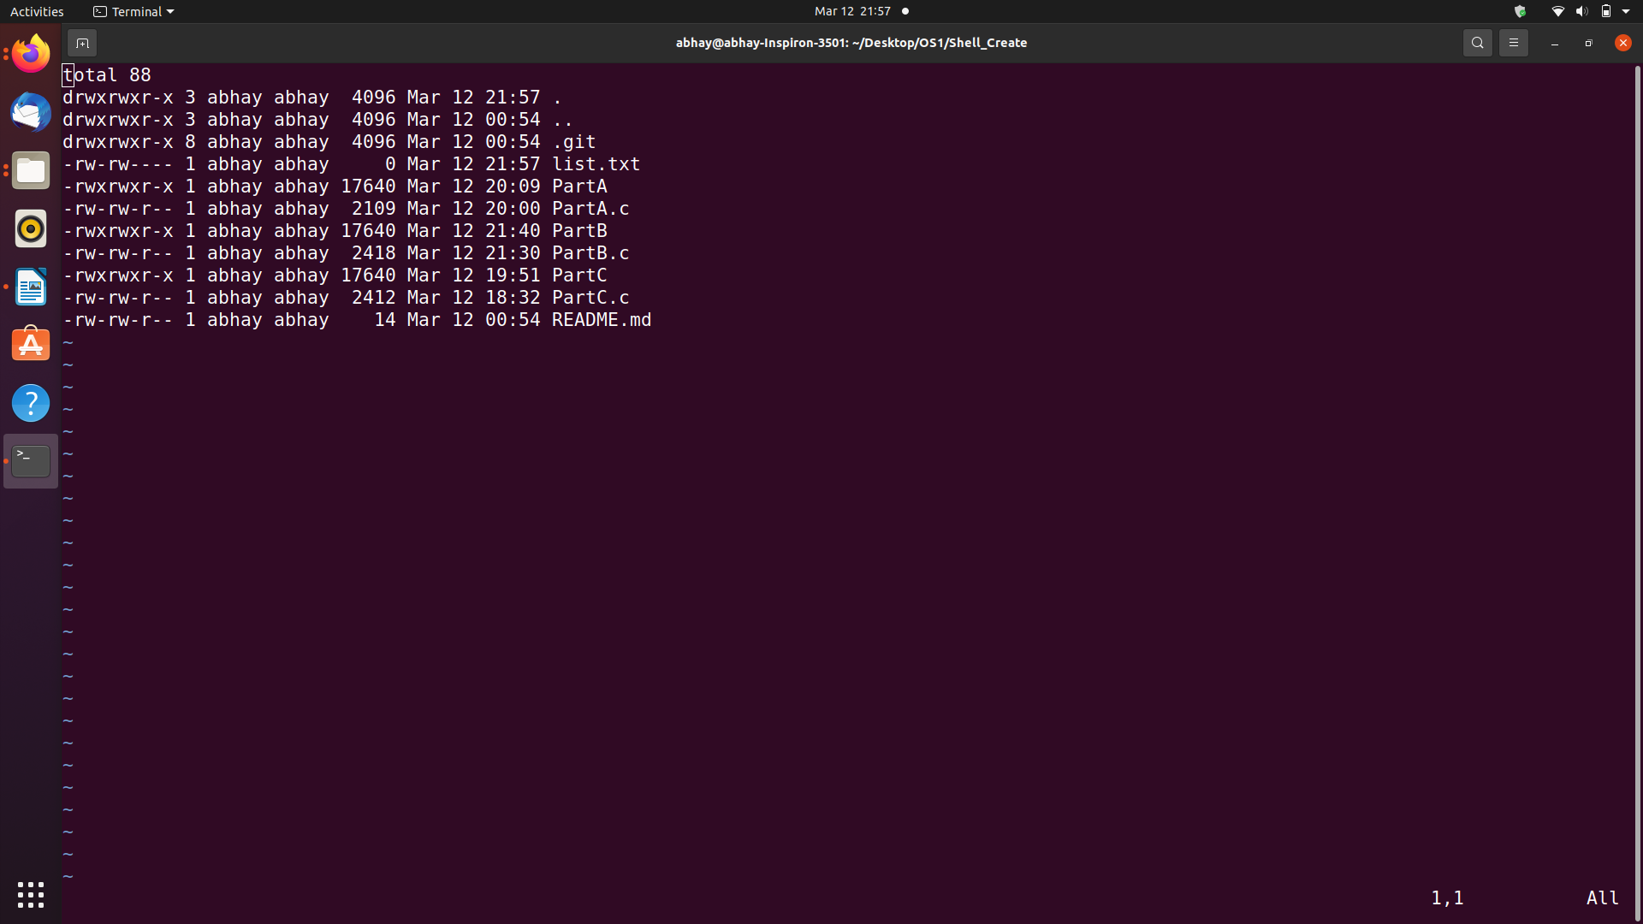.

Explanation :

* Include stdlib.h library which involve memory allocation , process control , conversions.
* Used Fork() System Fucntion which create the parser of 2^n
* Used System exit function to exit the terminal

* Made skipwhite fucntion, which remove whitespace by incrementing index if space is found
* Made split fuction, which splits the statement and convert them in token which store in argument array at zero index only.
* Made command fuction which uses inbuild ps2() fuction which take input token and give output.
* Made cleanup fuction which clearline.
* Main function take the input by fgets() fuction because it take full line input not as scanf().