Assignment :

In 3 branches (22q1,22q2,22q3) create index.htm file. Clone this repo into Jenkins master and deploy individual branch’s index.html on slave-1 ,slave-2, slave-3.

**Step-1**: launch 1 ec2-instance for Jenkins master and 3 for Jenkins slave.

Configure master ( install java, install maven-set env variable for maven, install git, install apache tomacat, wget Jenkins in tomcats-webapps)

Configure slaves ( install java )

**Step-2:** make nodes in Jenkins and connect them with master through ssh.

**Step-3:** create new repo. In it create branches (22q1,22q2,22q3). Each branch have its own index.html.

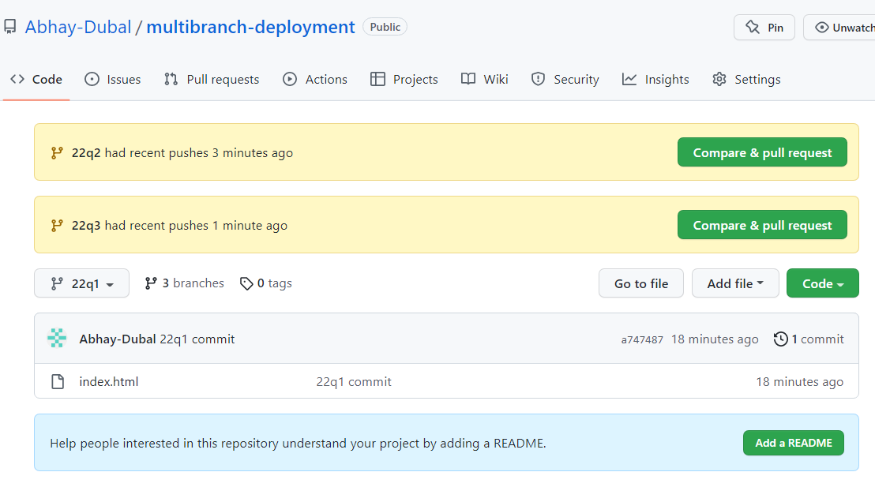

**Step-4:** write pipeline job to clone 22q1 branch in master and copy index into slave.

Give permission to target directories on slave to perform operation.

pipeline {

agent {

node {

label "master"

customWorkspace "/mnt/httpd-project/22q1"

}

}

stages {

stage ('clone repo') {

steps {

sh "rm -rf /mnt/httpd-project/22q1/multibranch-deployment"

sh "git clone https://github.com/Abhay-Dubal/multibranch-deployment.git -b 22q1"

sleep 5

sh "chmod -R 777 /mnt/httpd-project/22q1/multibranch-deployment/index.html"

sh "scp -i '/mnt/linserver.pem' /mnt/httpd-project/22q1/multibranch-deployment/index.html ec2-user@172.31.13.229:/mnt/slave-1/"

}

}

stage ('on slave -1') {

agent {

node {

label "qa"

customWorkspace "/mnt/slave-1"

}

}

steps {

sh "sudo yum install httpd -y"

sleep 5

sh "sudo service httpd start"

sh "sudo cp -r index.html /var/www/html"

sh "sudo chmod -R 777 /var/www/html/index.html"

}

}

}

}

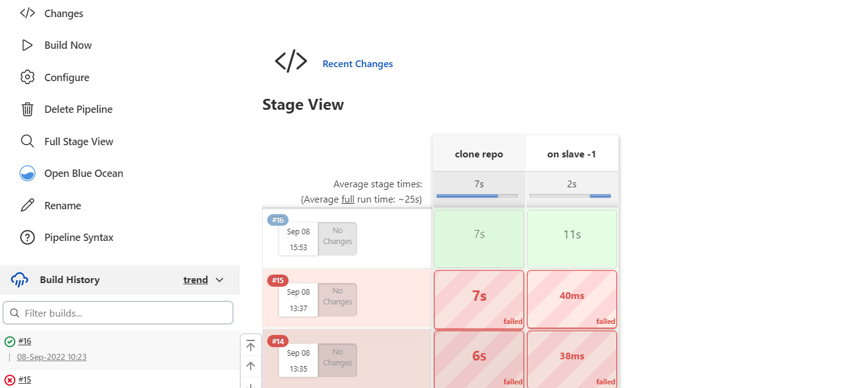



**Step 5:** write pipeline job to clone 22q2 branch in master and copy index into slave.

Give permission to target directory on slave to perform operation.

pipeline {

agent {

node {

label "master"

customWorkspace "/mnt/httpd-project/22q2"

}

}

stages {

stage ('clone repo') {

steps {

sh "rm -rf /mnt/httpd-project/22q2/multibranch-deployment"

sh "git clone https://github.com/Abhay-Dubal/multibranch-deployment.git -b 22q2"

sleep 5

sh "chmod -R 777 /mnt/httpd-project/22q2/multibranch-deployment/index.html"

sh "scp -i '/mnt/linserver.pem' /mnt/httpd-project/22q2/multibranch-deployment/index.html ec2-user@172.31.4.234:/mnt/slave-2/"

}

}

stage ('on slave -2') {

agent {

node {

label "172.31.5.105"

customWorkspace "/mnt/slave-2"

}

}

steps {

sh "sudo yum install httpd -y"

sleep 5

sh "sudo service httpd start"

sh "sudo cp -r index.html /var/www/html"

sh "sudo chmod -R 777 /var/www/html/index.html"

}

}

}

}

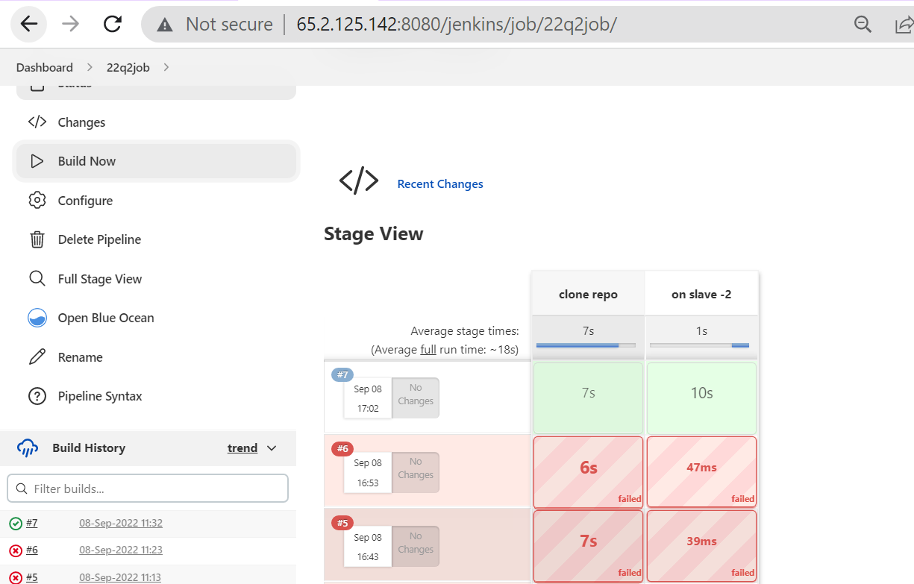

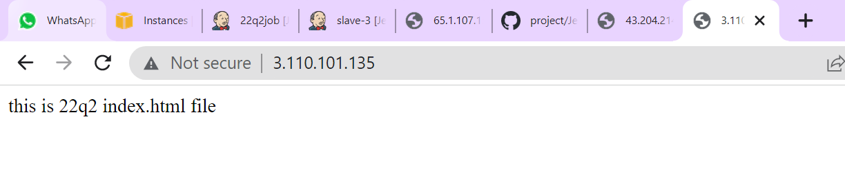

**Step 6:** write pipeline job to clone 22q3 branch in master and copy index into slave.

Give permission to target directory on slave to perform operation.

pipeline {

agent {

node {

label "master"

customWorkspace "/mnt/httpd-project/22q3"

}

}

stages {

stage ('clone repo') {

steps {

sh "rm -rf /mnt/httpd-project/22q3/multibranch-deployment"

sh "git clone https://github.com/Abhay-Dubal/multibranch-deployment.git -b 22q3"

sleep 5

sh "chmod -R 777 /mnt/httpd-project/22q3/multibranch-deployment/index.html"

sh "scp -i '/mnt/linserver.pem' /mnt/httpd-project/22q3/multibranch-deployment/index.html ec2-user@172.31.5.105:/mnt/slave-3/"

}

}

stage ('on slave -3') {

agent {

node {

label " 172.31.5.105"

customWorkspace "/mnt/slave-3"

}

}

steps {

sh "sudo yum install httpd -y"

sleep 5

sh "sudo service httpd start"

sh "sudo cp -r index.html /var/www/html"

sh "sudo chmod -R 777 /var/www/html/index.html"

}

}

}

}

