Assignment :

Clone game of life in Jenkins master also make package in Jenkins master and deploy this gameoflife.war package on 2 slaves.

**Step-1**: launch 1 ec2-instance for Jenkins master and 2 for Jenkins slave.

Configure master ( install java, install maven-set env variable for maven, install git, install Apache Tomacat, wget Jenkins in tomcats-webapps)

Configure slaves ( install java, install Apache tomcat- start tomcat server )

**Step-2:** make nodes in Jenkins and connect them with master through ssh.

**Step-3:** create pipeline job

Befor run build give permission to slaves directory where we deploy gameoflife.war file

pipeline {

agent {

node {

label "master"

customWorkspace "/mnt/git-project/"

}

}

stages {

stage ('clean local repo') {

steps {

sh "rm -rf /root/.m2/repository

}

}

stage ('clone repo') {

steps {

sh "rm -rf /mnt/git-project/game-of-life"

sh "git clone https://github.com/Abhay-Dubal/game-of-life.git"

}

}

stage ('build package') {

agent {

node {

label "master"

customWorkspace "/mnt/git-project/game-of-life"

}

}

steps {

sh "mvn clean"

sh "mvn install -DiskTests"

}

}

stage ('on slave-1'){

agent {

node {

label "master"

customWorkspace "/mnt/git-project/game-of-life/gameoflife-web/target"

}

}

steps {

sh "chmod -R 777 gameoflife.war"

sh "scp -i '/mnt/linserver.pem' gameoflife.war ec2-user@172.31.13.229:/mnt/server/apache-tomcat-9.0.65/webapps"

}

}

stage ('on slave-2'){

agent {

node {

label "master"

customWorkspace "/mnt/git-project/game-of-life/gameoflife-web/target"

}

}

steps {

sh "chmod -R 777 gameoflife.war"

sh "scp -i '/mnt/linserver.pem' gameoflife.war ec2-user@172.31.4.234:/mnt/server/apache-tomcat-9.0.65/webapps"

}

}

}

}

**Output :** console output

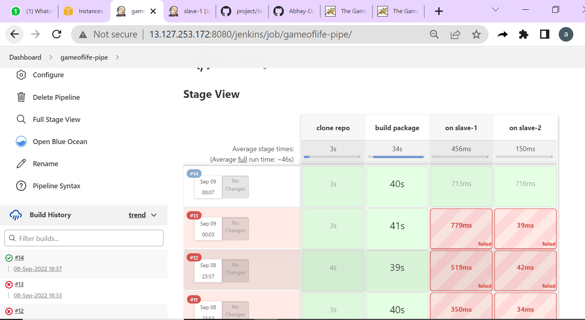

**Output :** blue ocean view

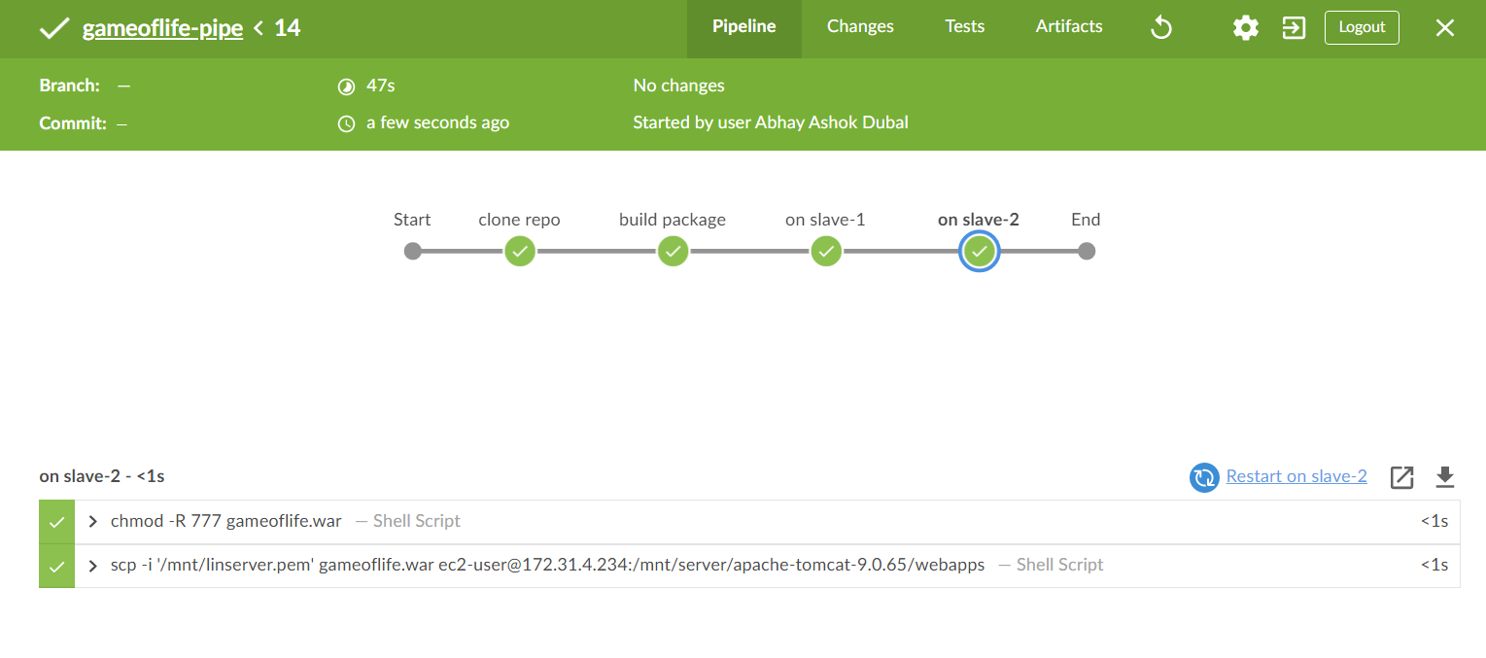

**Output :** Game-of-life deployed on slave-1

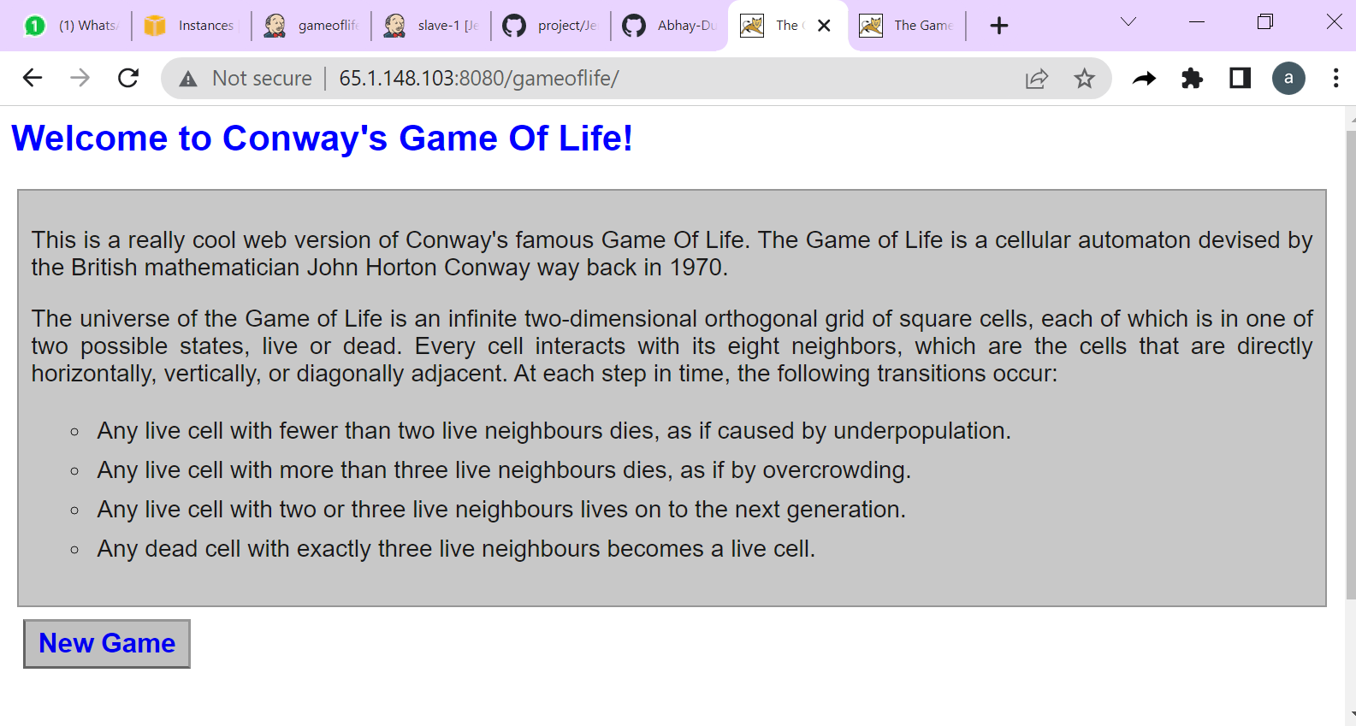

**Output :** Game-of-life deployed on slave-2

