Assignment :

Clone game of life in Jenkins master also make package in Jenkins master and deploy this gameoflife.war package on 2 slaves.

**Step-1**: launch 1 ec2-instance for Jenkins master and 2 for Jenkins slave.

Configure master ( install java, install maven-set env variable for maven, install git, install Apache Tomacat, wget Jenkins in tomcats-webapps)

Configure slaves ( install java, install Apache tomcat- start tomcat server )

**Step-2:** make nodes in Jenkins and connect them with master through ssh.

**Step-3:** create pipeline job

1. Befor run build give permission to slaves directory where we deploy gameoflife.war file
2. Configure jdk in global tool configuration. And give path /usr/lib/jvm/java-1.8.0-openjdk-1.8.0.332.b09-1.amzn2.0.2.x86_64

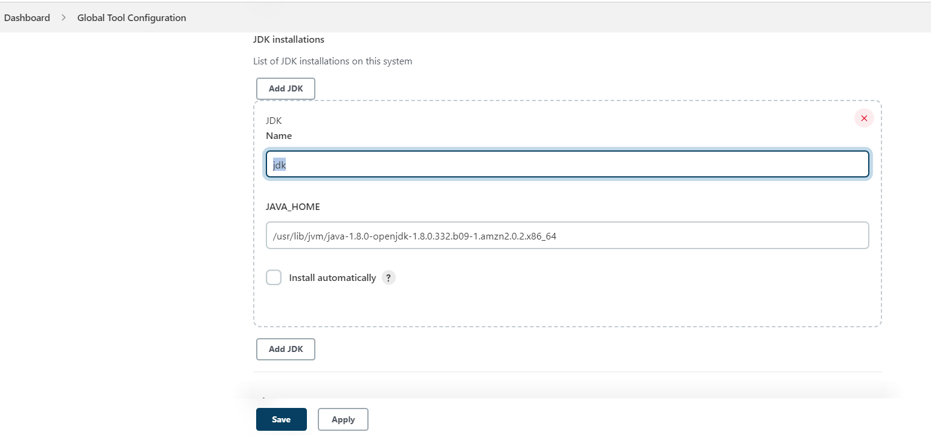

3.When u make node in Jenkins then add maven tool at last.

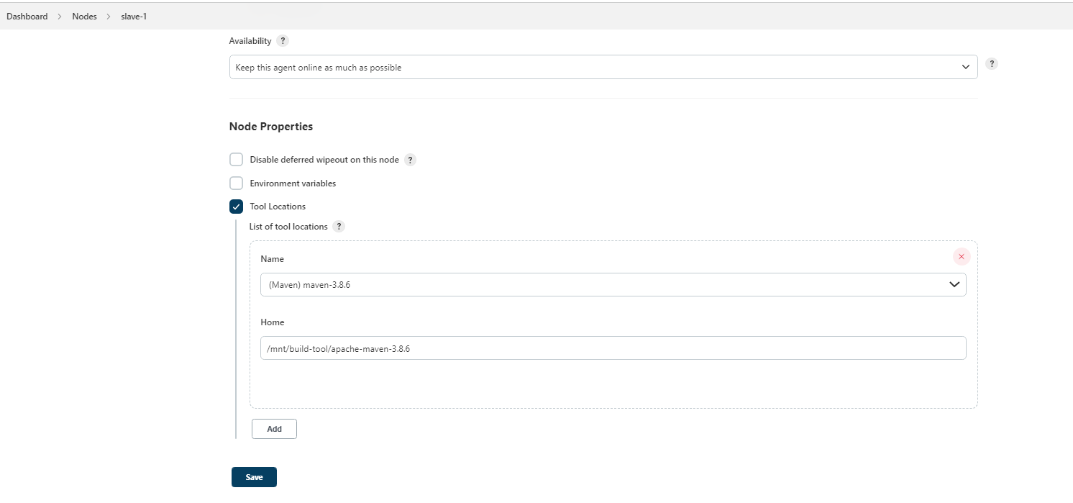

Pipeline Code :

pipeline {

agent {

node {

label "qa"

customWorkspace "/mnt/slave-1"

}

}

tools {

maven "maven-3.8.6"

jdk "jdk"

}

stages {

stage ('clean local repo of slave-1') {

steps {

sh "sudo rm -rf /root/.m2/repository"

}

}

stage ('clone repo on slave-1') {

steps {

sh "sudo rm -rf /mnt/slave-1/game-of-life"

sh "sudo git clone https://github.com/Abhay-Dubal/game-of-life.git"

}

}

stage ('make build in slave-1'){

agent {

node {

label "qa"

customWorkspace "/mnt/slave-1/game-of-life"

}

}

steps {

sh "sudo mvn clean"

sh "sudo mvn install -DisksTests"

}

}

stage ('deploy on slave-1 Tomcat') {

agent {

node {

label "qa"

customWorkspace "/mnt/slave-1/game-of-life/gameoflife-web/target"

}

}

steps {

sh "sudo chmod -R 777 gameoflife.war"

sh "sudo cp -r gameoflife.war /mnt/server/apache-tomcat-9.0.65/webapps"

}

}

stage ('clean local repo in slave-2') {

agent {

node {

label "dev"

customWorkspace "/mnt/slave-2"

}

}

steps {

sh "sudo rm -rf /root/.m2/repository"

}

}

stage ('clone repo in slave-2') {

steps {

sh "sudo rm -rf /mnt/slave-2/game-of-life"

sh "sudo git clone https://github.com/Abhay-Dubal/game-of-life.git"

}

}

stage ('make build in slave -2'){

agent {

node {

label "dev"

customWorkspace "/mnt/slave-2/game-of-life"

}

}

steps {

sh "sudo mvn clean"

sh "sudo mvn install -DisksTests"

}

}

stage ('deploy on slave-2 Tomcat') {

agent {

node {

label "dev"

customWorkspace "/mnt/slave-2/game-of-life/gameoflife-web/target"

}

}

steps {

sh "sudo chmod -R 777 gameoflife.war"

sh "sudo cp -r gameoflife.war /mnt/server/apache-tomcat-9.0.65/webapps"

}

}

}

}