Assignment -6

Clone game of life in master and build, then create custom image for Apache tomcat using dockerfile and deploy war file in Apache tomcat webserver that u created.

**Step -1 :** configure Jenkins master –

1. Yum update -y
2. Install java 8.
3. Install Apache tomcat, start tomcat – deploy Jenkins in tomcat webapps.
4. Install maven. Set environment variable.
5. Install docker – start docker.

**Step-2 :** Jenkins console :

1. Setup maven tool in global tool configuration.

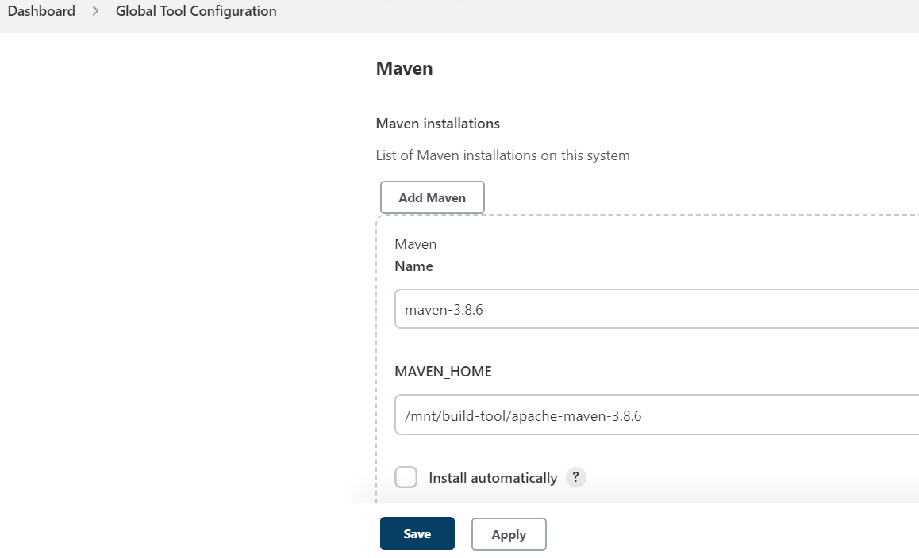

1. Set url of Jenkins

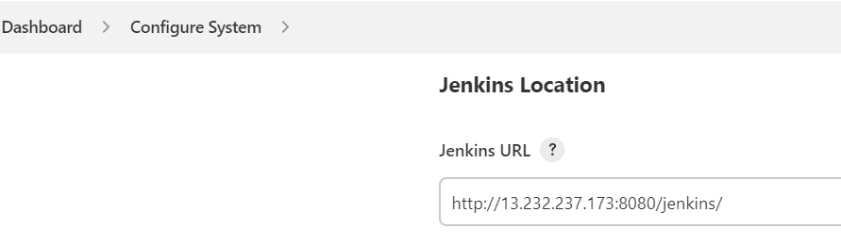

1. Create job -> select pipeline job 🡪 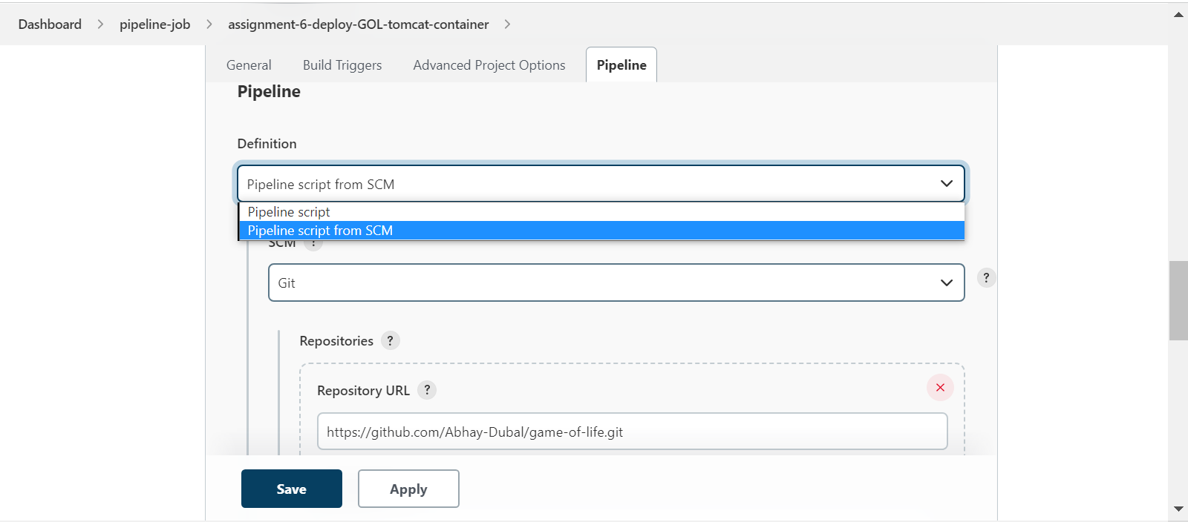

**Step-3** : create docker file in your Jenkins master instance.

1. cd /mnt/docker
2. Vi Dockerfile

FROM tomcat:9.0

MAINTAINER abhay

CMD ["catalina.sh", "run"]

COPY gameoflife.war /usr/local/tomcat/webapps

EXPOSE 8080

**Step-4 :** create Jenkinsfile in game-of-life repository home location and write code in it.

|  |
| --- |
| pipeline{ |
|  | agent { |
|  | node { |
|  | label "master" |
|  | customWorkspace "/mnt/git-project" |
|  | } |
|  | } |
|  | stages { |
|  | stage ('build project'){ |
|  | steps { |
|  | /*sh "rm -rf /root/.m2"*/ |
|  | sleep 5 |
|  | sh "mvn clean install" |
|  |  |
|  | } |
|  | } |
|  |  |
|  | stage ('diploy war') { |
|  | steps { |
|  | sh "cp -r /mnt/git-project/gameoflife-web/target/gameoflife.war /mnt/docker" |
|  |  |
|  | } |
|  | } |
|  |  |
|  | stage ('create custom image by docker file') { |
|  | steps { |
|  | dir ('/mnt/docker'){ |
|  | sh "chmod -R 777 gameoflife.war" |
|  | sh "docker build -t mytomcat ." |
|  | } |
|  | } |
|  | } |
|  | stage ('create container') { |
|  | steps { |
|  |  |
|  | sh "docker run --name my-container -itdp 8888:8080 mytomcat" |
|  |  |
|  | } |
|  | } |
|  |  |
|  | } |
|  |  |
|  | } |

**Step 5:** trigger build

