Assignment -7

Clone game of life in master and build, then on slave create custom image for Apache tomcat using dockerfile and deploy war file in Apache tomcat container using your custom image.

**Step -1 :** configure Jenkins master –

1. Yum update -y
2. Install java 8.
3. Install Apache tomcat, start tomcat – deploy Jenkins in tomcat webapps.
4. Install maven. Set environment variable.

**Step-2 :** Jenkins console :

1. Setup maven tool in global tool configuration.

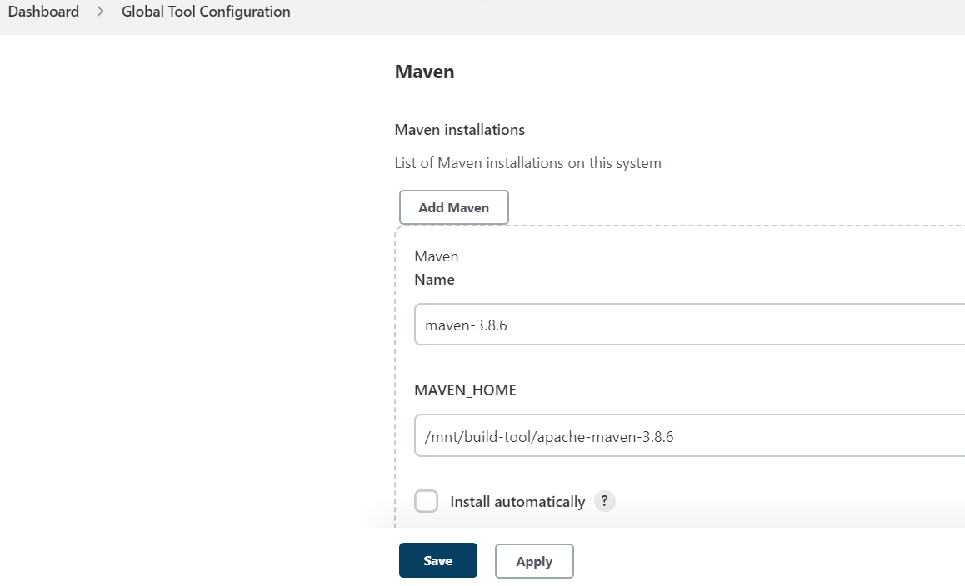

1. Set url of Jenkins:

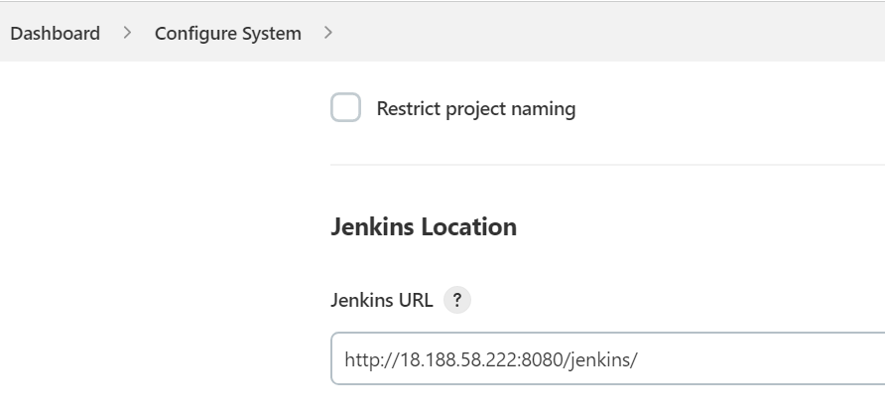

1. Select random port :

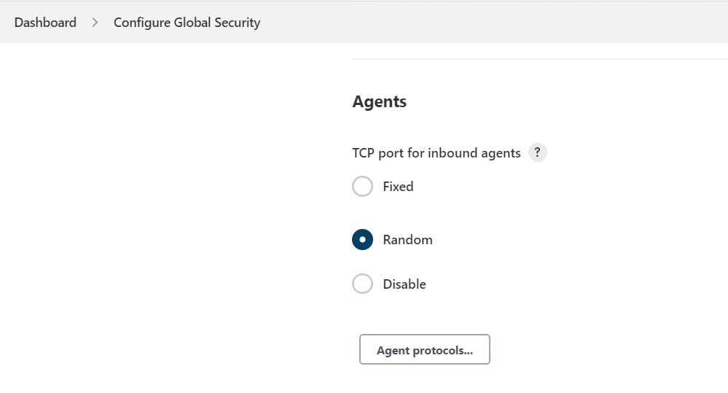

**Step-3 :**

1. create slave in Jenkins console. (by JNPL)

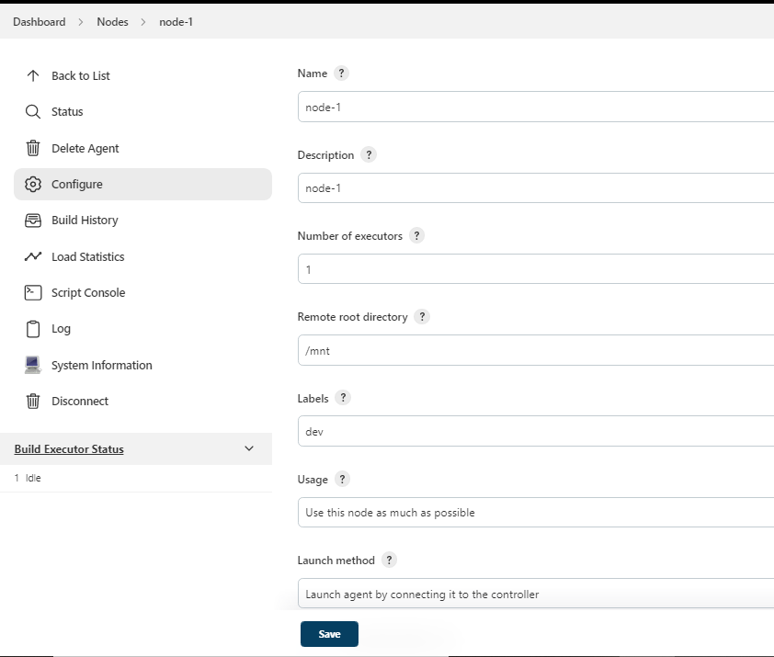

1. Connect this slave to master by running command in slave ec2 .

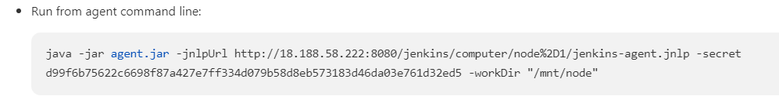

Copy agent.jar and wget in slave ec-2

Run above command : nohup “ command ” & ------- for continuous connection

Check it by tail -100f nohup.out. or in custom dir files created -remoting.jar, nohup.out etc

**Step-4** : Create docker file in slave :

1. /mnt
2. Vi Dockerfile

FROM tomcat:9.0

MAINTAINER abhay

CMD ["catalina.sh", "run"]

COPY gameoflife.war /usr/local/tomcat/webapps

EXPOSE 8080

**Step-5:** write pipeline for job

pipeline {

agent {

node {

label "master"

customWorkspace "/mnt/project"

}

}

stages {

stage ('clone repo') {

steps {

sh "rm -rf game-of-life*"

sh "git clone https://github.com/Abhay-Dubal/game-of-life.git"

}

}

stage ('mvn build') {

steps {

dir ('/mnt/project/game-of-life'){

sh "mvn clean install"

}

}

}

stage ('provide file permision'){

steps {

sh "chmod -R 777 /mnt/project/game-of-life/gameoflife-web/target/gameoflife.war"

sh "scp -i linserver.pem /mnt/project/game-of-life/gameoflife-web/target/gameoflife.war ec2-user@3.144.236.57:/mnt"

}

}

stage ('run docker file') {

agent {

node {

label "dev"

customWorkspace '/mnt'

}

}

steps {

/*sh "sudo rm -rf gameoflife.war"*/

sh "sudo docker build -t my-tomcat ."

sleep 10

sh "sudo docker run --name tom-container -itdp 8088:8080 my-tomcat"

}

}

}

}

**Step-6 :** befor trigger build if in pipeline you use scp command then first check by manually transfer file through scp (run command at master ec2).

**Step-7 :** trigger build

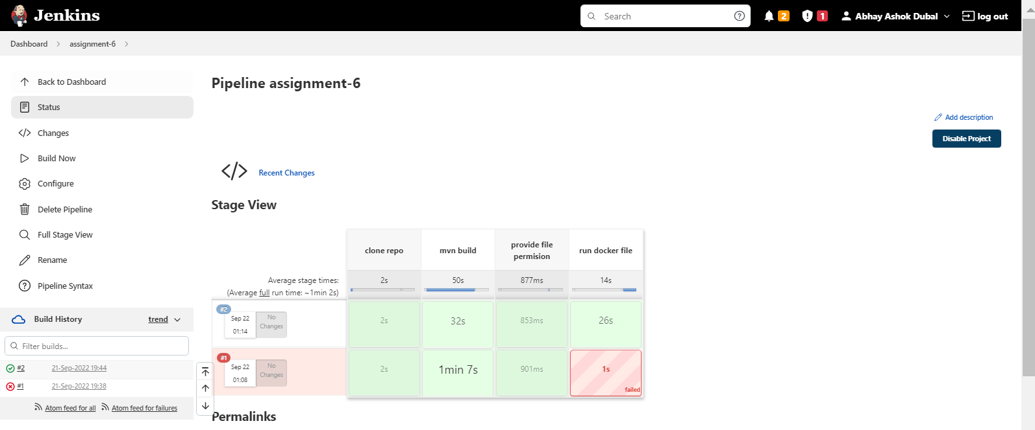

Step-8 : check output - enter slave public ip in browser :port that u bind in container and war file name.

Ex. http://3.144.236.57:8088/gameoflife/

