/* clone and deploy branches 22q1,22q2,22q3- index.httpd on 3 http container port 70,100,300 using multi-branch pipeline*/

**Step-1 :** Create directory directories in your master ( /mnt/docker/22q1,22q2,22q3) for each branch.

**Step-2** : Create git repository

* Create 3 branches and 22q1,22q2,22q3
* Create index.html and Jenkinsfile in each branch.

**Step-3** : write code in each Jenkins file.

1. For first branch 22q1 :

pipeline{

agent {

node {

label "master"

customWorkspace "/mnt/docker/22q1"

}

}

stages {

stage ('create container') {

steps {

/*sh "docker kill container1"

sh "docker rm container1"*/

sh "docker run --name container1 -itdp 60:80 httpd"

}

}

stage ('deploy index') {

steps {

sh "chmod -R 777 index.html"

sh "docker cp index.html container1:/usr/local/apache2/htdocs"

}

}

}

}

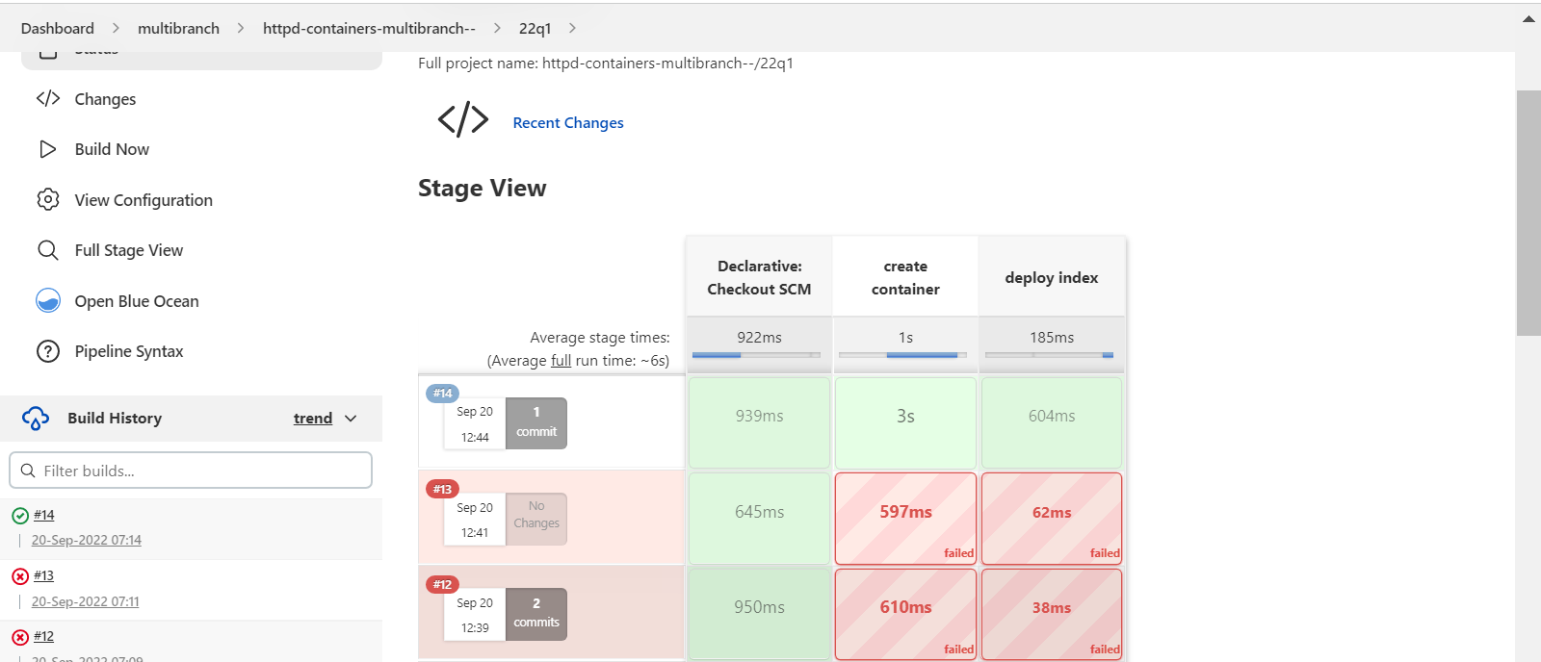



1. For branch 2 : 22q2 jenkinsfile

|  |
| --- |
| pipeline{ |
|  | agent { |
|  | node { |
|  | label "master" |
|  | customWorkspace "/mnt/docker/22q2" |
|  | } |
|  | } |
|  | stages { |
|  | stage ('create container') { |
|  | steps { |
|  | /*sh "docker kill container2" |
|  | sh "docker rm container2"*/ |
|  | sh "docker run --name container2 -itdp 100:80 httpd" |
|  |  |
|  | } |
|  | } |
|  | stage ('deploy index') { |
|  | steps { |
|  | sh "chmod -R 777 index.html" |
|  | sh "docker cp index.html container2:/usr/local/apache2/htdocs" |
|  |  |
|  | } |
|  | } |
|  |  |
|  |  |
|  | } |
|  | } |

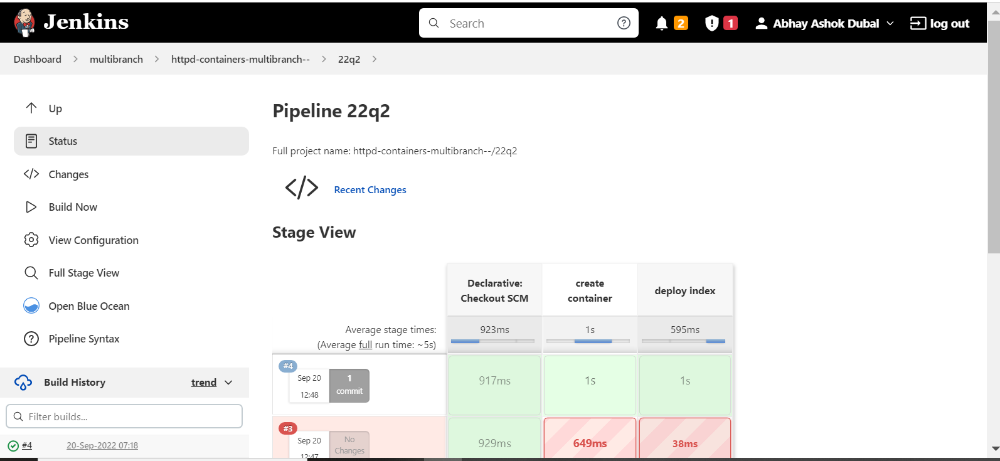



1. For branch 3 : 22q3 Jenkinsfile :

|  |
| --- |
| pipeline{ |
|  | agent { |
|  | node { |
|  | label "master" |
|  | customWorkspace "/mnt/docker/22q3" |
|  | } |
|  | } |
|  | stages { |
|  | stage ('create container') { |
|  | steps { |
|  | /*sh "docker kill container3" |
|  | sh "docker rm container3"*/ |
|  | sh "docker run --name container3 -itdp 200:80 httpd" |
|  |  |
|  | } |
|  | } |
|  | stage ('deploy index') { |
|  | steps { |
|  | sh "chmod -R 777 index.html" |
|  | sh "docker cp index.html container2:/usr/local/apache2/htdocs" |
|  |  |
|  | } |
|  | } |
|  |  |
|  |  |
|  | } |
|  | } |

