Sanketh T S
261100620010
Shared_pthread

/*
* Program: Shared versus Private Data using POSIX Pthreads
*
* Description:
* 1. Creates two threads using pthread_create().
* 2. Both threads access the same global variable 'shared'.
* 3. Each thread has its own local variable 'mine'.
* 4. getpid() returns the same process ID for both threads.
* 5. pthread_self() returns a unique thread ID for each thread.
* 6. Prints the addresses of shared and private variables.
* 7. pthread_join() waits for both threads to complete.
*/

#include <pthread.h>
#include <stdio.h>
#include <unistd.h>

// Global variable shared by all threads
int shared = 100;

// Thread function
static void *worker(void *arg)
{
(void)arg;

// Private local variable for each thread
int mine = 1;

// Get process ID
pid_t pid = getpid();

// Get current thread ID
pthread_t me = pthread_self();

// Print process and thread IDs
printf("pid=%d thread=%lu\n",
pid, (unsigned long)me);

// Print addresses of shared and private variables
printf(" &shared=%p &mine=%p\n",
(void *)&shared, (void *)&mine);

// Keep both threads alive briefly
sleep(1);

return NULL;
}

int main(void)
{
pthread_t t1, t2;

// Create first thread
pthread_create(&t1, NULL, worker, NULL);

// Create second thread
pthread_create(&t2, NULL, worker, NULL);

// Wait for first thread to finish
pthread_join(t1, NULL);

// Wait for second thread to finish
pthread_join(t2, NULL);

printf("Both threads completed.\n");

return 0;
}
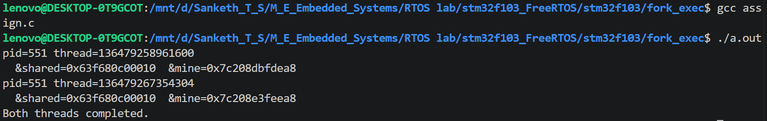

Fork_print
#include <stdio.h>
#include <unistd.h>
#include <sys/wait.h>

int main() {
pid_t pid = fork();

if (pid < 0) {
perror("fork failed");
return 1;
} else if (pid == 0) {
// Child process
printf("Child: my pid = %d, parent pid = %d\n", getpid(), getppid());
} else {
// Parent process
printf("Parent: my pid = %d, child pid = %d\n", getpid(), pid);
wait(NULL);
printf("Parent: child has exited\n");
}

return 0;
}
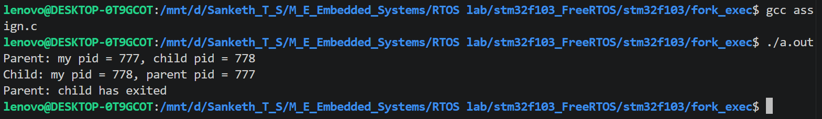

Fork_sleep
#include <stdio.h>
#include <unistd.h>
#include <sys/wait.h>

int main() {
pid_t pid = fork();

if (pid < 0) {
perror("fork failed");
return 1;
} else if (pid == 0) {
printf("Child: my pid = %d, parent pid = %d\n", getpid(), getppid());
printf("Child: sleeping for 20 seconds...\n");
fflush(stdout);
sleep(20);
printf("Child: woke up, exiting now\n");
} else {
printf("Parent: my pid = %d, child pid = %d\n", getpid(), pid);
printf("Parent: waiting for child to finish...\n");
fflush(stdout);

int status;
pid_t exited_pid = waitpid(pid, &status, 0);

if (exited_pid == pid) {
if (WIFEXITED(status))
printf("Parent: child %d exited with status %d\n", exited_pid, WEXITSTATUS(status));
else
printf("Parent: child %d did not exit normally\n", exited_pid);
}
}

return 0;
}
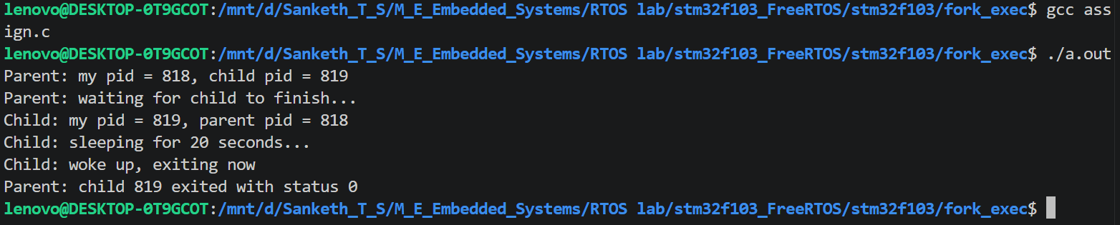

Fork_three_children
#include <stdio.h>
#include <unistd.h>
#include <sys/wait.h>

int main() {
int sleep_times[3] = {10, 20, 30};
pid_t child_pids[3];

for (int i = 0; i < 3; i++) {
pid_t pid = fork();

if (pid < 0) {
perror("fork failed");
return 1;
} else if (pid == 0) {
printf("Child %d: pid = %d, sleeping for %d seconds\n",
i, getpid(), sleep_times[i]);
fflush(stdout);
sleep(sleep_times[i]);
printf("Child %d: pid = %d, woke up after %d seconds\n",
i, getpid(), sleep_times[i]);
return 0;
} else {
child_pids[i] = pid;
}
}

printf("Parent: pid = %d, waiting for all children...\n", getpid());
fflush(stdout);

for (int i = 0; i < 3; i++) {
int status;
pid_t exited_pid = waitpid(child_pids[i], &status, 0);
if (exited_pid == child_pids[i] && WIFEXITED(status)) {
printf("Parent: child %d (pid %d) exited with status %d\n",
i, exited_pid, WEXITSTATUS(status));
}
}

printf("Parent: all children have exited\n");
return 0;
}
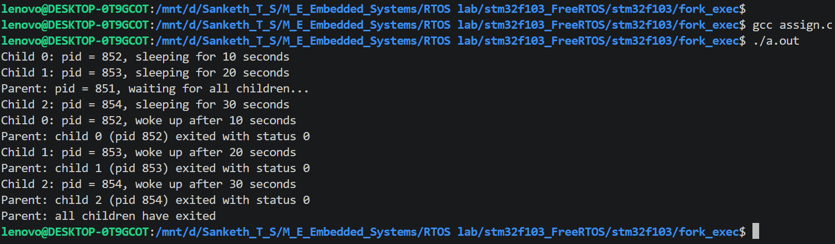

Fork_waitpid
#include <stdio.h>
#include <unistd.h>
#include <sys/wait.h>

int main() {
pid_t pid = fork();

if (pid < 0) {
perror("fork failed");
return 1;
} else if (pid == 0) {
printf("Child: my pid = %d, parent pid = %d\n", getpid(), getppid());
} else {
printf("Parent: my pid = %d, child pid = %d\n", getpid(), pid);

int status;
pid_t exited_pid = waitpid(pid, &status, 0);

if (exited_pid == pid) {
if (WIFEXITED(status))
printf("Parent: child %d exited with status %d\n", exited_pid, WEXITSTATUS(status));
else
printf("Parent: child %d did not exit normally\n", exited_pid);
}
}

return 0;
}
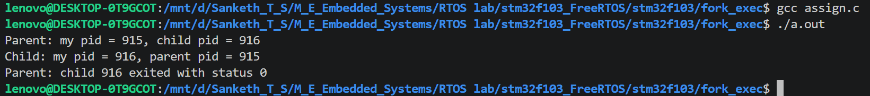

Rec_fork
#include <stdio.h>
#include <unistd.h>
#include <sys/wait.h>

int main() {
printf("Original parent: pid = %d\n", getpid());
fflush(stdout);

pid_t pid1 = fork();

if (pid1 < 0) {
perror("fork failed");
return 1;
} else if (pid1 == 0) {
// ---- child1 ----
printf("Child1: pid = %d, parent pid = %d\n", getpid(), getppid());
fflush(stdout);

pid_t pid2 = fork();

if (pid2 < 0) {
perror("fork failed");
return 1;
} else if (pid2 == 0) {
// ---- child2 ----
printf("Child2: pid = %d, parent pid = %d\n", getpid(), getppid());
fflush(stdout);

pid_t pid3 = fork();

if (pid3 < 0) {
perror("fork failed");
return 1;
} else if (pid3 == 0) {
// ---- child3 ----
printf("Child3: pid = %d, parent pid = %d, sleeping 10s\n", getpid(), getppid());
fflush(stdout);
sleep(10);
printf("Child3: pid = %d, woke up, exiting\n", getpid());
return 0;
} else {
int status;
waitpid(pid3, &status, 0);
printf("Child2: pid = %d, child3 (pid %d) exited\n", getpid(), pid3);
sleep(10);
printf("Child2: pid = %d, woke up, exiting\n", getpid());
return 0;
}
} else {
int status;
waitpid(pid2, &status, 0);
printf("Child1: pid = %d, child2 (pid %d) exited\n", getpid(), pid2);
sleep(10);
printf("Child1: pid = %d, woke up, exiting\n", getpid());
return 0;
}
} else {
// ---- original parent ----
int status;
waitpid(pid1, &status, 0);
printf("Original parent: pid = %d, child1 (pid %d) exited\n", getpid(), pid1);
}

return 0;
}
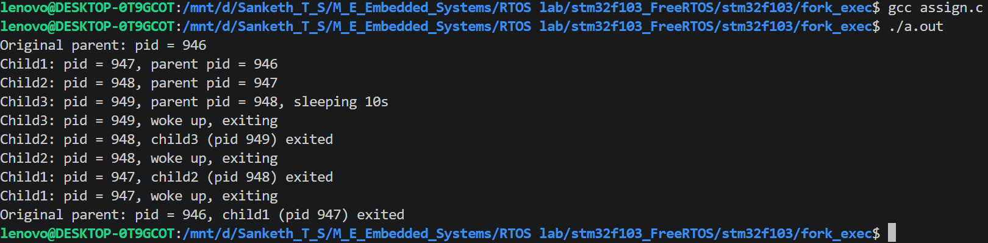

Fork_exec
#include <stdio.h>
#include <unistd.h>

int main() {
printf("exec_prog: pid = %d, starting count\n", getpid());
fflush(stdout);

for (int i = 1; i <= 10; i++) {
printf("%d\n", i);
fflush(stdout);
sleep(1);
}

return 0;
}

#include <stdio.h>
#include <unistd.h>
#include <sys/wait.h>

int main() {
printf("fork_exec: parent pid = %d\n", getpid());
fflush(stdout);

pid_t pid = fork();

if (pid < 0) {
perror("fork failed");
return 1;
} else if (pid == 0) {
printf("fork_exec: child pid = %d, about to exec\n", getpid());
fflush(stdout);

execl("./exec_prog", "exec_prog", NULL);

perror("execl failed");
return 1;
} else {
int status;
waitpid(pid, &status, 0);
printf("fork_exec: child (pid %d) exited\n", pid);
}

return 0;
}


