Customer Retention
Intelligence
  - Telecom Customer Churn
Analytics and Prediction
Abhay Pratap Singh
IBM Data Analytics Internship Final Project

2 Executive Summary
This project examines telecom customer churn using 7,043 customer records. Of these, 1,869 are labeled as churned, an observed churn rate of 26.54%. Data understanding, cleaning, exploratory analysis, KPI calculation, and segment comparisons lead to an interpretable Logistic Regression model and recommendations for retention pilots.
Observed churn is 42.71% for month-to-month contracts, 47.44% for customers with tenure of 0–12 months, and 53.73% for the overlapping electronic-check and month-to-month segment. These differences identify audiences for investigation, but do not establish causes.
On 1,409 held-out customers, the model achieves 80.62% accuracy, 65.93% precision, 55.88% recall, 0.6049 F1-score, and 0.8422 ROC-AUC. The majority-class baseline accuracy is 73.46%. At predicted churn probability ≥ 0.50, 317 of the 1,409 held-out customers are classified as high risk. Recommendations focus on testing onboarding, contract offers, support, billing assistance, and targeted outreach through controlled pilots.

3 Introduction
Customer churn is the departure of a customer from a service provider. In this project, churn is represented by the recorded Yes or No outcome. Understanding its distribution across customer groups can help a telecom business decide where to investigate service friction and how to allocate a limited retention budget.
Analytics contributes two complementary views: descriptive comparisons show where churn is concentrated, while the classifier ranks customers by modeled churn probability. Neither view measures the effect of a retention intervention. That effect must be learned through an appropriately designed pilot.

4 Problem Statement
The project aims to understand churn patterns, identify churn-associated segments and risk or opportunity areas, build an interpretable classification model, and translate the findings into actionable recommendations. Its scope is the supplied customer snapshot, rather than a dated forecast or an operational campaign.

5 Project Objectives
- Clean and understand the customer dataset, then calculate meaningful KPIs.
- Analyze churn patterns and identify associated customer characteristics.
- Build and evaluate Logistic Regression against a majority-class baseline.
- Identify high-risk held-out customers and propose measurable retention actions.

6 Dataset Description
The Telco Customer Churn dataset is available from the Kaggle source listed in Reference 1. The project does not claim ownership. Each row represents one customer, with demographics, services, contracts, billing, tenure, and charges. Currency remains unspecified.
Dataset attribute | Observed value
Customer records | 7,043
Original columns | 21
Target variable | Churn: Yes or No
Identifier | customerID
Churned customers | 1,869
Observed churn rate | 26.54%
Blank TotalCharges values | 11
Duplicate rows / duplicate IDs | 0 / 0

All blank TotalCharges values occur at zero tenure. They are treated as zero under the explicit assumption that accumulated charges have not yet been recorded. The data does not contain dates defining a prediction horizon, campaign costs, intervention outcomes, or a direct customer reason-for-churn field.

7 Tools and Technologies
Python and Jupyter Notebook provide the analysis environment. pandas and NumPy support preparation and calculations; Matplotlib and seaborn produce the charts; scikit-learn provides the preprocessing pipeline, Logistic Regression, baseline classifier, and evaluation metrics. The notebook records the package versions used in its execution.

8 Methodology
Data Understanding → Data Cleaning → Exploratory Data Analysis → KPI Analysis → Churn Driver Analysis → Data Preprocessing → Logistic Regression → Evaluation → Risk Analysis → Business Recommendations
The dataset is split into 80% training and 20% testing using stratification on churn and random_state = 42. This produces 5,634 training customers and 1,409 held-out test customers. Churn = Yes is encoded as 1 and treated as the positive class.
A scikit-learn pipeline standardizes the three numerical predictors and one-hot encodes the 16 categorical predictors. It learns scaler statistics and categories only from training data. customerID is retained for traceability, but excluded from predictors, as are the target and its derivatives. Original tenure is used in the model; tenure bands are used only for exploration.
Predictions use a fixed threshold of 0.50, including equality. The test set supports final evaluation and risk ranking; it is not used to tune parameters or the threshold. Descriptive analysis covers the full snapshot and is kept separate from predictive evaluation.

9 Data Cleaning and Preparation
The notebook preserves the raw data and works on a copy. Text fields are stripped of surrounding whitespace. TotalCharges is converted to numeric, making its whitespace-only entries explicit missing values. The 11 missing values are filled with zero only where tenure equals zero; unexpected non-numeric text or missing charges at positive tenure would raise a validation error.
Duplicate rows and duplicate customer IDs are checked, with none found. Service availability is checked against related categories. Labels such as No internet service and No phone service are retained, and SeniorCitizen is treated as a category. Churn is mapped to a binary target. All 7,043 customers are retained; no valid extreme-charge observations are removed.

10 Key Performance Indicators
KPI | Value | Population
Total Customers | 7,043 | Full dataset
Observed Churn Rate | 26.54% | Full dataset
Average Monthly Charges | 64.76 | Full dataset; currency unspecified
Average Tenure | 32.37 months | Full dataset
High-Risk Customers in Held-Out Test Set | 317 of 1,409 | Held-out test set only

317 of the 1,409 held-out customers were classified as high risk at predicted churn probability ≥ 0.50. This count does not describe all 7,043 customers and is not extrapolated to the full dataset. The observed churn rate is a snapshot measure, not a monthly or annual churn estimate.

11 Exploratory Data Analysis
Observed customer segment | Customers | Churn rate
Month-to-month contract | 3,875 | 42.71%
Tenure 0–12 months | 2,186 | 47.44%
Electronic check and month-to-month | 1,850 | 53.73%

Each rate uses the customers in that segment as its denominator. The combined payment-and-contract segment overlaps other groups, so its customer count cannot be added to their counts. These are observed associations, not causal effects. Customer selection and related attributes may explain part of the differences.

12 Visual Analysis
Figures 1–7 are original chart outputs from the executed notebook. Segment comparisons describe observed outcomes; model figures describe the held-out test set.
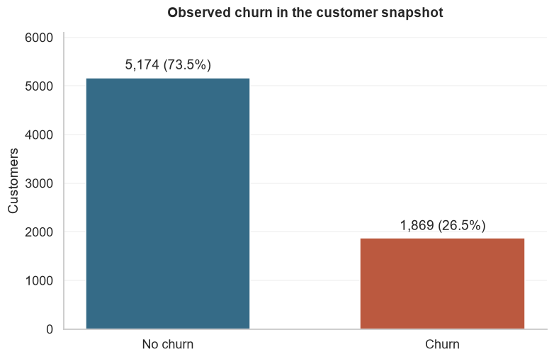
Figure 1. Observed churn distribution in the full customer snapshot
The 1,869 churned customers form the minority class. The larger non-churn group makes a majority-class baseline important when interpreting accuracy.
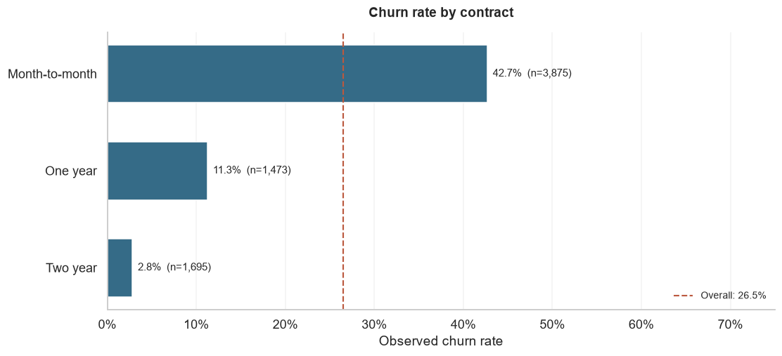
Figure 2. Observed churn rate by contract type
Month-to-month churn is 42.71%, compared with 11.27% for one-year and 2.83% for two-year contracts. These differences support testing optional offers, not assuming that contract changes prevent churn.

Customer tenure and monthly charges
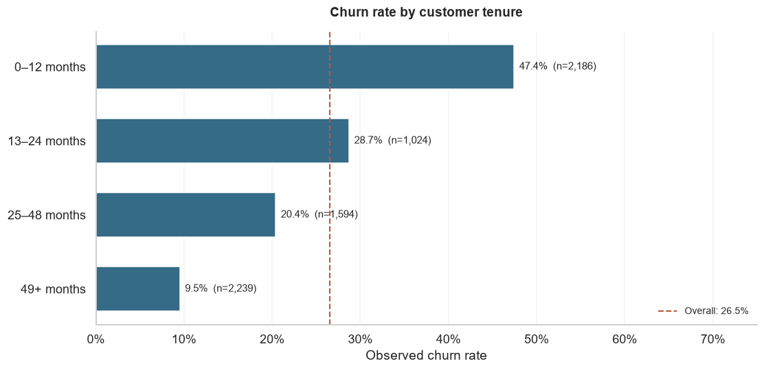
Figure 3. Observed churn rate across tenure groups
The 0–12 month group has 47.44% churn, compared with 9.51% in the 49+ month group. These are cross-sectional groups rather than a tracked cohort or survival estimate.
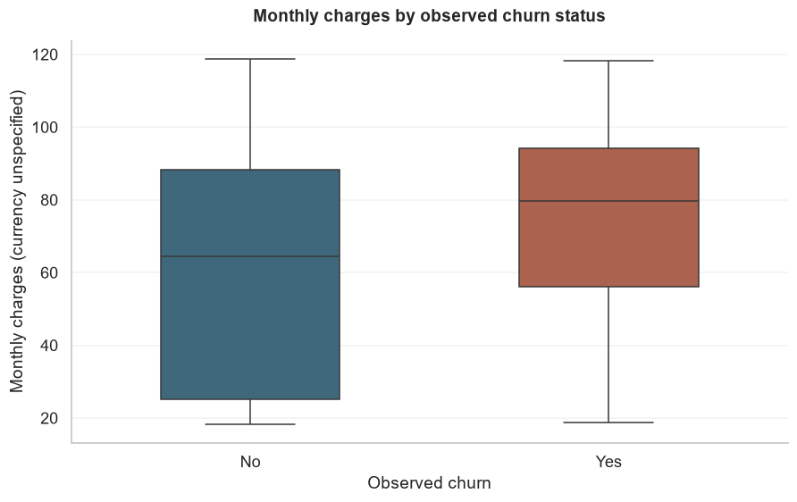
Figure 4. Distribution of monthly charges by observed churn status
Mean monthly charges are 74.44 for churned customers and 61.27 for non-churned customers. Service mix and customer characteristics may contribute to the difference. Currency is unspecified.

Service and payment comparisons
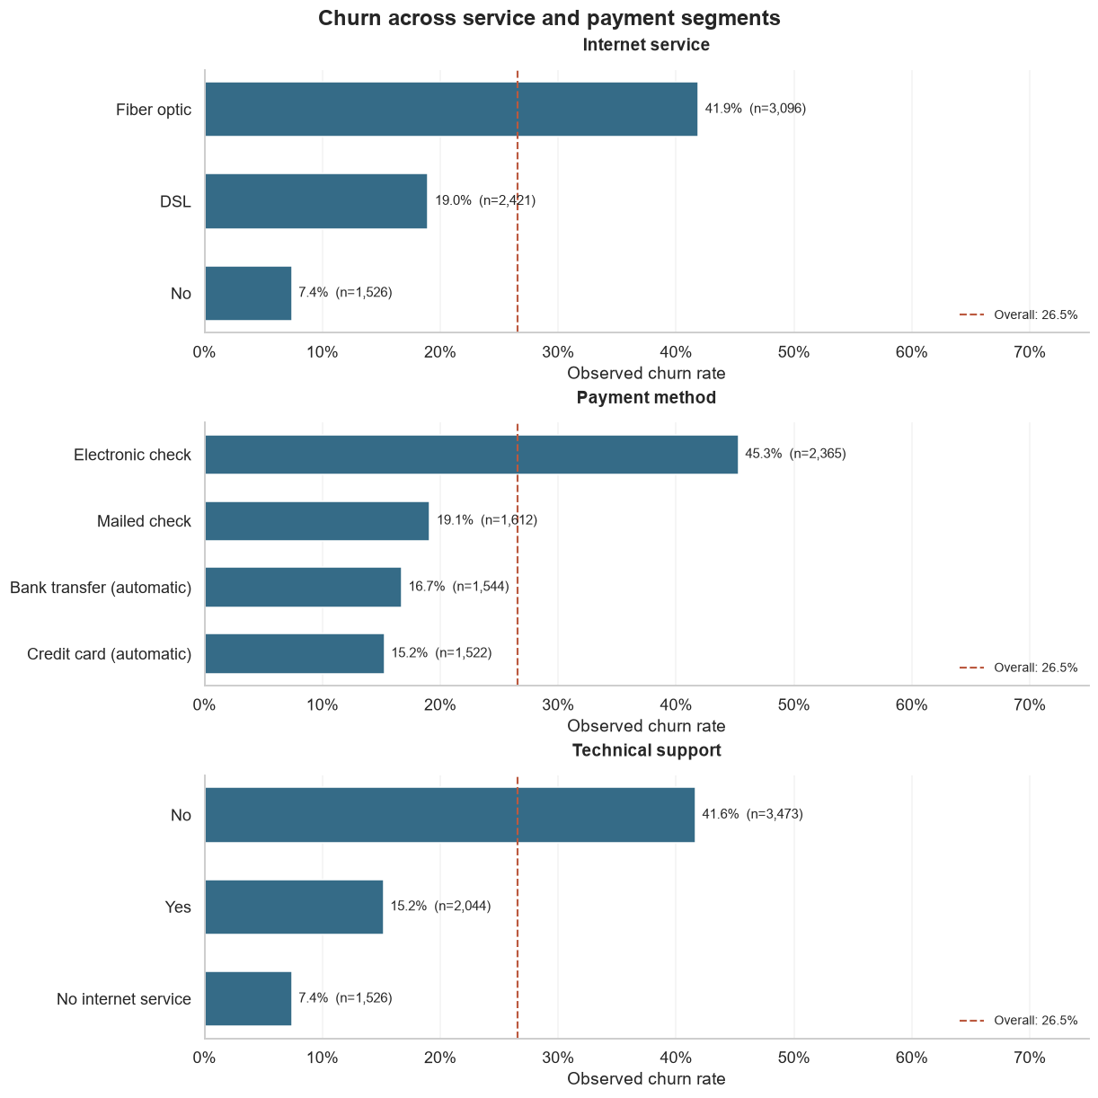
Figure 5. Observed churn across internet service payment and support categories
Fiber optic customers have 41.89% churn and electronic-check customers have 45.29% churn. Customers without technical support have 41.64% churn versus 15.17% among those with support. These categories may share customer characteristics.
The panels identify questions for operational investigation: whether customers experience unresolved service problems, whether billing creates friction, and whether access to support meets their needs. Complaint and service-quality data would be needed to choose and evaluate a specific intervention.

13 Machine Learning Model
Logistic Regression matches the binary target and returns a probability estimate for churn. It provides an interpretable starting point at an appropriate level of complexity for this project. Its coefficients describe conditional associations and can be discussed alongside the segment analysis.
The fitted model uses regularization with C = 1.0, the lbfgs solver, and a maximum of 2,000 iterations. It converged in 40 iterations. No class weighting or resampling is applied. One reference category per categorical predictor is omitted during encoding. Standardized numerical predictors retain their original continuous information.
The model is linear in log-odds and may miss nonlinear relationships or interactions. Related service indicators and charge variables can share explanatory information. Coefficients are not evidence that changing a feature will change churn, and estimated probabilities have not been assessed for calibration.

14 Model Evaluation
All results below use the same 1,409 held-out customers. Accuracy, precision, recall, and F1-score use the 0.50 threshold with Yes as the positive class. ROC-AUC is calculated from predicted probabilities across thresholds.
Metric | Logistic Regression | Majority baseline
Accuracy | 80.62% | 73.46%
Precision | 65.93% | 0.00%
Recall | 55.88% | 0.00%
F1-score | 0.6049 | 0.0000
ROC-AUC | 0.8422 | 0.5000

The baseline always predicts the training majority class. It identifies no churners; precision is reported as zero by convention when no positive predictions are made. Its accuracy demonstrates why accuracy alone is insufficient for this imbalanced problem.
Logistic Regression improves on baseline accuracy and its 0.8422 ROC-AUC indicates useful ranking discrimination within this dataset. Precision of 65.93% means many flagged customers did churn, but some did not. Recall of 55.88% is moderate: the model identifies 209 churners while missing 165.
A false negative is a customer who actually churned but was predicted not to churn. A false positive is a customer who did not churn but was predicted to churn. These imply missed cases and potentially unnecessary contact, respectively. Their relative business costs are unknown, so the specified threshold is not described as cost-optimal.

Held-out classification and ranking
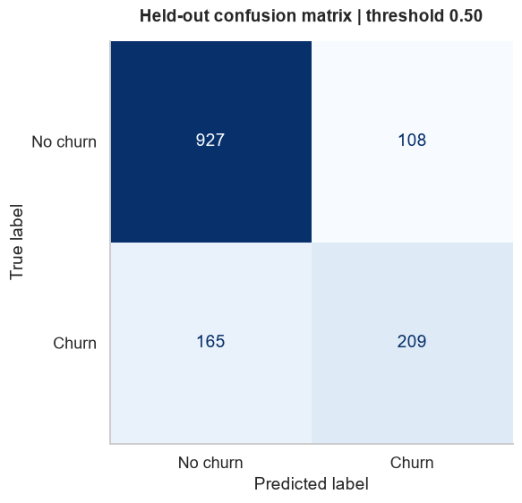
Figure 6. Confusion matrix at predicted churn probability threshold 0.50
True negatives = 927; false positives = 108; false negatives = 165; true positives = 209. Rows show actual outcomes and columns show predictions.
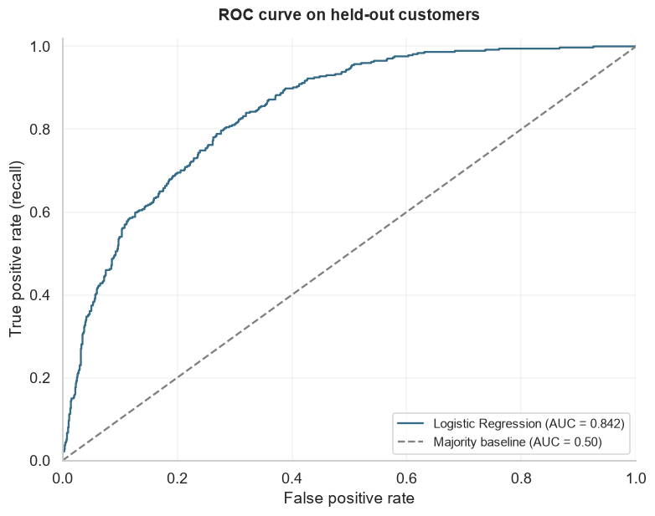
Figure 7. ROC curve for the held-out test customers
ROC-AUC is 0.8422, compared with 0.5000 for constant baseline scores. Ranking discrimination does not establish calibrated probabilities or campaign effectiveness.

15 Churn Driver and Coefficient Analysis
The largest negative model associations include two-year contracts and tenure; fiber optic service has the largest positive coefficient among the displayed predictors. The table preserves the notebook’s coefficients rounded to three decimals. Positive coefficients indicate higher modeled churn log-odds and negative coefficients indicate lower log-odds, conditional on other included predictors.
Predictor | Coefficient | Comparison or unit
Two-year contract | -1.314 | Versus month-to-month
Tenure | -1.257 | One training standard deviation
Fiber optic service | 1.181 | Versus DSL
One-year contract | -0.684 | Versus month-to-month
TotalCharges | 0.528 | One training standard deviation
Electronic check | 0.393 | Versus automatic bank transfer
MonthlyCharges | -0.467 | One training standard deviation

The conditional MonthlyCharges coefficient is negative even though churned customers have higher mean monthly charges in the descriptive comparison. These answer different questions. Tenure, accumulated charges, and service choices are related; the tenure–TotalCharges correlation is 0.826. Coefficients should be interpreted together rather than as isolated causes or a universal importance ranking.

16 Risk and Opportunity Analysis
Overlapping customer segment | Customers | Observed churn
Early tenure and month-to-month | 1,994 | 51.35%
Fiber optic with no technical support | 2,230 | 49.37%
Electronic check and month-to-month | 1,850 | 53.73%

These descriptive groups suggest opportunities for onboarding, optional contract offers, support access, and billing assistance. They overlap and must not be summed. Their rates alone do not establish which customers would respond to an intervention.
Predictive risk is separate: 317 of 1,409 held-out customers meet the probability threshold of 0.50, including 209 observed churners and 108 non-churners. A further 165 actual churners fall below the threshold. This is a retrospective ranking, not a list of current eligible prospects. Future outreach needs a current customer cohort and a defined follow-up period.

17 Business Recommendations
The following five actions should be tested through controlled retention pilots. Compare outcomes with a suitable control group, define the follow-up period before launch, and track contact or incentive costs. No guaranteed reduction in churn is inferred from the associations.

Early-tenure onboarding
Finding: Customers with 0–12 months of tenure have 47.44% observed churn.
Proposed action: Test an enhanced onboarding and support programme with early service check-ins.
Suggested measurement: Compare retention between pilot and control groups over a predefined follow-up period.

Optional contract offers
Finding: Month-to-month customers have 42.71% observed churn.
Proposed action: Test voluntary contract-conversion offers for suitable customers, with clear terms and without assuming the contract itself prevents churn.
Suggested measurement: Track incremental retention, offer uptake, and incentive cost per additional retained customer.

Service experience and support
Finding: Fiber optic customers have 41.89% observed churn; the fiber-optic group without technical support has 49.37%.
Proposed action: Investigate complaints and service quality, then test assistance addressing the issues identified.
Suggested measurement: Track issue resolution and subsequent retention against a comparable untreated group.

Billing and payment assistance
Finding: Electronic-check customers have 45.29% observed churn, rising to 53.73% in the month-to-month overlap.
Proposed action: Review billing friction and test clearer communication and optional payment assistance.
Suggested measurement: Compare billing complaints, failed payments, and incremental retention between pilot and control groups.

Validate targeted outreach
Finding: 317 of 1,409 held-out customers are flagged at probability ≥ 0.50, with 65.93% precision and 55.88% recall.
Proposed action: Validate risk-ranked outreach on current eligible customers, with capacity limits and monitoring for missed churners.
Suggested measurement: Track incremental retained customers, contact costs, opt-outs, and outcomes across customer groups.

18 Limitations
- Observational data cannot establish causation; associations may reflect customer selection and unmeasured factors.
- There are no dates defining a temporal prediction horizon. A random holdout does not establish performance on future customers, and availability of features at a real scoring date is unverified.
- Logistic Regression may miss nonlinear relationships, and correlated predictors complicate coefficient interpretation.
- Recall is moderate, so some churners are missed at the fixed 0.50 threshold. Probabilities are not assessed for calibration and the threshold is not optimized for campaign costs.
- Evaluation uses one held-out split, without confidence intervals, external validation, or a subgroup performance audit.
- The dataset lacks campaign costs, margins, intervention outcomes, and a direct customer reason-for-churn variable. Savings and return on investment cannot be established.
- Zero replaces blank TotalCharges values only at zero tenure under a documented assumption. Billing records would be needed to confirm it.

19 Conclusion
The analysis identifies elevated observed churn among early-tenure and month-to-month customers, including an electronic-check overlap with 53.73% churn. Logistic Regression improves on majority-baseline accuracy and provides useful ranking discrimination, with 0.8422 ROC-AUC, while its 55.88% recall leaves meaningful gaps. The business value lies in turning these findings into measured pilots and learning which actions improve retention, rather than treating associations as intervention effects.

20 Future Scope
Reasonable extensions include cross-validation to assess stability; threshold tuning on training-only validation data using business costs; comparison with tree-based models; carefully validated feature engineering; probability calibration; retention-experiment tracking; and monitoring on later customer cohorts. These are future extensions, not implemented results. Operational use would also require fairness review and verification of feature availability at scoring time.

21 References
1. Telco Customer Churn. Kaggle dataset source. The dataset is attributed to this source; ownership is not claimed by this project.
https://www.kaggle.com/datasets/blastchar/telco-customer-churn
2. Abhay Pratap Singh. AbhayPratapSingh_CustomerChurnAnalytics.ipynb. Executed project notebook containing the calculations, model results, original figures, and reproducibility checks.

