PII Redaction Tool: Evaluation Report
Scaler AI Labs assignment. Evaluation strategy, metrics and error analysis for the run that produced output/redacted.docx from the Red Herring Prospectus (KSH International Limited).

1. Summary
- Held-out prospectus test: entity precision 0.978, recall 0.978, F1 0.978; token-level accuracy 0.996 (45 gold PII spans in 65 paragraphs).
- Development prospectus sample: precision 1.000, recall 0.965, F1 0.982 (86 spans). No tuning was done on the test set, so its numbers are the ones to trust.
- Synthetic held-out test (SSN, cards, DOB, IPs and the other types the prospectus lacks): precision 0.978, recall 0.915, F1 0.945.
- Ablation: on the prospectus test set regex-only reaches F1 0.722 and raw NER F1 0.493 (precision only 0.349). The curated hybrid is what makes both precision and recall high.
- Images: the prospectus embeds a PAN card and an Aadhaar card as photographs. OCR-based redaction covers all 9 text fields OCR could read on them, pixelates both faces and blanks both QR codes (section 3.5).
- End to end: 1 of 44 test PII strings survive in the output file; 0 inconsistent replacements out of 849; format preserved for 164/164 phones/emails/IDs; runtime 22.9 s for 126 pages.

2. Evaluation strategy

2.1 What counts as PII (decided before measuring)
Precision is only meaningful if the boundary of 'PII' is explicit, so the policy is fixed up front and used identically by the tool and by the annotation:
- Redacted: names of individuals; email addresses; phone numbers; websites of organisations; postal addresses; private companies, LLPs, trusts and banks (including the issuer and its short brand forms); SSNs; credit cards; dates of birth; IP addresses; identifiers such as CIN, PAN, GSTIN, Aadhaar, SEBI registration numbers.
- Kept on purpose: regulators, exchanges, depositories and government bodies (SEBI, BSE, NSE, RoC, MCA, pollution control boards); defined terms ('the Company', 'BRLMs'); statutes; ordinary dates (the prospectus date, agreement dates); money amounts; page and section numbers; order, ticket, invoice and tracking numbers (not personal data).
- Borderline, decided explicitly: a bare 10-digit number is treated as a phone number only if it starts with 6-9 and does not follow order/ticket/invoice/reference words; a 4-octet number after 'firmware/version/build' is a version, not an IP; a date is a DOB only next to a birth cue ('DOB', 'born', 'date of birth').

2.2 Datasets
Set | What | Size | Role
Prospectus dev | 70 paragraphs sampled from the prospectus (seed 7), hand annotated | 86 spans | Used while building the tool
Prospectus test | 65 further paragraphs (seed 99, disjoint from dev), hand annotated before the tool ever saw them | 45 spans | Held out: run once for the final numbers
Synthetic dev | Ticket-style sentences built from Faker values, with look-alike non-PII | 480 spans | Used while building
Synthetic test | Same generator, new seed (4242) | 480 spans | Held out

Why two kinds of data. The prospectus contains no SSNs, credit cards, dates of birth or IP addresses, so recall for those types cannot be measured on it. The synthetic sets fill that gap and also contain deliberate traps: 16-digit tracking numbers that fail the Luhn check, 10-digit order IDs, firmware version strings shaped like IPs, ordinary dates, ticket numbers and amounts. Faker generates the values independently of the detectors, so the test is not circular.
How the prospectus sample was drawn. Stratum A (about 60%) is paragraphs matching a keyword heuristic for contact and entity details (email, Limited, LLP, Contact Person, Office, Trust ...); stratum B is uniformly random. Without stratum A most paragraphs are prose with no PII and recall would be meaningless. Annotation is by exact substring: a string listed as PII is PII at every place it occurs in that paragraph.

2.3 Metrics
- Entity level (primary): a predicted span is a true positive if its type matches and it overlaps a gold span with IoU >= 0.5 (relaxed) or exactly (strict). Precision = TP/(TP+FP), recall = TP/(TP+FN), F1 = harmonic mean. Reported per type and micro-averaged.
- Token level: every whitespace token is PII or not, label-agnostic (was sensitive text replaced?). Accuracy = (TP+TN)/all tokens, plus precision, recall and F1. Accuracy is high by construction because most tokens are not PII, so it is reported alongside precision/recall and not on its own.
- Leak rate: share of gold PII strings still present in the redacted .docx (checks body, tables, headers, hidden field codes).
- Fake quality: same real value always maps to the same fake; format preserved (phone digit count, valid email syntax, ID length); no replacement identical to its original.

2.4 System variants (ablation)
- Regex only: patterns, checksums, address and legal-suffix company rules; no model.
- Raw NER + regex: spaCy PERSON/ORG spans taken as-is on top of the patterns.
- Hybrid: the delivered tool. NER only proposes names; proposals must pass vocabulary, place, acronym and name-list checks, then a document-wide lexicon finds every other mention (including ALL-CAPS).

3. Results

3.1 Headline: held-out prospectus test
Metric | Relaxed match | Strict match
Precision | 0.978 | 0.978
Recall | 0.978 | 0.978
F1 | 0.978 | 0.978
Token accuracy | 0.996 | -
Token precision / recall / F1 | 0.994 / 0.973 / 0.983 | -

3.2 Ablation
Set | System | Precision | Recall | F1 | Token acc.
Prospectus dev | Regex only | 1.000 | 0.558 | 0.716 | 0.933
 | Raw spaCy NER + regex | 0.441 | 0.698 | 0.540 | 0.870
 | Hybrid (this tool) | 1.000 | 0.965 | 0.982 | 0.986
Prospectus test | Regex only | 0.963 | 0.578 | 0.722 | 0.958
 | Raw spaCy NER + regex | 0.349 | 0.844 | 0.493 | 0.872
 | Hybrid (this tool) | 0.978 | 0.978 | 0.978 | 0.996
Synthetic dev | Regex only | 1.000 | 0.777 | 0.875 | 0.921
 | Raw spaCy NER + regex | 0.744 | 0.900 | 0.814 | 0.928
 | Hybrid (this tool) | 0.980 | 0.919 | 0.948 | 0.965
Synthetic test | Regex only | 1.000 | 0.775 | 0.873 | 0.926
 | Raw spaCy NER + regex | 0.737 | 0.908 | 0.813 | 0.924
 | Hybrid (this tool) | 0.978 | 0.915 | 0.945 | 0.970

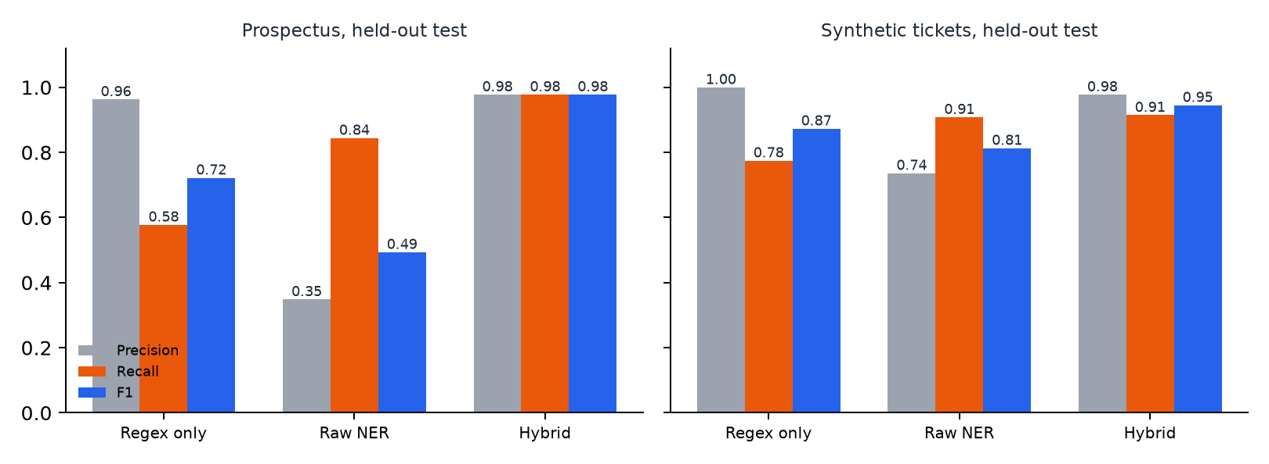
Raw NER finds most names but also flags 'Offer', 'Promoters', 'UPI', 'Bandra Kurla Complex' and similar as people or organisations, so its precision collapses on a legal/financial document. Regex alone is precise but cannot find a name or a company without a legal suffix. The hybrid keeps NER's recall and removes its false positives.

3.3 Per PII type (hybrid, relaxed match)
Type | n | P | R | F1 | n | P | R | F1
ADDRESS | 14 | 1.000 | 0.786 | 0.880 | 24 | 1.000 | 0.958 | 0.979
CREDIT_CARD | - | - | - | - | 24 | 1.000 | 1.000 | 1.000
DOB | - | - | - | - | 72 | 1.000 | 1.000 | 1.000
EMAIL | 13 | 1.000 | 1.000 | 1.000 | 48 | 1.000 | 1.000 | 1.000
ID_NUMBER | 6 | 1.000 | 1.000 | 1.000 | - | - | - | -
IP_ADDRESS | - | - | - | - | 72 | 1.000 | 1.000 | 1.000
ORG | 41 | 1.000 | 0.976 | 0.988 | 48 | 0.809 | 0.354 | 0.493
PERSON | 39 | 1.000 | 1.000 | 1.000 | 72 | 0.918 | 0.931 | 0.924
PHONE | 11 | 1.000 | 1.000 | 1.000 | 72 | 1.000 | 0.944 | 0.971
SSN | - | - | - | - | 48 | 1.000 | 1.000 | 1.000
URL | 7 | 0.875 | 1.000 | 0.933 | - | - | - | -

Columns 2-5: prospectus, dev and test pooled. Columns 6-9: synthetic held-out test. '-' means the type does not occur in that set.
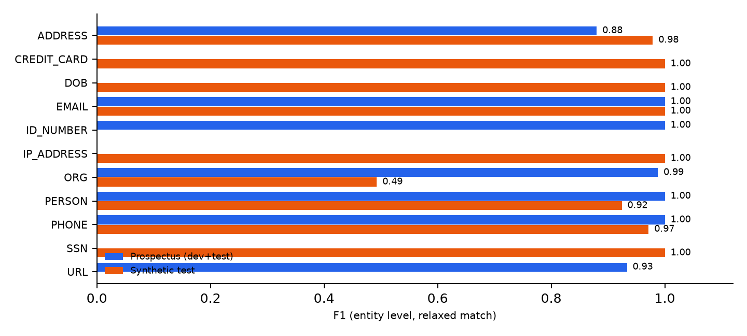
Names the tool has never been given: the name list is built from Faker's en_US/en_IN/en_GB locales plus a small Indian list. PERSON recall on synthetic names from those locales is 0.979 (n=48); on German, French, Spanish, Polish and Dutch names it is 0.833 (n=24). Those are caught through context cues ('this is X', 'Regards, X', 'Contact Person: X'); a foreign name with no cue and not in the list would be missed.

3.4 Checks on the redacted file
Check | Result
Gold PII strings still present (prospectus dev) | 3 / 86 (leak rate 0.035)
Gold PII strings still present (prospectus test) | 1 / 44 (leak rate 0.023)
Values replaced in the whole document | 849 ORG 271, PERSON 216, URL 107, EMAIL 104, ADDRESS 54, LOCALITY 37, PHONE 36, ID_NUMBER 24
Same original mapped to different fakes | 0
Replacement identical to original | 0
Format preserved (phones, emails, IDs) | 164/164
Structure vs. source (paragraphs, tables, rows, runs, drawings, sections) | identical counts; same package parts; opens in Word without repair
Hidden hyperlink field codes | 105 HYPERLINK mailto: codes redacted (they carry the real email even when the visible text is changed)
Runtime | 22.9 s for the 126-page document

3.5 Pictures inside the document
The prospectus contains 8 embedded images, including two identity-card photographs (a PAN card and an Aadhaar card) that carry names, father's names, dates of birth, ID numbers, an address, photos, QR codes and a handwritten signature. None of that is text, so the text pipeline cannot see it. Images are handled separately: OCR (RapidOCR) reads each picture, the same detectors plus ID-card layout rules find PII in the OCR text, matching regions are covered with black boxes, faces are pixelated, QR codes are blanked, and the document's hidden page-one thumbnail is removed. A photograph cannot be given a believable fake value the way text can, so blanking is used instead of replacement.
Card | Field | OCR-readable before | OCR-readable after
image4.png | PAN number | yes | no
image4.png | Name | yes | no
image4.png | Father's name | yes | no
image4.png | Date of birth | yes | no
image5.png | Name | yes | no
image5.png | Father's name | yes | no
image5.png | Date of birth | yes | no
image5.png | Aadhaar number (front) | yes | no
image5.png | Address (locality) | no | no
image5.png | Address (PIN) | yes | no

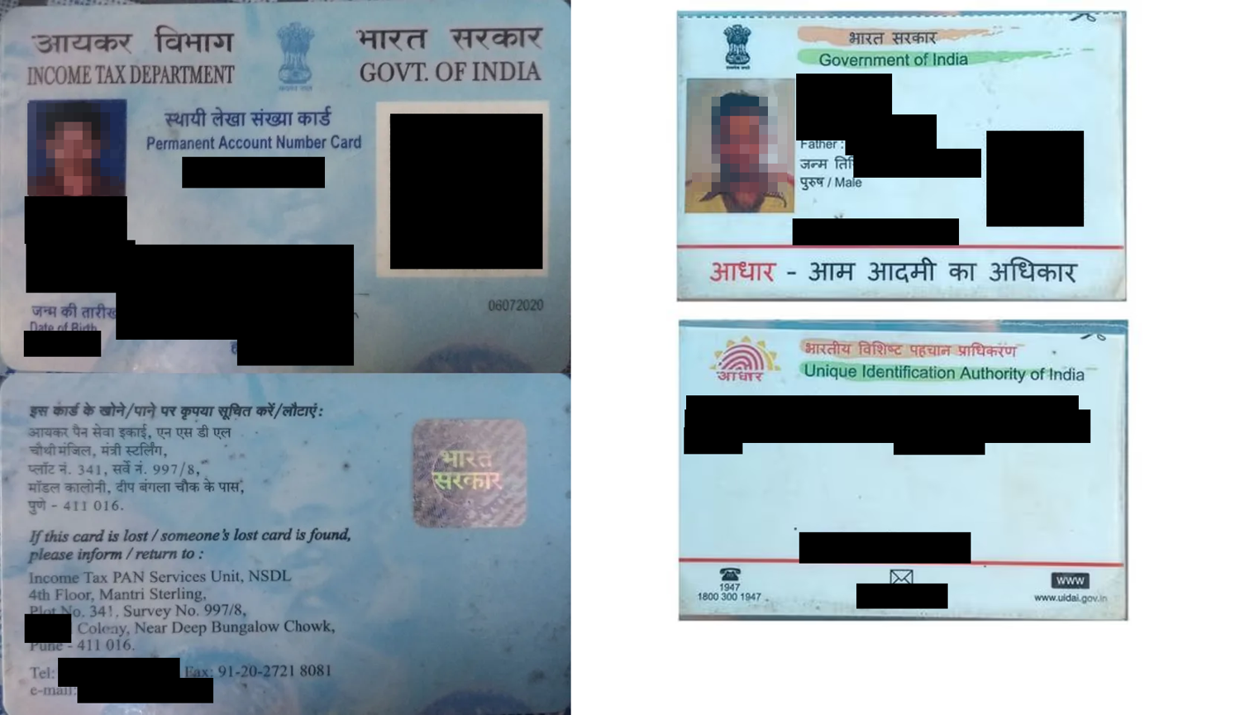
The two ID-card images as they appear in output/redacted.docx (only the redacted versions are shown here on purpose).
Result: 9 of 9 text fields that OCR could read in the originals can no longer be read after redaction; faces detected fell from 2 to 0. By eye, both QR codes, both photos and the PAN card's handwritten signature are covered. One field ('Address (locality)') was never readable by OCR in the original so it does not count in the score, although the address block is covered by layout rule.
Caveats: this is a proxy (machine readability, not a human reading a partly covered word); the ID rules were developed on these two cards, so the result is in-sample; OCR cannot read Devanagari or handwriting (the Hindi lines above each name are covered by position, not by reading them); a low-resolution photographed QR is found by a texture heuristic, not decoded; and the tax office's own printed address on the PAN card's back is partly covered too, which is over-redaction.

4. Error analysis
Every remaining error on the two prospectus sets, and the reason:
Set | Type | Label | String | Cause
dev | FN | ORG | Al-Ahleia Switchgear Co. | no rule fired
dev | FN | ADDRESS | Lodha I Think Techno Campus, O-3 Level | no rule fired
dev | FN | ADDRESS | 3rd Floor, 362, Satguru House Next to Tanishq Showroom, CTS No. 30 | no rule fired
test | FN | ADDRESS | Pune 411 045 Maharashtra, India | no rule fired
test | FP | URL | www.sebi.gov.in/sebiweb/other/OtherAction.do?doRecognisedFpi=yes&intmI | flagged but not PII under the policy

- Addresses without a PIN code ('Lodha I Think Techno Campus, O-3 Level', 'CTS No. 30') have no anchor for the address rule. A gazetteer of building/road words would raise recall at some precision cost.
- A split address whose PIN has no dash and no comma ('Pune 411 045 Maharashtra, India') is rejected on purpose: a bare 6-digit number after a word is too often a reference number.
- Company names without a legal suffix ('Al-Ahleia Switchgear Co.') are only found through suffix rules and the learned brand lexicon.
- Public-body URLs (the SEBI website) are flagged because the URL rule does not know which domains belong to regulators; the annotation policy says they are not PII.
Synthetic test errors by type: FN ADDRESS x1; FN ORG x31; FN PERSON x5; FN PHONE x4; FP ORG x4; FP PERSON x6. The dominant one is ORG false negatives: Faker's US company names are surname lists ('Medina, Roberts and Thomas') with no legal suffix, which the suffix-based rule cannot recognise. Others: 10-digit numbers without any cue, US military addresses (APO/FPO) without a comma before the state, and names with lower-case particles ('Evi de Jong').

5. Limitations of this evaluation
- The gold sets are small (about 130 prospectus spans). Confidence intervals are wide: one error moves recall by roughly 2 points.
- The annotator is the tool's author. The test set was annotated before the detector ran on it and not used for tuning, but a second annotator and an inter-annotator agreement score would be the next step.
- The tool learns its name/company lexicon from the whole document text before detecting (unsupervised, no labels are ever used), so the text of the test paragraphs is seen during that learning step; only the labels are held out. This mirrors real use, where the document being redacted is the document being read.
- Process note: after the first held-out run, five further fixes were made (a guard so no company name is ever left unchanged, splitting 'X Limited and Y Limited' into two companies, treating building-name words as localities only in address-like lines, 'Cash and Bank Balances' no longer read as a bank, and not creating empty header parts). They came from auditing the full list of replacements in the whole 126-page document, not from test-set errors, and the evaluation was re-run afterwards with the same numbers.
- The synthetic set is generated from templates, so it measures pattern coverage, not the variety of real tickets.
- The text metrics score the prospectus's text only. Images are evaluated separately in section 3.5, on two cards, in-sample.

6. Reproduce
python eval/make_sample.py; python eval/make_synthetic.py eval/synthetic.json 2026; python eval/make_synthetic.py eval/synthetic_test.json 4242; python eval/evaluate.py; python eval/build_report.py

