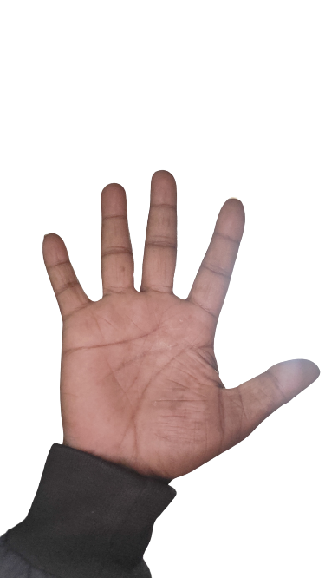

To Move the mouse

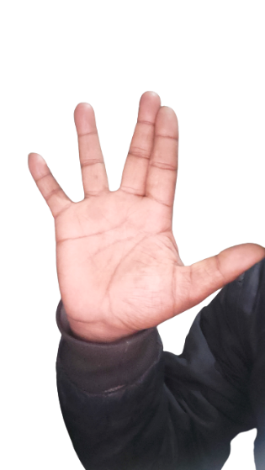

Left Click

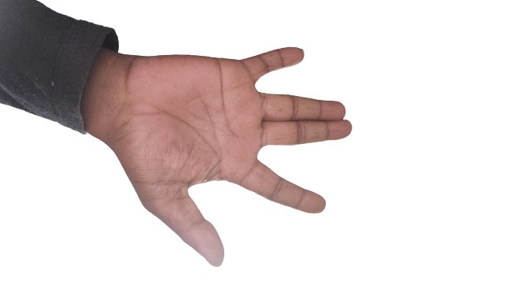

Right Click

Scroll Up

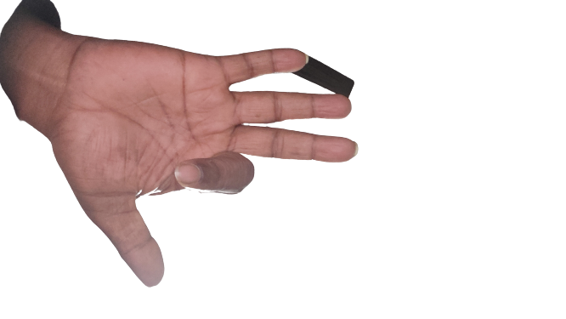

Scroll Down

Scroll Down

Move Left To decrease Volume

Move Right To increase Volume

Move Up To increase Brightness

Move Down To decrease Brightness

// Media Control

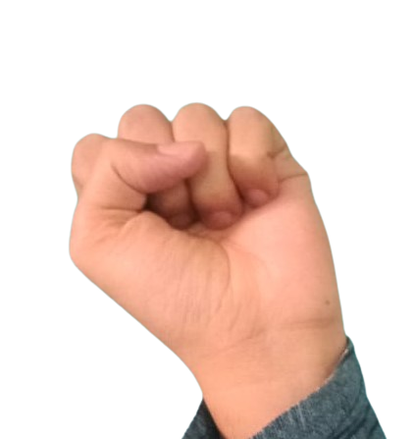

Starting Position

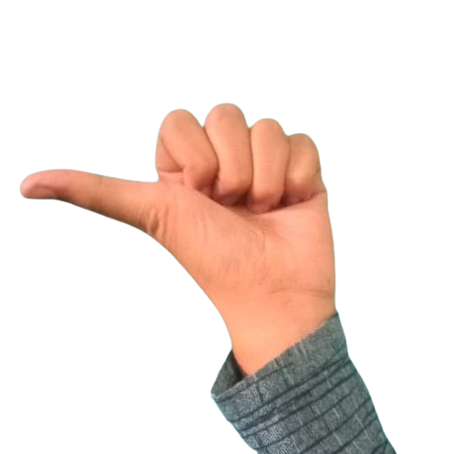

Backward few seconds

Forward few seconds

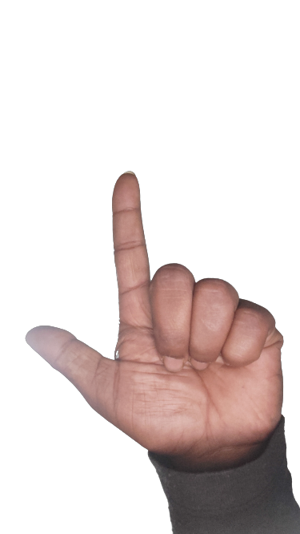



Play/Pause