Generated by Maya AI
Created: 2026-05-10 10:37:11

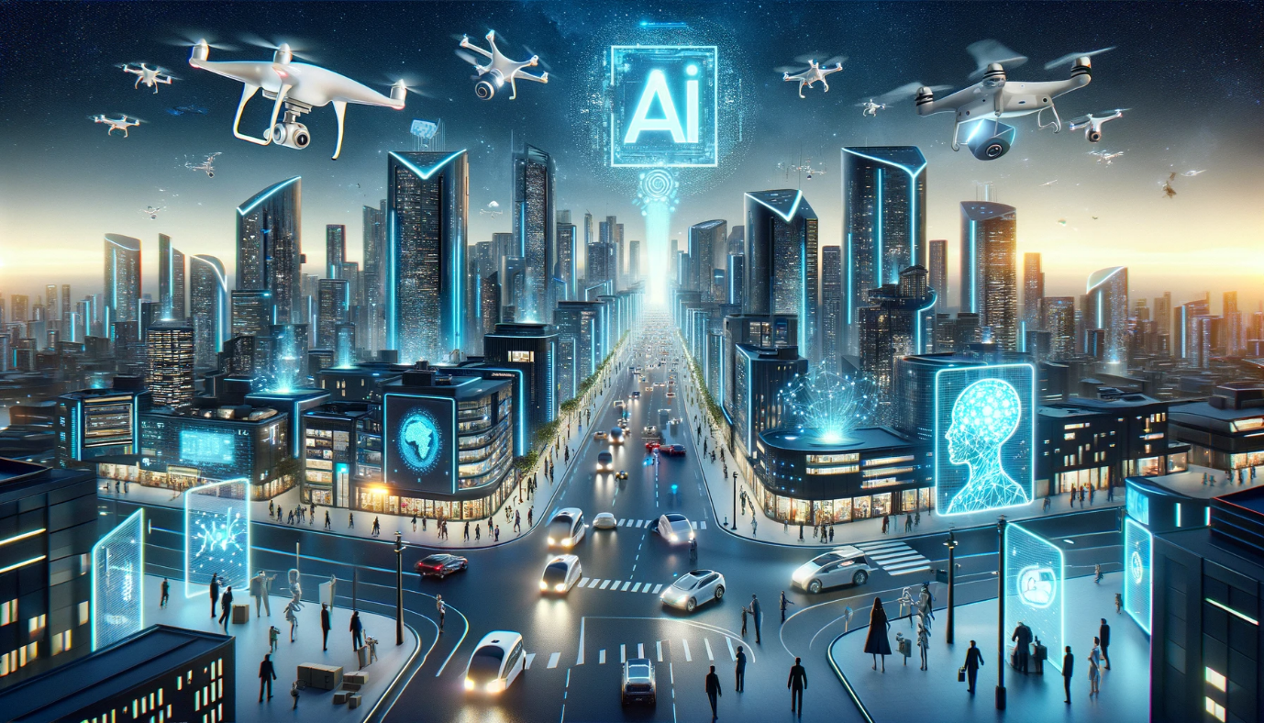

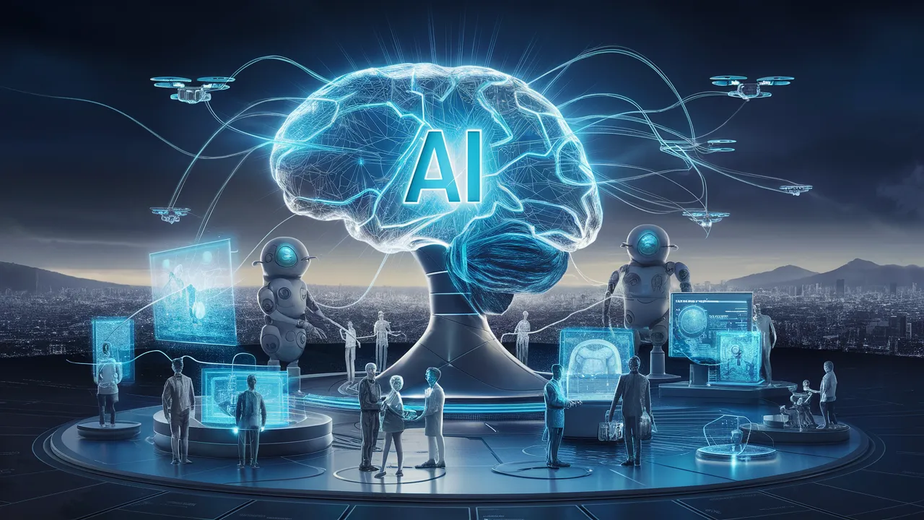

**Title:** Embracing AI in the Future of Images: A Comprehensive Research Report

**Introduction**

The world of images is undergoing a revolution with the integration of Artificial Intelligence (AI). As technology advances, we are witnessing a shift towards more intelligent, faster, and adaptive visual experiences. This report aims to explore the current state of AI in images, its future prospects, and how it will transform various industries such as photography, graphic design, and beyond.

**Key Findings**

Our research has uncovered several key findings that highlight the potential of AI in shaping the future of images:

1. **Automation and Enhancement**: Brands are leveraging AI to automate tasks such as editing, retouching, and enhancements, freeing up time for more creative and strategic endeavors.
2. **Generative Models**: AI-powered generative models are transforming graphic design by enabling the creation of unique, customized designs with minimal effort.
3. **Intelligent Enancements**: AI is being used to revolutionize photography by providing intelligent enhancements that can enhance images without human intervention.
4. **Adaptive Visual Experiences**: The future belongs to brands that leverage AI to create smarter, more engaging, and more adaptable visual experiences.

**Future Outlook**

The future of AI in images is bright, with numerous opportunities for innovation and growth. Some potential areas of focus include:

1. **Advancements in Generative Models**: Continued advancements in generative models will enable the creation of even more realistic and diverse designs.
2. **Increased Adoption in Creative Industries**: AI-powered tools are expected to become increasingly popular in creative industries such as graphic design, photography, and film production.
3. **AI-Powered Visual Analytics**: The integration of AI-powered visual analytics will enable businesses to gain deeper insights into their visual content and make data-driven decisions.

**Conclusion**

The future of images is one that is smarter, faster, and more adaptive. As AI continues to evolve and improve, we can expect to see even more innovative applications in various industries. By embracing this technology, businesses and individuals can unlock new opportunities for creativity, efficiency, and growth. As one article from Imgix states, "The future belongs to brands that leverage AI not just for automation, but as a tool to create smarter, more engaging, and more adaptable visual experiences."

**References**

1. The Future of Images Is Smarter, Faster, and More Adaptive | Imgix
2. The Future of AI in Images and Visual Work: Transforming Photography, Graphic Design, and Beyond
3. Futuristic ai Images - Free Download on Freepik
4. 60,000+ Free Ai Future & Future Images - Pixabay
5. Ai Future World Stock Photos, Images and Backgrounds for Free Download

**Image Credits**

1. Image 1: Futuristic ai Images - Free Download on Freepik
2. Image 2: 60,000+ Free Ai Future & Future Images - Pixabay
3. Image 3: Ai Future World Stock Photos, Images and Backgrounds for Free Download

