Gensights
Progress Documentation:
How project is set up?
- 2 repositories in the github is maintained for this project.
- One repo uses Django as backend and other repo uses fastapi as backend.
- Django repo handles overall webapp while fast api repo handles AI portion of project.
- Both repos are dockerized and networking is also already handled for easy running.
- There is docker compose file for running both the repos and communication between the repos are also handled through network.
- For Django repo uv is used for faster set up and dependencies on various frameworks, libraries are handled through pyproject.toml file
- For Fast api it is handled using pip.
- Virtual environments are also set up through docker.
- To avoid headache of large commands to run migrations in Django app, “just” command is also implemented. You can just type `just manage` to handle any Django commands.
Example: just manage makemigrations, just manage createsuperuser

The whole projects runs with single command, docker compose up –build.

- Organization registration:
- Register organization from Django admin panel, this can be shifted to frontend for managing organization by global it support.
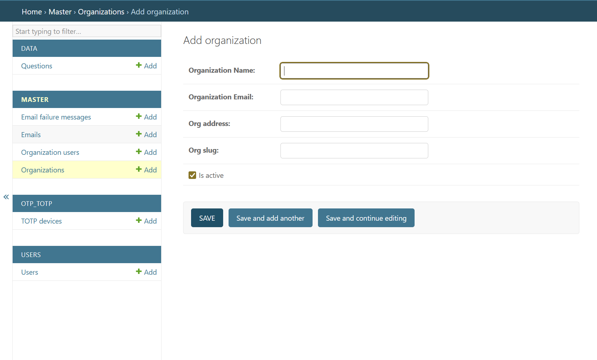

After registering the organization, slug for that organization will be, org_slug:gensights(Multitenancy) so every organization will have different url to view the webapp.

- Add user from Django admin panel as of now.
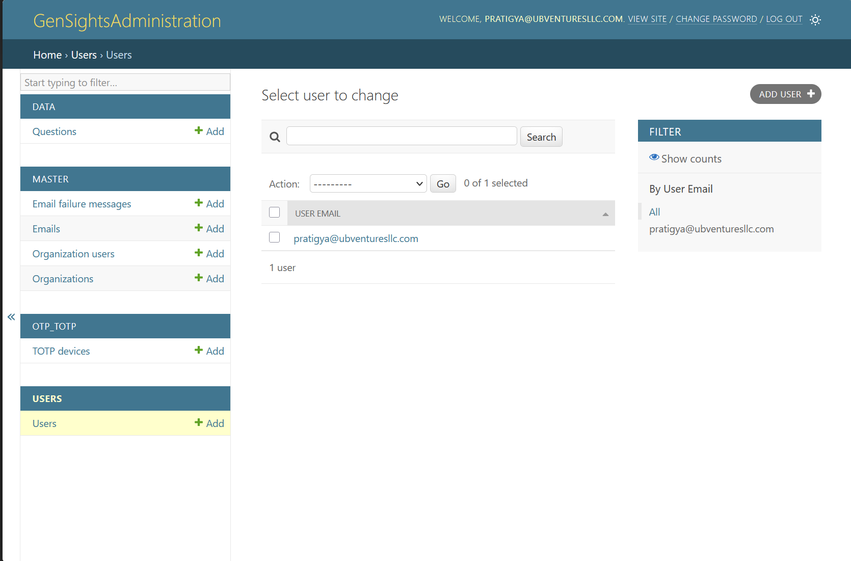

- Add user as organization user from Django admin panel so that user can login to that webapp.
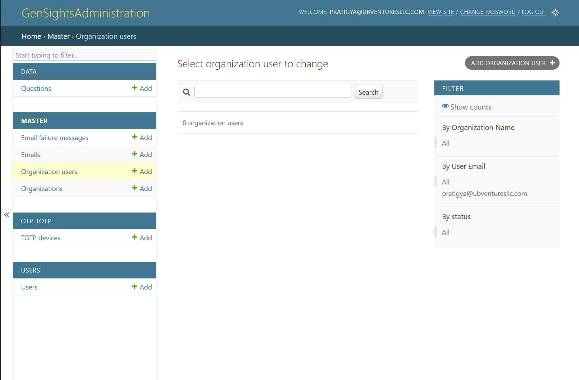
- Login flow:
MFA is implemented in the login flow.
- First time user logs in with the user id and password as registered from admin panel(Global IT Support)

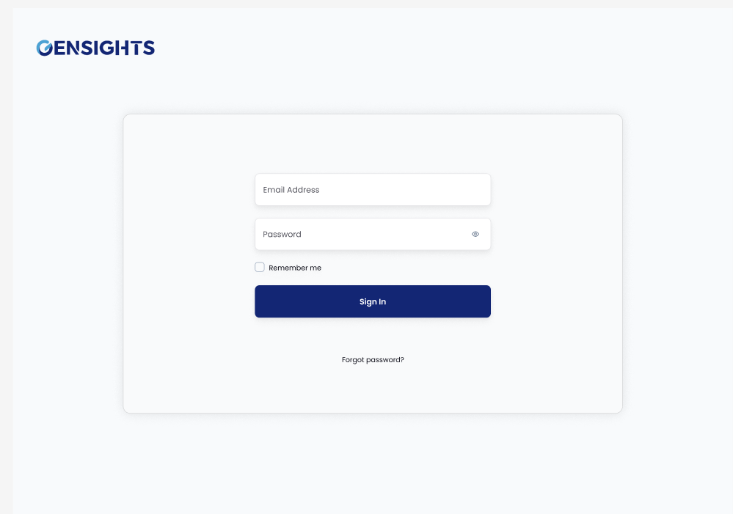

- Shows mfa set up ui with qr code, User scans the qr code with any authenticator app, otp code is refreshed in the authenticator app in every 30 seconds.

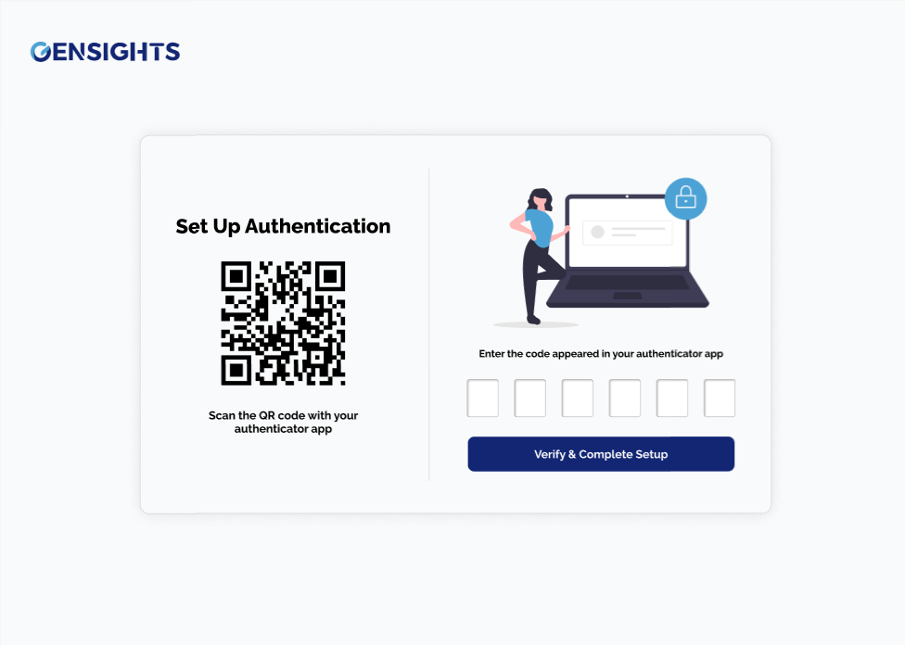
- User sets up the mfa and gets logged into dashboard.

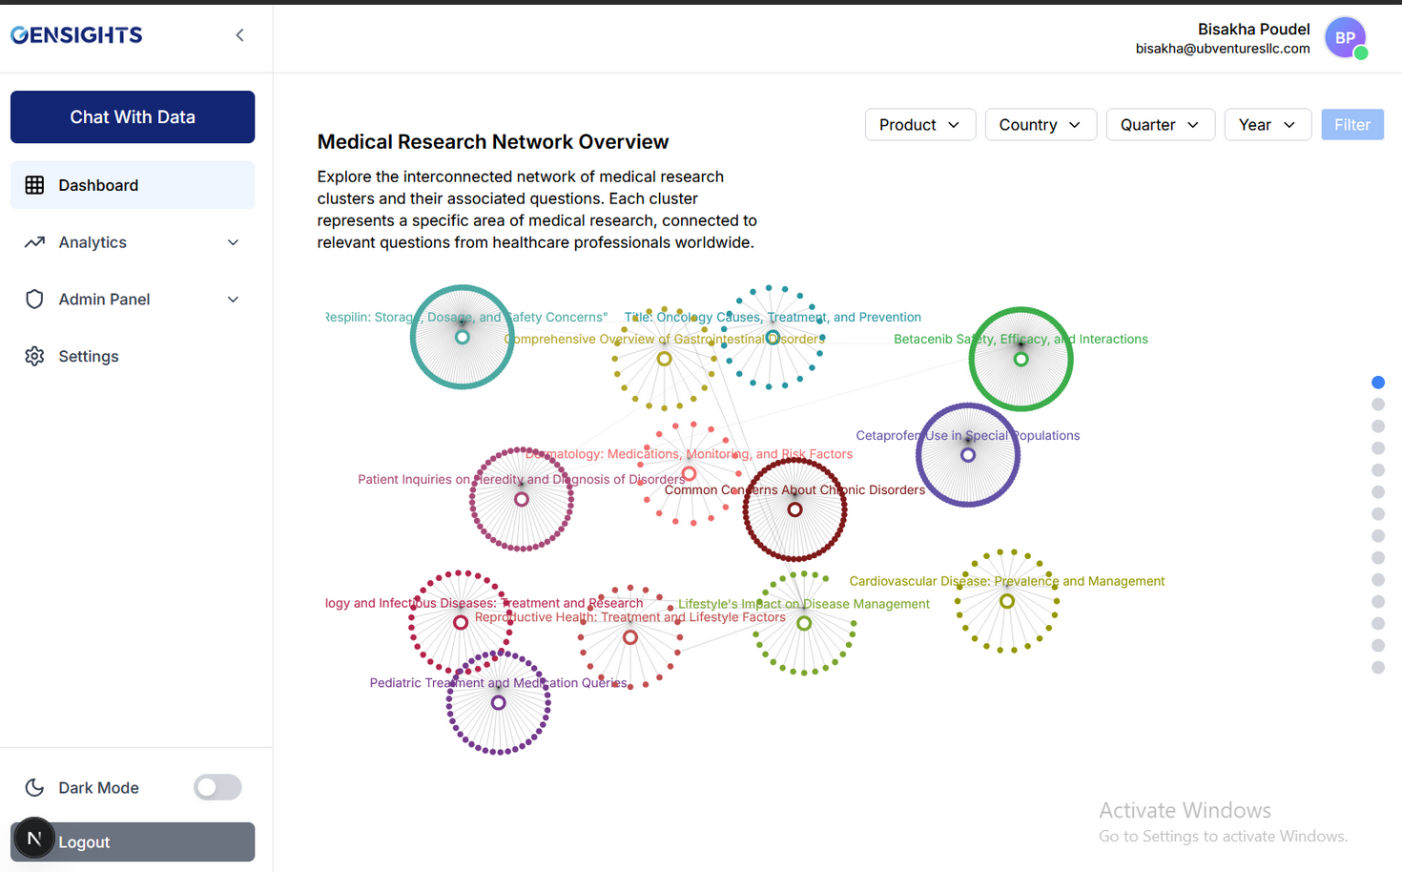
Other than Global IT Support, Login flow goes like:
Global IT Support adds user with their roles from admin panel and the user gets a email.
- email contains login email and temporary password.
- user first logs in with these credentials, then change password option is there for user to customize their password.
-User then sets up mfa with qr code shown, otp is verified and user is logged in with corresponding flows.
Note:
Backend portion for changing password and sending email is already done, frontend is yet to be implemented.

- API exposed in swagger ui for easy view.
All the apis available for Django app can be viewed with:
http://127.0.0.1:8000/api/v1/docs#/

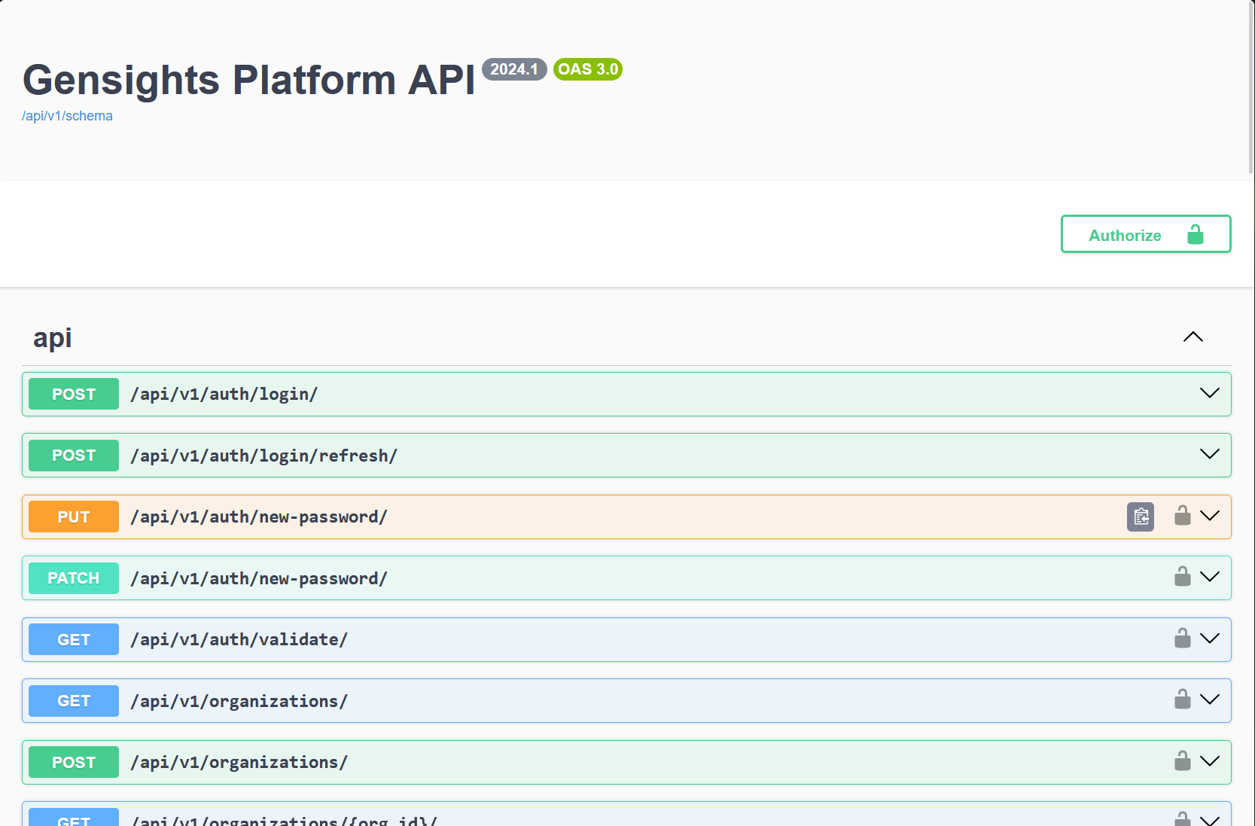

- Data injection:
Data can be uploaded in different formats from Django admin panel.
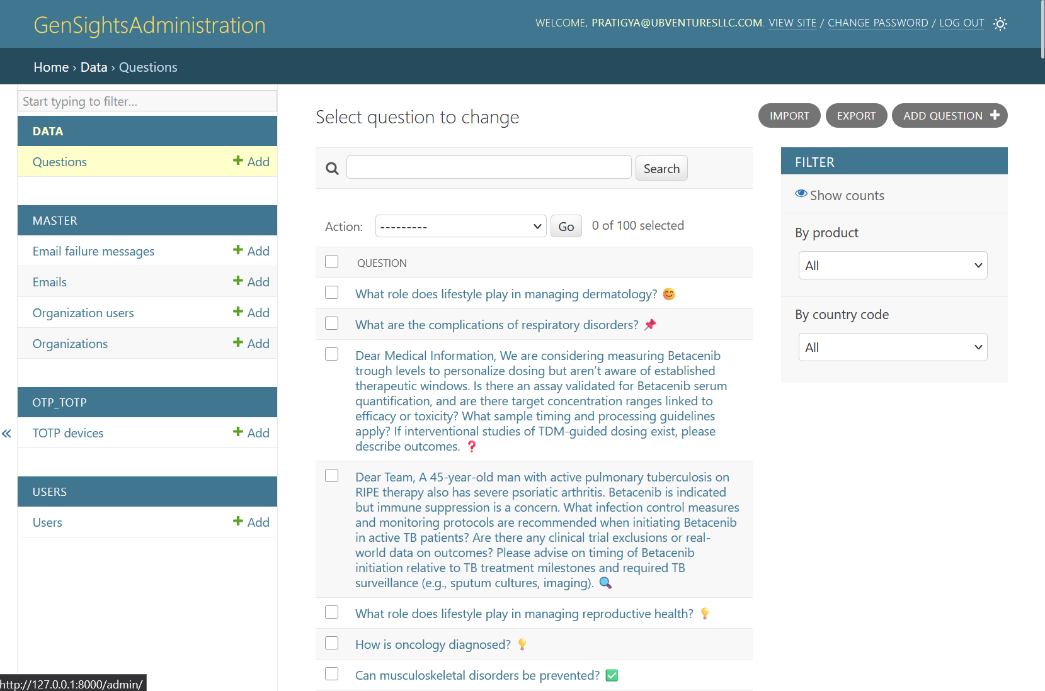
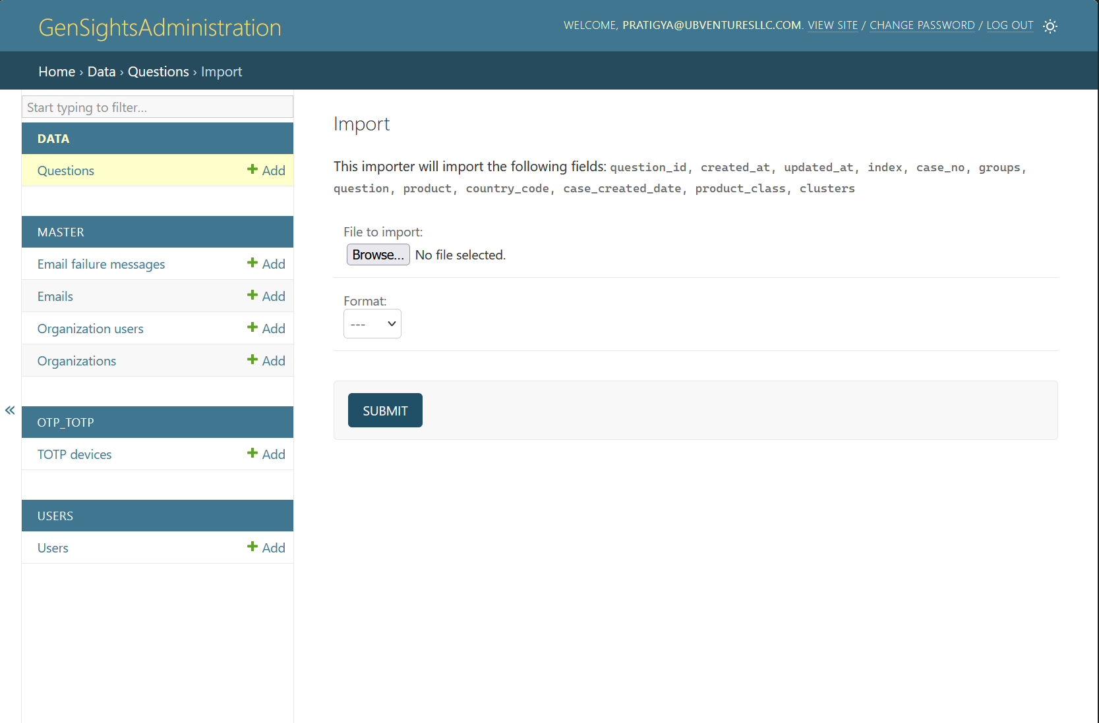

- Data preparation for bringing data to simulate real one.
https://colab.research.google.com/drive/1ajnegd7tN9jhcNTU8ynTa2SFTutGRfEK?usp=sharing

5) Data Preparation
- Created csv file from docs in the format needed
- Added emojis, unicodes(noise) in data
- Add case no, country and case created date for each data.
Final dataset view:
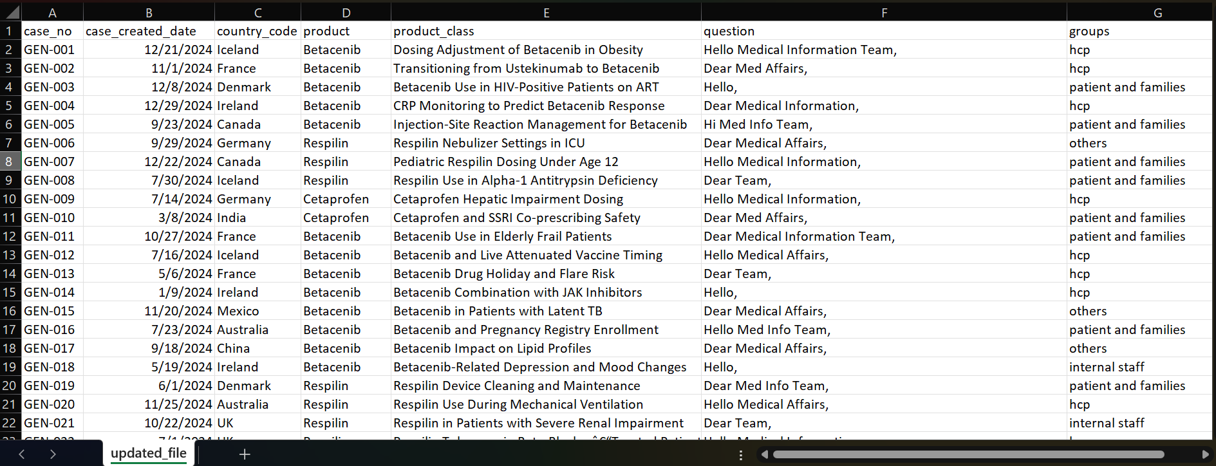
6) Background Tasks
- Question embedding and clustering
Upon injecting data from admin panel, a background task runs that not just saves data but also creates embedding of each data point and saves the data to pinecone vector database. After all data being saved clustering is also done as background tasks.
- Send email task
Any email that goes from our system can be sent through this task.
- User invitation email
- Change password email
- temporary token sending email
This background task is already programmed in backend, frontend integration is remaining.

- Alert invited user task
After user is invited, until the user logs in to the system, user is sent alert through email. After user status is switched from invited to active, this task will stop to alert user.
This is scheduled task that runs in fixed period of time.
Once send email task is integrated by frontend, this task will also be active by itself.

- Resend failed email task
When a email sending fails due to any reasons(connectivity issue, user inactive suddenly) then this task runs to resend the email.
Once send email task is integrated by frontend, this task will also be active by itself.

- Delete email records task
To avoid saving sent emails forever, a background task runs periodically to clean up these emails from system.

Dashboard view

These colorful circles represent data clusters. Each cluster is a group of related data points, formed based on semantic similarity. Here the data point is question about the product. A single data point can be associated with multiple clusters, like this data point it is associated with these both clusters represented with colors and we can view this by just clicking this data point.
Every cluster comes with a Title and a Summary that tells the story behind the data.
Users can refine what they see by applying various filters:
Product (e.g., Respillin), Country, Time Period (Year + Quarter)
Remaining work:
Caching needs to be implemented, for frontend and backend both
Set up for caching is already there

Chat with Data
Progress:
From the backend side, websocket connection for chat with data is already done. A agentic flow to answer user query is done. Tools for different type of questions are built. When there is user query, then llm provided with tools redirects the query to specific tool and the tool runs for answering the user query. Query can also be to create visualizations of different types. Currently there are tools to handle those as well.
Chat with data will need optimization for creating visualization for every query.
Remaining work on chat with data from frontend and backend:
- Authorization headers along with user data.
- Showing past conversation of the user
Websocket connection is completed with frontend but complete connection with creation of interactive visualization is not done. Also with every answers ui properties are also passed in frontend, it is yet to be handled.

Analytics:
Requirements
User should be able to view different type of visualizations for overall data.
1) Weekly timeline
- User chooses a quarter and he gets to see the weekly distribution of data across the quarter.
- Visualization should be bar graph, where x axis is week, and y axis is percentage of questions in that week.
- Each bar should be segmented based on who asked the questions i.e groups. Groups in the data will be(hcp, patient and families, others, internal staff)
- Insights should also be shown like a summary of the visualization, example if a week has sudden raise in the questions then why there is raise or summary of those trending questions.
2)Topics by groups
-Visualization should be bar graph where x axis is groups of those people who asks questions.
Groups are: hcp, patient and families, others, internal staff
Y axis will be percentage of questions asked by that group.
- Each bar should be segmented based on the cluster titles of the questions.
- filters on the basis of roles should be available
3)Topics by country
- Visualization should be bar graph where in x axis there are countries, and y axis the percentage of questions asked from countries.
- Each bar should be segmented based on the cluster titles of the questions.
-filters on the basis of roles should be available

4)Topics by months:
-Similar as weekly distribution, questions percentage is calculated for monthly basis. User selects a year and monthly question distribution with topics will be seen in the visualization.
-Visualization will be a bar graph, where x axis will be the month and y axis will be the percentage of questions covered by that month.
-Each bar should be segmented based on the cluster titles of the questions.
-Filters wil be there based on roles .

5) Country by topics
Requirments need to be confirmed
Frontend and Backend both portions are not started yet for analytics.

Admin panel:
User management:
Global IT support team get to see the Users onboarded.

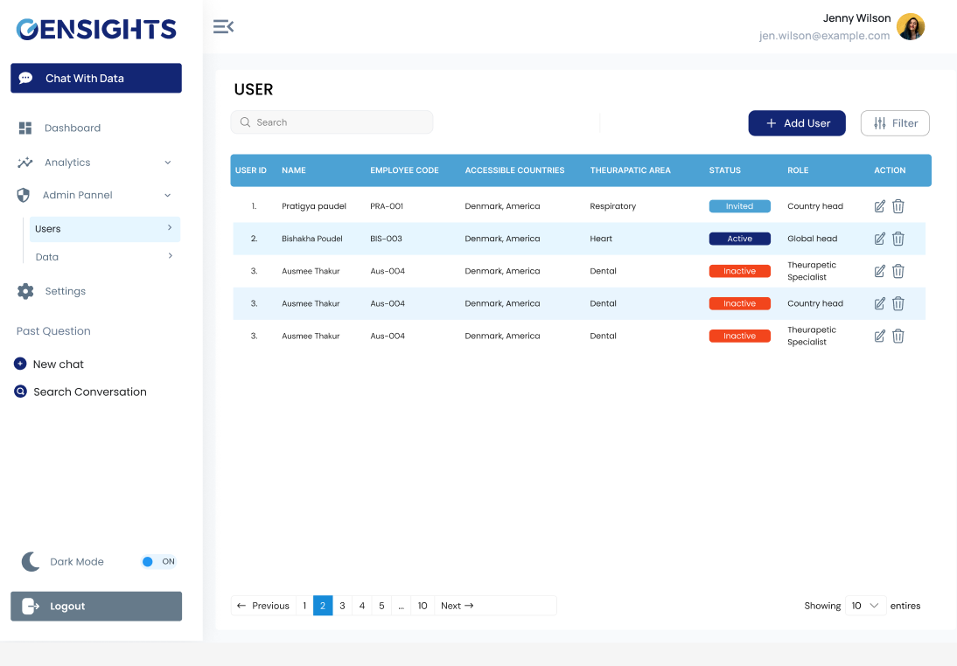
User management panel inside admin panel allows global it support team to add users on the system and invite them to login.
Upon adding email should go to that user with temporary password.
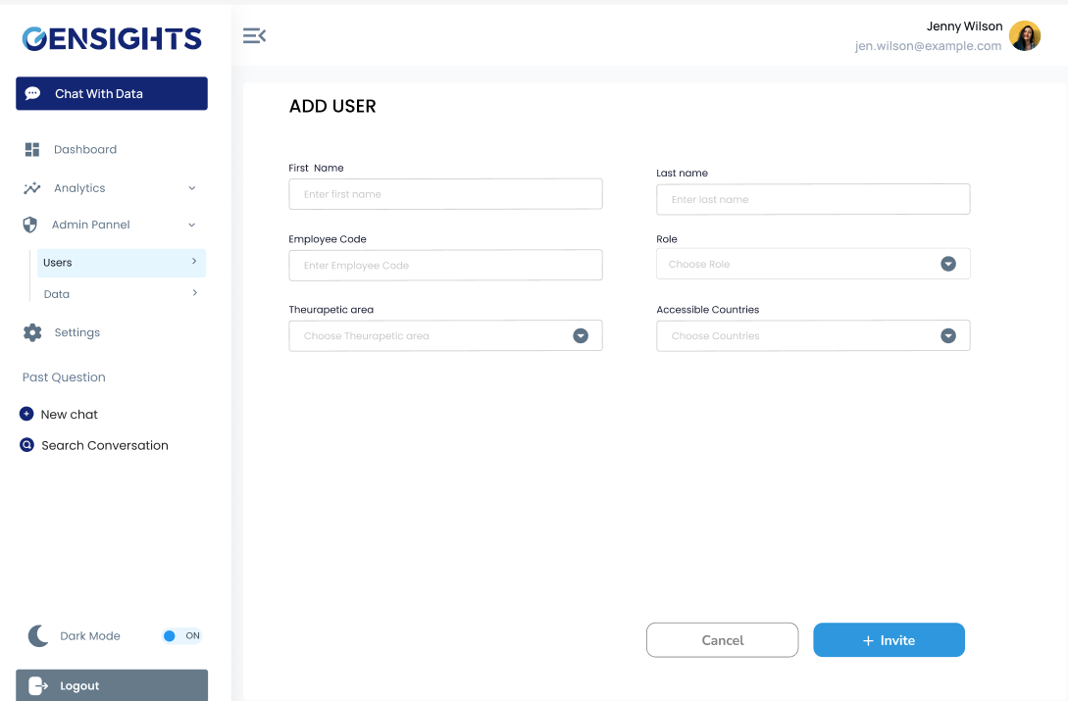
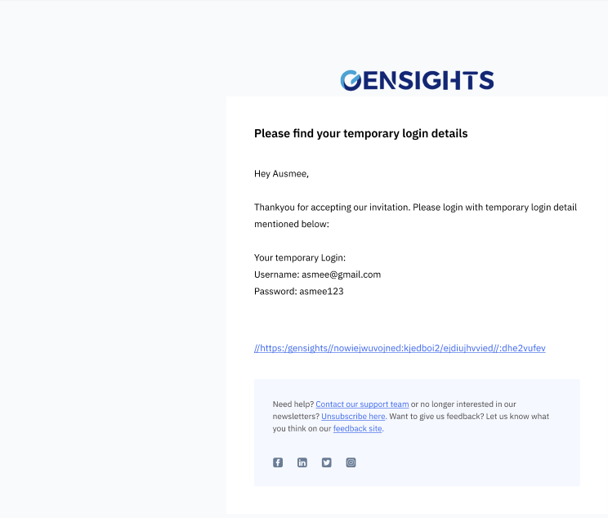
Global IT support team can filter the users.
Filters available are:
-Filter by country,
-Filter by therapeutic area
- Filter by roles
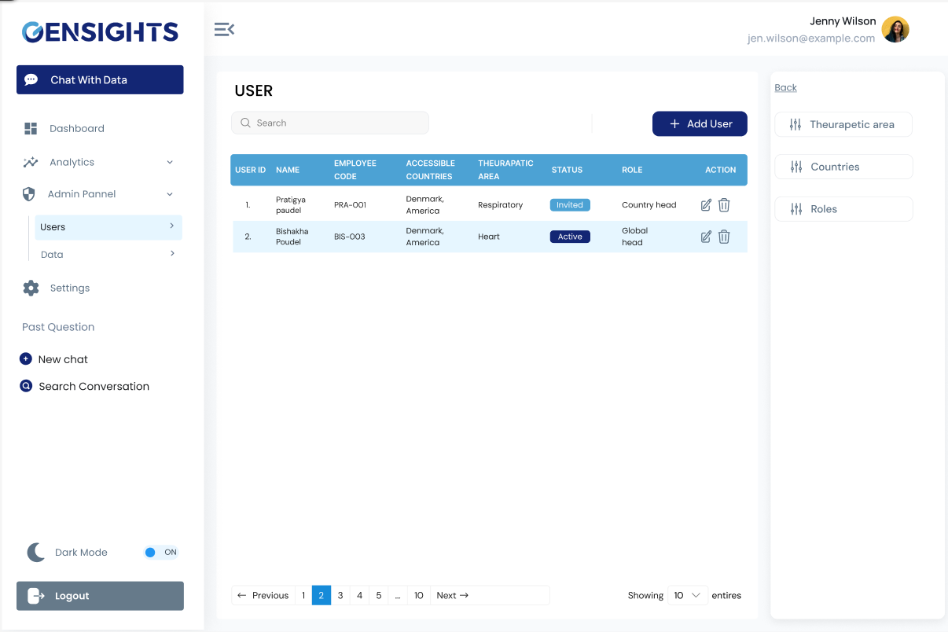

Django viewset for user management section is already done from backend.
Need to add filters and other necessary apis in backend.
Frontend is yet to be started.
Data Section:
Global business and global it support team gets to import data from this section. It will be same as django admin panel.
Roles of our system:

Module: Dashboard

SN | Global Business | Global IT Support | Country Head | Therapeutic specialist
1. | Can view all data regardless of country and and therapeutic area. | Can view all data regardless of country and and therapeutic area. | Can view all data within a country of all time period but of all therpeutic areas. | Can view data of a country/region of all time period and also of a single therapeutic area products of which this role is specialist of.
2. | Filter available for this role will be product, country and timeperiod(year and quarter). | Filter available for this role will be product, country and timeperiod(year and quarter). | Filter available for this will be product of all therapeutic area and of all time period.  No country filter | Filter available for this role will be product included within that therapeutic area only of all time period.  No country filter.

Module: Chat with data
SN | Global Business | Global IT Support | Country Head | Therapeutic specialist
1. | Chat with data also while answering the question with this role can take reference of all the data. | Chat with data also while answering the question with this role can take reference of all the data. | Chat with data also while answering the question with this role can take reference of all the data but within that country only. | Chat with data also while answering the question with this role can take reference of data associated with the product within specific therapeutic area and of countries he has access to.

Module: Analytics

SN | Global Business | Global IT Support | Country Head | Therapeutic specialist
1. | Can view visualization of all data regardless of country and and therapeutic area. | Can view visualization of all data regardless of country and and therapeutic area. | Can view visualizaition of all data within a country of all time period but of all therpeutic areas. | Can view visualization of data of a country/region of all time period and also of a single therapeutic area products of which this frole is specialist of.

New Requirements:
PII detector for frontend and backend.
Translation service, question can be asked in any language in chat with data.
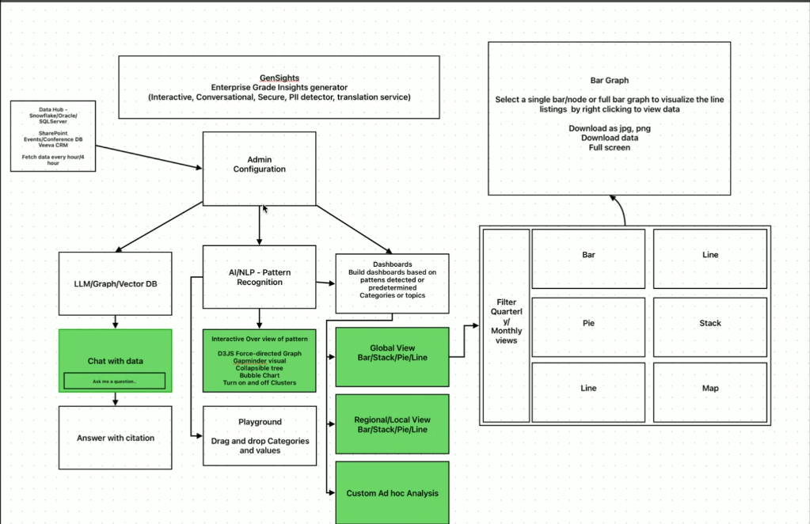
Playground module is yet to be discussed.

