#List the top 10 models & brands that have less screen size.

select brand_name, model, screen_size from(

select brand_name, model, screen_size, dense_rank() over(order by screen_size) as rnk from SmartPhones) a

where a.rnk<=10;

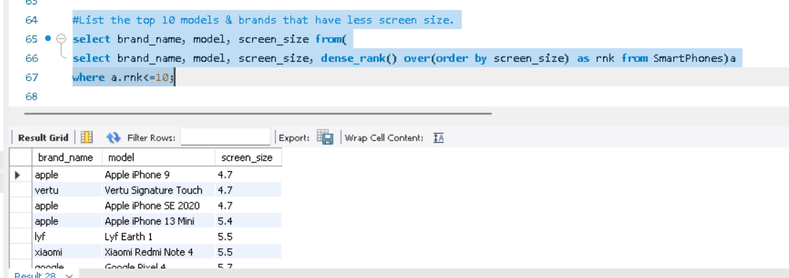

#list the top 5 brands & models that have the highest RAM capacity and internal memory.

select brand_name, model, ram_capacity, internal_memory from(

select brand_name, model, ram_capacity, internal_memory, dense_rank() over(order by ram_capacity desc, internal_memory desc) as

rnk from smartphones)a where rnk <=5;

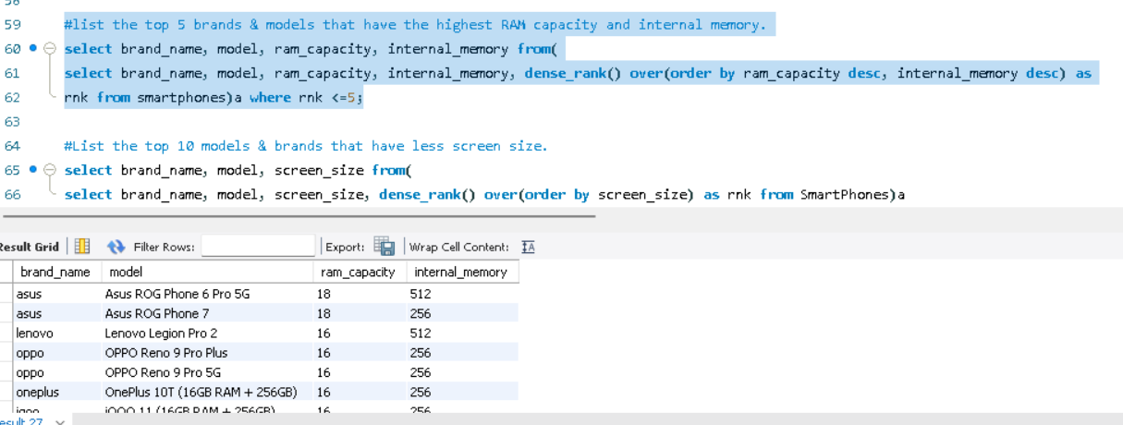

#Top 5 highest battery capacity models & their brands.

select brand_name, model, battery_capacity from (

select brand_name, model, battery_capacity, dense_rank() over(order by battery_capacity desc) as rnk

from SmartPhones)a where a.rnk<=5 limit 5;

v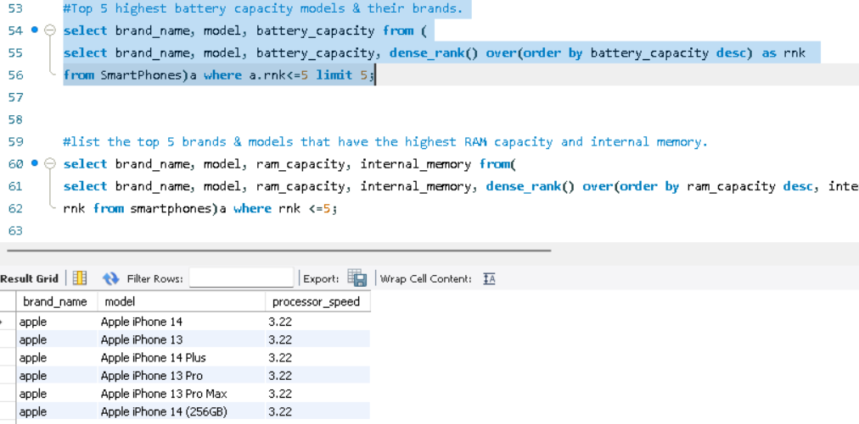

#Highest processor speed as per model and brand.

select brand_name, model, processor_speed from(

select brand_name, model, processor_speed, dense_rank() over(order by processor_speed desc) as rnk

from SmartPhones)a where a.rnk=1;

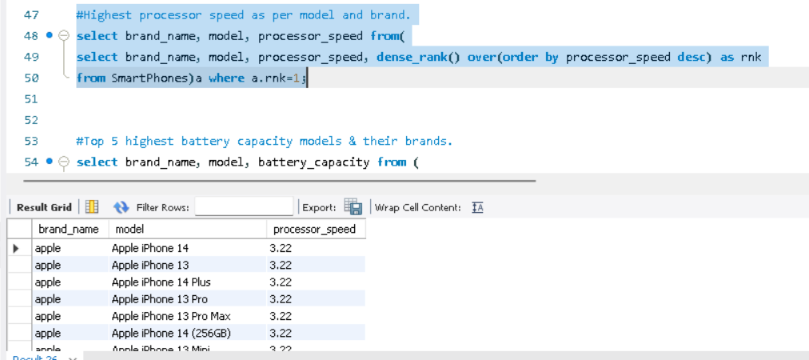

#number of cores per model. rank them by the number of cores.

select * from ( select distinct model, num_cores as number_of_cores, dense_rank() over(order by number_of_cores) as rnk from smartphones ) a

order by 3;

#Number of processor brands are available? and the number of models per each brand.

select count(distinct processor_brand) number_of_processor_brand from smartphones;

SELECT

processor_brand, COUNT(model)

FROM

smartphones

WHERE

processor_brand IS NOT NULL

GROUP BY processor_brand

ORDER BY 2 DESC;

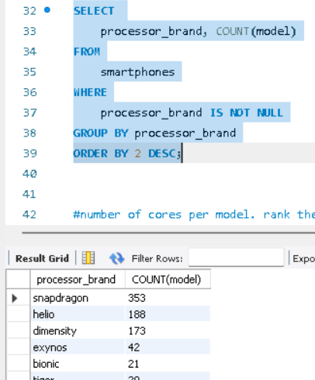

#mobiles that do not have 5g or have ir blaster.

select model from smartphones

where has_5g= 0 or has_ir_blaster=1;

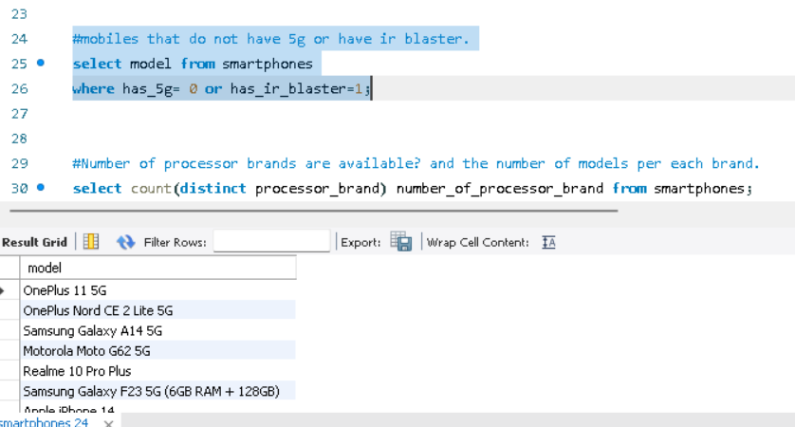

#Top 3 Highest rating brands and models.

select model, brand_name, rating from (

select brand_name, rating, model,dense_rank() over(order by rating desc) as rnk from smartphones) a

where a.rnk<=3 order by rnk limit 3;

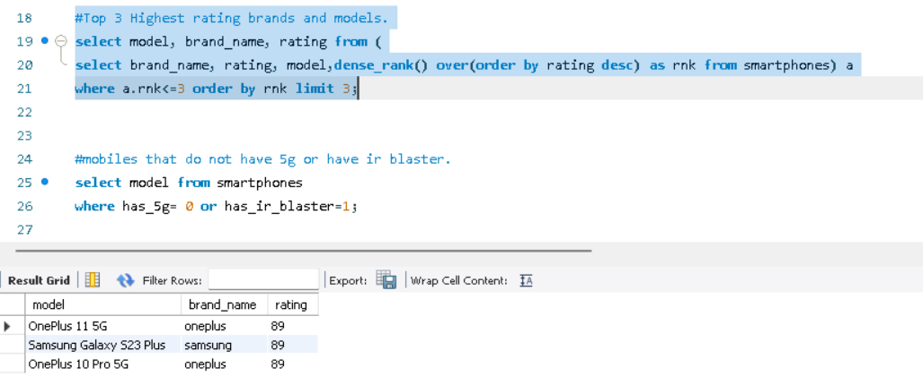

#total price of each brand’s mobiles, models, and also brands and their models.

select brand_name, sum(price) total_cost from smartphones group by brand_name order by 1 asc;

select model, sum(price) total_cost from smartphones group by model order by 1 asc;

select brand_name,model, sum(price) total_cost from smartphones group by brand_name, model order by 1 asc;

