NAME – ABHAY

TITLE - EMERGENCY PANIC ALARM BOARD
FOOTPRINT 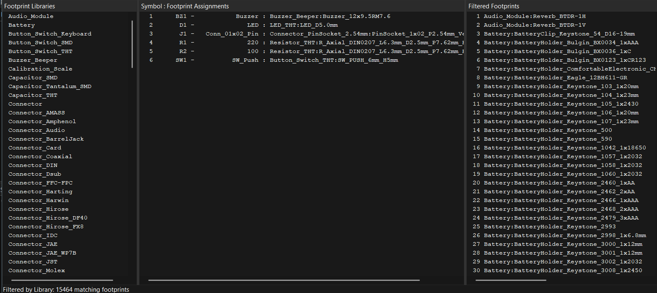SCHEMATIC 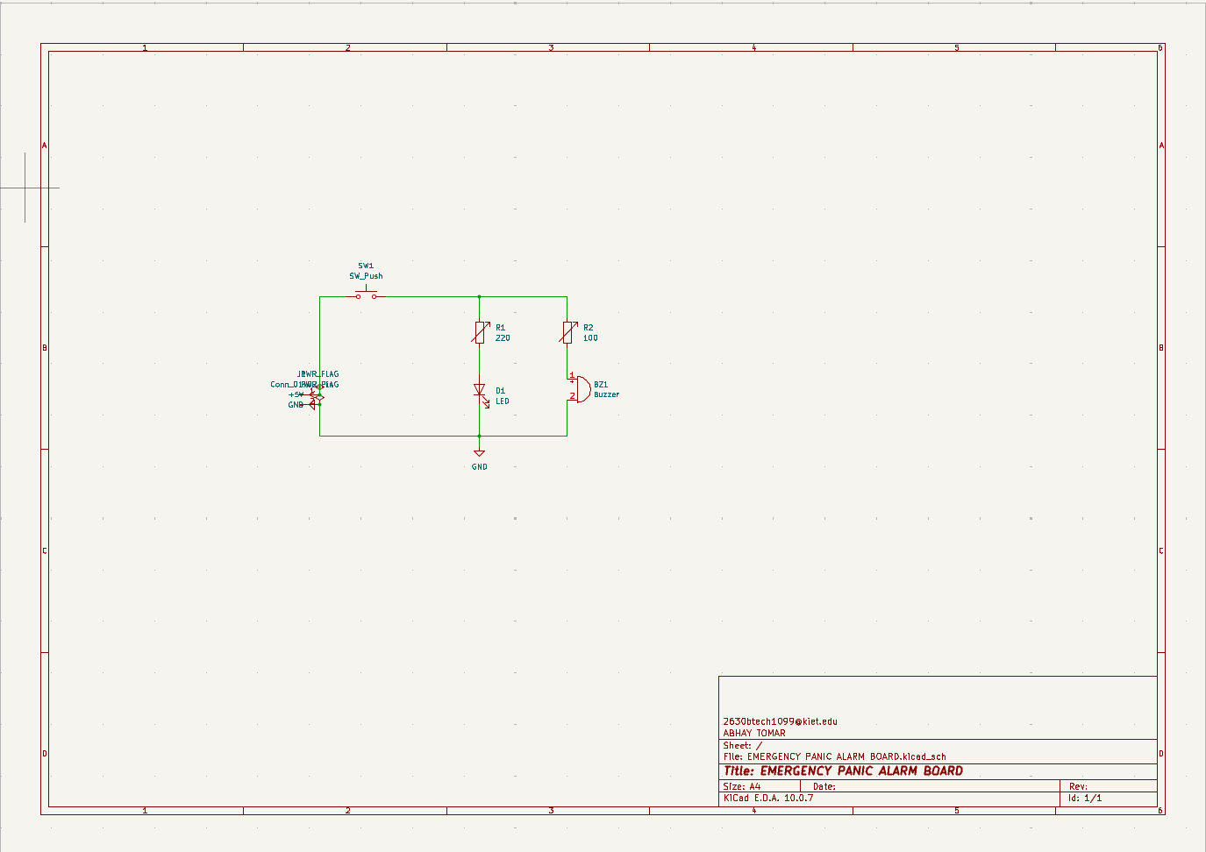

2D PCB VIEW
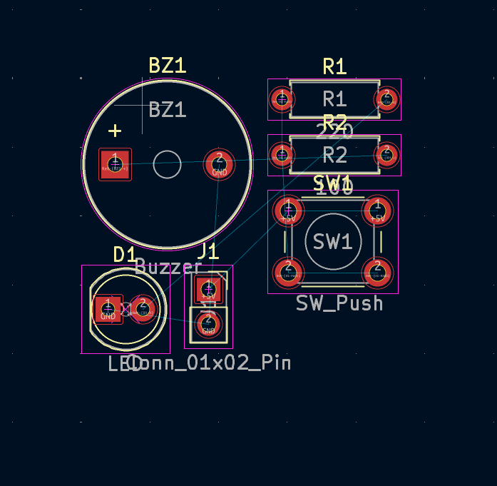

3D PCB VIEW


