**Aim**-

Design a system for a gift-box such that whenever it is opened, it produces sound for 1000 Ms and blinks red and green LEDs alternatively, as long as it is open

**Circuit Diagram:**

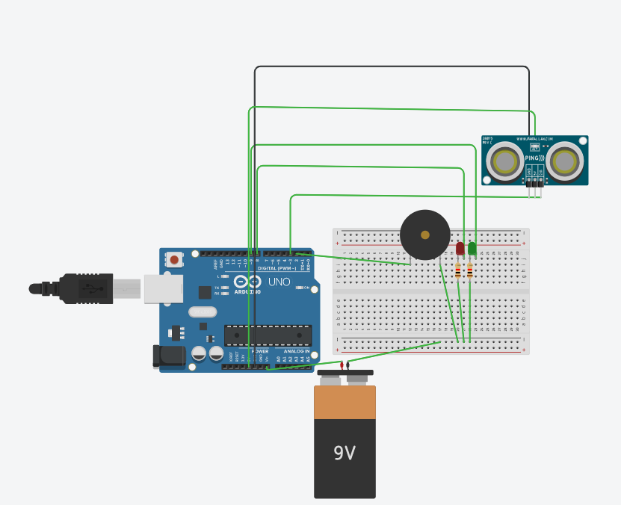

**Theory –**

**Concept Used:**

IN THIS I USED THE DISTANCE ULTRASONIC SENSOR TO MEASURE THE DISTANCE WHEN THE BOX OPENS, THE LIGHTS STARTS BLINKING AFTER THE DISTANCE CONDITION IS SATISFIED, AND THE SPEAKER STARTS MAKING THE SOUND.

**Learning & Observations**:

LEARNED THE USE OF DISTANCE ULTRASONIC SENSOR, FOR GLOWING LEDS AND SPEAKER.

AFTER A PARTICULAR DISTANCE THE LIGHTS STARTED GLOWING.

**Problems & Troubleshooting**:

FIRST PROBLEM I FACED WAS THAT I WAS NOT TAUGHT ABOUT THIS IN THE CLASS THIS QUESTION WAS OUT OF THE SYLLABUS.OTHER PROBLEM WAS JOINING THE SPEAKER COMPONENT TO THE BREADBOARD.

**Precautions**:

ATTACH THE TERMINALS OF THE BATTERY PROPERLY AND TIGHTEN THE COMPONENTS.

**Learning Outcomes**:

I LEARNT ABOUT THE USE OF SPEAKER AND THE DISTANCE CALCULATOR SENSOR.