xlm-roberta-base:
Epoch | Training Loss | Validation Loss | Accuracy
1 | 0.687400 | 0.631548 | 0.763666
2 | 0.545200 | 0.592032 | 0.776819
3 | 0.420200 | 0.644592 | 0.782573

✅ xlm-roberta-base Accuracy: 0.7855
Confusion Matrix:
[[ 16 0 1 9 12]
[ 4 0 0 5 3]
[ 2 0 278 114 6]
[ 4 0 106 1245 117]
[ 11 0 20 108 373]]
 | Precision | Recall | F1-Score | Support
Angry | 0.432 | 0.421 | 0.427 | 38
Fear | 0.000 | 0.000 | 0.000 | 12
Happy | 0.686 | 0.695 | 0.691 | 400
no | 0.841 | 0.846 | 0.843 | 1472
sad | 0.730 | 0.729 | 0.729 | 512
Accuarcy |  |  | 0.786 | 2434
Macro avg | 0.538 | 0.538 | 0.538 | 2434
Weighted avg | 0.781 | 0.786 | 0.784 | 2434

distilbert-base-multilingual-cased :

Epoch | Training Loss | Validation Loss | Accuracy
1 | 0.751100 | 0.710760 | 0.728730
2 | 0.665900 | 0.663926 | 0.752569
3 | 0.448200 | 0.702256 | 0.761200

✅ distilbert-base-multilingual-cased Accuracy: 0.7457
Confusion Matrix:
[[ 8 0 2 11 17]
[ 2 3 0 6 1]
[ 4 0 219 153 24]
[ 2 0 99 1250 121]
[ 7 2 21 147 335]]
 | Precision | Recall | F1-Score | Support
angry | 0.348 | 0.211 | 0.262 | 38
Fear | 0.600 | 0.250 | 0.353 | 12
Happy | 0.642 | 0.547 | 0.591 | 400
no | 0.798 | 0.849 | 0.823 | 1472
sad | 0.673 | 0.654 | 0.663 | 512
Accuarcy |  |  | 0.746 | 2434
Macro avg | 0.612 | 0.502 | 0.538 | 2434
Weighted avg | 0.738 | 0.746 | 0.740 | 2434

ai4bharat/IndicBERTv2-SS
Epoch | Training Loss | Validation Loss | Accuracy
1 | 0.956900 | 0.970157 | 0.619400
2 | 0.911700 | 0.912590 | 0.638718
3 | 0.882200 | 0.879578 | 0.648582

Confusion Matrix:
[[ 0 0 1 22 15]
[ 0 0 0 9 3]
[ 0 0 71 283 46]
[ 0 0 51 1300 121]
[ 0 0 17 276 219]]

Accuracy: 0.6532456861133936

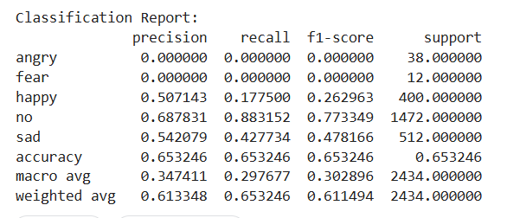

bert-base-multilingual-cased
Epoch | Training Loss | Validation Loss | Accuracy
1 | 0.711000 | 0.676383 | 0.747637
2 | 0.609900 | 0.612836 | 0.766543
3 | 0.490500 | 0.620043 | 0.772298

Confusion Matrix:
[[ 8 0 3 9 18]
[ 2 3 0 4 3]
[ 3 0 233 143 21]
[ 0 0 99 1254 119]
[ 9 3 34 121 345]]

Accuracy: 0.7571898110106821

