xlm-roberta-base:
Epoch | Training Loss | Validation Loss | Accuracy
1 | 0.687400 | 0.631548 | 0.763666
2 | 0.545200 | 0.592032 | 0.776819
3 | 0.420200 | 0.644592 | 0.782573

✅ xlm-roberta-base Accuracy: 0.7855
Confusion Matrix:
[[ 16 0 1 9 12]
[ 4 0 0 5 3]
[ 2 0 278 114 6]
[ 4 0 106 1245 117]
[ 11 0 20 108 373]]
 | Precision | Recall | F1-Score | Support
Angry | 0.432 | 0.421 | 0.427 | 38
Fear | 0.000 | 0.000 | 0.000 | 12
Happy | 0.686 | 0.695 | 0.691 | 400
no | 0.841 | 0.846 | 0.843 | 1472
sad | 0.730 | 0.729 | 0.729 | 512
Accuarcy |  |  | 0.786 | 2434
Macro avg | 0.538 | 0.538 | 0.538 | 2434
Weighted avg | 0.781 | 0.786 | 0.784 | 2434

XLM-RoBERTa-Base-weighted:
Class Weights: tensor([12.5981, 41.4128, 1.2169, 0.3307, 0.9520])
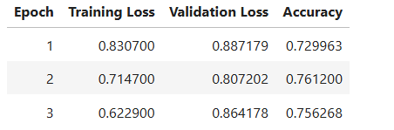
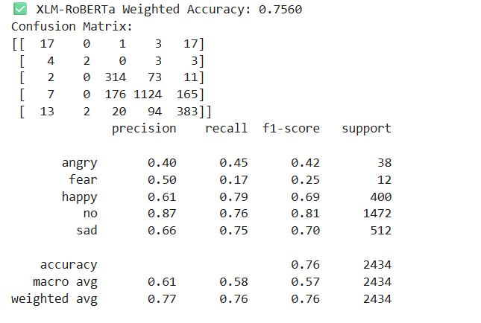

XLM-ROBERTA-AFTER AUGMENTATION:
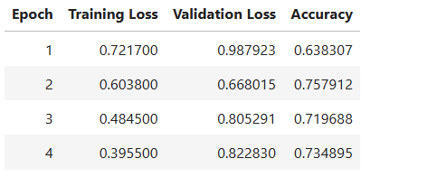
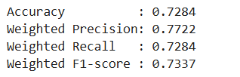
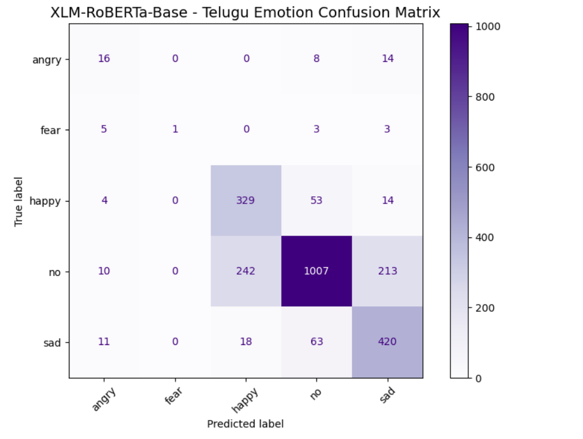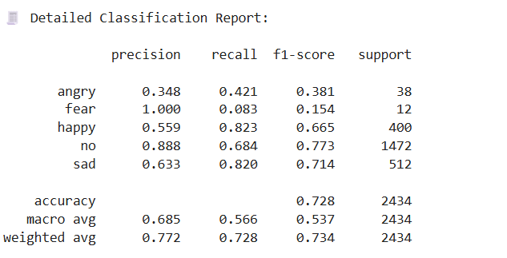
XLM-ROBERTA-AFTERAUGUMENTATION-AFTERWEIGHTS
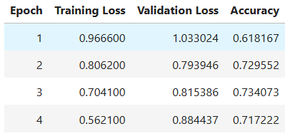
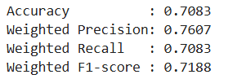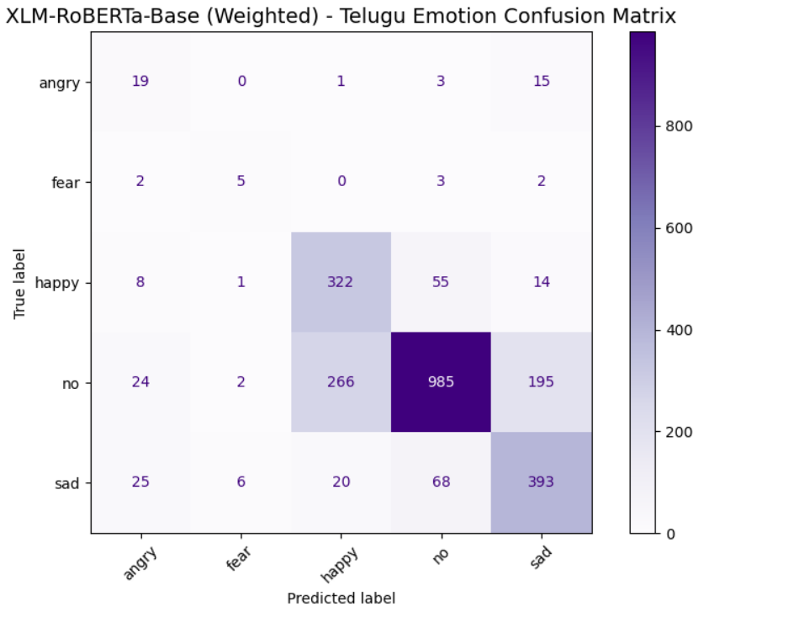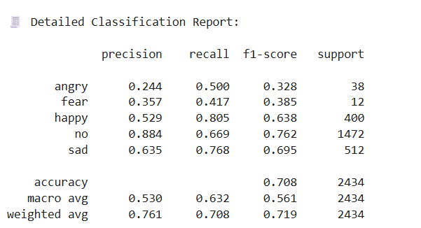

ran by mistake and dataset is like rest classes except no are added once more so the rows in other classes will be 2 times
