RoleAuthDemo - ASP.NET Core MVC (Secure Login & Role-Based Authorization)

Project Overview

This project demonstrates secure login and role-based authorization in an ASP.NET Core MVC application using Identity. It includes:

- Authentication with `UserManager` and `SignInManager`.
- Secure password hashing.
- Role-based authorization (`Admin`, `User`).
- CSRF protection with `AntiForgeryToken`.
- HTTPS enforcement with `RequireHttps`.
- Sensitive data protection using Data Protection API.

How This Project Was Created

1. Create a new MVC project

dotnet new mvc -n RoleAuthDemo
cd RoleAuthDemo

2. Add required packages

dotnet add package Microsoft.AspNetCore.Identity.EntityFrameworkCore
dotnet add package Microsoft.EntityFrameworkCore.SqlServer
dotnet add package Microsoft.EntityFrameworkCore.Tools
dotnet add package Microsoft.EntityFrameworkCore.Design
dotnet add package Microsoft.AspNetCore.DataProtection

3. Configure Identity and DbContext

Created `ApplicationUser.cs` model extending `IdentityUser`.
Added `ApplicationDbContext.cs` inheriting from `IdentityDbContext<ApplicationUser>`.
Configured services in `Program.cs` (Identity, DbContext, HTTPS, Data Protection).

4. Add Controllers & Views

`AccountController` → Login, Logout, AccessDenied.
`AdminController` → Dashboard (Admin only).
`UserController` → Profile (User/Admin).
Views: `Login.cshtml`, `Dashboard.cshtml`, `Profile.cshtml`, `AccessDenied.cshtml`.

5. Role Seeding

Implemented `SeedData.cs` to create roles (`Admin`, `User`) and default accounts.
Called seeding in `Program.cs`.

6. Security Enhancements

Added `[ValidateAntiForgeryToken]` and `@Html.AntiForgeryToken()`.
Enforced HTTPS with `RequireHttpsAttribute` and `UseHttpsRedirection()`.
Used Data Protection API in `AccountController`.

Setup Instructions

1. Navigate

cd RoleAuthDemo

2. Install EF Tools (if not already installed)

dotnet tool install --global dotnet-ef

3. Apply Migrations & Create Database

dotnet ef migrations add InitialCreate # Only if migrations folder not present
dotnet ef database update

4. Run the Application

dotnet run

You should see output similar to:
Now listening on: https://localhost:5001

Application URLs

- Home: `https://localhost:5001/`
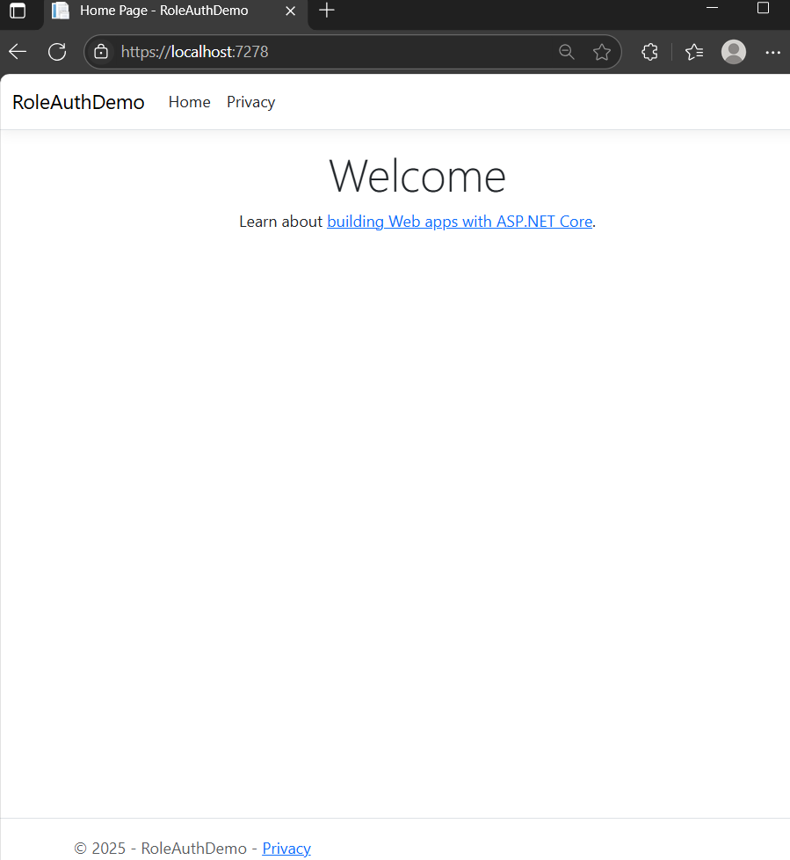

- Login: `https://localhost:5001/Account/Login`
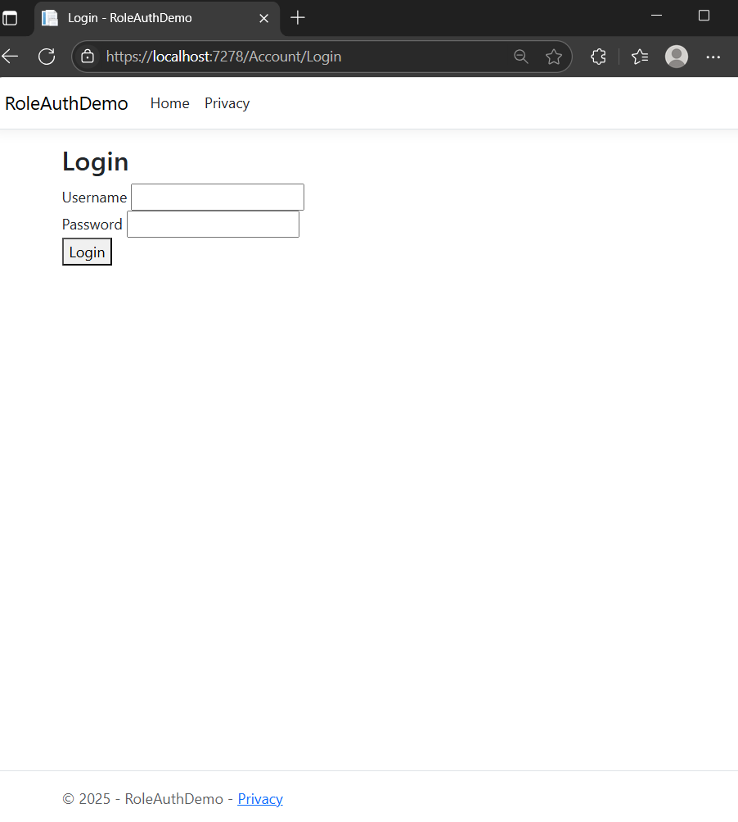
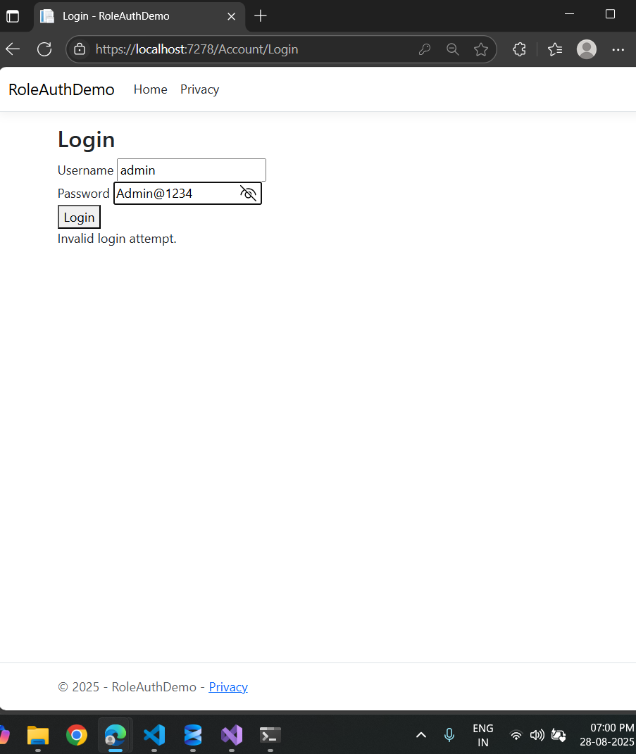

- Admin Dashboard: `https://localhost:5001/Admin/Dashboard`
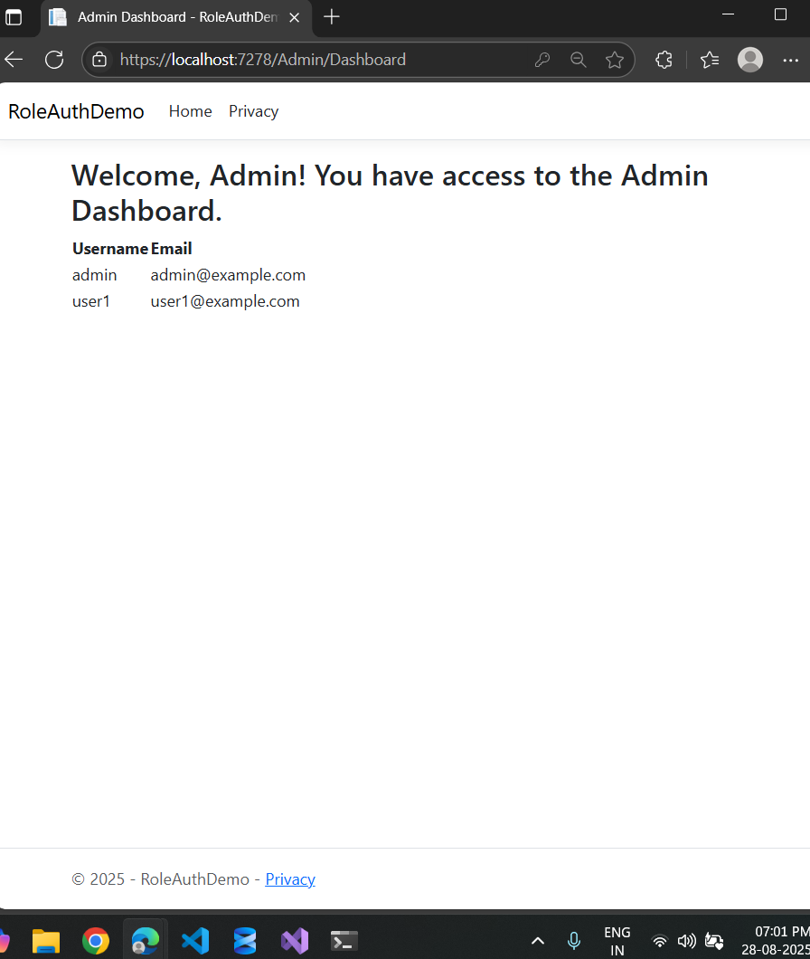

- User Profile: `https://localhost:5001/User/Profile`
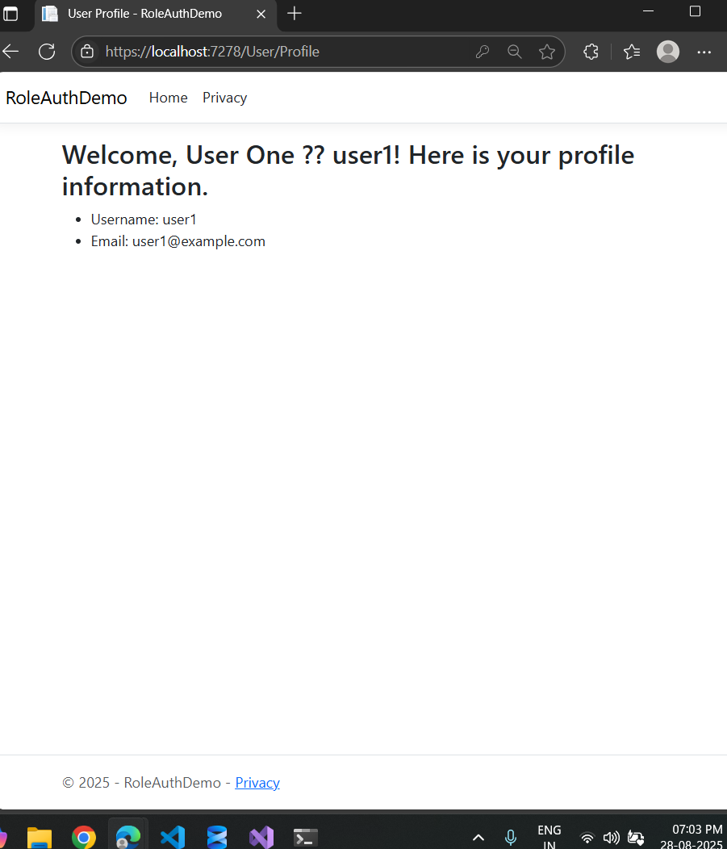
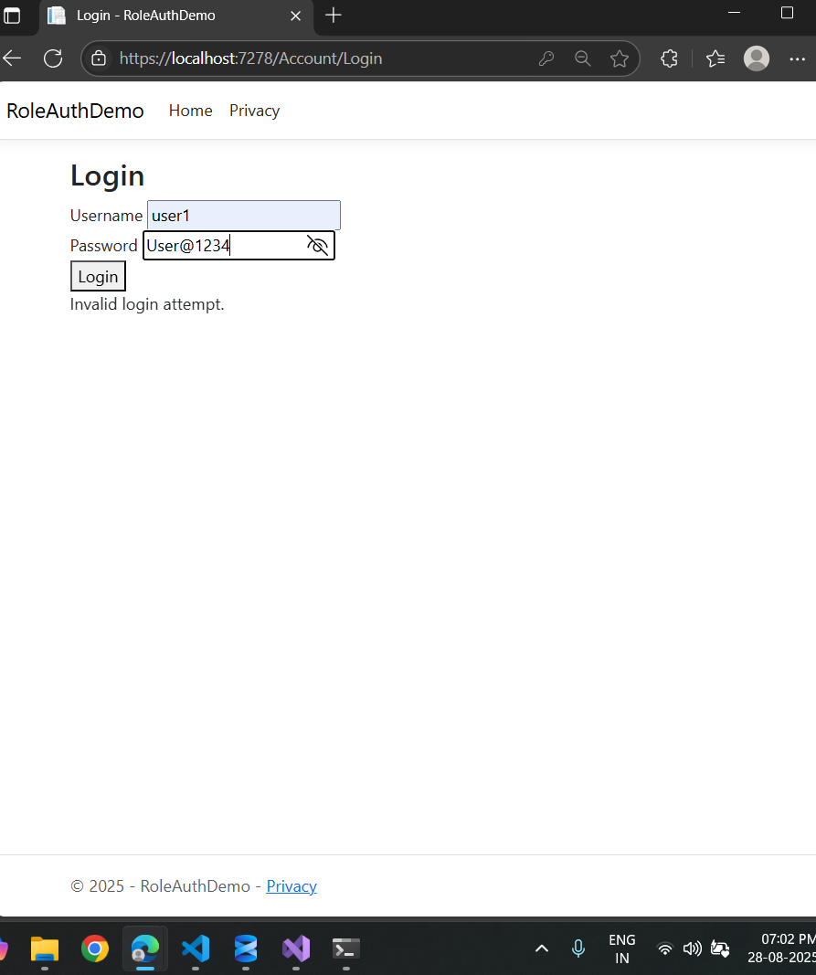

- Access Denied: `https://localhost:5001/Account/AccessDenied`
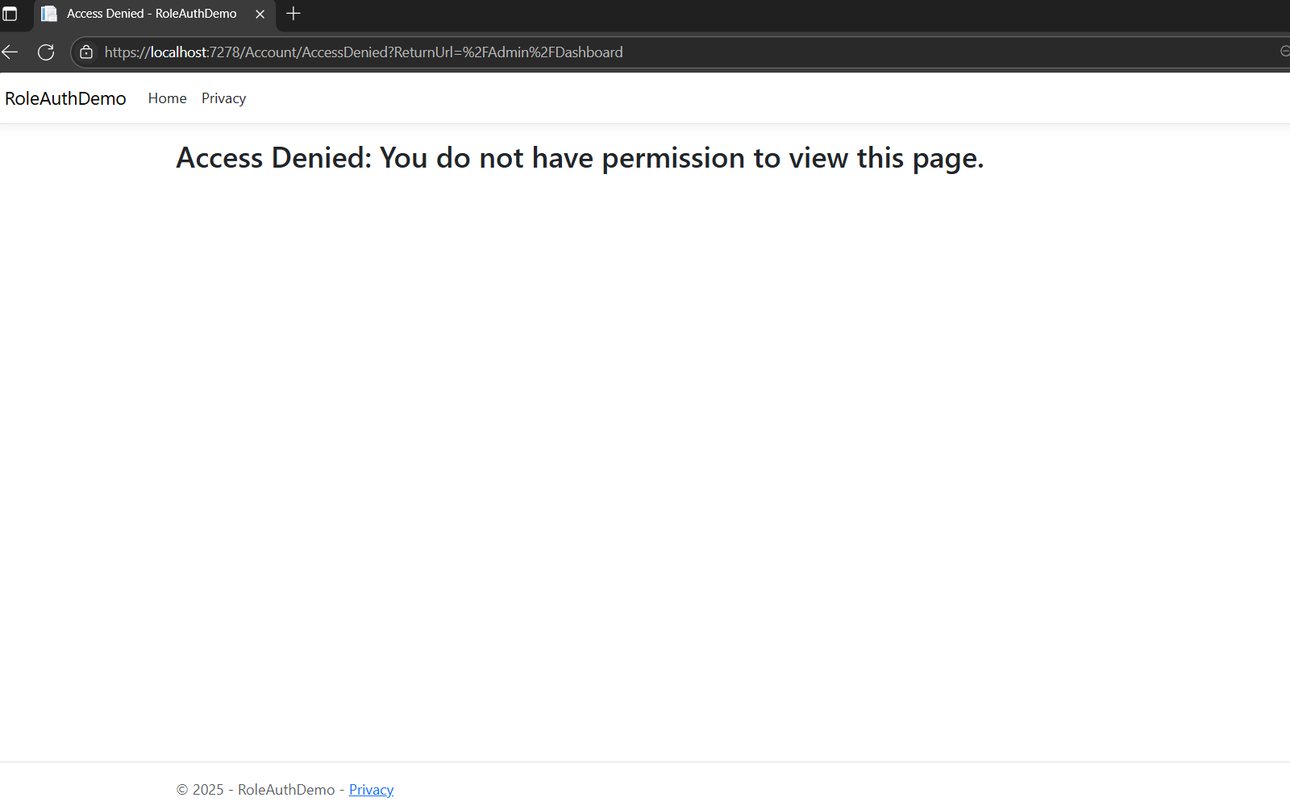

Accounts

The application consist of two default accounts:

Admin

- Username: `admin`
- Password: `Admin@123`

User

- Username: `user1`
- Password: `User@123`

Testing Scenarios

A. Admin Login

1. Navigate to `/Account/Login`.
2. Enter `admin / Admin@123`.
3. Redirects to `/Admin/Dashboard` with welcome message.

B. User Login

1. Navigate to `/Account/Login`.
2. Enter `user1 / User@123`.
3. Redirects to `/User/Profile` with profile message.

C. Unauthorized Access

- Login as `user1` and try to access `/Admin/Dashboard`.
- You should see `Access Denied` page.

Security Features Implemented

- Password Hashing: Managed by ASP.NET Core Identity.
- Role-Based Authorization: `[Authorize(Roles="Admin")]`, `[Authorize(Roles="User,Admin")]`.
- CSRF Protection: `@Html.AntiForgeryToken()` in forms, `[ValidateAntiForgeryToken]` in actions.
- HTTPS Enforcement: `RequireHttpsAttribute` + `app.UseHttpsRedirection()`.
- Data Protection API: Protects sensitive data (e.g., email).

