**Subject Nam**

**e:**

Source Code Management

**Subject Code:**

CS181

**Cluster:**

Beta

**Department:**

CSE



**Department of Computer Science & Engineering**

Chitkara University Institute of Engineering and Technology, Punjab

# Jan- June (2021-22)

Institute/School **Chitkara University Institute of Engineering**

Name **and Technology**

**Department of Computer Science &**

Department Name

**Engineering**

**Bachelor of Engineering (B.E.), Computer**

Programme Name

**Science & Engineering**

|  |  |  |  |
| --- | --- | --- | --- |
| Course Name | **Source Code Management** | | Session **2021-22** |
| Course Code | **CS181** | | Semester/Batch **2nd/2021** |
| Group No G01 - | |

**Name: Abhinav Goyal**

**Roll No: 2110990049**

**Date: April 8, 2022**

22

# **Table of Content**

|  |  |  |
| --- | --- | --- |
| **S. No.** | **Title** | **Page No.** |
| 1 | Version Control with Git | I |
| 2 | Objective | II |
| 3 | Installation Of Git | 1 - 5 |
| 4 | Setting Up GitHub Account | 6 |
| 5 | Configuration of GIT | 7 |
| 6 | Program to Generate Logs | 8 - 11 |
| 7 | Create and Visualize Branches | 12-15 |
| 8 | GIT Lifecycle Description | 16 - 17 |
| 9 | Uploading Data on GitHub | 18-20 |
| 10 | Final project | 21 |

33

## 1. Version Control with GIT

Version control systems are software tools that help software teams manage changes to source code overtime. As development environments have accelerated, version control systems help software teams work faster and smarter.

A version Control system records all the changes made to a file or set of files, so a specific version may be called later if needed.

**How version control helps high performing development and DevOps teams prosper?**

1. Version Control Systems (VCS) have seen great improvements over the past few decades and some are better than others.

1. VCS are sometimes known as SCM (Source Code Management) tools or RCS (Revision Control System).

1. One of the most popular VCS tools in use today is called

Git. Git is a Distributed VCS, a category known as DVCS, more on that later. Like many of the most popular VCS systems available today, Git is free and open source.

44

## 2. Objective of GIT

Git is a version control system used for tracking changes in computer files. It is generally used for source code management in software development.

* Git is used to tracking changes in the source code
* The distributed version control tool is used for source code management
* It allows multiple developers to work together
* It supports non-linear development through its thousands of parallel branches

**Features of Git =>**

* Tracks history
* Free and open source
* Supports non-linear development
* Creates backups
* Scalable
* Supports collaboration
* Branching is easier
* Distributed development

55

## 3. Installation of GIT

### Step 1 =>

To download the Git installer, visit the Git official site and go to the download page.

The link for the download page is <https://git-scm.com/downloads>

The page looks like as: -

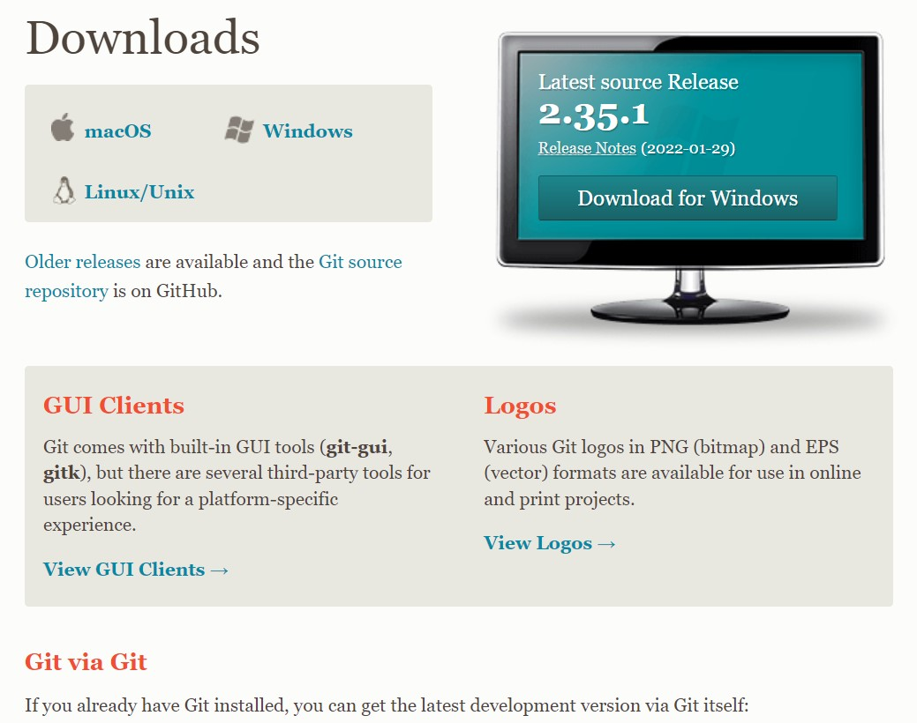

Click on the package given on the page as **download 2.23.0 for windows**. The download will start after selecting the package.

Now, the Git installer package has been downloaded.

### Step 2 =>

Click on the download installer file and then click on next.

The page looks like as: -

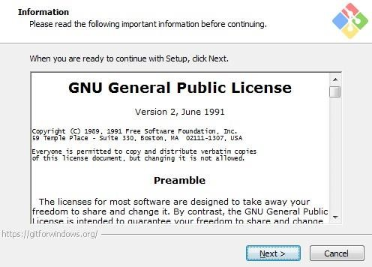

### Step 3 =>

Simply click on the next button as it automatically selects the required file.

The page looks like as: -

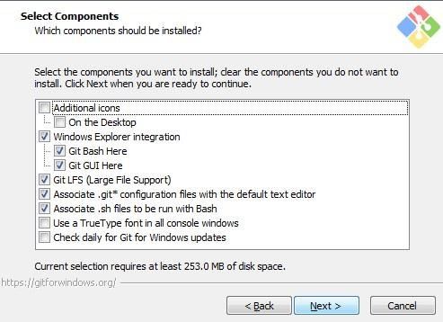

### Step 4 =>

You can choose your preferred choice. Click next to continue.

The page looks like as: -

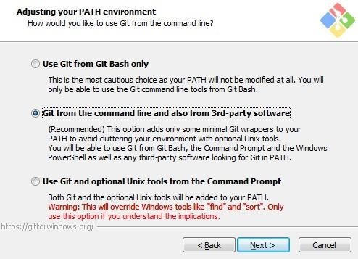

### Step 5 =>

***Note*: -** Just simply click on next as it automatically selects the

required file.

The page looks like as:

-

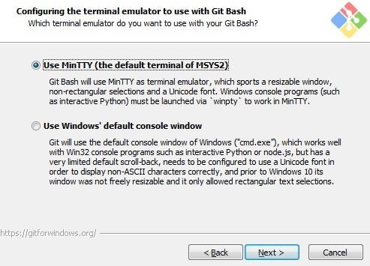

### Step 6 =>

The Git is getting download in your system

The page looks like as: -

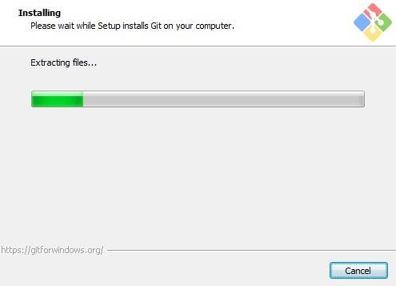

### Step 7 =>

You can check that Git is install by simply type git - -version in

The page looks like as: -

GIT is finally installed on your desktop.

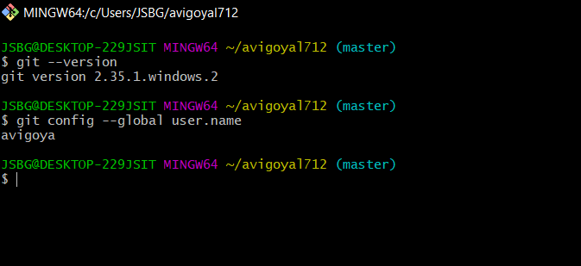

## 4. Setting Up GitHub Account

### Step 1 =>

To set up your GitHub account you need to visit <https://github.com/>and click sign-up.

### Step 2 =>

Enter your email, username and desired password.

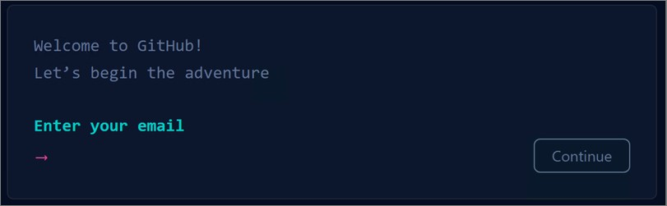

Your account is created

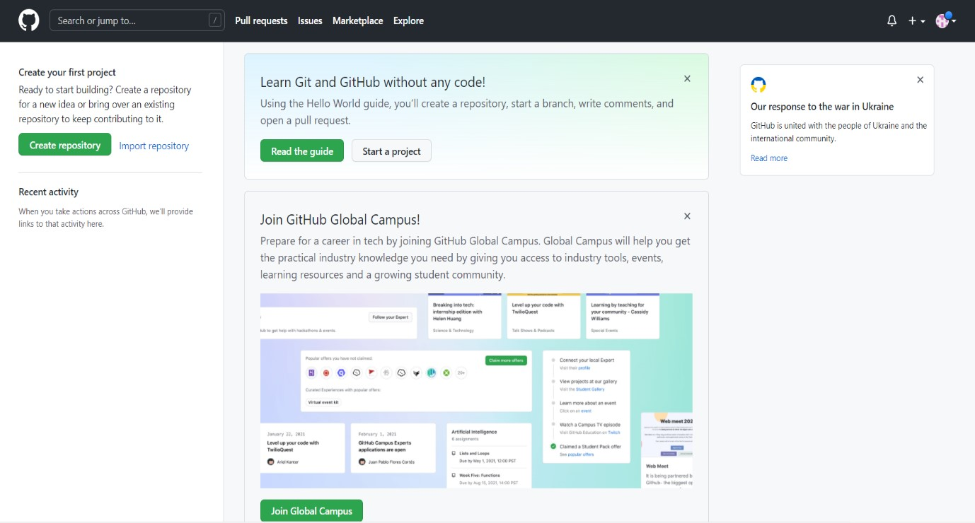

## 5. Configuration Of GIT

### Step 1 =>

1. config --global user.email "Your Email”
2. Set your username: git config --global user.name "Your Name"

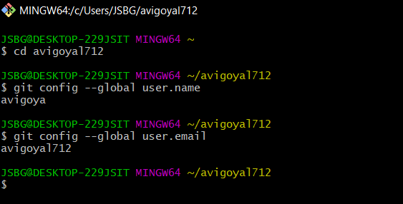

### Step 2 =>

You can check configuration of Git by typing -

1. git config --list

The page looks like as: -

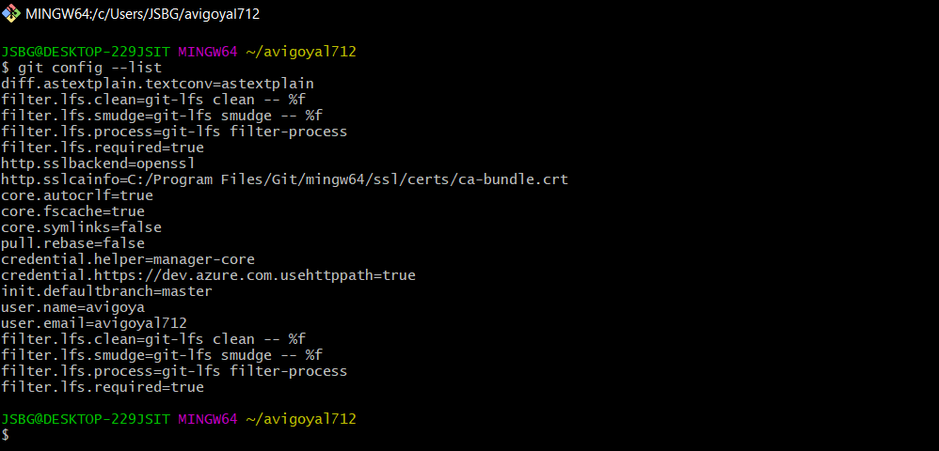

## 6. Program to Generate logs

Advantage of version control systems like git is that it can record changes.

‘Git log’ command is used to display all these changes that were made by the user in the repository. Log is a record of all the previous commits.

To understand Logs, we need to get familiar with all the commands that are used in making changes to a repository.

1. Repository: A repository is a directory that contains all the

project-related data.

1. Git init: The git init command is used to create a new blank repository.
2. Git status: We can list all the untracked, modified and deleted files using the git status command.
3. Git add: Adds all the untracked and modified files to the staging area.
4. Git commit: Git commit finalizes the changes in the repository. Every commit is saved in the branch you are working in and can be used to revert back to older versions of the project.

# **Making GIT Repository**

## **Step1: GIT INIT**

Initializing a new repository, You Can do it by typing: -

1. git init

The page looks like as: -

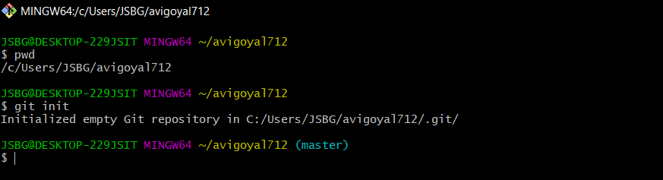

## **Step2: ADDING THE FILES TO THE FOLDER**

Just like (Samples...)

The page looks like as: -

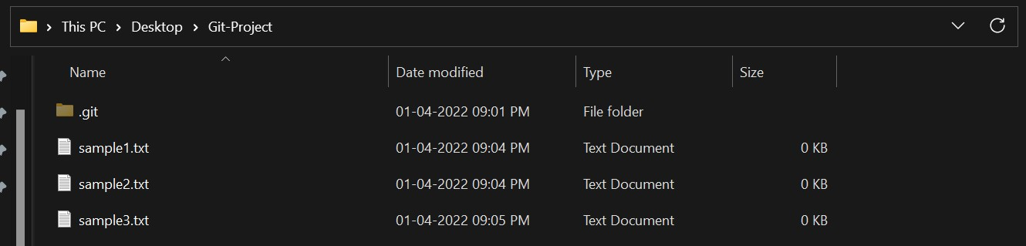

## **Step3: GIT ADD**

The git add command adds a change in the working directory to the staging area.

You Can do it by typing: - 1. git add .

2. git add (current file name)

The page looks like as: -

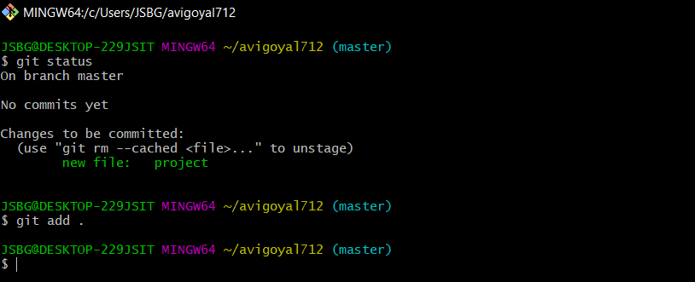

## **Step4: GIT COMMIT**

The "commit" command is used to save your changes to the local repository.

You Can do it by typing: -

1. git commit -m”any text”

The page looks like as: -

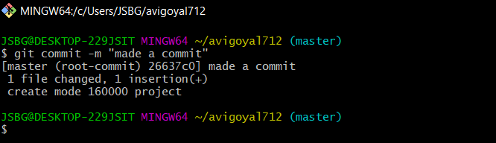

## **Step5: GIT LOG**

Git log will show all the commits made by the author with their time.

After every commit the checksum value (written In yellow color) of the folder changes.

Checksum is used to verify that the data in that file has not been tampered with or manipulated, possibly by a malicious entity.

You Can do it by typing: -

1. git log

The page looks like as: -

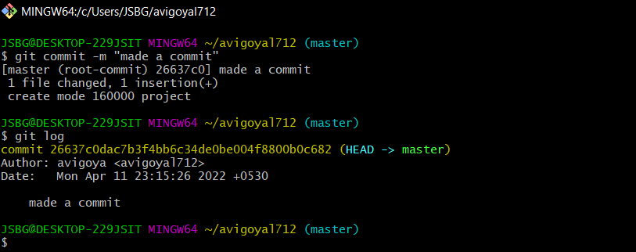

## 7. Create and Visualize Branches

A branch in Git is simply a lightweight movable pointer to one of these commits. The default branch name in Git is master.

### Step1: CHECKING UP THE BRANCHES

You can check which branch you are working in by using the command

1. ‘git branch’

The default branch is always the master branch. The page looks like as: -

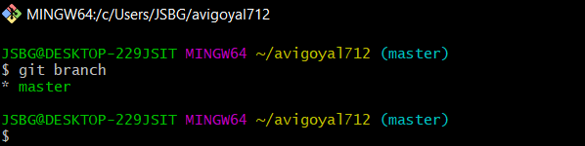

### Step2: CHECKING MULTIPLE BRANCHES

You Can do it by typing: -

1. git branch (BRANCH NAME) The page looks like as: -

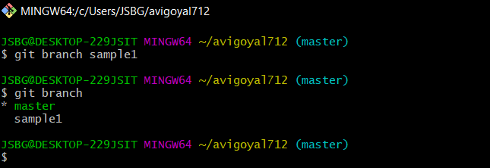

### Step3: CHANGING BRANCHES

To switch to the other branch

You Can do it by typing: -

1. git checkout (BRANCH NAME)

your page look like as

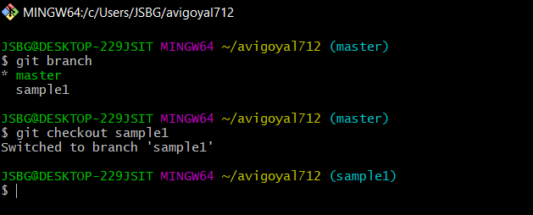

### Step4: NOW ADD FILE TO THE NEW BRANCH AND COMMIT IT

The page looks like

as:

-

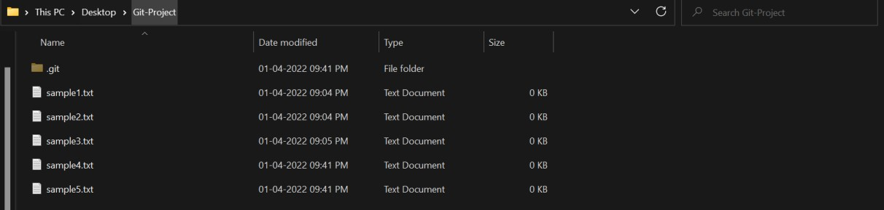

### Step5: NOW SWITCH TO BRANCH AND CHECK FILE

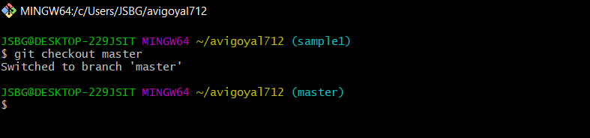

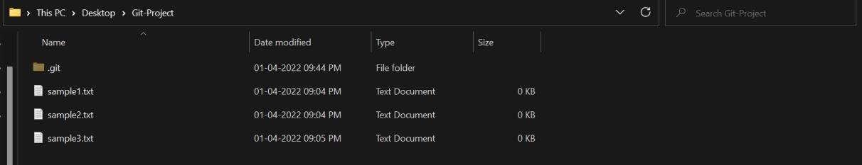

Now you can see that there is no file named HelloWorld.txt in the master branch because we created the file in the sample1 branch. So, it will be exclusive to the feature1 branch.

### Step6: GIT MERGING

Now you can merge two branches by command.

1. git merge (BRANCH NAME)

If you want to merge a new branch in master branch you need to first checkout into the master branch and then run the command.

The page looks like as: -

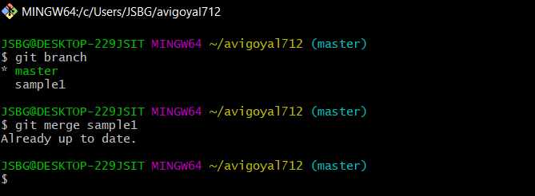

Now you can check the files in the master branch.

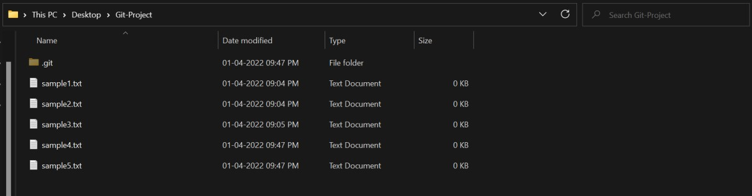

As you can see the sample4.txt and sample5.txt files are added into the master branch.

### Step7: RUNNING GIT LOG

By running git log command on the master branch you can see all the commits made in master as well as the sample1 branch.

The page looks like as: -

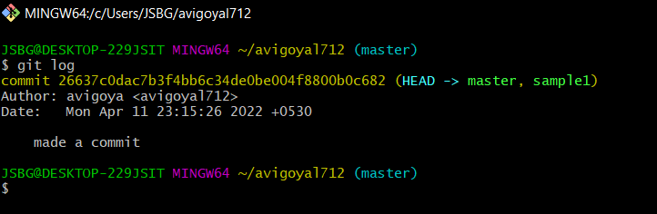

## 8. Git Lifecycle Description

There are three stages for git lifecycle:

1. Working directory
2. Staging area
3. Git repository

**Working Directory:**

The working directory is the folder in your local computer where the project files and folders are stored.

The local directory is created by the command ‘git init’ which creates a ‘.git’ named folder which is used to track the files in the directory.

‘.git folder’ is generally hidden but can be tracked enabling hidden files.



**Staging area:**

The staging area has those files which are supposed to go to the next commit. Only those files which are needed to go to the next commit stay in the staging area.

You can shift the files to the git repository by using the command

‘git add --a’.

**Git repository:**

Now since we have all the files that are to be tracked and are ready in the staging area, we are ready to commit our files using the git commitcommand. Commit helps us in keeping the track of the metadata of the files in our staging area. We specify every commit with a message which tells what the commit is about.

You can commit files by using command ‘git commit -m “message”’

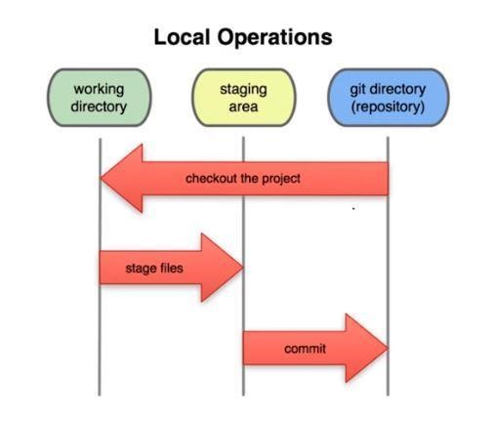

## 9. Uploading Data on GitHub

NOTE-

YOU HAVE TO MAKE A REPOSITORY IN GITHUB.

### Step1) CREATING REPOSITORY IN GITHUB

The page looks like as:

-



By clicking on new you are able to make a new repository.

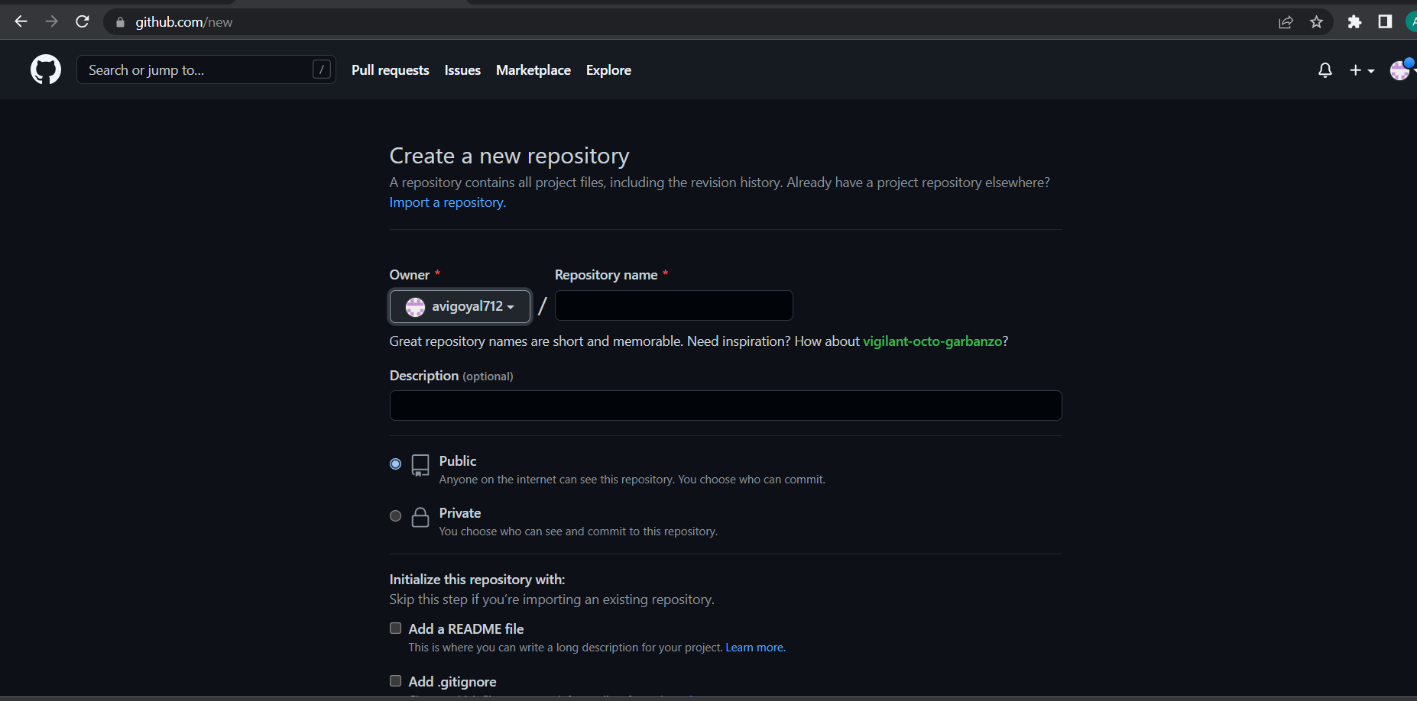

Write the repository name and click on next.



Your GITHUB Repository has been created.

### Step2) GIT ADDING REMOTE BRANCH

Git stores a branch as a reference to a commit, and a branch represents the tip of a series of commits.

You Can do it by typing: -

1. git branch -M main

The page looks like as: -

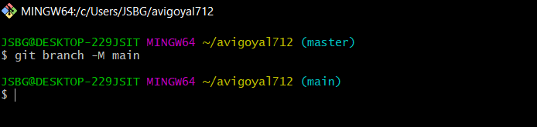

### Step3) GIT ADDING REMOTE ORIGIN

Is a Git repository that's hosted on the Internet

You Can do it by typing: -

1. git remote add origin (URL)

The page looks like as: -



### Step4) GIT PUSHING

The git push command is used to upload local repository content to a remote repository.

You Can do it by typing: -

1. git push -u origin main

# **Final Result**

1. Document in your system

The page looks like as: -

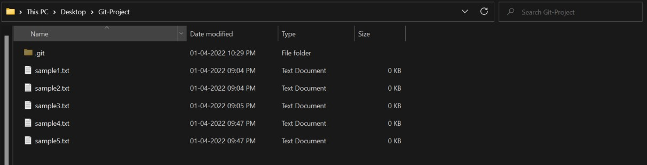

1. Document in your GITHUB Repository

The page looks like as: -

