Healthcare Appointment Intelligence
Predicting Patient No-Shows Using Machine Learning and Power BI

Project Overview:
This project analyzes healthcare appointment data to identify the factors that influence patient no-shows. The dataset was cleaned, explored, and transformed using Python. Multiple machine learning models were developed to predict the probability of patients missing their appointments. The final insights were presented through an interactive Power BI dashboard to support data-driven decision-making and improve healthcare appointment management.

Objectives:
- Analyze patient appointment data.
- Identify factors responsible for missed appointments.
- Build machine learning models for no-show prediction.
- Classify patients into different risk levels.
- Develop an interactive Power BI dashboard for business insights.

Key Insights:

Waiting Time Analysis
Patients with longer waiting times were more likely to miss their appointments. The highest no-show rates were observed for appointments scheduled 1–3 months after booking, making waiting time the strongest predictor of patient attendance.

Age Group Analysis
Teenagers recorded the highest no-show rate (25.95%), followed by young adults (23.13%). Senior citizens had the lowest no-show rate (15.12%), indicating that younger patients are less likely to attend scheduled appointments.

SMS Reminder Analysis
Patients receiving SMS reminders generally showed better attendance for appointments with longer waiting periods. Reminder systems can therefore help reduce missed appointments when waiting times are high.

Neighborhood Analysis
Some neighborhoods consistently showed higher no-show rates than others. SANTOS DUMONT, SANTA CLARA, and ITARARÉ were among the highest-risk neighborhoods, suggesting that targeted interventions may improve attendance.

Machine Learning Insights
Among all evaluated models, Gradient Boosting achieved the highest ROC-AUC (0.7342), while waiting time, age, SMS reminders, and neighborhood were identified as the most influential factors affecting appointment attendance.

Business Recommendations:
- Reduce appointment waiting times wherever possible, as longer waiting periods are strongly associated with higher no-show rates.
- Strengthen reminder strategies, especially for patients with long waiting times and those classified as medium or high risk.
- Focus awareness and follow-up efforts on younger patients, particularly teenagers and young adults.
- Provide additional support and targeted communication in high-risk neighborhoods to improve appointment attendance.
- Integrate the machine learning prediction model into the appointment scheduling system so that healthcare staff can identify high-risk patients and take preventive actions.

Conclusion:
This project successfully analyzed healthcare appointment data and identified the major factors influencing patient no-shows. Machine learning techniques were used to predict the probability of missed appointments, while Power BI dashboards transformed the analytical results into meaningful business insights. The findings can help healthcare organizations reduce missed appointments, optimize resource utilization, and improve the overall efficiency of patient care through data-driven decision-making.

Power BI Dashboard:
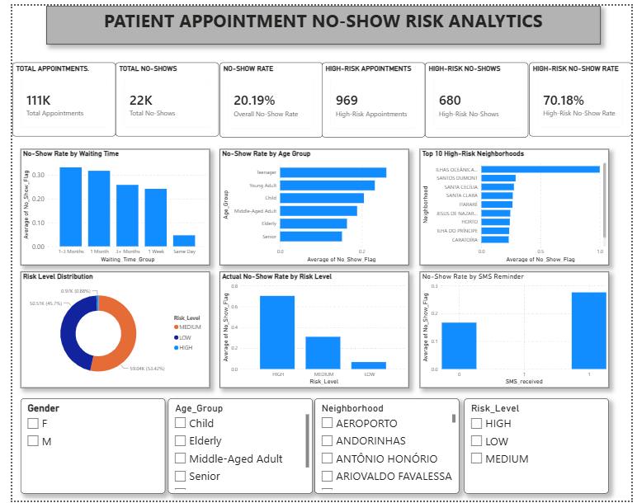

Thank You!

Report Prepared By

Abhay Joshi

