Student Performance Prediction using Machine Learning

Name: Abhay Joshi
Internship: ReadyNest Internship Program
Week: 4
Project: Student Performance Prediction using Machine Learning
Tools Used:
• Python
• Pandas
• NumPy
• Matplotlib
• Seaborn
• Scikit-learn
• VS Code

Objective:
The objective of this project is to build a predictive analytics system capable of predicting student GPA using machine learning techniques. The project includes data preprocessing, exploratory data analysis (EDA), model development, prediction, and performance evaluation to identify factors that influence academic performance.

Dataset Description:
The dataset contains information about students, including demographic details, study habits, attendance, parental support, tutoring, extracurricular activities, and academic performance. The target variable selected for prediction is GPA (Grade Point Average).

Methodology:

Data Collection:
- The student performance dataset was loaded into a Pandas DataFrame using Python.
- The dataset contained academic, demographic, and behavioral information about students.

Data Preprocessing:
- Checked the dataset structure using head(), shape, columns, and info().
- Verified that there were no missing values.
- Verified that there were no duplicate records.
- Selected the input features and target variable for model training.

Exploratory Data Analysis (EDA):
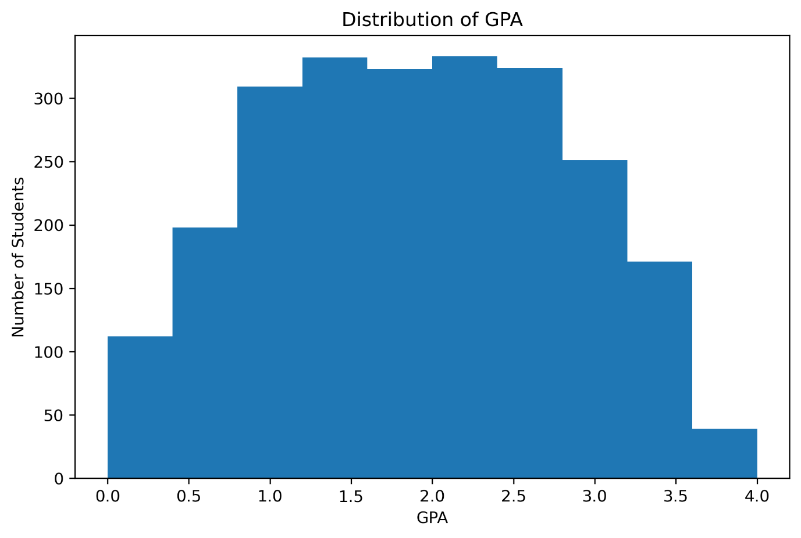
Figure 1: Distribution of Student GPA
The histogram shows the distribution of student GPA values in the dataset. Most students have GPAs concentrated in the middle range, indicating that the dataset contains a balanced distribution of academic performance.
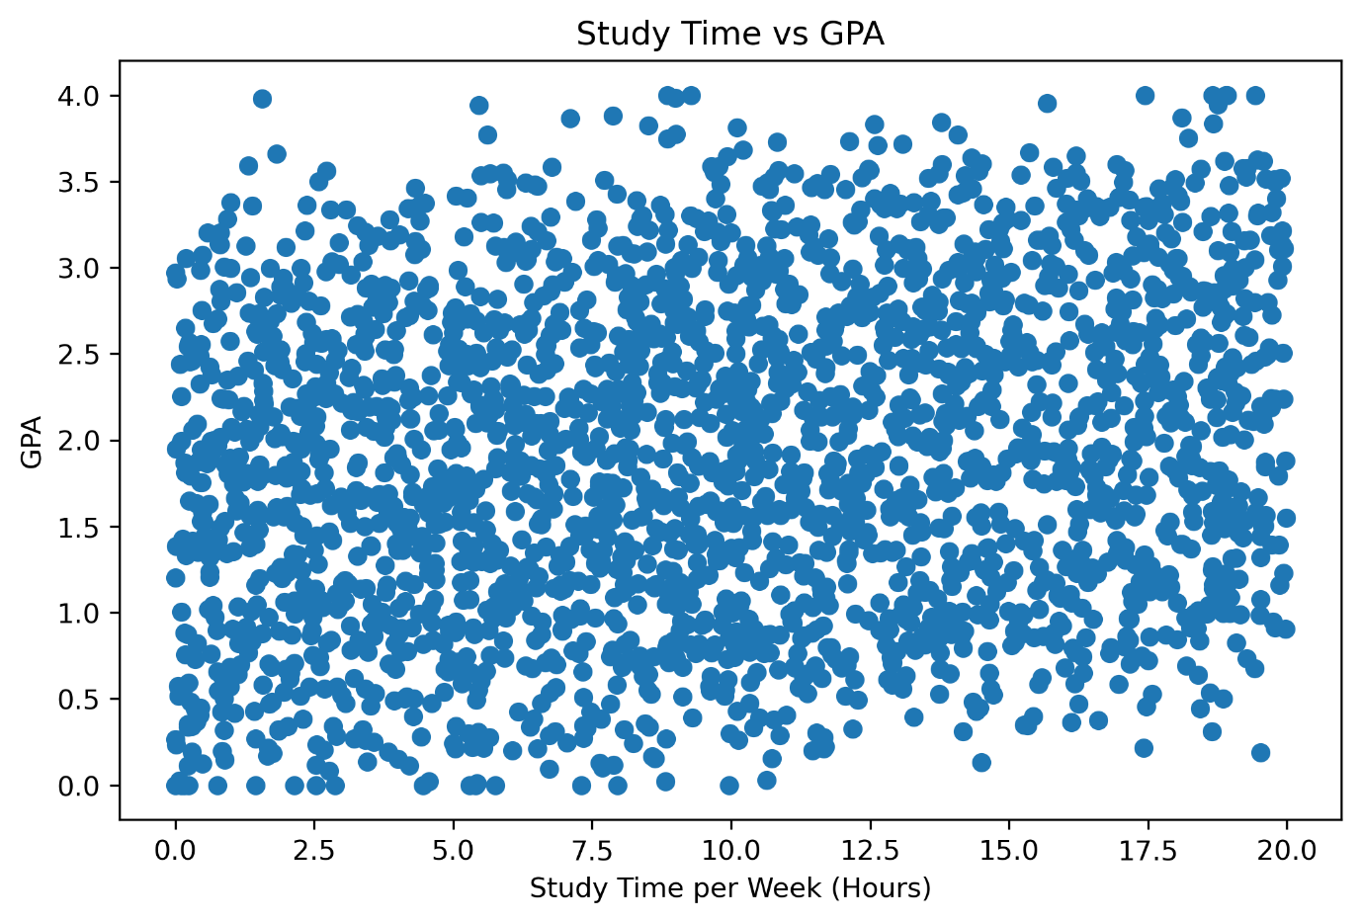
Figure 2: Study Time per Week vs GPA
The scatter plot illustrates the relationship between weekly study time and GPA. Students who spend more time studying generally tend to achieve higher GPAs, indicating a positive relationship between study habits and academic performance.
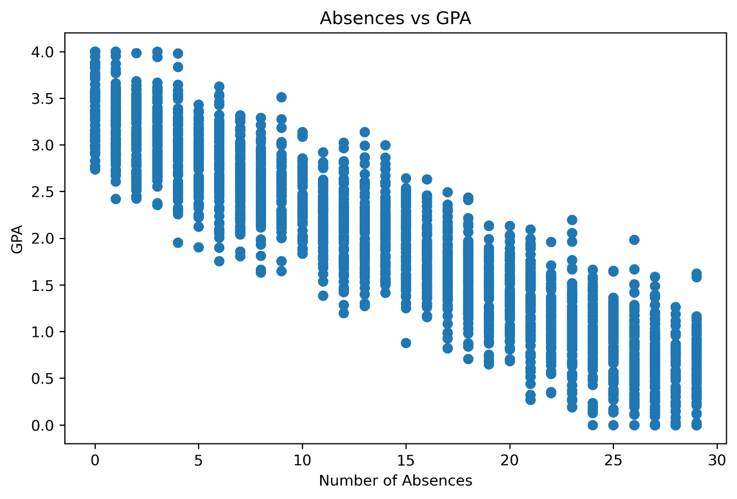
Figure 3: Number of Absences vs GPA
The scatter plot shows the relationship between student absences and GPA. Students with a higher number of absences generally tend to have lower GPAs, suggesting that regular attendance plays an important role in academic performance.
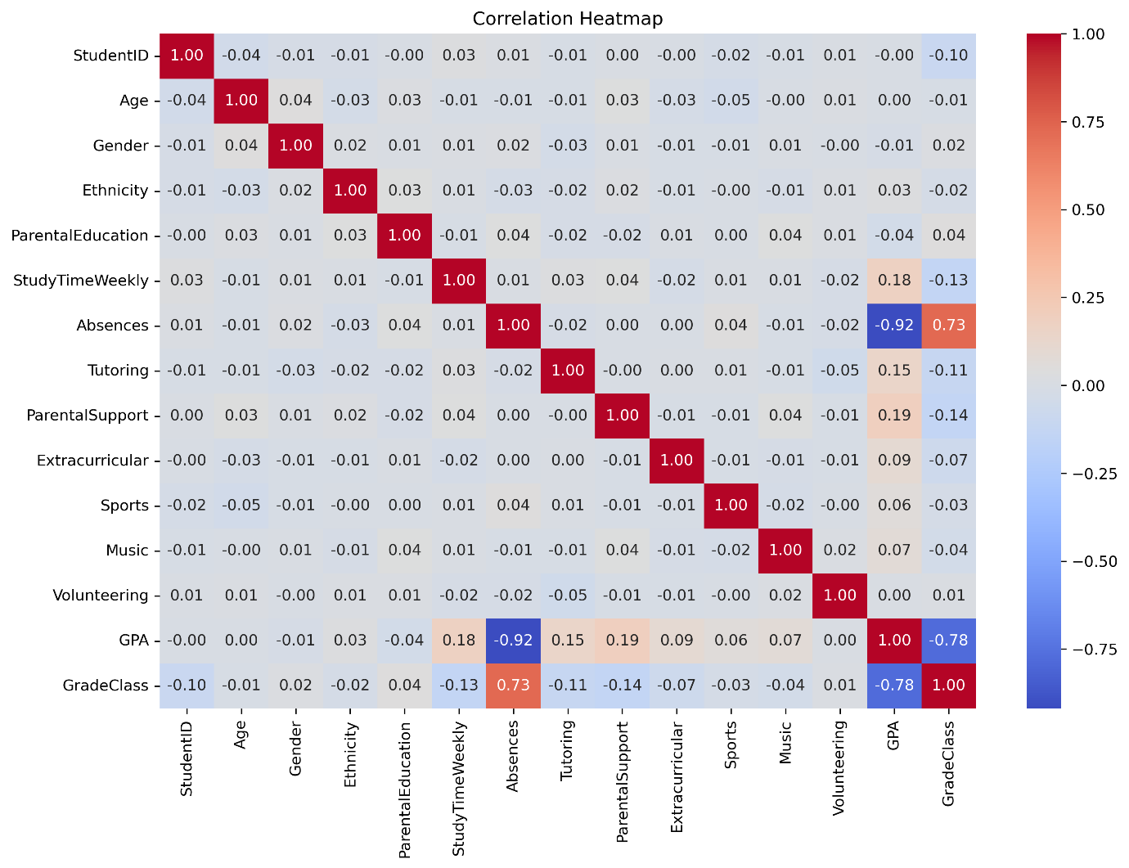
Figure 4: Correlation Heatmap of Student Performance Dataset
The correlation heatmap illustrates the relationships among all numerical variables in the dataset. It helps identify which features are positively or negatively associated with GPA and provides valuable insights for feature selection in the machine learning model.
- Analyzed the distribution of GPA.
- Examined gender distribution.
- Studied the relationship between study time and GPA.
- Analyzed the impact of absences on GPA.
- Examined parental support and tutoring effects.
- Generated a correlation heatmap to understand relationships between variables.

Model Building:
- Selected GPA as the target variable.
- Split the dataset into 80% training and 20% testing using train_test_split().
- Built a Linear Regression model using Scikit-learn.
- Trained the model on the training dataset.
- Generated predictions using the testing dataset.

Model Evaluation:
The model was evaluated using:
- Mean Absolute Error (MAE)
- Mean Squared Error (MSE)
- R² Score

Results:

Model Performance:
The Linear Regression model was trained using 80% of the dataset and evaluated on the remaining 20%.
The model achieved the following performance:
Metric | Value
Mean Absolute Error (MAE) | 0.1553
Mean Squared Error (MSE) | 0.0387
R² Score | 0.9532
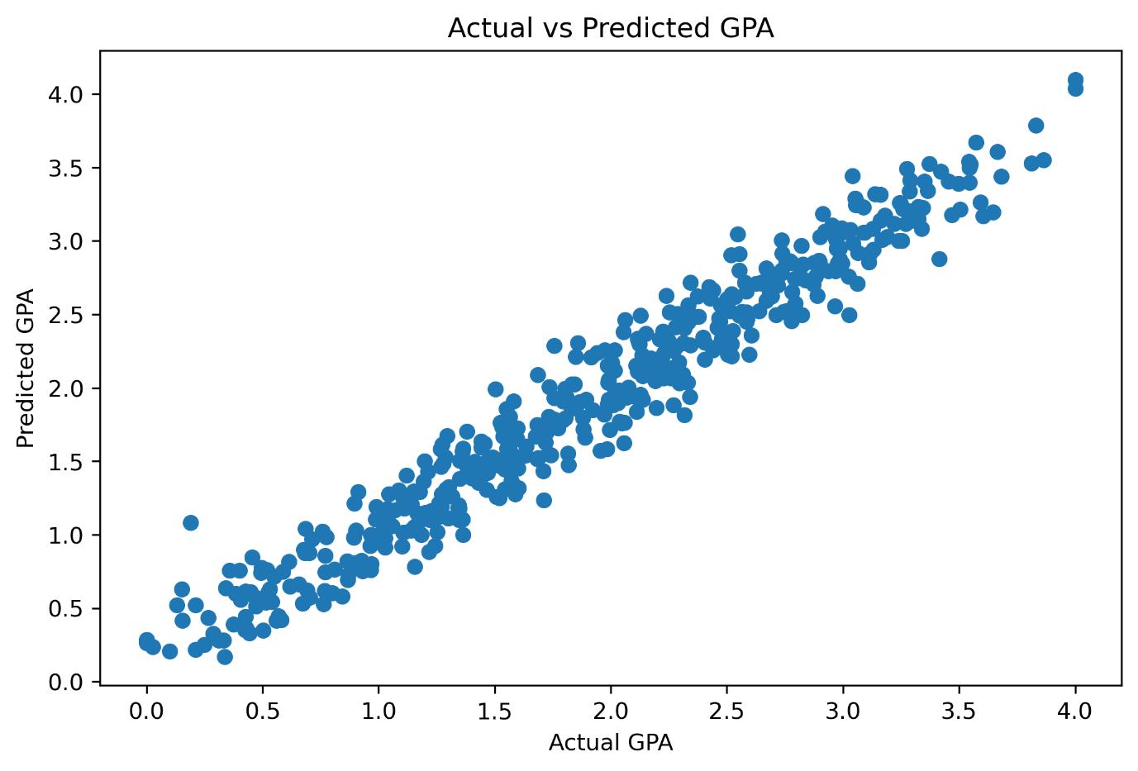
Figure 5: Actual GPA vs Predicted GPA
The scatter plot compares the actual GPA values with those predicted by the Linear Regression model. The close alignment between the predicted and actual values demonstrates the model's excellent predictive performance, which is further supported by the high R² Score of 0.9532.

Interpretation:
- The model achieved an R² Score of 0.9532, indicating excellent predictive performance.
- The Mean Absolute Error (0.1553) shows that the predicted GPA values are, on average, very close to the actual GPA values.
- The low Mean Squared Error (0.0387) indicates that the model makes only small prediction errors.
- Overall, the Linear Regression model performed very well on this dataset and can accurately predict student GPA.

Key Insights:
- Students who spent more time studying generally achieved higher GPAs.
- A higher number of absences was associated with lower academic performance.
- Parental support showed a positive relationship with student GPA.
- Students who received tutoring generally performed better than those who did not.
- The correlation analysis highlighted the variables most closely related to GPA, helping identify important factors influencing academic performance.

Conclusion:
This project successfully developed a predictive analytics system to predict student GPA using a Linear Regression model. The dataset was preprocessed, analyzed using exploratory data analysis, and used to train and evaluate the machine learning model. The model achieved an R² Score of 0.9532, indicating excellent predictive performance. The project demonstrates how machine learning can be used to analyze educational data and support data-driven decision-making.

Future Scope:
- Compare the performance of multiple machine learning models such as Decision Tree, Random Forest, and XGBoost.
- Train the model using larger and more diverse student datasets.
- Develop a web-based application where users can enter student details and receive GPA predictions.
- Continuously update the model with new data to improve prediction accuracy.

References:
- Kaggle – Student Performance Dataset
- Python Documentation
- Pandas Documentation
- NumPy Documentation
- Matplotlib Documentation
- Seaborn Documentation
- Scikit-learn Documentation

