**Assignment – A1**

**UML Diagrams**

1. Use-Case Diagram :

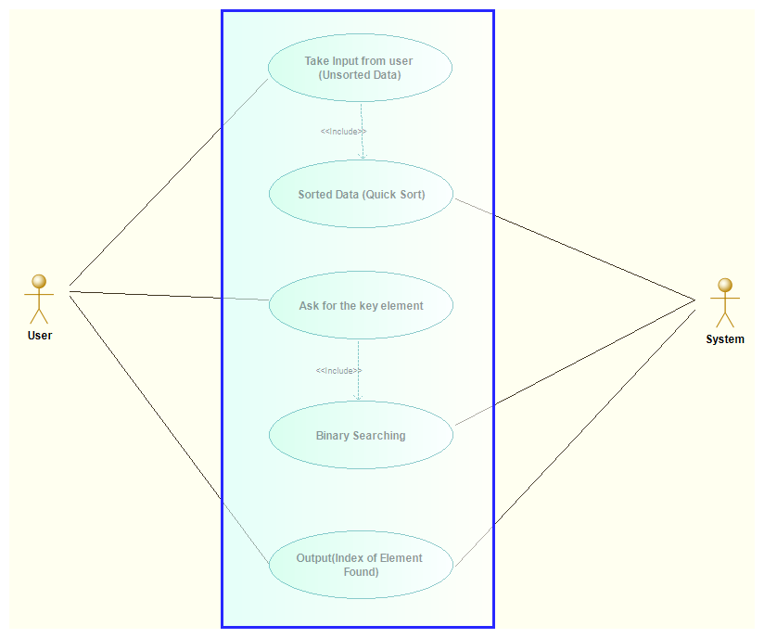

1. Activity Diagram :

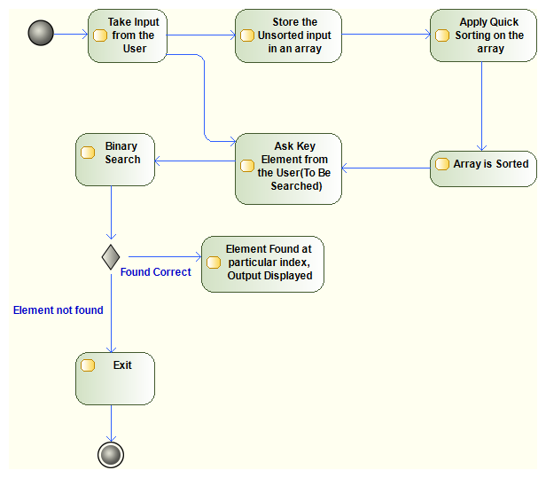

1. State Machine Diagram :

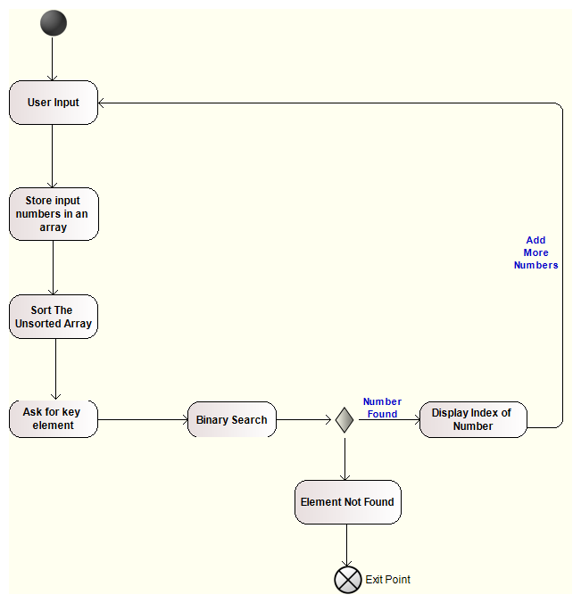

1. Class Diagram :

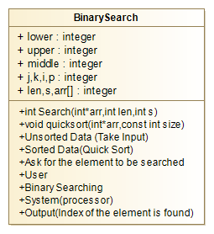

1. Sequence Diagram :

