**Assignment A2**

**(UML Diagrams)**

**1. Use-case Diagram**

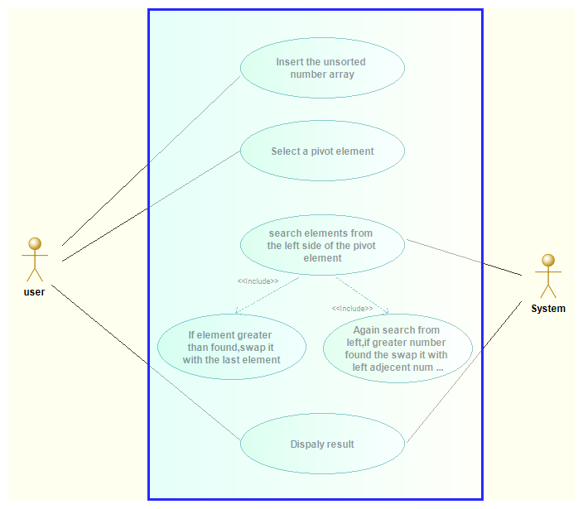

2. Activity Diagram

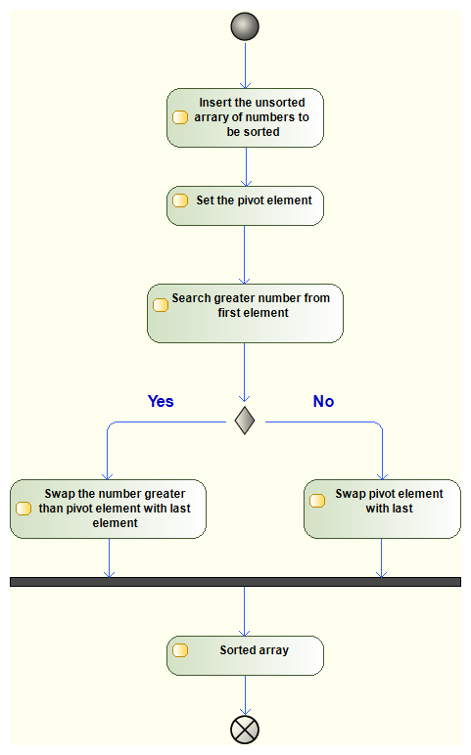

3. State Diagram

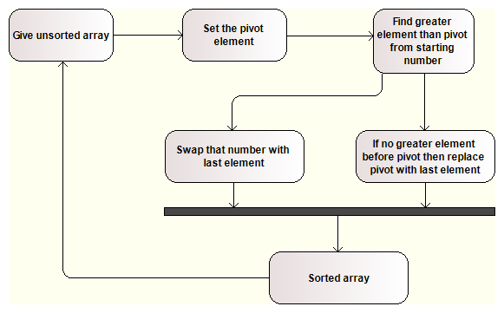

4. Sequence Diagram

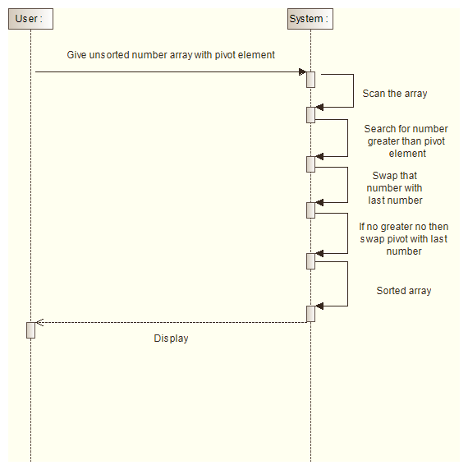

0

5. Class Diagram

