UML DIAGRAMS

1. State-Machine Diagram:

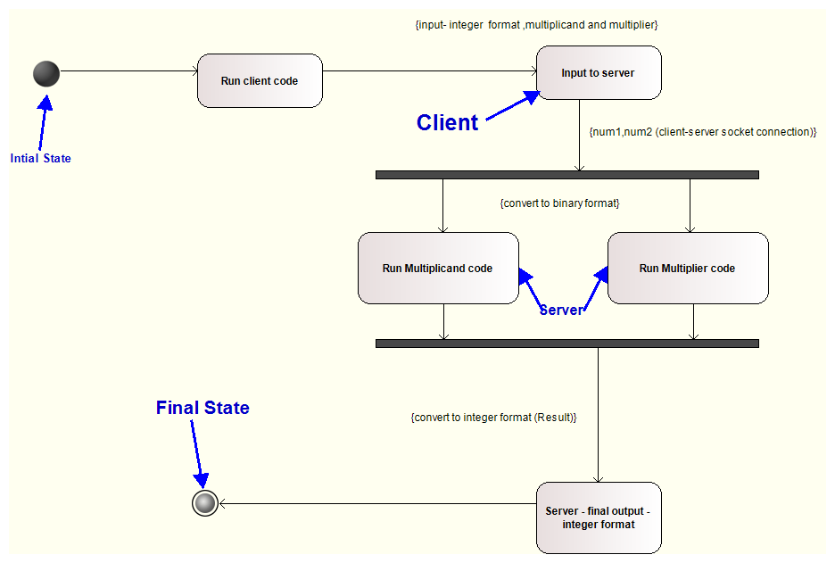

2. Activity Diagram:

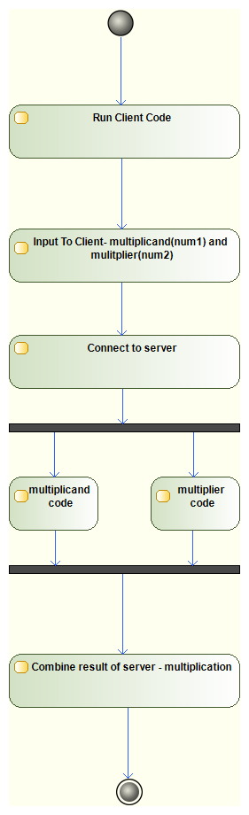

3. Sequence Diagram:

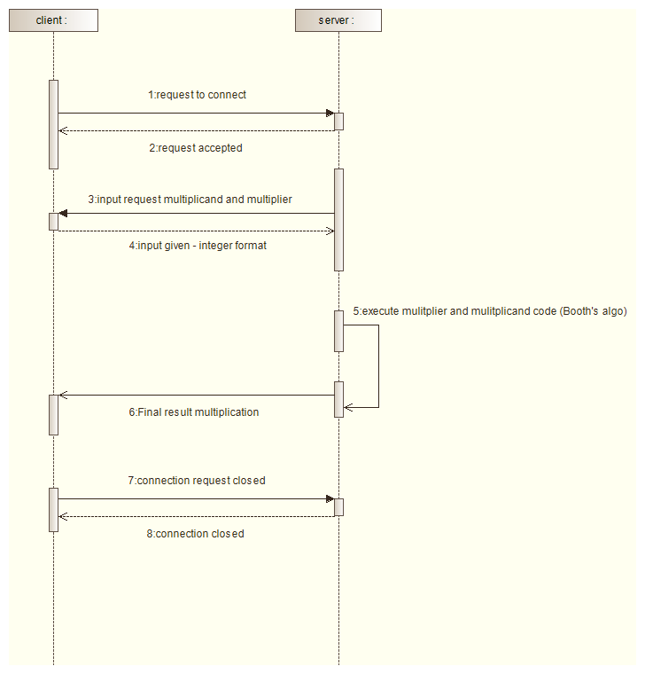

4. Use-Case Diagram:

