**Assignment – A5**

**UML Diagrams**

1. Use-case Diagram :

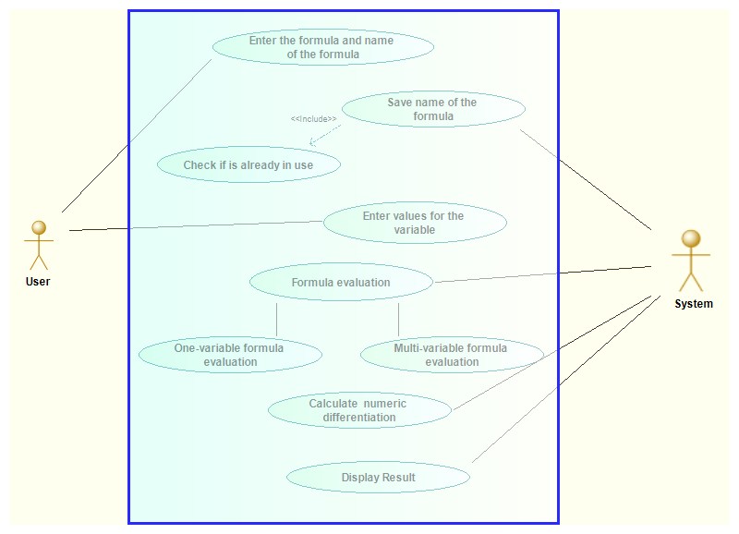

1. Activity Diagram :

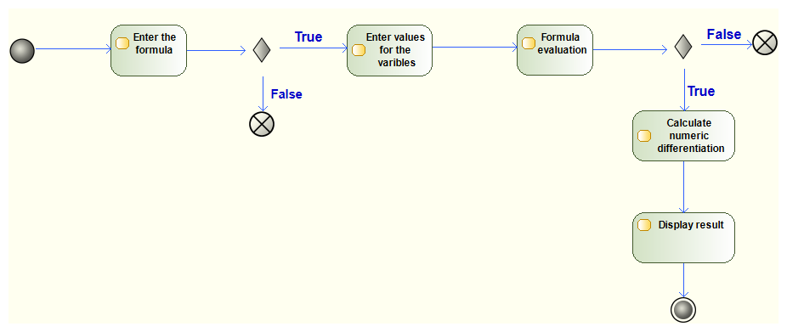

1. Sequence Diagram:

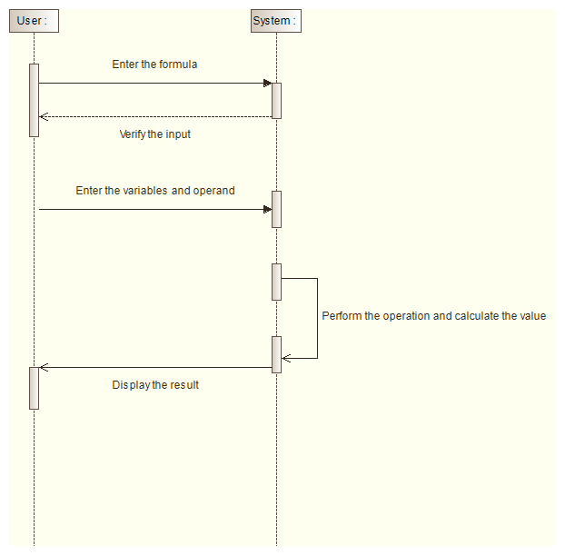

1. State Machine:

