**Assignment – A1**

**UML Diagrams**

1. Use-Case Diagram :

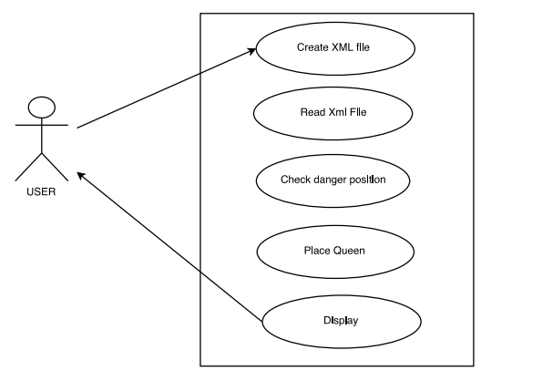

1. Activity Diagram :

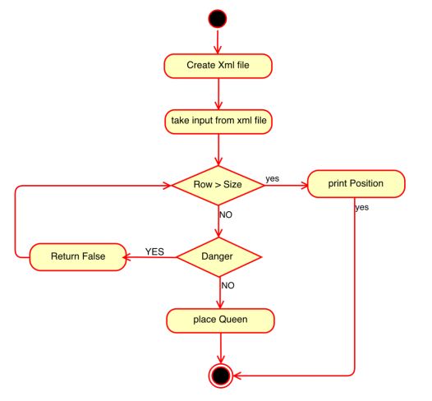

1. Sequence Diagram :

