**Odd-Even Sort:-**

1. **Use-Case Diagram:-** fjghjklbg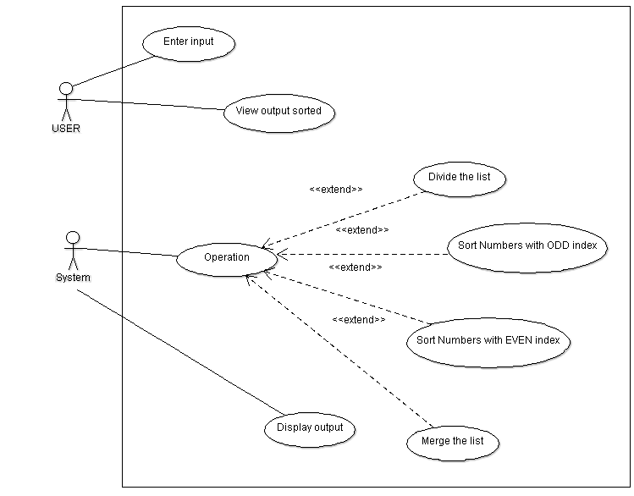
2. **State Diagram:-** 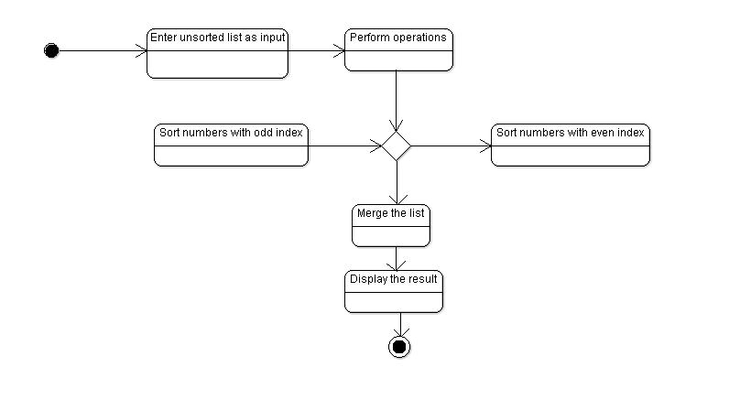
3. **Activity Diagram:-**

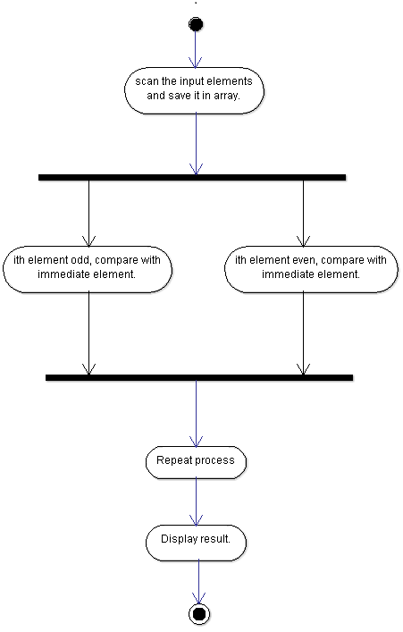

1. **Class Diagram:-**

