Institute of Engineering & Technology
Department of Computer Engineering & Application

Enhancing Creative Content Generation Using Adaptive Generative AI (Chhaya AI)
A Project Report submitted in partial fulfilment of the requirements for the award of the degree of
Bachelor of Technology
in
Computer Science and Engineering
(AIML)
by
Ansh Yadav
Abhay Kumar
Adarsh Katara

Group No.: 01
Under the Guidance of

Project Guide Signature :

DECLARATION
We, Ansh Yadav, Abhay Kumar, Adarsh Katara, students of B.Tech in Computer Science and Engineering (Artificial Intelligence and Machine Learning) at GLA University, Mathura, hereby solemnly declare that the project report entitled "Enhancing Creative Content Generation Using Adaptive Generative AI (Chhaya AI)" submitted in partial fulfillment of the requirements for the award of the degree of Bachelor of Technology is an authentic record of our original work carried out during the eighth semester under the valuable guidance and supervision of Project Guide, Department of Computer Engineering & Applications.
We further declare that the work presented in this report is a result of our own efforts, research, and contributions, except where explicit references have been made.
The findings, designs, implementations, and conclusions drawn are based on the project conducted by us.
This work has not been submitted elsewhere, either in part or in full, for the award of any degree, diploma, or academic qualification.
We also acknowledge that we have adhered to the ethical guidelines, academic integrity, and project norms set by the University throughout the course of this project.

CERTIFICATE
This is to certify that the project report entitled "Enhancing Creative Content Generation Using Adaptive Generative AI (Chhaya AI)" submitted by Ansh Yadav, Abhay Kumar, Adarsh Katara in partial fulfillment of the requirements for the award of the degree of Bachelor of Technology in Computer Science and Engineering (Artificial Intelligence and Machine Learning) from GLA University, Mathura, is a bona fide record of the original work carried out by them under my supervision and guidance during the academic year 2025-2026.
The work embodied in this report is genuine to the best of my knowledge and has not been submitted, either in part or in full, for the award of any other degree or diploma in this or any other institution.
The students have fulfilled all the requirements as per the academic guidelines prescribed by the University.
Project Guide
Department of Computer Engineering & Applications
GLA University, Mathura

Project Guide
Technical Trainer
Department of Computer Engineering & Applications GLA University, Mathura

ACKNOWLEDGEMENT
The successful completion of any project is never the work of a single individual.
It is the culmination of collective effort, guidance, and support from many quarters.
We take this opportunity to express our profound gratitude to all those who have contributed directly or indirectly to the successful execution of this project.
We extend our sincere thanks to our project guide for continuous guidance, constructive criticism, and encouragement.
We are grateful to the Head of Department and all faculty members for providing the necessary infrastructure and academic environment.
Finally, we thank our parents and friends for their unwavering moral support and motivation.

ABSTRACT
Chhaya AI is an adaptive multi-modal creative intelligence system that assists users in generating text, image, and audio content through a unified workflow.
The platform blends prompt engineering with a persistent creative memory and feedback loops to keep outputs aligned with user intent, cultural context, and stylistic preferences.
The system integrates specialized engines for each modality (Gemini for prompt generation, Stability AI for images, Runway for video, and ElevenLabs + Suno for narration and music).
A Node.js API orchestrates generation requests, applies constraints, and records adaptive profiles, while a React-based UI provides workspaces for iterative refinement.
This report presents the problem motivation, architecture, methodology, and evaluation of Chhaya AI, demonstrating how a modular, feedback-driven pipeline can enhance creative production quality, consistency, and speed.

- Synopsis 1
- Technical Keywords 2
2.1 Area of Project . . . . . . . . . . . . . . . . . . . . . . . . . . . . 2
2.2 Technical Keywords . . . . . . . . . . . . . . . . . . . . . . . . . . 2
- Introduction 3
3.1 Project Idea . . . . . . . . . . . . . . . . . . . . . . . . . . . . . . 3
3.2 Motivation of the Project . . . . . . . . . . . . . . . . . . . . . . . 4
3.3 Literature Survey . . . . . . . . . . . . . . . . . . . . . . . . . . . 5
- Problem Definition and scope 7
4.1 Problem Statement . . . . . . . . . . . . . . . . . . . . . . . . . . 7
4.1.1 Goals and objectives . . . . . . . . . . . . . . . . . . . . . 7
4.1.2 Statement of scope . . . . . . . . . . . . . . . . . . . . . . 8
4.2 Major Constraints . . . . . . . . . . . . . . . . . . . . . . . . . . . 8
Methodologies of Problem solving . . . . . . . . . . . . . . . . . . 9
4.3.1 Analysis . . . . . . . . . . . . . . . . . . . . . . . . . . . 9
Design 10
Development 10
Evaluation 10
Outcome 10
Applications 10
Hardware Resources Required 10
Software Resources Required 11
- Project Plan 12
Project Model Analysis 12
Reconciled Estimates 13
Cost Estimation using COCOMO(Constructive Cost) Model 13
Risk Management w.r.t. NP Hard analysis 14
Risk Identification 14
Risk Analysis 14
Project Schedule 16
Project task set 16
Timeline chart 16
- Software requirement specification 17
Introduction 17
Purpose and Scope of Document 17
Use Case View 17
Functional Model and Description 18
Data Flow Diagram 18
Activity Diagram: 20
Non Functional Requirements: 21
Sequence Diagram 22
- Detailed Design Document 23
Introduction 23
System Architecture 23
Architectural Design 25
Module 1 : Data-set Gathering 25
Module 2 : Pre-processing 26
Module 3: Data-set split 27
Module 4: Model Architecture 28
Module 5: Hyper-parameter tuning 29
- Project Implementation 31
Introduction 31
Tools and Technologies Used 32
Planning 32
UML Tools 32
Programming Languages 32
Programming Frameworks 32
IDE 32
Versioning Control 32
Cloud Services 32
Application and web servers: 33
Libraries 33
Algorithm Details 33
Dataset Details 33
Preprocessing Details 33
Model Details 34
Model Training Details 37
Model Prediction Details 39
- Software Testing 40
Type of Testing Used 40
Test Cases and Test Results 41
- Results and Discussion 42
Screen shots 42
Outputs 46
Model results 46
- Deployment and Maintenance 48
Deployment 48
Maintenance 48
- Conclusion and Future Scope 50
Conclusion 50
Future Scope 50
- References 51
- Project Planner 53
- Paper Published Summary 55
- Participation Certificate 59
- Plagiarism Report 60
- Information of Project Group Members 61

Area of Project
Artificial Intelligence, Generative AI, and Human-in-the-loop creative tooling for multi-modal content.

Technical Keywords
    - Generative AI, Prompt Engineering, Multi-modal Generation, Adaptive Memory, Feedback Learning, JWT Auth, React, Node.js.

Project Idea
Build an adaptive creative studio that supports text, image, and audio generation in one workflow.
The system maintains a persistent creative memory, enforces cultural alignment, and refines outputs based on explicit feedback and edits.

Motivation of the Project
Creative teams often juggle multiple tools for scripting, visuals, and audio.
This fragmentation leads to context loss and inconsistent style.
Chhaya AI addresses this by providing a unified pipeline where intent, tone, and constraints persist across modalities, improving coherence and reducing iteration time.

Literature Survey
Recent advances in large language models and diffusion-based image models have enabled rapid creative generation.
However, most systems remain single-modal and lack long-term memory.
Research in prompt engineering, retrieval-augmented generation, and preference learning highlights the value of structured controls and feedback loops.
Chhaya AI incorporates these ideas by combining a reasoning layer, creative memory, and modality-specific engines.

Problem Statement
Enhancing Creative Content Generation Using Adaptive Generative AI (Chhaya AI).

Goals and objectives
Develop a multi-modal creative platform, maintain persistent creative memory, enforce cultural and tonal constraints, and enable feedback-driven refinement.
      - Ensure that the platform is usable, scalable, and produces consistent outputs across text, image, audio, and video.

Statement of scope
The scope includes a web-based UI, API orchestration, prompt generation, and integration with third-party generation services.
Non-goals include training proprietary foundation models or building production-grade deployment pipelines.

Major Constraints
- External API rate limits, model costs, and latency are primary constraints.
- Additional constraints include safe content filtering, storage limits for generated assets, and maintaining prompt privacy.

Methodologies of Problem solving

Analysis
      - Requirement analysis focused on user flows for prompt creation, generation, and feedback.
We identified critical system components: authentication, generation orchestration, creative memory, and analytics.

Design
The design uses a layered architecture: UI, API gateway, adaptive processing, and data services.
Each layer exposes clear interfaces, enabling substitution of model providers or storage systems.

Development
Development was done in Node.js for the backend and React for the frontend.
We integrated Gemini, Stability AI, Runway, ElevenLabs, and Suno through service adapters and created a shared schema for generation requests.

Evaluation
Evaluation considered prompt quality, cross-modal consistency, responsiveness, and usability.
Tests focused on API responses, memory updates, and correct routing to each generation engine.

Outcome
A working prototype that generates multi-modal creative outputs, adapts to feedback, and provides a cohesive workflow in a single interface.

Applications
Content creators, marketing teams, social media managers, and educators can use Chhaya AI to generate scripts, visuals, and audio assets with consistent style and context.

Hardware Resources Required
Standard development laptop (8GB+ RAM), internet access for API calls, and optional GPU for local experimentation.

Sr. No. | Parameter | Minimum Requirement
1 | Intel Xeon E5 2637 | 3.5 GHz
2 | RAM | 16 GB
3 | Hard Disk | 100 GB
4 | Graphic card | Optional

Software Resources Required
Node.js, npm, React (Vite), Firebase Auth, and third-party AI SDKs/APIs (Gemini, Stability, Runway, ElevenLabs, Suno).

Project Model Analysis
A hybrid Agile model was adopted.
Iterations were structured around delivering functional workspaces (text, image, audio, video) and integrating user feedback into creative memory.

Reconciled Estimates
      - Effort estimates considered API integration time, UI development, and testing.
Revisions were applied after early spikes to balance integration complexity with UI polish.

Cost(in Rs) | Description
5260 | Pre-processing the dataset on GCP
2578 | Training models on on GCP
761 | Google Colab Pro subscription
3000 | Deploying project to GCP using Cloud engine

Cost Estimation using COCOMO(Constructive Cost) Model
Using a small-scale organic model, the estimated effort is modest due to heavy reliance on managed AI services.
The main cost drivers are integration and UI/UX iteration rather than algorithmic implementation.

Risk Management w.r.t. NP Hard analysis

Risk Identification
Identify provider outages, API key misconfiguration, and inconsistent output quality.

Risk Analysis
Prioritize risks by likelihood and impact, emphasizing service availability and compliance constraints.

ID | Risk Description | Probability | Impact
 |  |  | Schedule | Quality | Overall
1 | Does it over blur comparing with other non- facial areas of the video? | Low | Low | High | High
2 | Does it flick? | High | Low | High | High
3 | Does it have a change of skin tone near the edge of the face? | Low | High | High | Low
4 | Does it have a double chin, double eyebrows, double edges on the face? | High | Low | High | Low
5 | When the face is partially blocked by hands or other things, does it flick or get blurry? | High | High | High | High

Probability | Value | Description
High | Probability of occurrence is | > 75%
Medium | Probability of occurrence is | 26 − 75%
Low | Probability of occurrence is | < 25%

Project Schedule

Project task set
Task sets included UI design, backend service integration, authentication, creative memory, and generation testing.

Timeline chart
A Gantt-style timeline was maintained with weekly milestones for each module and integration checkpoint.

Introduction

Purpose and Scope of Document
This report documents the system requirements, architecture, design decisions, implementation details, testing, and deployment considerations for Chhaya AI.

Use Case View
Primary use cases include: create prompt, generate text, generate image prompt, generate audio prompt, generate video, submit feedback, and update creative memory.

Functional Model and Description
The functional model maps user requests to generation services.
Requests are validated, enriched with memory and controls, routed to the appropriate engine, and stored for feedback learning.

Data Flow Diagram
Data flows from the UI to the API gateway, into the creative engine for intent analysis, then to modality-specific services, and finally to storage and feedback modules.

Activity Diagram:
User selects workspace -> enters prompt -> sets controls -> triggers generation -> views output -> submits feedback -> memory updates.

Non Functional Requirements:
The system must be responsive, secure, and reliable.
Target latency for prompt generation is under a few seconds.
      - Logs and monitoring should provide traceability and error diagnosis.

Sequence Diagram
UI sends request -> API validates -> memory service enriches -> generation engine produces output -> API stores result -> UI displays output.

Introduction

System Architecture
Chhaya AI uses a layered architecture with UI, API gateway, adaptive processing, and data services.
Each generation engine is encapsulated as a service adapter to allow future replacement without large refactors.

Architectural Design

Module 1: Prompt Intake
For making the model efficient for real time prediction. We have gathered the data from different available data-sets like FaceForensic++(FF)[1], Deepfake detection challenge(DFDC)[2], and Celeb-DF[3]. Futher we have mixed the dataset the col- lected datasets and created our own new dataset, to accurate and real time detection on different kind of videos. To avoid the training bias of the model we have consid- ered 50% Real and 50% fake videos.
Deep fake detection challenge (DFDC) dataset [3] consist of certain audio alerted video, as audio deepfake are out of scope for this paper. We preprocessed the DFDC dataset and removed the audio altered videos from the dataset by running a python script.
After preprocessing of the DFDC dataset, we have taken 1500 Real and 1500 Fake videos from the DFDC dataset. 1000 Real and 1000 Fake videos from the FaceForensic++(FF)[1] dataset and 500 Real and 500 Fake videos from the Celeb- DF[3] dataset. Which makes our total dataset consisting 3000 Real, 3000 fake videos and 6000 videos in total. Figure 2 depicts the distribution of the data-sets.

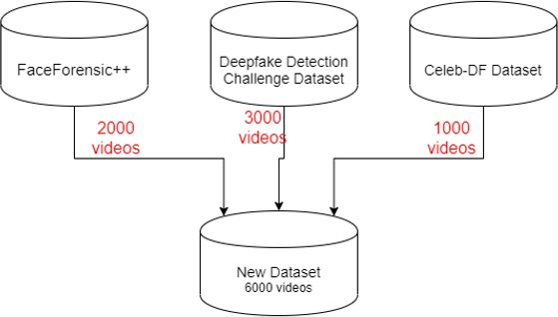

Figure 7.4: Dataset

Module 2: Intent & Constraint Alignment
In this step, the videos are preprocessed and all the unrequired and noise is removed from videos. Only the required portion of the video i.e face is detected and cropped. The first steps in the preprocessing of the video is to split the video into frames.
After splitting the video into frames the face is detected in each of the frame and the frame is cropped along the face. Later the cropped frame is again converted to a new video by combining each frame of the video. The process is followed for each video which leads to creation of processed dataset containing face only videos. The frame that does not contain the face is ignored while preprocessing.
To maintain the uniformity of number of frames, we have selected a threshold value based on the mean of total frames count of each video. Another reason for selecting a threshold value is limited computation power. As a video of 10 second at 30 frames per second(fps) will have total 300 frames and it is computationally very difficult to process the 300 frames at a single time in the experimental envi- ronment. So, based on our Graphic Processing Unit (GPU) computational power in experimental environment we have selected 150 frames as the threshold value. While saving the frames to the new dataset we have only saved the first 150 frames of the video to the new video. To demonstrate the proper use of Long Short-Term Memory (LSTM) we have considered the frames in the sequential manner i.e. first 150 frames and not randomly. The newly created video is saved at frame rate of 30 fps and resolution of 112 x 112.

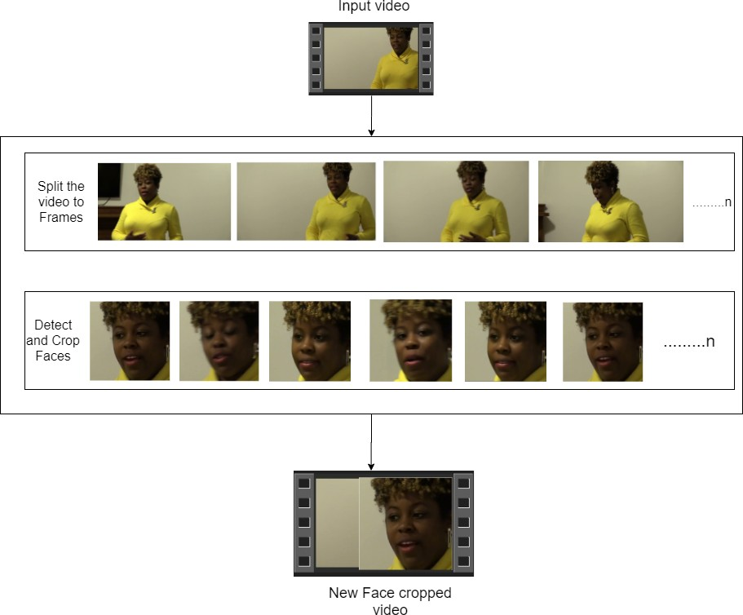

Figure 7.5: Pre-processing of video

Module 3: Engine Routing
The dataset is split into train and test dataset with a ratio of 70% train videos (4,200) and 30% (1,800) test videos. The train and test split is a balanced split i.e 50% of the real and 50% of fake videos in each split.

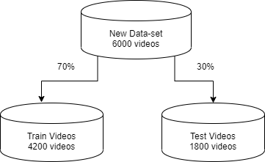

Figure 7.6: Train test split

Module 4: Multi-Engine Generation
Our model is a combination of CNN and RNN. We have used the Pre- trained ResNext CNN model to extract the features at frame level and based on the extracted features a LSTM network is trained to classify the video as deepfake or pristine. Us- ing the Data Loader on training split of videos the labels of the videos are loaded and fitted into the model for training.

ResNext :

Instead of writing the code from scratch, we used the pre-trained model of ResNext for feature extraction. ResNext is Residual CNN network optimized for high per- formance on deeper neural networks. For the experimental purpose we have used resnext50_32x4d model. We have used a ResNext of 50 layers and 32 x 4 dimen- sions.
Following, we will be fine-tuning the network by adding extra required layers and selecting a proper learning rate to properly converge the gradient descent of the model. The 2048-dimensional feature vectors after the last pooling layers of ResNext is used as the sequential LSTM input.

LSTM for Sequence Processing:

2048-dimensional feature vectors is fitted as the input to the LSTM. We are using 1 LSTM layer with 2048 latent dimensions and 2048 hidden layers along with 0.4 chance of dropout, which is capable to do achieve our objective. LSTM is used to

process the frames in a sequential manner so that the temporal analysis of the video can be made, by comparing the frame at ‘t’ second with the frame of ‘t-n’ seconds. Where n can be any number of frames before t.
The model also consists of Leaky Relu activation function. A linear layer of 2048 input features and 2 output features are used to make the model capable of learning the average rate of correlation between eh input and output. An adaptive average polling layer with the output parameter 1 is used in the model. Which gives the the target output size of the image of the form H x W. For sequential processing of the frames a Sequential Layer is used. The batch size of 4 is used to perform the batch training. A SoftMax layer is used to get the confidence of the model during predication.
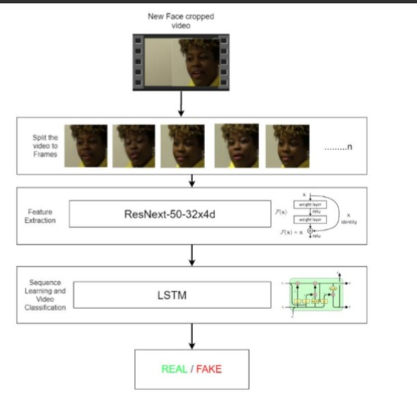

Figure 7.7: Overview of our model

Module 5: Adaptive Controls
It is the process of choosing the perfect hyper-parameters for achieving the maxi- mum accuracy. After reiterating many times on the model. The best hyper-parameters for our dataset are chosen. To enable the adaptive learning rate Adam[21] optimizer with the model parameters is used. The learning rate is tuned to 1e-5 (0.00001) to

achieve a better global minimum of gradient descent. The weight decay used is 1e-3.
As this is a classification problem so to calculate the loss cross entropy approach is used.To use the available computation power properly the batch training is used. The batch size is taken of 4. Batch size of 4 is tested to be ideal size for training in our development environment.
The User Interface for the application is developed using Django framework.
Django is used to enable the scalability of the application in the future.
The first page of the User interface i.e index.html contains a tab to browse and upload the video. The uploaded video is then passed to the model and prediction is made by the model. The model returns the output whether the video is real or fake along with the confidence of the model. The output is rendered in the predict.html on the face of the playing video.

Chapter 8
Project Implementation

Introduction
This document describes the design and implementation of Chhaya AI, an adaptive multi-modal creative platform.
The system coordinates multiple AI services while maintaining stylistic continuity and user feedback loops.

Tools and Technologies Used

Planning
      - Agile sprints with weekly integration checkpoints and UI reviews.

UML Tools
      - Draw.io and Figma for diagrams and UI planning.

Programming Languages
      - JavaScript, TypeScript, and Python for tooling scripts.

Programming Frameworks
      - React, Express.js, and Vite.

IDE
      - Visual Studio Code.

Versioning Control
      - Git and GitHub.

Cloud Services
      - Firebase Auth, hosted AI APIs, and optional object storage.

Application and web servers:
      - Node.js runtime with Express API and Vite dev server.

Libraries
      - @google/generative-ai, firebase, zod, axios/fetch, and utility libraries.

Algorithm Details

Dataset Details
No offline dataset training is required; the system relies on user prompts and feedback as dynamic data inputs.

Preprocessing Details
- Prompts are normalized, control parameters validated, and memory signals merged to ensure consistent formatting and safety.

Model Details
Text prompt generation uses Gemini; image generation uses Stability; video generation uses Runway; audio generation uses ElevenLabs (speech) and Suno (music).

Model Training Details
- Chhaya AI does not train custom models; it orchestrates external engines and updates user profiles using stored feedback.

Model Prediction Details
- Prediction is performed via API calls to the chosen engine, with results stored and tagged by modality and context.

Type of Testing Used
Unit tests for services, API integration tests for endpoints, UI smoke tests, and manual workflow validation.

Test Cases and Test Results
Test cases include authentication, generation success/failure handling, memory update correctness, and UI state updates.
Results show stable responses across common workflows.

Case id | Test Case Description | Expected Result | Actual Result | Status
1 | Upload a word file in- stead of video | Error message: Only video files allowed | Error message: Only video files allowed | Pass
2 | Upload a 200MB video file | Error message: Max limit 100MB | Error message: Max limit 100MB | Pass
3 | Upload a file without any faces | Error message:No faces detected. Cannot pro- cess the video. | Error message:No faces detected. Cannot pro- cess the video. | Pass
4 | Videos with many faces | Fake / Real | Fake | Pass
5 | Deepfake video | Fake | Fake | Pass
6 | Enter /predict in URL | Redirect to /upload | Redirect to /upload | Pass
7 | Press upload button without selecting video | Alert message: Please select video | Alert message: Please select video | Pass
8 | Upload a Real video | Real | Real | Pass
9 | Upload a face cropped real video | Real | Real | Pass
10 | Upload a face cropped fake video | Fake | Fake | Pass

Screen shots
Screenshots include the Landing page, Dashboard, Prompt Studio (text/image/audio), Media Generation page, and Feedback panel outputs.

Model Name | Dataset | No. of videos | Accuracy
model_90_acc  _20_frames_ FF_data | FaceForensic++ | 2000 | 90.95477
model_95_acc  _40_frames_ FF_data | FaceForensic++ | 2000 | 95.22613
model_97_acc  _60_frames_ FF_data | FaceForensic++ | 2000 | 97.48743
model_97_acc  _80_frames_ FF_data | FaceForensic++ | 2000 | 97.73366
model_97_acc  _100_frames_ FF_data | FaceForensic++ | 2000 | 97.76180
model_93_acc  _100_frames_ celeb_FF_data | Celeb-DF + FaceForen- sic++ | 3000 | 93.97781
model_87_acc  _20_frames_ final_data | Our Dataset | 6000 | 87.79160

Deployment
The system supports local development using Node.js and Vite.
Production deployment would use containerized services and secure environment variables for API keys.

Conclusion
Chhaya AI demonstrates how adaptive creative intelligence can unify multi-modal generation into a coherent workflow.
The system improves consistency, reduces iteration time, and enables personalized creative output.

Future Scope
Future work includes improved memory embeddings, real-time collaboration, richer analytics, and on-device inference options.

