Hardware safety requirements:

* Hardware development is not always based on the hardware requirement, but ISO26262 mandates that
* It describes how safety mechanisms should be implemented
* It should contain,
  + How do hardware elements cover the transient faults
  + How tolerant are the safety mechanism to external failures?
  + How are the safety mechanism detecting internal and external failures

Technical safety concept shall describe:

* The relevant interfaces
* Functional aspects of the safety mechanism
* The performance of the safety mechanism
* Configurations aspects
* Known issues or errors
* Production factors

Faults:

* Systematic Faults
  + Human factor
  + Processes
  + Specifications
  + Technical design
  + Software errors
  + Hardware faults
* Random faults
  + Hardware faults

FSC:

FTTI – Fault tolerant time interval

In case of faults, the system should be capable of transitioning to a state where the effect of the faults is minimized or eliminated.

How the violation of safety goal will be avoided by the item?

* Redundancies
* Time limitation for measuring
* A particular qualification measure to avoid physical degradation of a hardware component
* Triggering conditions, use case and FIT rates should be defined.

Safety goal:

What to do(guide word) + function + malfunction + (additional information)

HARA:

* Define the functions of the items
  + Functions of items and its interactions within the items
* Define the malfunction of the items
  + Malfunctions that can appear for each function
* Tailor the operational situations
  + Select the database relevant operational situation for the context of the functions that the item can implement
* Define the effect of malfunctions
  + Based on the operational situations and the malfunctions define the effect over the items

Derivation: the creation of requirement based on an analysis of higher-order requirements (ex. availability requirements)

Allocation: the assignment of a requirement to one or more system elements within the architecture. (ex. thrust requirement > propulsion requirements)

Flow Down: assigning requirement to one or more lower-level elements. (ex. water resistant requirement > all elements exposed to outside environment)

Traceability: the creation of linkage from one system elements to others (ex. mtbf requirements > availability requirements)

System engineer must know how:

- test able

- Produced

- packaged

- transported

Pre-planned product improvement requirements (P3I)

Sys Engg mush work with reliability SMEs

RFA - request for action

RFI - request for information

RVTM - requirements verification and traceability matrix

How to write requirement statement:

* Specific intent
* Desired capability
* Desired level of performance
* Functions or behavioral characteristics
* Not specifying how functions/behaviors are performed (calling for specific components)
* requirement should not specify specific piece of hardware of software into the system
* Determining proper hardware or software is not job description of the systems engineer. It is job of SMEs.
* each requirement should be unambiguous (all parties have same understanding of the requirements)
* requirement should be complete (stand alone, independent of other requirements, avoid cross referencing other requirements, avoid pronoun)
* requirement must be feasible (should not request impossible or unrealistic behavior or feature, some time all req are individually feasible but collection of them are not feasible)
* requirements should be verifiable (analysis, demonstration, test or inspection)
* requirement can use illustration/graphics

Architecture Definition

* it is abstract representation of system elements
* architecture should be implementation free
* is being performed as enabled for other process
* It is primary artifact for the system requirements specifications etc.

Primary goal for architecture definition:

* produce alternate concepts
* compare concepts in trade studies
* select one or more concept alternative(s)

Inputs to architecture definitions:

* Life cycle concepts
* system function definition
* system requirements
* system functional interface identification
* System requirements traceability
* Updated RVTM
* Design traceability
* Interface definition update identification
* Life cycle constraints.

Goes into architecture definition

* Prepare for architecture definition
* Develop architecture viewpoints
* Develop models and views
* Relate the architecture to the design
* Assess architecture candidates
* Manage the selected architecture

Output of architecture definition

* Architecture definition strategy
* System architecture description
* System architecture rationale
* Documentation tree
* Preliminary interface definition
* Technical performance measure needs and data
* Architecture traceability
* Architecture definition record.

Architecture views

* operational (user's perspective)
* logical (acquirer/customer's perspective)
* Physical (designer's perspective)

Architecting is abstract/inductive. More art than science designing is deductive. More science than art

Architecture is not a modeling language.

Model based systems engineering (MBSE)

* systems engineering (requirement development, functional and mission development, physical definition)
* MBSE tool
* MBSE language (sysML)

A thing that performs a function is called physical including software

System model domains -

* Requirement domain: description of mandatory things your widget needs to do
* Behavioral domain: all the ways your widget should behave goes
* Structural domain: what your widget is made out of is in structural domain

Interfaces: (forces, energy, data, signals or materials)

SysML - Systems modeling language and UML - unified modeling language:

* Modeling language: artificial language of communicating concept in standardized way
* agreed upon grammar and vocabulary
* mostly graphical

Unified modeling language:

* general purpose modeling language for software engineer that is intended to provide a standard way to visualize the design of a software system

System modeling language:

* general purpose modeling language for systems engineer that is intended to provide a standard way to visualize the design of a system (hardware and software)
* it adds two new diagram (requirements and parametric)

Type of diagrams:

* Structure Diagram types
  + Bdd - block definition diagram
  + ibd - internal body diagram
  + par - parametric diagram
  + pkg - package diagram
* Behavior diagram types
  + act - activity diagram
  + seq - sequence diagram
  + stm - state machine diagram
  + ucd - use case diagram
* Requirement diagram type
  + req - requirement diagram

BDD (block definition diagram)

* it is a structure of system showing system blocks, their attributes, property and interactions
* analogue to class diagram in UML
* good for systems hierarchy

IBD (internal block diagram)

* internal structure of single structure of the block
* inputs on the perimeter of diagram are brought in

Activity diagram

* Depicts system behaviors, sequencing, decision and other logic between system behaviors
* functional interfaces (force, energy, data, signal, material)
* control flow is dotted line and object flow is solid line
* decision node needs logic

Sequence diagram (never saw using this diagram)

* blocks
* relation between blocks and actors
* synchronous messages or call messages

State machine

* behavioral diagram
* on state, off state, degraded state
* nested state (substate)
* start point and end point are important

Parametric diagram

* performance, reliability and SWaP analysis (size weight and power)

Package diagram

* hierarchy diagram
* architecture diagram
* requirement domain, behavior domain and structural domain\

UML diagrams:

* Behavioral Diagram
* Activity diagram
* State machine diagram
* Interaction diagram
* Timing diagram
* Interaction overview diagram
* Communication diagram
* Sequence diagram
* Use case diagram

Structure diagram

* component diagram
* class
* composite
* deployment
* package
* object

Behavioral/functional domain:

* function/behavior and activity are synonymous in sysengg

Function is an action performed by system element that converts inputs to output. Function:

* uses input
* generates output
* based on requirements/context/scenario
* decomposes/decomposed by sub-function
* performs/performed by component

Activities vs action

* Activities are overarching system behavior, composed of actions. These are decomposed into lower-level actions.
* Actions are leaf level system behavior. Actions are not decomposed. Actions are basic units of functionality.

Activity must have at-least one input and one output.

Outputs are always different than inputs

Sequence diagram always draws relation between physical elements from functional perspective.

Functional block diagram:

- it depicts relation between internal elements to external entity

Use case:

it is a list of steps user will most likely deploy, operate, support or dispose of a system to achieve a desired goal.

* helps refine requirements.
* foster top-down design
* preempt errors and faults
* save time and money preventing faults/ errors from existing
* help decompose the problem into more manageable segment

Elements of an usecase:

* Actors: a stakeholder / one or more actors.
* Summary: description of an use case in paragraph from
* goal: primary outcome desired by an actor
* pre-condition: things that must be true prior to starting the use-case guarantees: the least the system can do for the actor, if the goal is not met.
* trigger: step 1 in course of an environment
* course of event: numbered list of actions the actor/s and system take to accomplish the goal.
* alternative path:

Primary source of function:

* Requirement specifications
* Context Diagram
* Life Cycle Concepts
* Legacy and predecessor system functions
* Parent functions

Top-down systems engineering:

* The behavioral domain is bases on
  + the requirements domain
  + the mission domain
  + itself
* the behavioral domain is not based on
  + the physical domain

Top-down sys engg

* Needs, technology driver, context basis of:
  + life cycle concepts and requirements basis of:
    - functions basis of:
      * hardware/ software

Hardware and software are based on functions. Functions are not based on hardware and software.

Stakeholder needs and requirements definition focus:

* high-risk systems ands subsystem entities
* defining systems and subsystem performance requirements/MOEs
* defining the lifecycle concepts

Architecture definition focus:

* Decompose system and subsystem functions until makes/buy decision can be made at component level
* Mitigate function-related risks into the green
* Complete the rest of the functional architecture for non-primary-mission scenarios, fail modes and recovery operations
* Heavy use of analysis, modeling and simulations

Interfaces:

* Force
* Energy
* Data
* Signal
* Material

Functional block diagram does not show logic or sequence, but it shows activities from one to other.

Primary source of function:

* Requirement specifications
* Context diagram
* Life cycle concepts
* Legacy and predecessor system functions
* Parent function

Requirement development -> functional and mission development -> Physical design

Validating system concept:

* Evaluate system performance using models, sims and prototypes
* Perform system level conceptual analysis and simulation “effectiveness” runs through missions, scenarios and use cases
* Primary focus is on mission critical performance attributes (KPP)
* Prototype may be used to demonstrate critical technologies
* Rely on independent evaluations and user feedback!

System/ product development process (INCOSE)

* Agreement Process
  + Acquisition process
  + Supply process
* Enterprise Process:
  + Enterprise environmental management process
  + Investment management process
  + System lifecycle management process
  + Resource management process
  + Quality management process
* Technical management process:
  + Project planning process
  + Project assessment and control process
  + Decision management process
  + Risk management process
  + Configuration management process
  + Information management process
  + Measurement process
  + Quality assurance process
* Technical process:
  + Business/ mission analysis process
  + Stakeholders needs and requirement definition process
  + System requirement definition process
  + Architecture definition process
  + System analysis process
  + Design definition process
  + Implementation process
  + Integration process
  + Verification process
  + Transition process
  + Validation process
  + Operation process
  + Maintenance process
  + Disposal process
* Organizational Project-enabling processes:
  + Life cycle model management process
  + Infrastructure management process
  + Portfolio management process
  + Human resource management process
  + Quality management process
  + Knowledge management process

# Design Definitions

Inputs:

* Lifecycle concepts
* System function definitions
* System requirements
* Functional interface identification
* System architecture description
* System architecture rationale
* Preliminary interface definition
* Preliminary TPM needs and data
* Architecture traceability
* Interface definition update identification
* Implementation traceability
* Life cycle constraints

Process:

* Prepare for design definition
* Establish design characteristics and design enablers related to each system elements
* Assess alternatives for obtaining system elements
* Manage the design

Output:

* Design definition strategy
* System design description
* System design rationale
* Interface definition
* TPM needs and data
* Design traceability
* System element description
* Design Definition record

# System Analysis Process

Concept

* Business/ mission analysis
* Stakeholder needs/ requirement definitions
* System requirement definition
  + These are reviewed and approved at system requirement gate review
* Architecture definition

Agreement process: In this process company hire potential external supplier to help with the system requirement generation and analysis may be.

System Development:

* Design definition
* Implementation
* Integration
* Verification

System Production:

* Validation
* Transition

Utilization

* Support
* Operation

Maintenance:

Request for Proposal:

* Also called as solicitation
* Formal means of initiating a contract for products and services from experts
* Can include purchasing already-existing systems, as-is
* Can include only labor
* Can include developing and end items
* Can span relatively brief periods of item, or
* Can span quite long periods of time.

Statement of work: services and service-related product

System requirement specification: end item description

Technology readiness level: it is a measurement scale of how mature (ready) as system segment is

* Applicable to individual system elements
* Also applicable to the system as whole

TRL1 : is least mature system

TRL9 : is most mature system

TRL1:

* An idea, based on known scientific research
* Expressed in analytical terms
* Documented in scientific white papers

TRL2:

* Rudimentary analytical studies
* Technology unproven/ does not exist
* Relies on analysis of scientific principle
* Idea validated with stakeholders
  + May invest in proof-of-concept development

TRL3:

* Proof of concept development
* Use of analysis and lab experiments
* Software logic, pseudo-code (UML model)

TRL4:

* Lab testing
* Validated concept against original idea
  + Without rigorous testing
  + Just to see if it works/ is feasible
* May be integrated with other elements

TRL5:

* Mature the design
  + Design-in the “ilities”
* Software alpha release
  + Focus on functionality “does it work?”

TRL6:

* Mature the prototype
* Entity exhibits full functionality of primary characteristics
* Software beta release
  + Focus on usability/ use satisfaction
* Sunny day scenario tests

TRL7:

* Demonstrated in controlled operational scenarios (user group sessions)
* System possesses primary features, functions, characteristics
* More rigorous environmental/ rainy day testing

TRL8:

* Baseline the design
* Build test articles, conduct operational testing

TRL9:

* Finalized product
* Fielded, in use by actual users
* Entity performs mission in real environment with real user(s)

Systems Engineer needs to consider forward integration into the production line and also to retrofit

Lead systems engineer/ chief engineer/ technical director

SEMP: Systems Engineering Management Plan

Interfaces:

* Human-machine interfaces
* Environmental interfaces
* Segment interfaces
* Software module interfaces

Interfaces are showed in the segment level context diagram.

Behavioral diagram:

* Activity diagram, sequence diagrams and state machine diagram are the three options that sysml offers to specify the system behavior.
* The behavior diagram is intended to provide clarity for example about the internal process, business process, or the interaction of different systems.

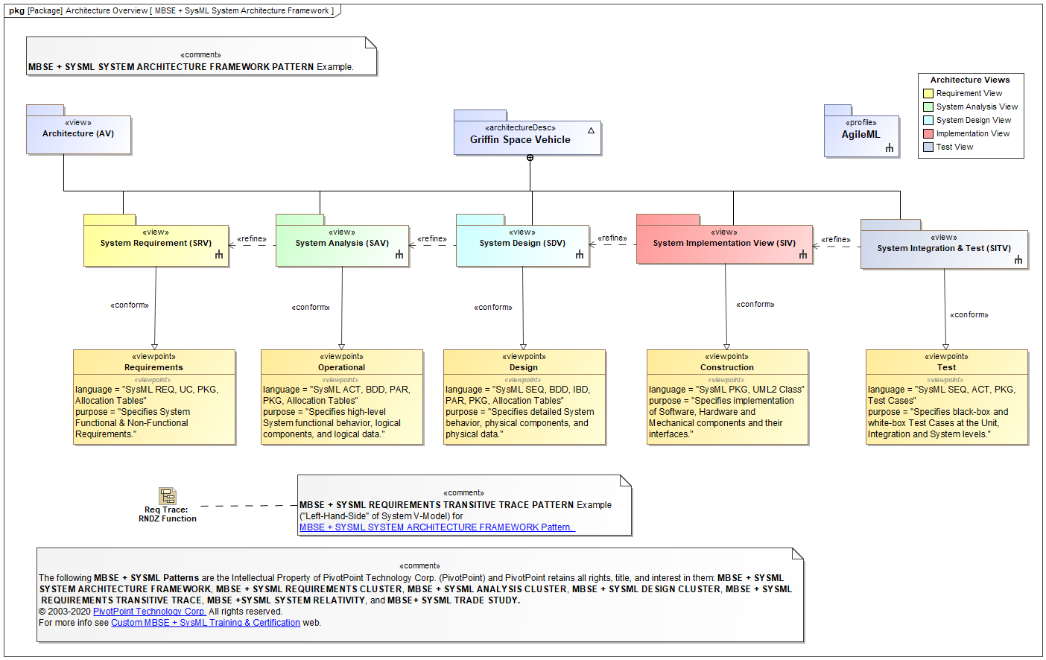

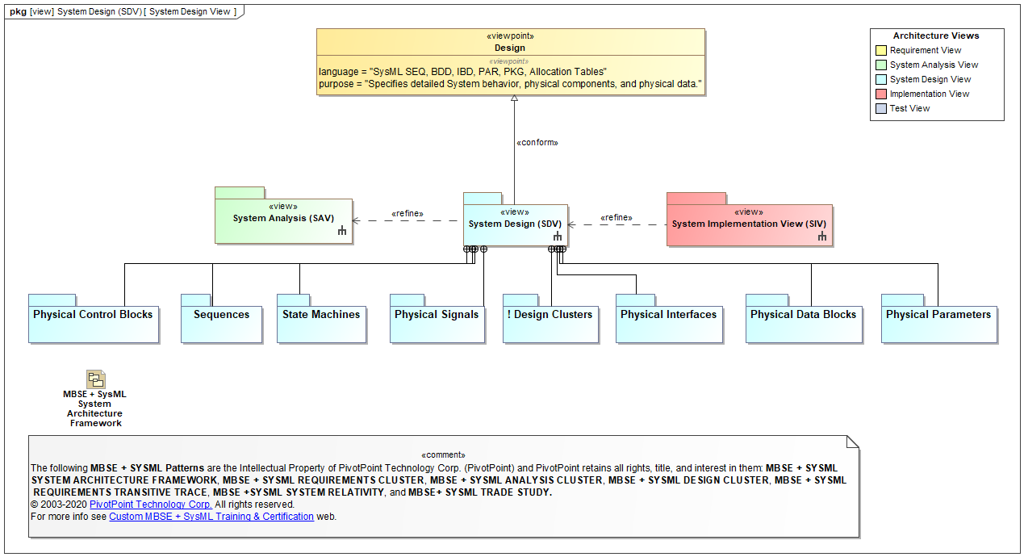

Loosely bound and tightly coupled functions: BAD example

Tightly bound and loosely coupled functions: GOOD example

Test types in test plan:

* Segment level (unit)
* System integration
* Stress/ failure mode
* Validation (user) tests
* Regression (re-test)
* System-level (post-integration)

Unit test: it is a software development process to test smallest testable part of an application called units, are individually scrutinized for proper operation.

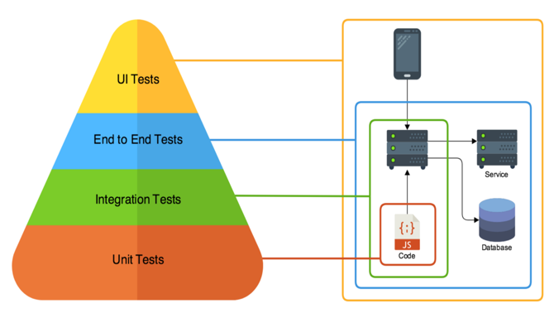 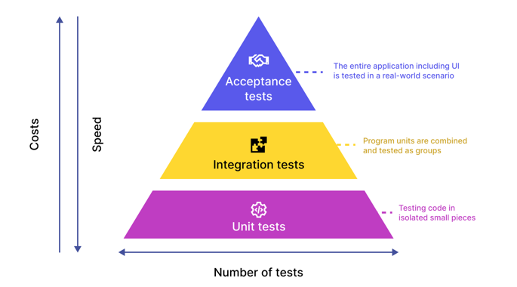

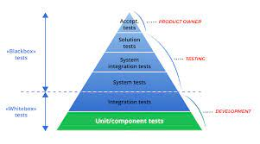 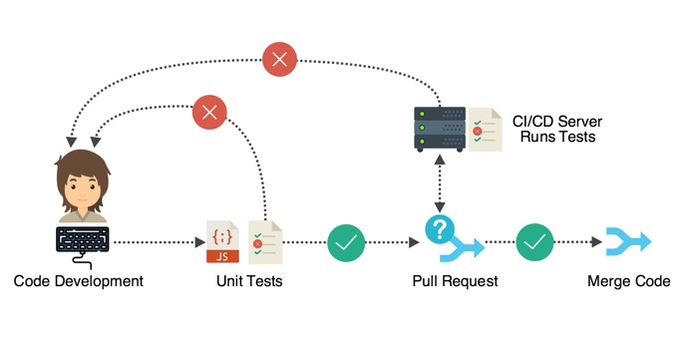

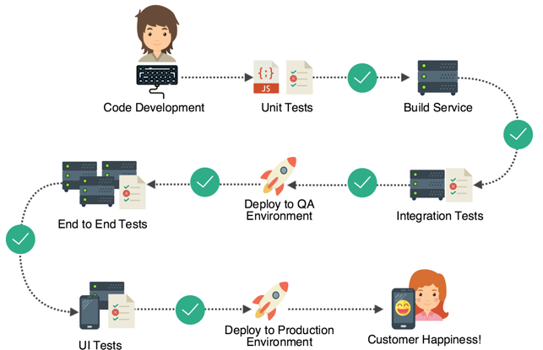 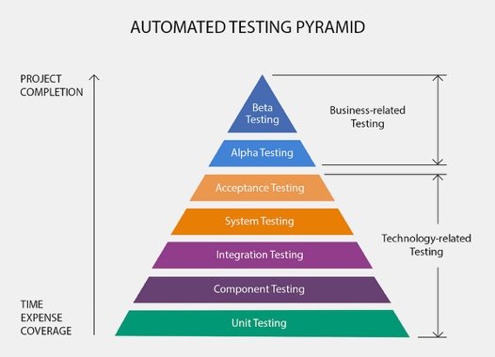

Integration tests: white-box testing and black-box testing

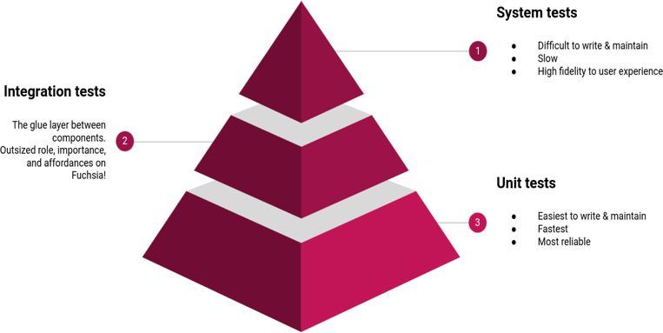 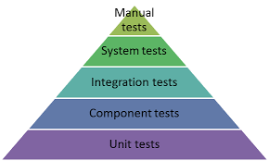

Regression test:

* It is a type of software testing conducted after a code update to ensure that the update introduced no new bugs.
* It is re-running functional and non-functional tests to ensure that previously developed and tested software still performs as expected after a change. If not, that would be called a regression.

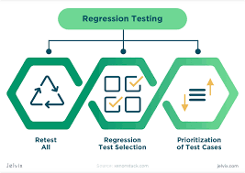 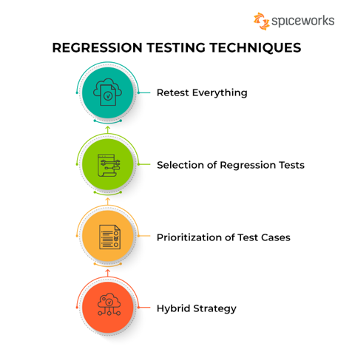

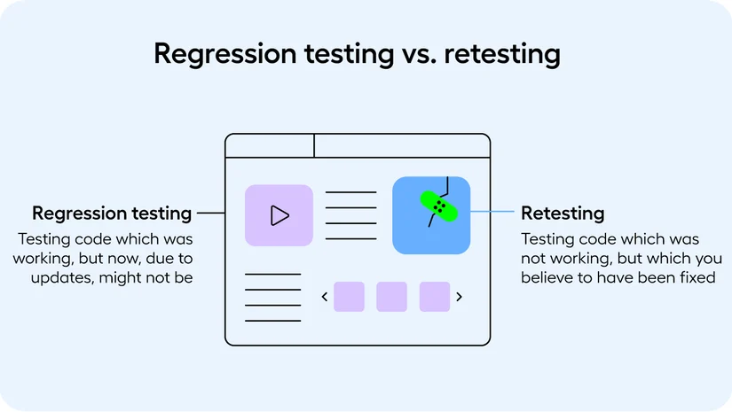

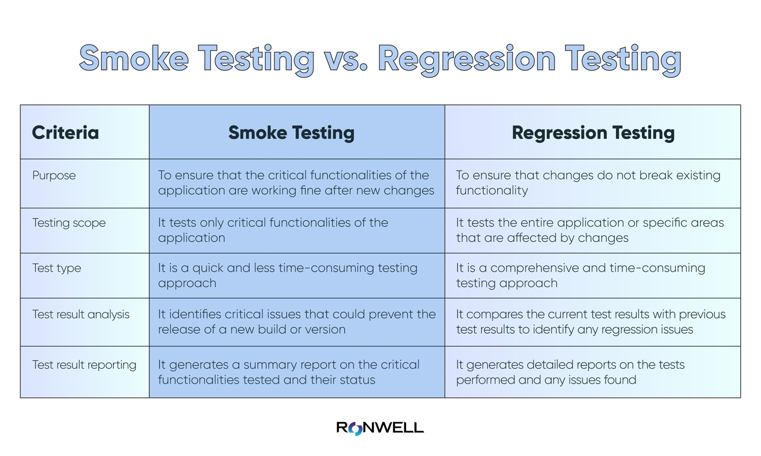

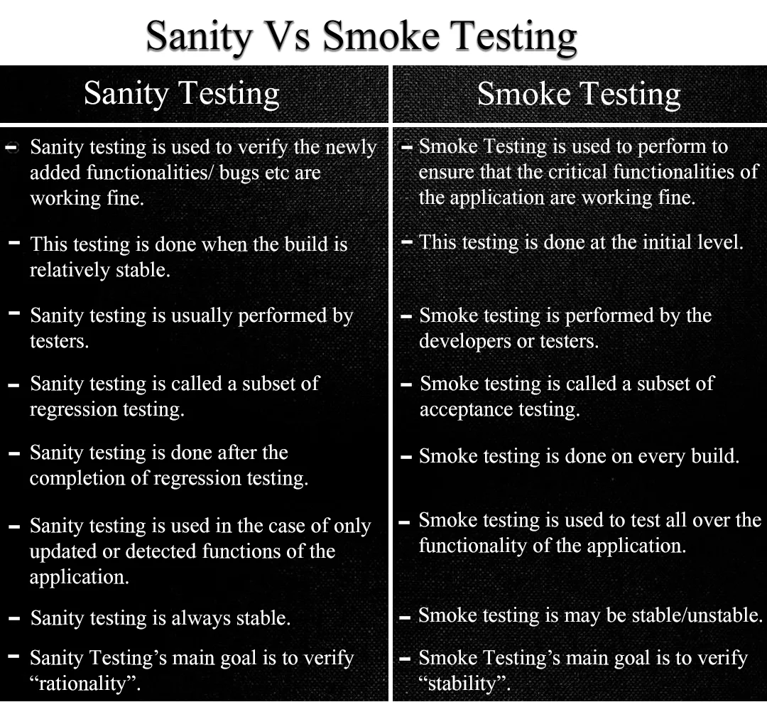

System Analysis:

* All-encompassing (used throughout lifecycle)
* Perform modeling, simulation, math analysis, prototyping
* Reduce cost
* Reduce risk

Implementation (segment construction)

* Inputs
  + Life cycle concepts
  + System architecture description
  + System architecture rationale
  + System design description
  + System design rationale
  + Interface definition
  + Design traceability
  + System element description
* Plan for implementation
* Perform implementation
  + Convert segment/ design spec descriptions in HW/SW
  + Capture processes used in necessary
  + Refine designs down to part levels
  + Perform analysis for optimal configuration
  + Conduct segment level peer review and working groups
  + Begin integration and verification process (bottom-up)
  + Perform and support HW/SW configuration audits
  + Develop enabling / support elements for segments
  + Work with other team members to foster integration
* Manage result of implementation
* Output
  + Implementation strategy
  + Implementation enabling system requirements
  + Implementation constraints
  + System elements
  + System elements documents
  + Training material
  + Implementation traceability
  + Implementation reports
  + Implementation record

Integration:

* Inputs:
  + Life cycle concepts
  + Interface definition
  + System element description
  + System element
  + System element documentation
  + Implementation traceability
  + Accepted system or system element
* Prepare for integration
* Perform integration
* Manage results of integration
* Output:
  + Integration strategy
  + Integration enabling system requirement
  + Integration constraints
  + Integration procedures
  + Integrated system or system elements
  + Interface definition update identification
  + Integration report
  + Integration record

Project planning:

* It is perpetual/ on-going
* Helps identify risks
* Helps identify resources
* Co-ordination is necessary
* Establish the foundation of the project.
* Can be used as enabler
* IMP: integrated master plan

Project Management Plan:

* Risk management
* Configuration management
* Schedule management
* Cost management
* Human resource management
* Quality management
* Communication management
* Procurement management
* Stakeholder management
* Integration management
* Technical management

Project Planning Process:

Input:

* + Organization strategy plan
  + Source document
  + Supply response
  + Project portfolio
  + Life cycle models
  + Project direction
  + Strategy documents
  + Project tailoring strategy
  + Project lessons learned
  + Documentation tree
  + Quality management corrective actions
  + Qualified personnel
  + Quality assurance plan

Process:

* + Define the project
  + Plan the project and technical management
  + Activate the project

Output:

* + SEMP
  + Project constraints
  + Project infrastructure needs
  + Project human resources
  + Work breakdown structure (wbs)
  + Project schedule
  + Project budget
  + Acquisition need
  + Project planning record

System design is top-down process.

Integration is a bottom-up process.

Integrate one unproven item or identity at a time.

Integration is a **verification** exercise:

* Components are integrated
* Interfaces are verified
* Interoperability is demonstrated

System integration process:

* Inspect/ verify components
* Integrate components up to integration points
* Conduct verification of regression testing on integrated components
  + Update architecture/ documentation
  + Proceed to validation/ acceptance testing
  + Integrate with next higher IP

Deficiency resolution process:

* Identify and prioritize deficiencies
* Redesign components or interfaces
  + Assess impact of uncorrectable deficiencies
* Update baseline

Signal types:

* Actual (actual signal between actual components)
* Simulated (represent responses/ behaviors of components from a control device)
* Stimulated (actual signal from other than actual components)
* Emulated (mimic actual interface, processing, sequences and performance characteristics)

Verification process:

* Each system segment is tested to assure compliance with specifications

Validation:

* Systems are tested in operational environment to assure they can accomplish mission and satisfy end user needs.

If verification and validation if both does not result in successful product, it may be due to:

* Specification is not drafted properly
* Stakeholder needs are not communicated properly

Validation takes place at production phase or some time during product development.

Verification:

* Inputs:
  + Life cycle concepts
  + Systems requirements
  + Verification criteria
  + Updated RVTM (Requirements verification and traceability matrix)
  + Interface definition
  + Integrated system (or elements)
  + Integration report/s
* Prepare for verification
* Perform verification
* Manage result of verification
* Outputs:
  + Verification strategy
  + Verification enabling system requirements
  + Verification constraints
  + Verification procedures
  + Final RVTM
  + Verified system (elements)
  + Verification report
  + Verification record

Principles of verification:

* Measuring elements against their associated requirements to ensure the components was “build right”.

|  |  |  |  |
| --- | --- | --- | --- |
| RVTM (Requirement Verification and Traceability Matrix) | | | |
| Requirements | **Refined By** | **Refines** | **Verification** |
| Parent requirement | Child requirement | Stakeholder requirement / Capability requirement | Analysis/ inspection/ demonstration etc. |

**Verification activities:**

* Analysis: using models, simulation and data to verify key aspects of component attributes or performance.
  + Simulation: using models or mock-ups to verify the requirements
  + Similarity: verification by reviewing previously acquired data, hardware or applications from a different system with enough similarity to the current system under evaluation.
* Demonstration: qualitative assessment of functional performance.
* Inspection: physical evaluation of a components and or component documentation against prescribed specification to verify design feature.
* Test: the execution of procedures, measuring and recording of output data and comparing results against prescribed requirements.

Type of relation between process 1 and process 2: bi-directional

|  |  |  |
| --- | --- | --- |
| **Process 1** | **Process 2** | **Relations** |
| Use cases | Scenarios | Supports / supported |
| Scenarios | Missions | Comprises/ comprised of |
| Mission | Life cycle concept | Contain/ contained in |
| Life cycle concept | Stakeholder requirements | Augments/ Augmented by |
| Stakeholder requirements | Systems requirements | Refines/ refined by |
| Stakeholder requirements | MOEs | Describe/ described by |
| Systems requirements | MOPs | Characterize / characterized by |
| MOEs | MOPs | Traceable to |
| Life cycle concepts | Validation activity | Guides / guided by |
| Validation activity | Components | Validates/ validated by |
| Components | Verification | Verifies/ verified by |
| Verification activity | Systems requirements | Based on/ basis of |

Low Rate Production:

* Producing as system slowly with the intent of refining the system for production and refining the production process.
* LRP units may be used to validate the system against the stakeholder requirements specification.

Validation: systems are tested in operational environment to assure they can accomplish missions and satisfy end user needs.

Verification is developmental test and fulfills the requirements in the SyRS and is ready for the next life cycle stage (typically production)

Validation is operational test and fulfills the requirements in the StRS and is ready for use in the operational environment.

Certain validation test can be conducted in conjunction with the verification test.

Validation:

* Input:
  + Life cycle concepts
  + Stakeholder requirements
  + Final RVTM
  + Installed system
  + Transition report
  + Validation criteria
* Prepare for validation
* Perform validation
* Manage the results of validation
* Output:
  + Validation strategy
  + Validation enabling system requirements
  + Validation constraints
  + Validation procedures
  + Validation requirements
  + Validated systems
  + Validation report
  + Validation record

Organizational Project Enabling process:

* Life cycle model management process:
  + Define, implement and maintain the appropriate life cycle process/ procedure, policies and models.
* Infrastructure management process
* Portfolio management process
* Human resource management process
* Quality management process
* Knowledge management process:
  + make the best use of organizational knowledge by creating, sharing, using and managing the knowledge and information within the organization.

Specialty engineering principles:

* Affordability
  + Total life cycle cost:
    - R&D + higher order integration (includes Preliminary research and prototyping)
    - Development + test + manufacturing (includes development only, development + test and production only costs)
    - Product support includes (utilization and support)
    - Retirement cost
  + Reaching affordability goals:
    - Use the proper contract type for the effort
    - Build modularity into system designs
    - Use performance-based logistics
    - Eliminate/ reduce inefficient processes
    - Use open markets/ competition
    - Focus on well written requirements
    - Provide training and increasing knowledge base
* Electromagnetic compatibility
* Environmental engineering
* Reliability, maintainability and availability (RM&A)
* System Safety
  + Safety engineering tools
    - Fault tree analysis
    - System element hazard analysis
    - Health hazard analysis
    - Probabilistic risk assessment
    - System operation hazard analysis
    - Functional hazard analysis
    - Preliminary hazard analysis
* Models and Simulation (M&S)
  + Benefits of M&S:
    - Helps validate concepts
    - Captures preliminary concepts and designs
      * Enhances productivity
      * Understand system limitations
    - Helps understand system aspects
      * Environment
      * Scenarios
      * Human-machine interactions
    - Enables more informed decision making
    - Helps identify risks, issues and opportunities early
    - Enables more informed cost, schedule and resource estimations.
* Human system integration (HSI)
* System Security
* Resilience Engineering: system is not fully operational. It is built into a design incrementally.
  + Inputs:
    - Threat analysis
    - Objectives for resiliency
    - System description/ missions
    - Resiliency principles
    - Solution proposals
  + Create model/ sims of threat and system recovery
  + Select/ implement resilience principles
  + Select MOEs
  + Perform impact analysis
  + Output:
    - Description of resiliency solutions
    - System response
    - Impact assessment
    - Recovery time.
* Product Support Engineering
* Value Engineering

Software and system engineering:

* OSEM: object oriented systems engineering

Systems Engineering:

* Requirement analysis
* Functional design
* Physical design
* Design validation

Software engineering:

* Software analysis
* Software design
* Software coding/ implementation
* Software testing/ integration

Software development process:

* Linear (waterfall)
  + Analysis
  + Design
  + Coding/ unit test
  + Integration/ system tests
  + Operation/ maintenance

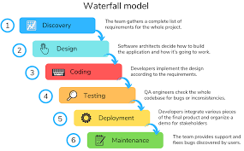

* Incremental
  + Same as linear with incremental development for features
* Evolutionary (spiral)
  + Four quadrants
    - Identify objectives, alternatives and constraints
    - Evaluate alternative, risk mitigation
    - Develop and test top-down
    - Next iteration planning

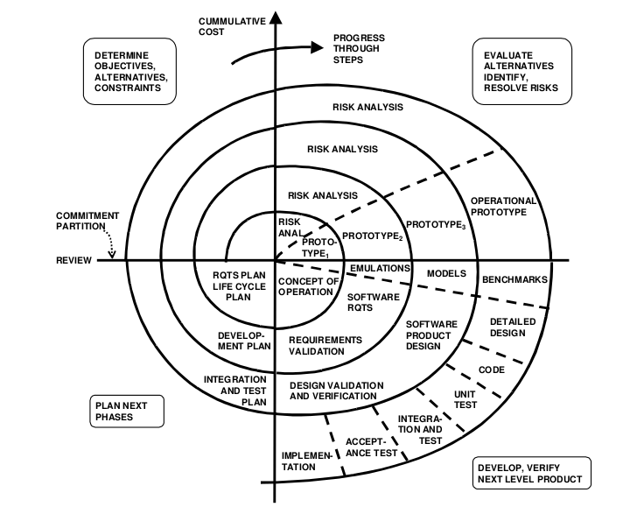

* Agile
  + Best suited for small/ medium projects
  + Heavy user/ customer involvement
  + Agile percepts:
    - Cant be planned with high precision
    - Integrate as soon as possible
    - Requirements are not solidified up front

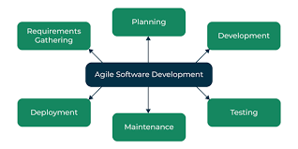

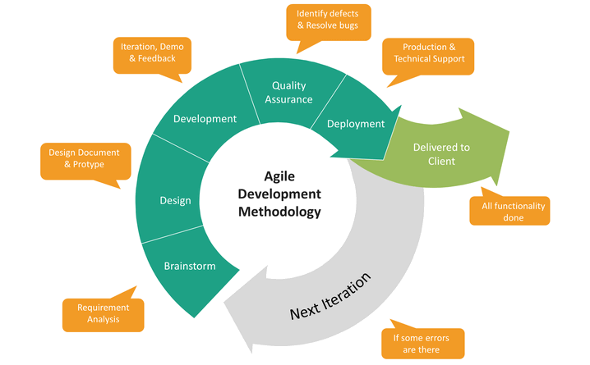

Systems engineer’s job is to guide each specialty area (hardware and software) for design and development of complex system.

Concept Development

* Software requirements domain defined
* Software functional domain defined
* Software physical domain identified
* Purpose : Develop robust sets of software requirements
* Watch for unreasonable stakeholder expectation
  + “Software will solve it” mentality is faulty
* Involve software engineers in process to maintain feasibility
* Wide range of customer expectations may not be feasible given time/ cost constraints
  + Apply appropriate development strategy (e.g. iterative, prototyping etc.)

Systems development:

* Software requirement elicitations
  + SYS engineers must bridge language gap between software engineers and stakeholders/ customers
  + Tools to help bridge gap:
    - Use cases
    - Functional flow diagram (activity, sequence)
    - Object process methodology (OPM) diagrams
  + Use same requirements elicitation techniques
    - Interviews, questionnaires, survey, problem/ issue database, observations etc.
* Writing software requirements:
  + Use same general principle for writing software requirements
    - Feasible, testable, unambiguous etc.
  + Software engineers /SMEs should be present as a part of software requirement development
    - Contribute heavily toward defining and refining requirements
    - Implication (cost, schedule, technical) should be provided for each requirement or set of requirements
  + Development strategy can drive the depth software requirements are developed, ex.:
    - Iterative = incremental software builds definitions.
    - Agile = specifications very broad, relying on agile methods to work out details.

System production

Utilization

Support

Retirement

Unified modeling language is standardized well supported architecting language for software.

* Many commercial applications that support
* Result in robust, organized database that describes conceptual software
* Universal/ used by customers and developers alike

Object oriented software architectures:

* It is effective with systems that receive, process and export data regularly.
  + Primarily due to software object transaction
  + Ex.
    - Inventory management
    - Reservation systems
    - Financial management system
    - Web pages
    - E-commerce solutions (eg. Paypal, amazon)
* OO is not as effective with heavy computations and algorithms

SEIT:

* Higher order coordination
* Ensure system meets OpsCon, BRS and STRS
* Identify and resolve issues
* Perform process and team audits

Lean Systems Engineering:

* Top 10 product development challenges
  + Too much time spent putting out fires
  + Lack of robust risk management
  + Unclear roles and responsibilities
  + Unclear, incomplete, unstable requirements
  + Lack of planning
  + Inefficient process
  + Improper use of metrics
  + Lack of coordination
  + Team lacks knowledge and skill required
  + Poorly managed resources

Agile Design Principles:

* Modularity
* High adaptive interfaces
* Re-useability (re-deployable)
* Peer-to-peer interaction
* Distributed control of information
* Different commitment period
* Self-organized
* Evolving infrastructure
* Redundancy and diversity of internal elements
* Elastic capacity