OPERATING

SYSTEMS

21AIE202

LAB REPORT - 1

SYSTEM CALLS

Date: 10 - 09 2022

Submitted By:

Abhay Nanduri

21130

**SYSTEM CALLS**

**Aim:** To Execute Different System Calls In Linux Operating System

**Q1)**

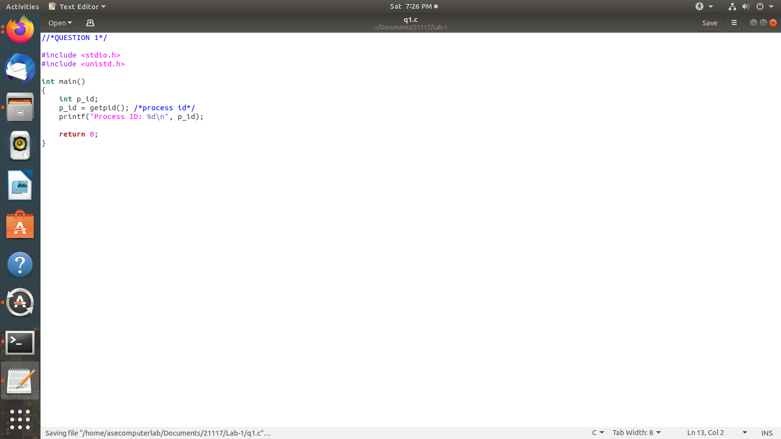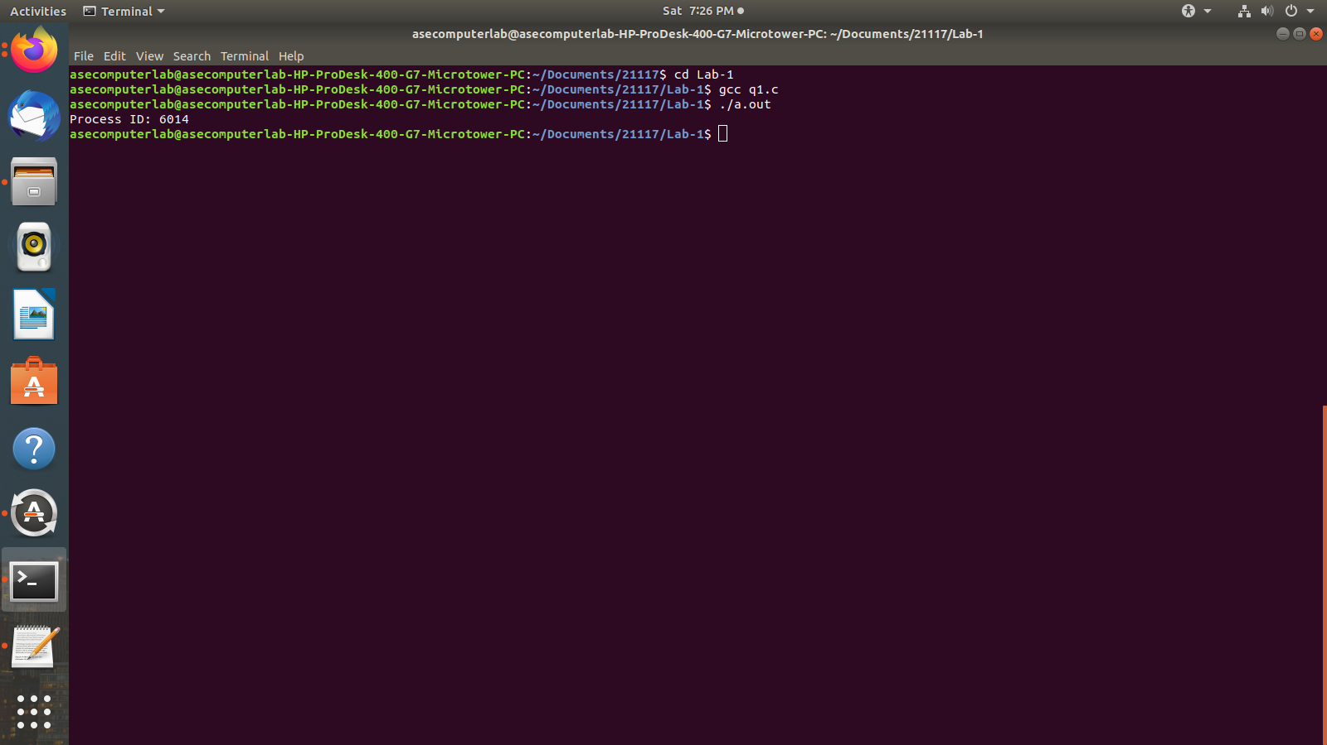

**Q2)**

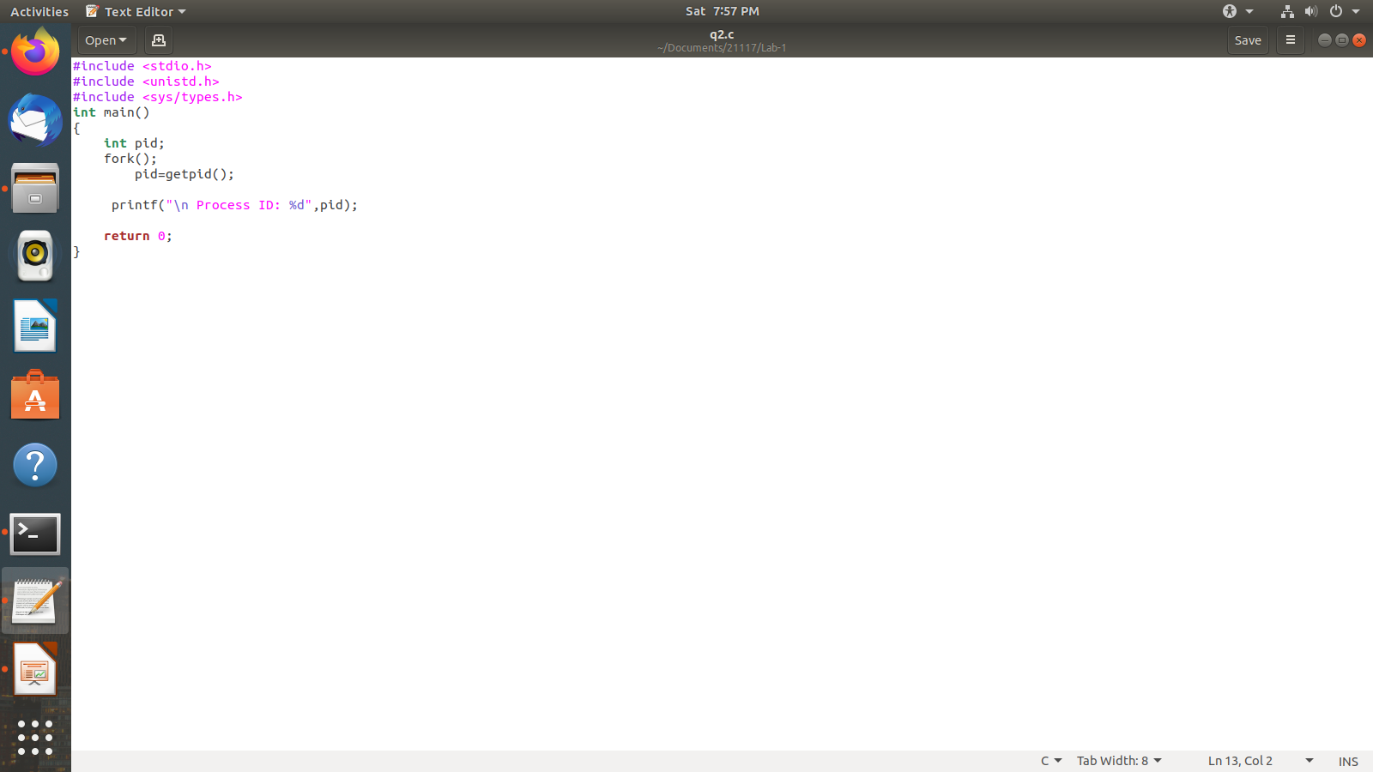

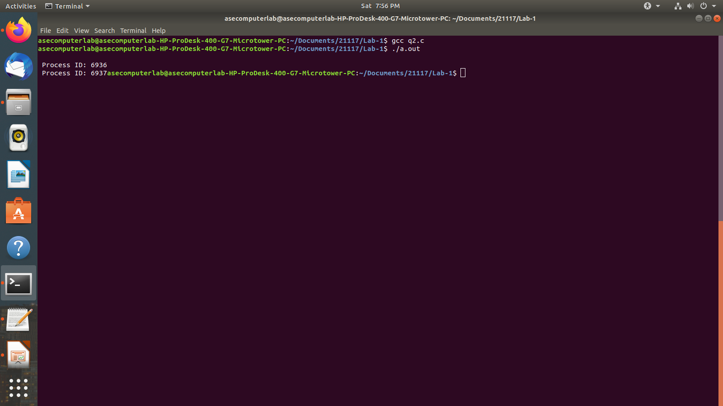

**Q3)**

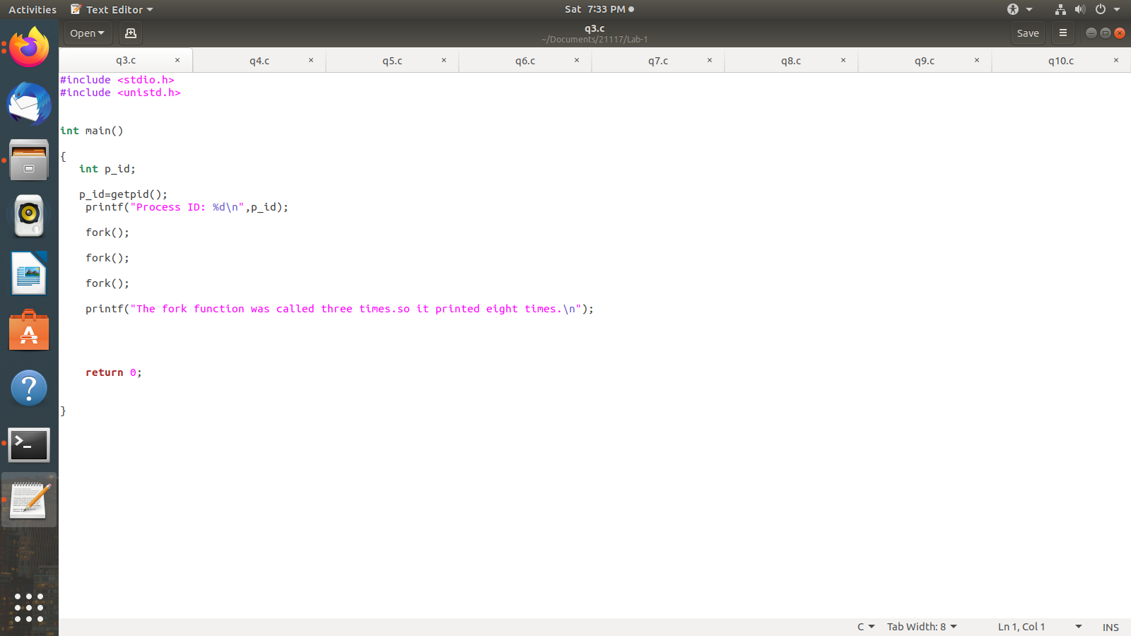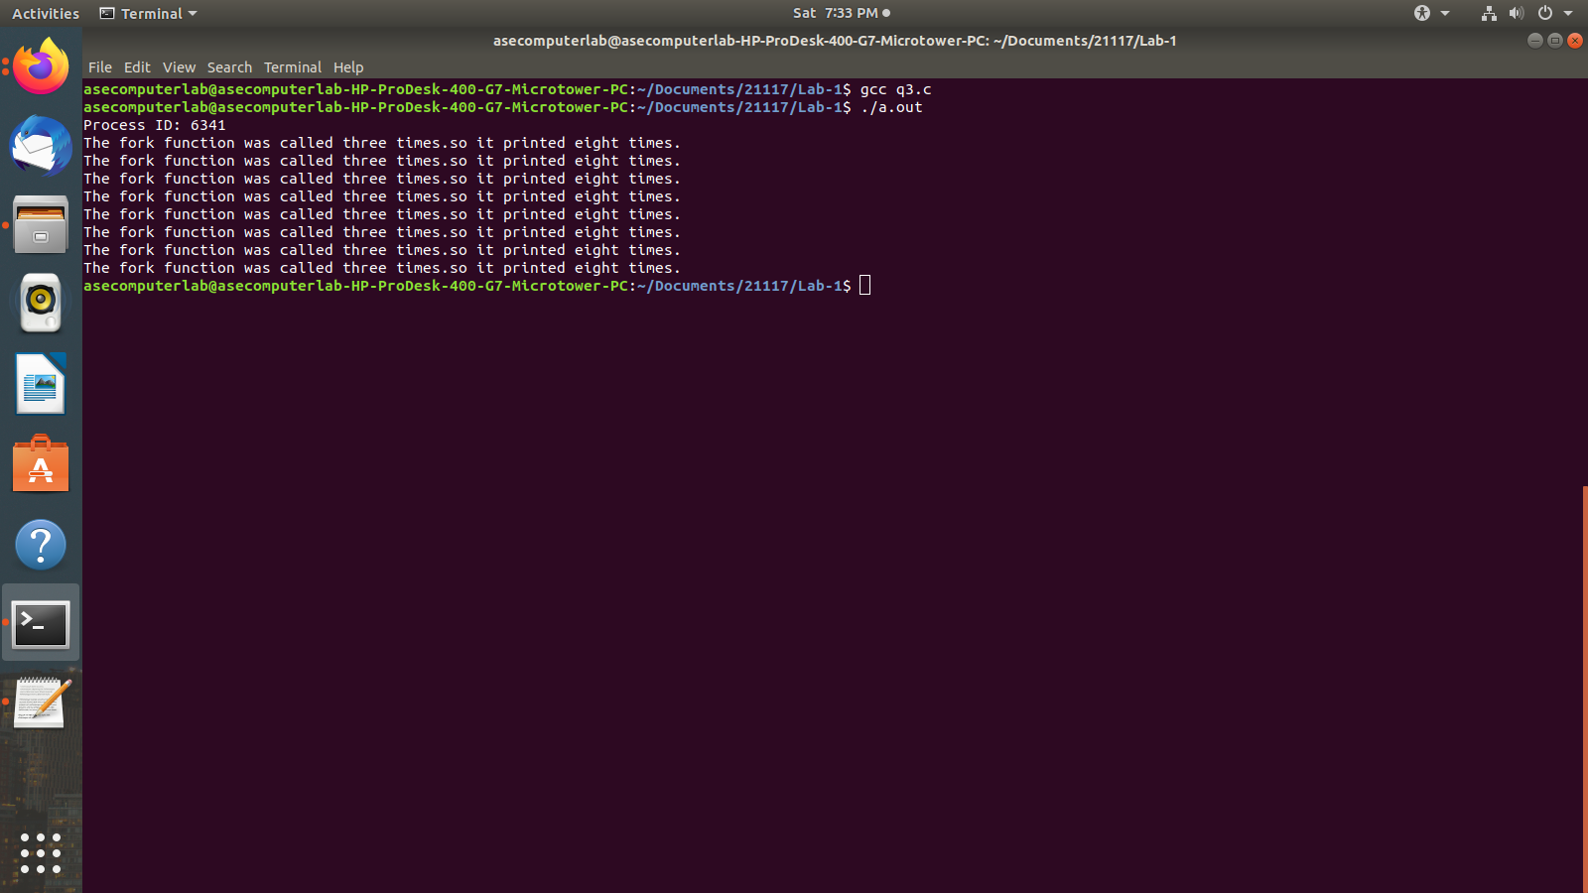

Algorithm: Fork is basically used to call the same process again. So, in this code we have used fork() 3 times, which will make the process execute 8 times. Here the process is the print statement.

**Q4)**

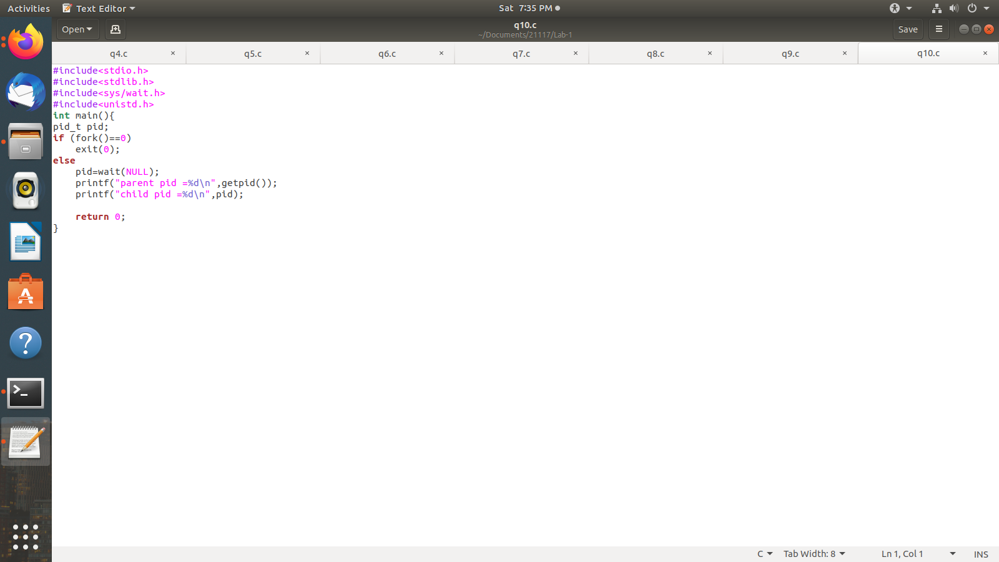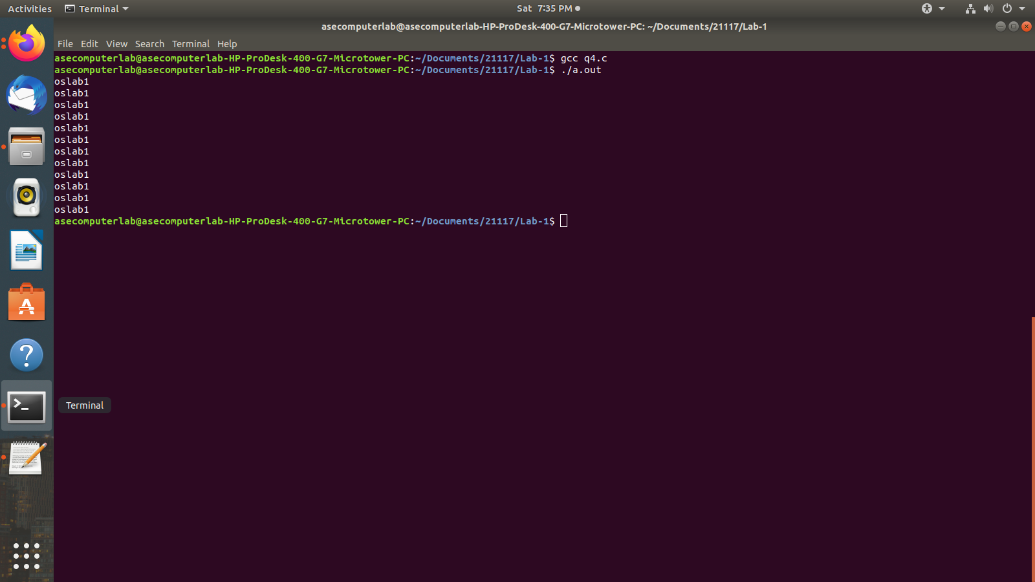

**Q5)**

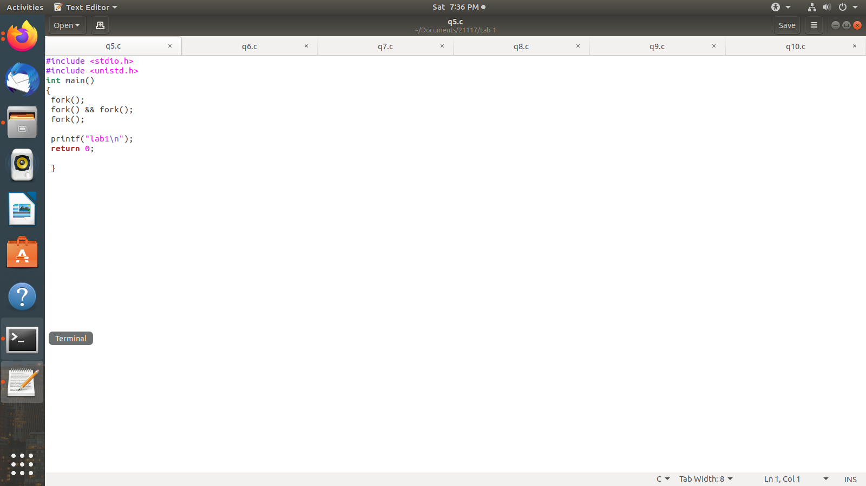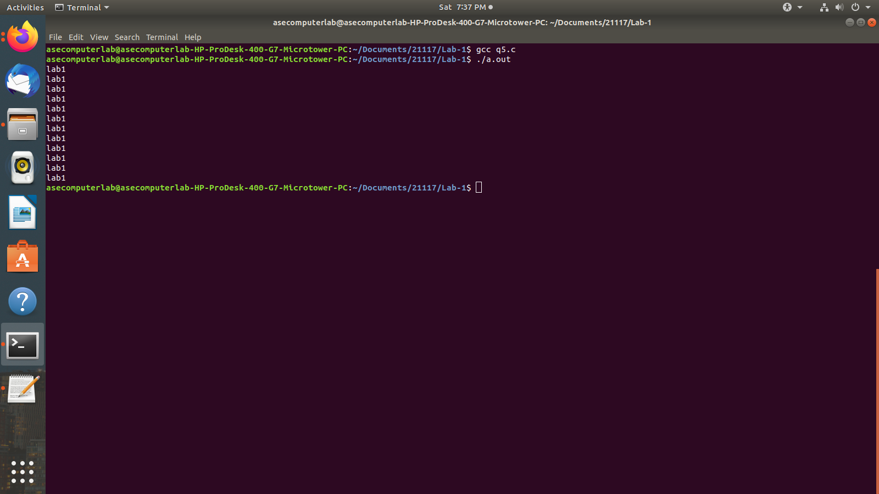

**Q6)**

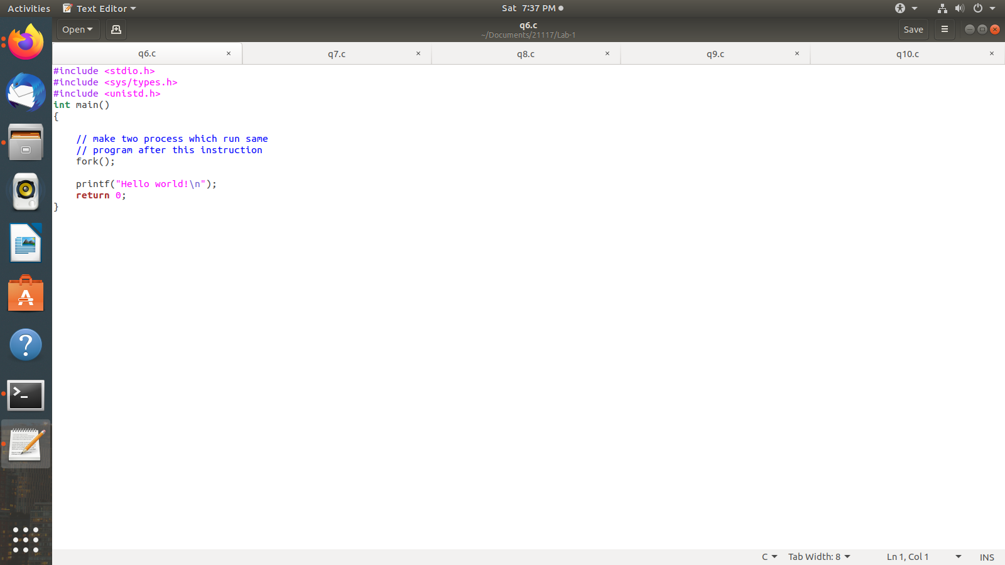

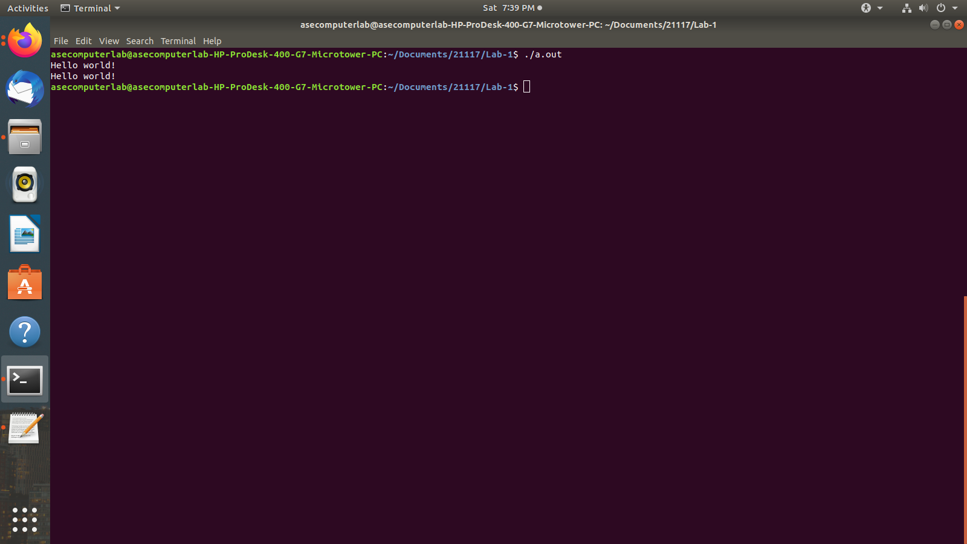

**Q7)**

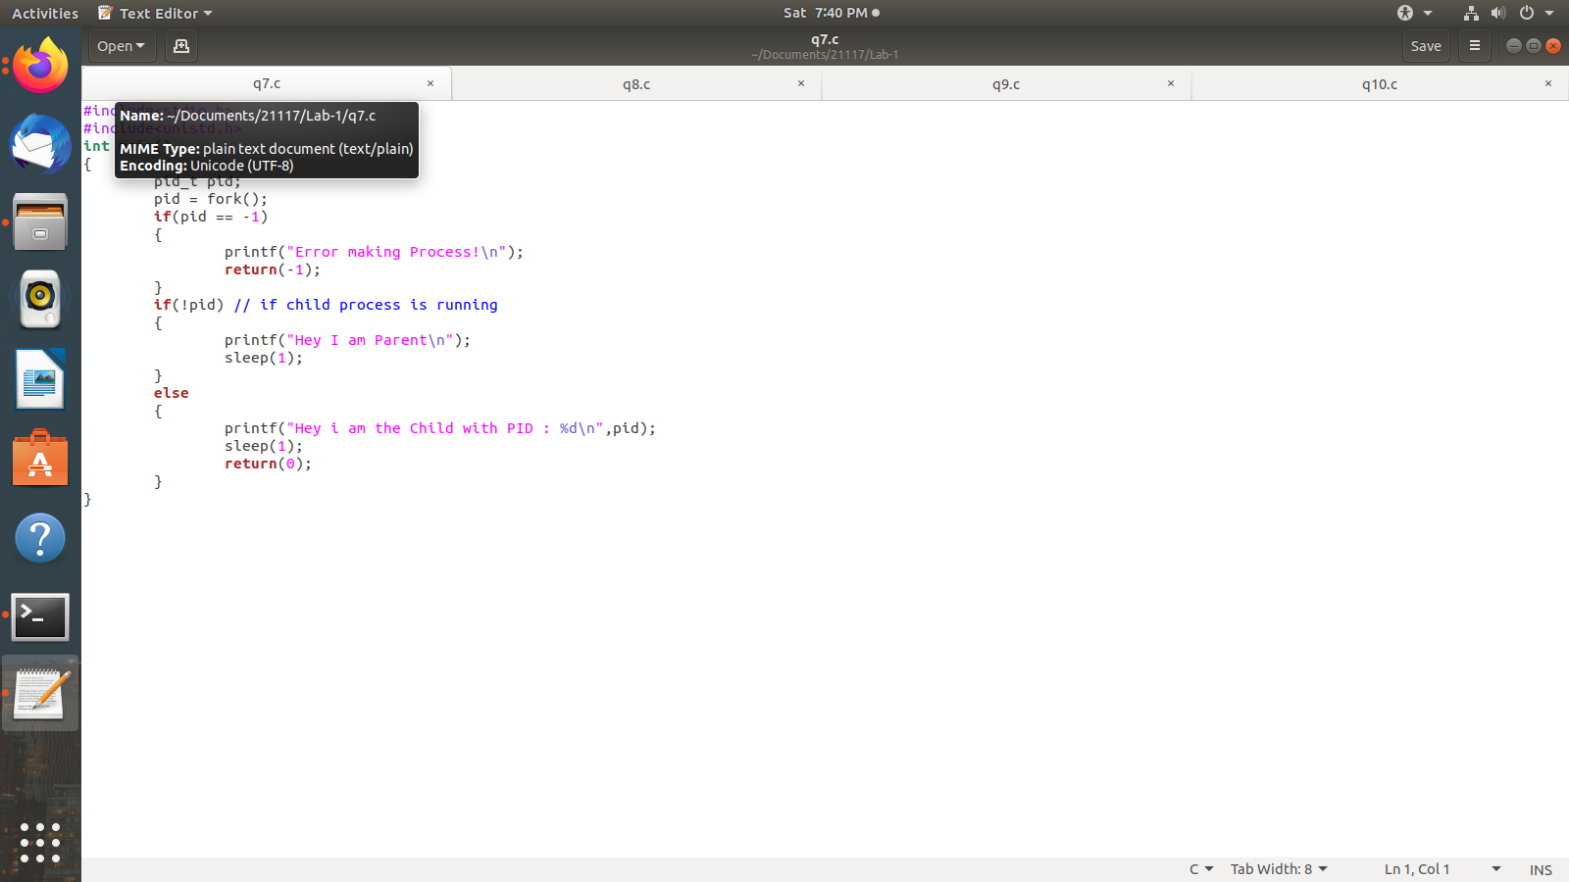

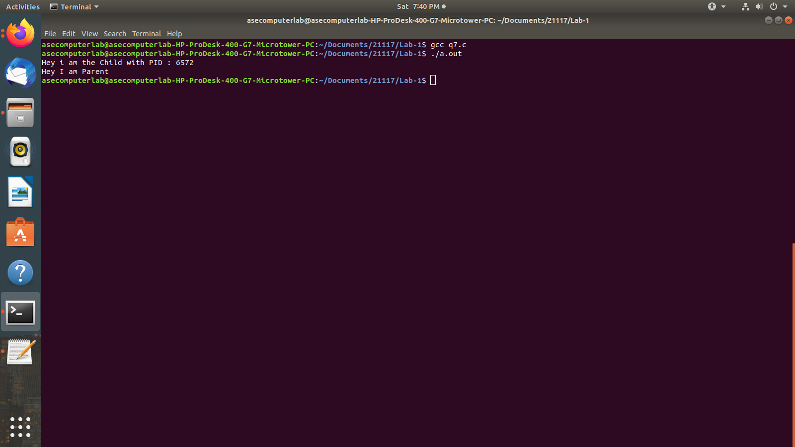

**Q8)**

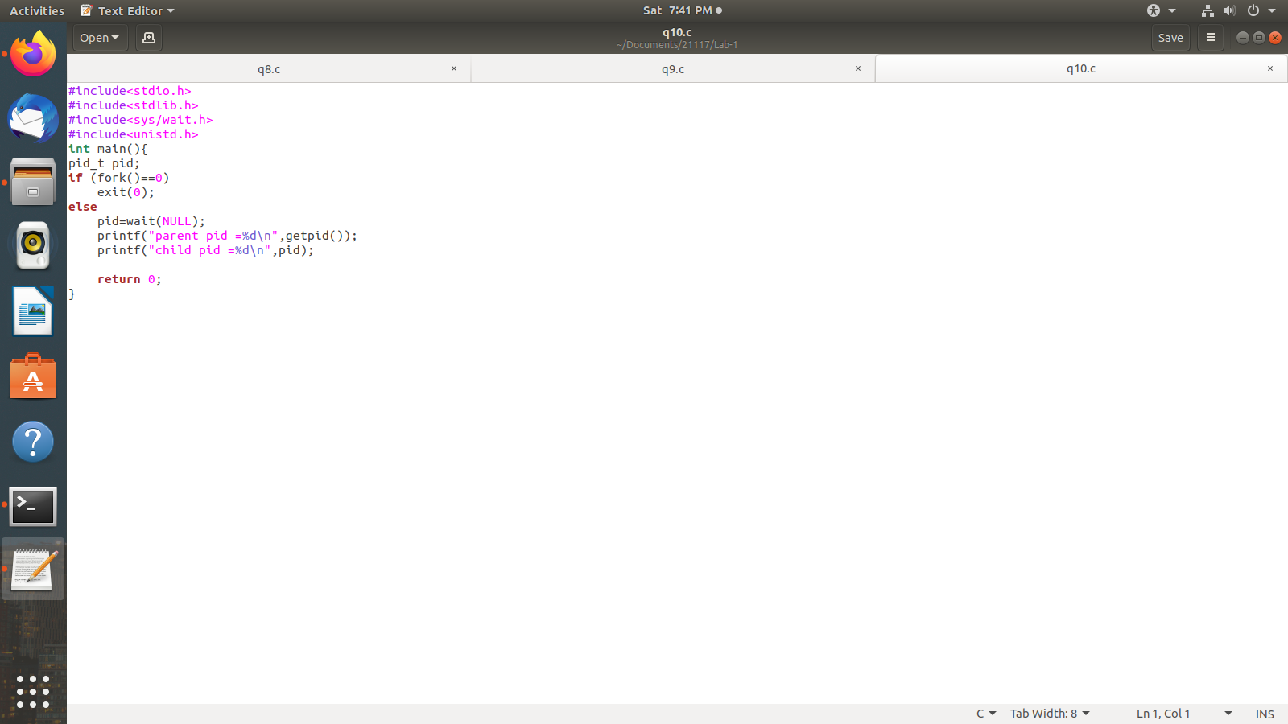

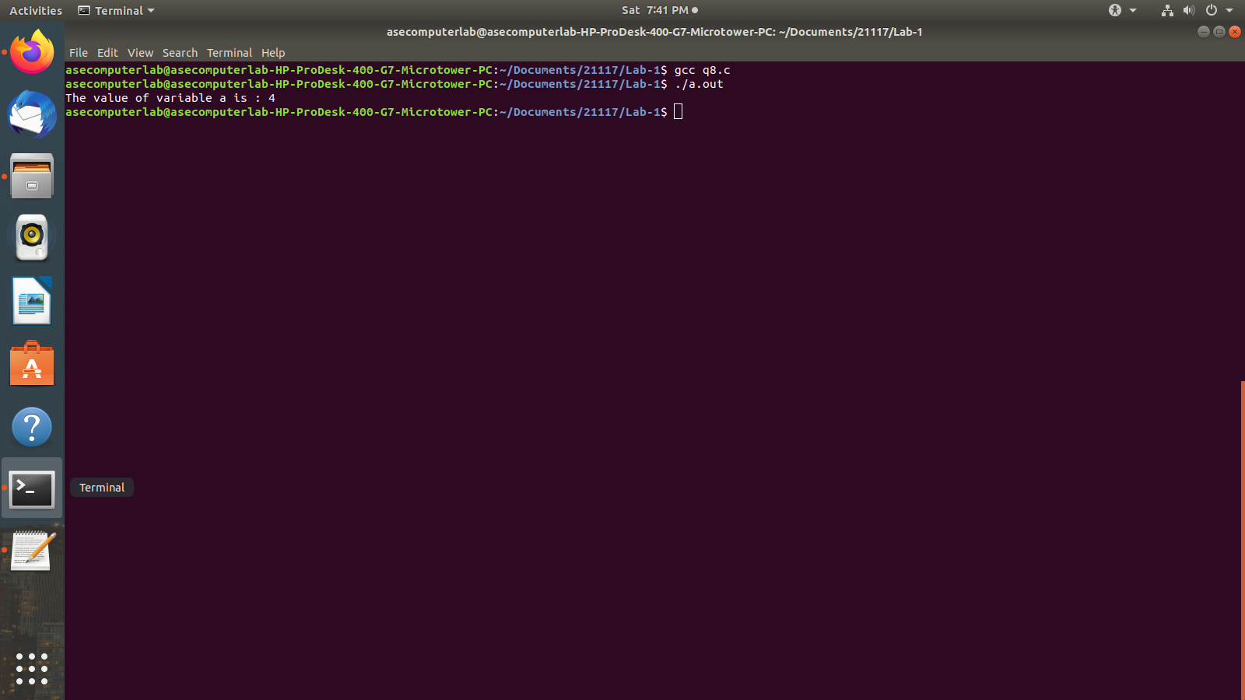

**Q9)**

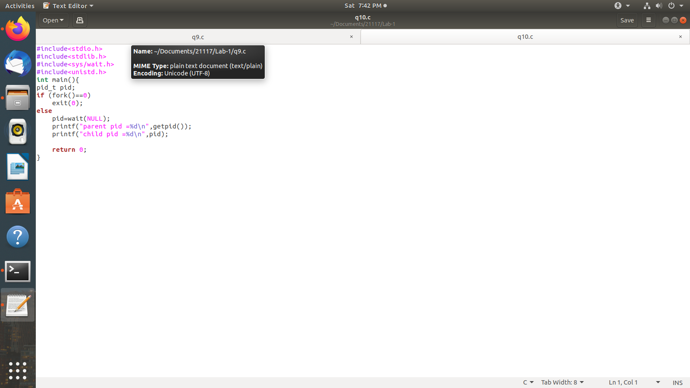

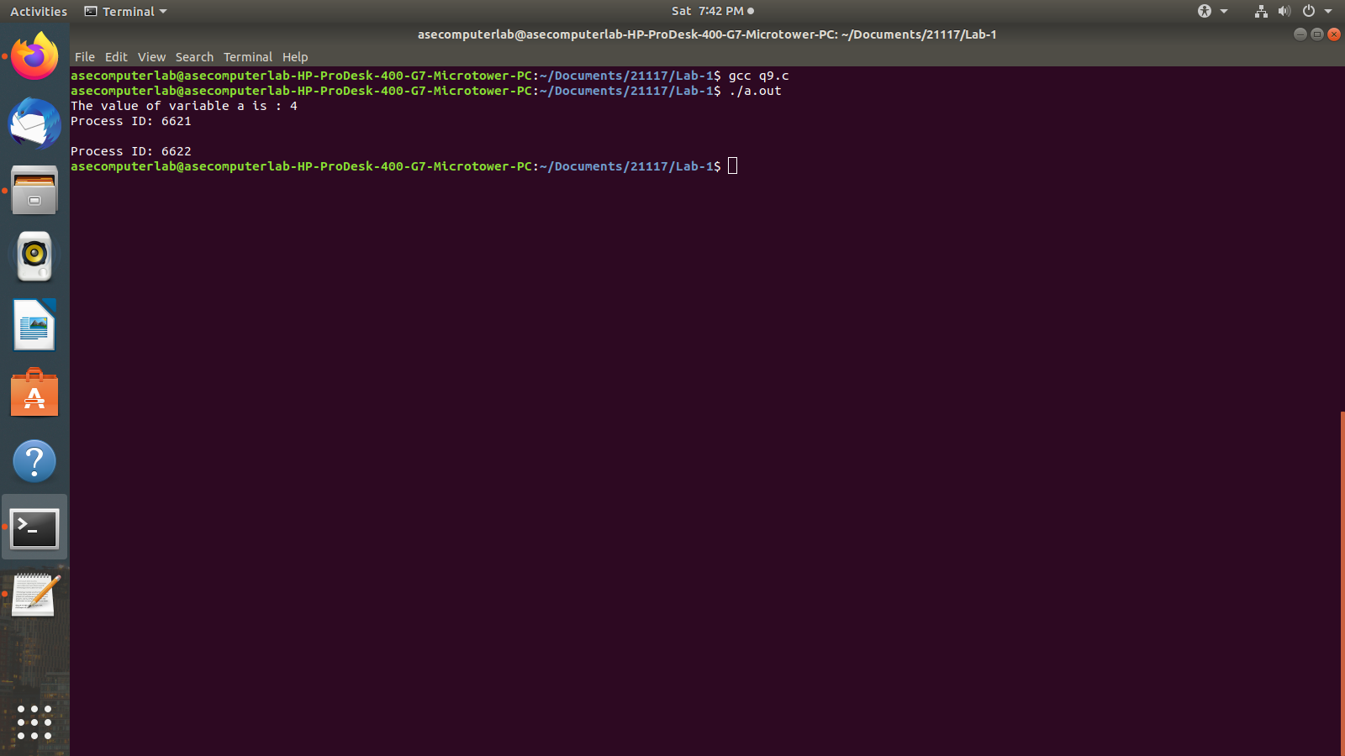

**Q10)**

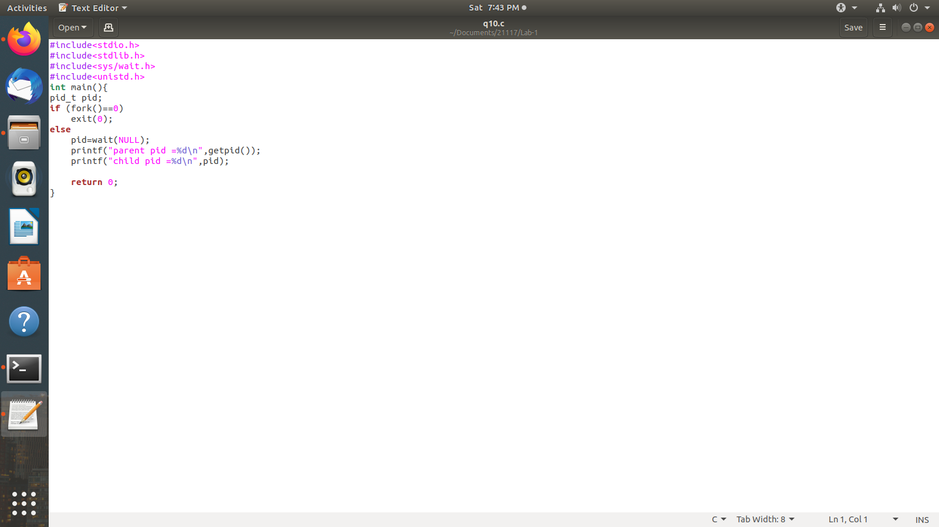

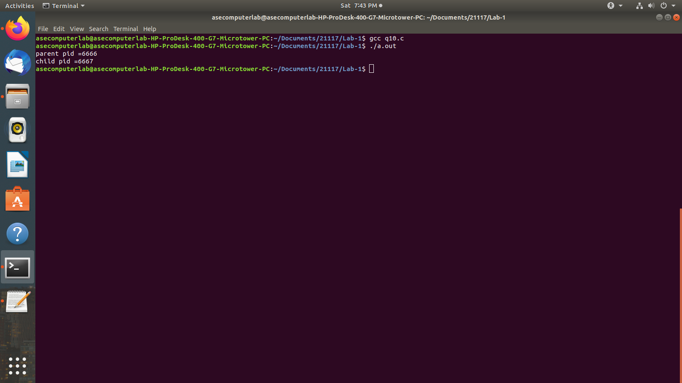

**Observation:** In this experiment we have seen how fork function works and how we switch between processes and also how the OS works on a kernel level. We learnt about how system calls work.