OPERATING

SYSTEMS

21AIE202

LAB REPORT - 3

CPU SCHEDULING ALGORITHMS

21-09-2022

Submitted By:

Abhay Nanduri

21130

**CPU Scheduling Algorithms**

**1)First Come First Serve (FCFS)**

The First Come First Serve or the FCFS scheduling algorithm is by far the simplest CPU scheduling Algorithm. In this, the process which requests CPU first will be allotted or scheduled first.

Algo:

Input number of processes.

        Burst time for each process

        Init waiting time of P1 as 0.

        Calculate the waiting time of each process( wt=wt+bt)

        Calculate turn around time (tt=wt+bt)

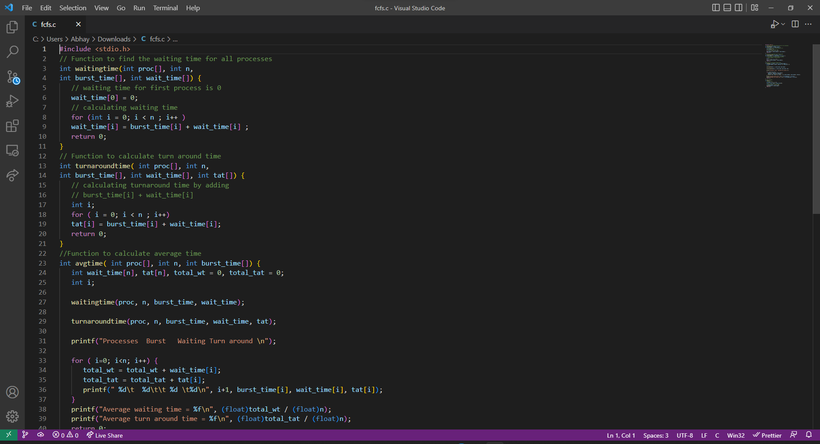

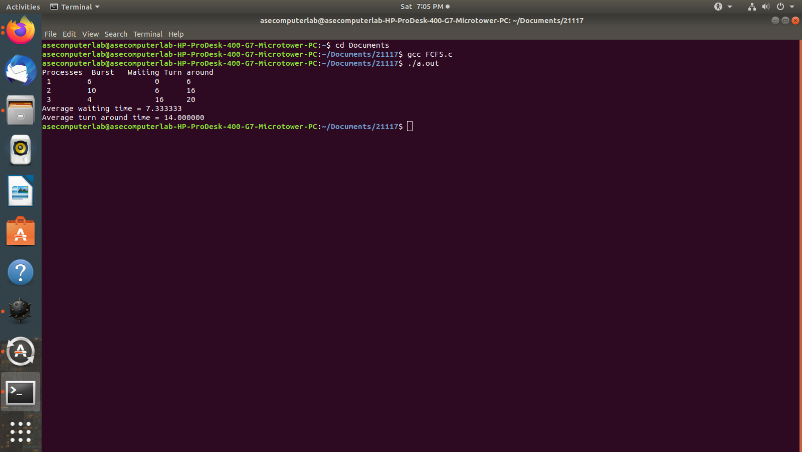

**2)Shortest Job First(SJF)**

SJF scheduling algorithm, schedules the processes according to their burst time. In SJF scheduling, the process with the lowest burst time, among the list of available processes in the ready queue, is going to be scheduled next.

Algo:

        1) Enter number of processes.

        2) Burst time for each process

        3) Sort in ascending order

        4) Initialize Wait time as 0

        5) Calculate the waiting time of each process( wt=wt+bt)

        6) Calculate turn around time (tt=wt+bt)5

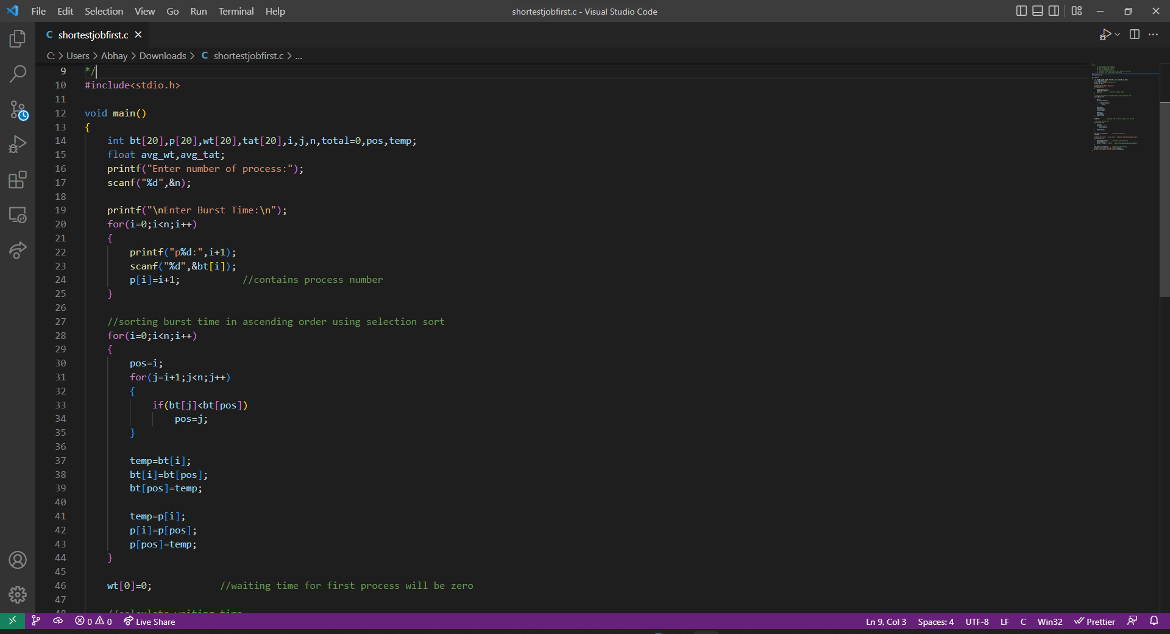

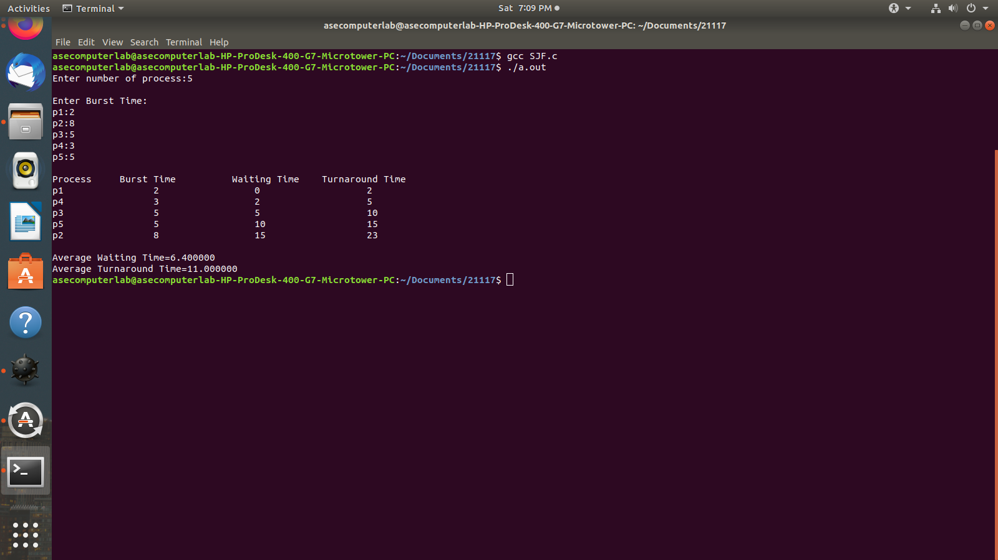

**Conclusion:**

In this experiment we have learnt and implemented the First Come First Serve scheduling algorithm and the Shortest Job First Algorithm.