OPERATING

SYSTEMS

21AIE202

LAB REPORT - 2

INTER-PROCESS COMMUNICATION

14-09-2022

Submitted By:

Abhay Nanduri

21130

**Aim:** In this experiment we aim to learn and implement the different ways through which inter-process communication is carried out.

**Inter-Process Communication Through Message Queue:**

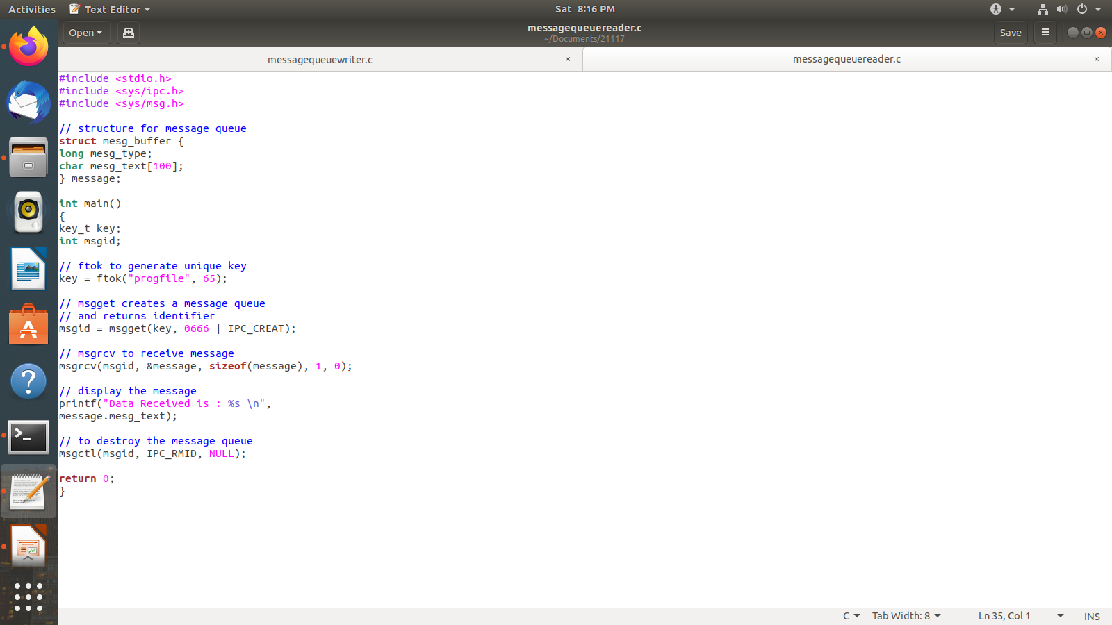

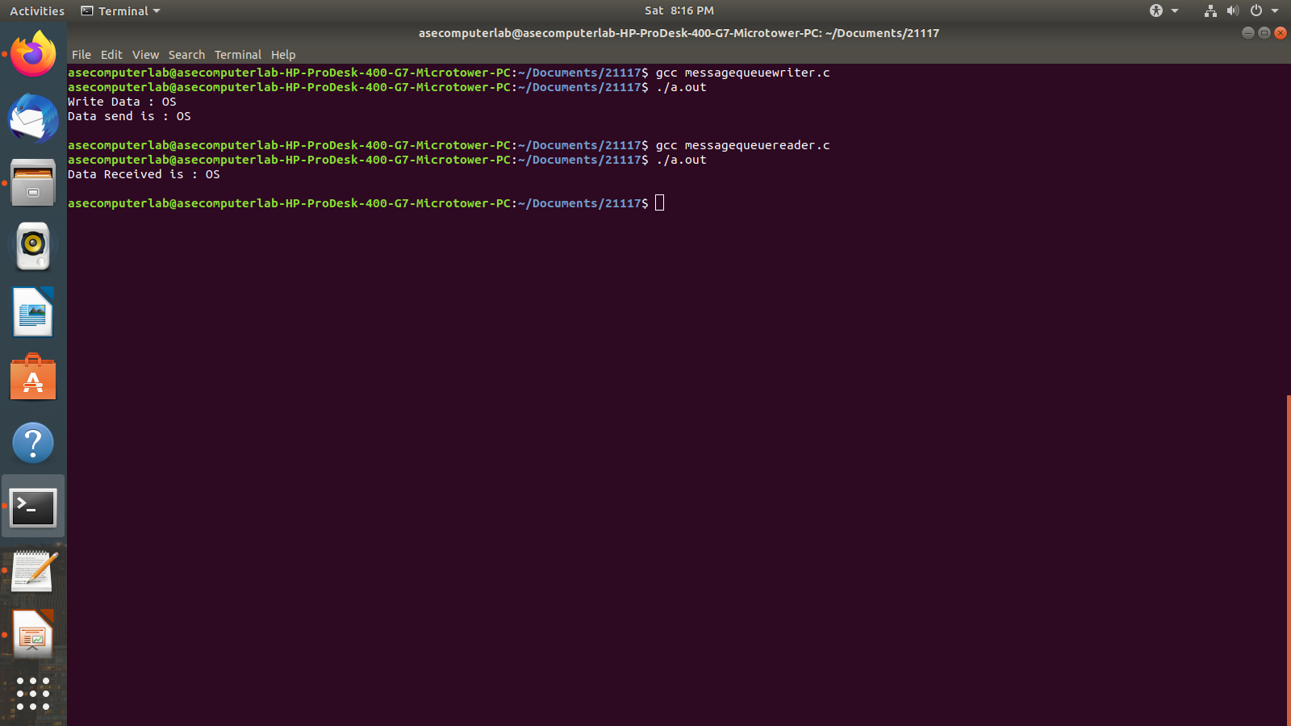

**Inter-Process Communication through Shared Memory**:

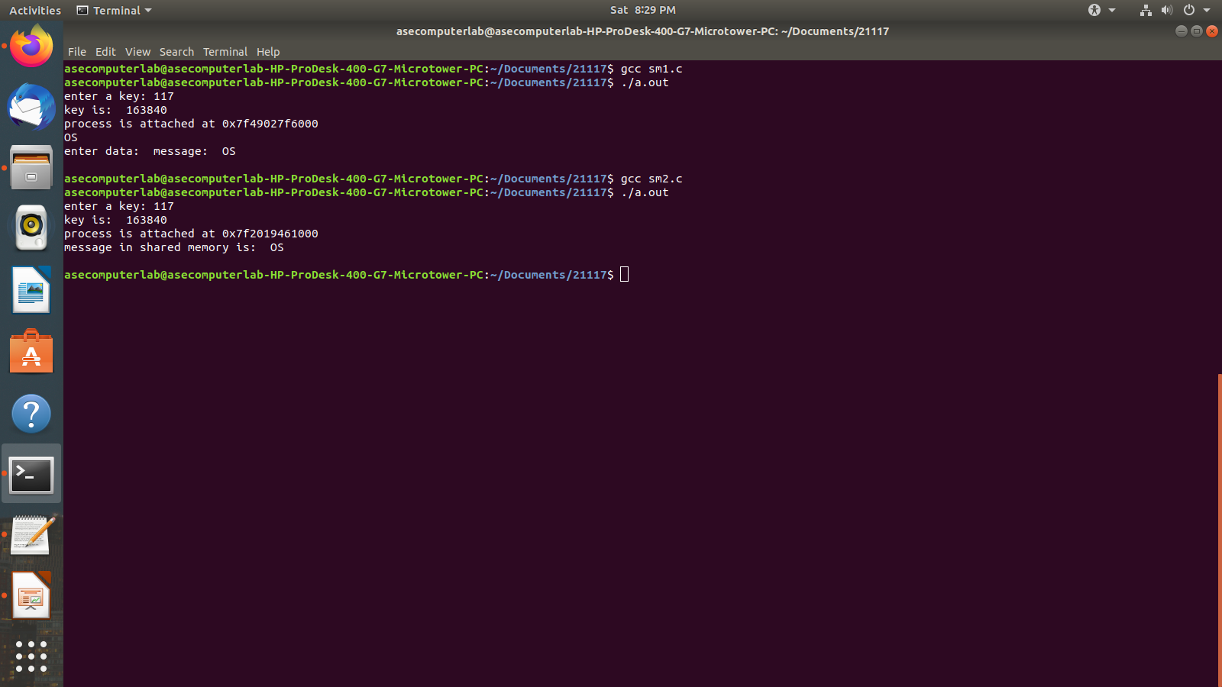

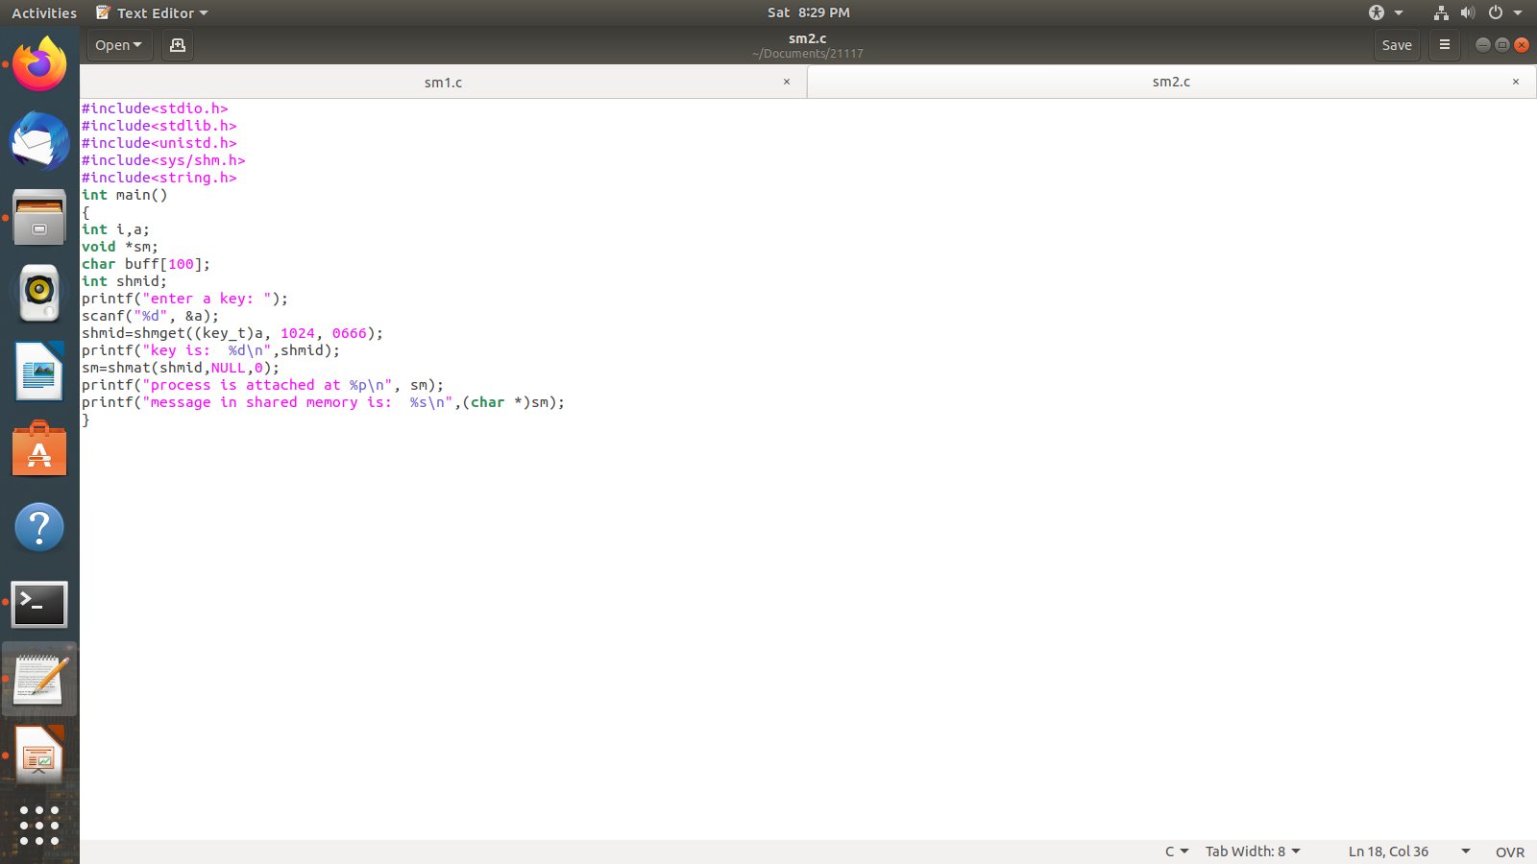

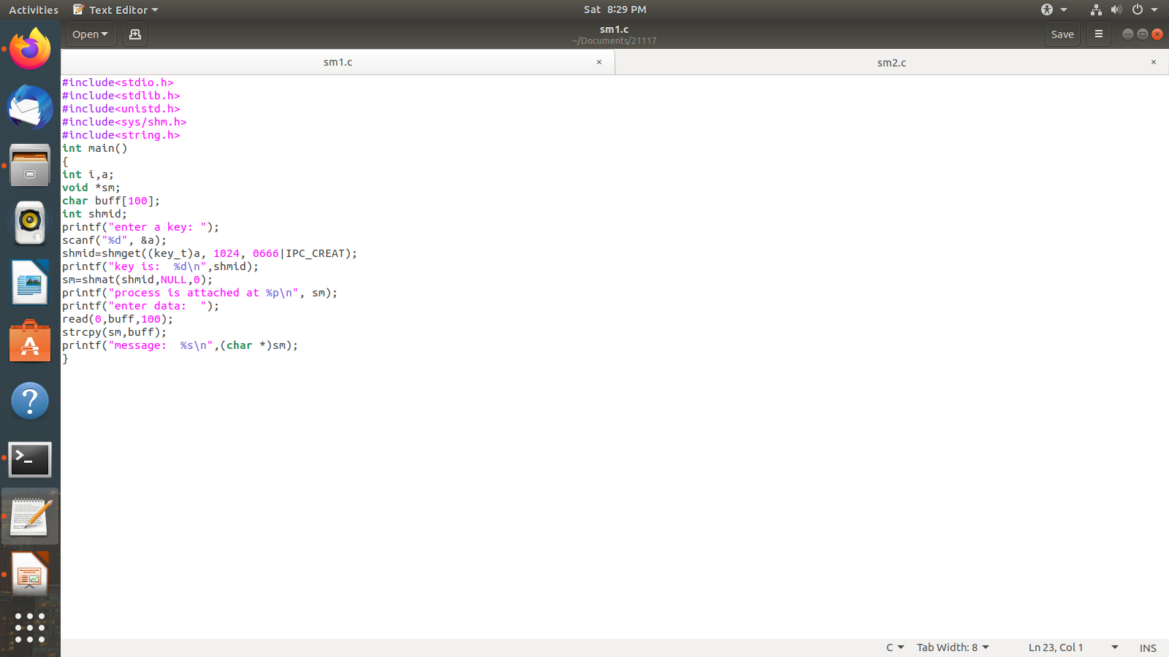

**Conclusion**

In this experiment we have seen the two methods in which Inter-process communication is carried out, i.e through Message passing and through shared memory.

We saw how we use pid to identify and communicate with a process.We see what the shmget(), shmat(), shmdt() functions

and also the msgget() and msgsnd() and msgrcv().