Consumer Complaints Data Wrangling Using Shell Commands
This project demonstrates shell-based data wrangling and exploratory analysis on a consumer complaints dataset. The analysis uses Unix command-line tools such as awk, cut, sort, uniq, wc, and head to clean complaint records, validate IDs, extract dates, analyse product categories, and identify text patterns in complaint narratives.

Objective 1: Identify the date range of complaint records

Code:
awk -F',' 'NR>1 && $2 ~ /^[0-9]{2}\/[0-9]{2}\/[0-9]{4}/ {
split($2, d, " "); print d[1]
}' consumer_complaints.csv | sort | awk 'NR==1{print "Earliest Date: " $0} END{print "Latest Date: " $0}'

Output:

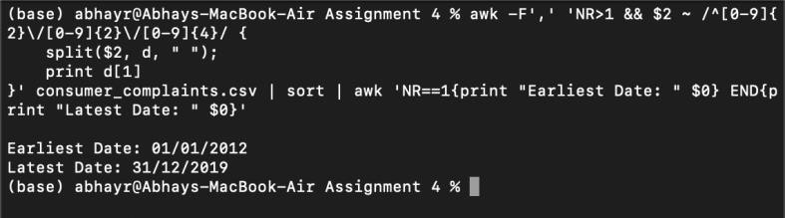

Explanation:

To identify the overall date range of complaints in the dataset, we focused solely on the Date_received column (column 2) from consumer_complaints.csv. We did not apply any filters to Complaint ID or other fields, as data cleaning steps are covered in later questions.

We stripped off the time component from each Date_received value using a split operation on the space character. Then, we sorted all valid dates and extracted the earliest and latest entries to determine the full temporal span of the complaints in their raw form.

The results showed that complaints range from 01/01/2012 to 31/12/2019, providing an overview of the dataset's coverage before any filtering or validation steps are applied.

Objective 2: Validate Complaint IDs and clean date values

Objective 2.1 Count invalid Complaint IDs

Code:
awk -F',' 'NR>1 && $1 !~ /^[0-9]{7}$/ {print $1}' consumer_complaints.csv | wc -l

Output:

Explanation:
We validated the format of the Complaint ID column to ensure it contains only 7-digit numeric values, as required. Using a regular expression, we filtered out all rows where:
    - The ID was not purely numeric, or

    - The number of digits was not exactly 7
This resulted in 285,336 invalid rows, which we will exclude in subsequent processing steps to ensure data consistency and accuracy.

Objective 2.2 Filter invalid records and remove time values

Code:
awk -F',' 'NR==1 || ($1 ~ /^[0-9]{7}$/ && $2 ~ /^[0-9]{2}\/[0-9]{2}\/[0-9]{4}/) { split($2, d, " ");
$2 = d[1];
OFS=",";
print $1, $2, $3, $4, $5, $6, $7, $8, $9, $10, $11, $12, $13, $14;
}' consumer_complaints.csv > filtered_complaints.csv

Output:
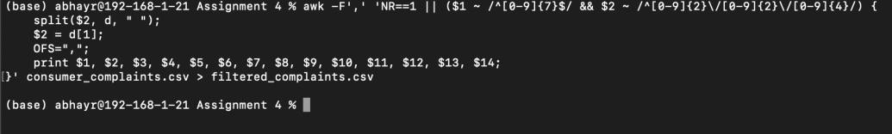

Explanation:
In this step, we performed essential data cleaning to prepare the dataset for further analysis. Specifically, we:
- Removed all rows with invalid Complaint IDs, ensuring that only rows with exactly 7-digit numeric complaint IDs were retained.
- Stripped time components from the Date_received column. Many entries included timestamps (e.g., “29/04/2020 23:13”), which we converted to a standardized date format (DD/MM/YYYY) using a split operation.
These operations help ensure consistency and reliability in the dataset. The cleaned data, which maintains the original structure and includes all 14 columns, was saved to a new file named filtered_complaints.csv. This file will be used for all remaining questions in Task A to ensure results are based on valid and well-formatted records only.

Objective 2.3 Preview the cleaned dataset

Code:
head -n 4 filtered_complaints.csv
Output:
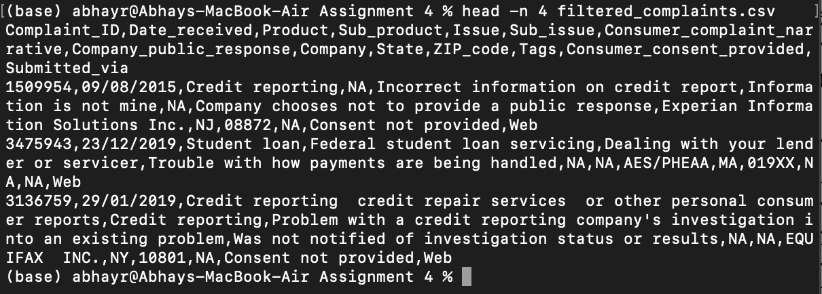

Explanation:

We used the head command to inspect the first three data rows of the cleaned dataset (filtered_complaints.csv). This preview confirms that:
    - The header row is intact

    - The Complaint ID values are valid 7-digit numbers
    - The Date_received column contains only date values in DD/MM/YYYY format, with no time components remaining
This step helps validate that the cleaning logic applied in Q2-b was correctly implemented.

Objective 3: Identify first and last mentions of “Student loan”
Code:
awk -F',' 'NR==1 || $7 ~ /Student loan/ {print $2}' filtered_complaints.csv | tail -n +2 | sort | awk 'NR==1{print "First Mention: " $0} END{print "Last Mention: " $0}'

Output:
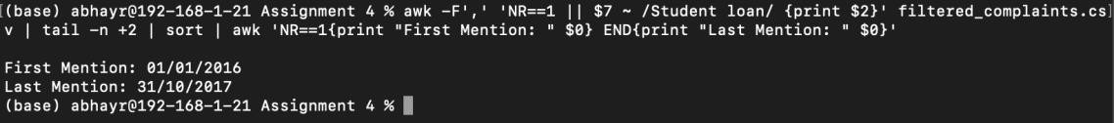

Explanation:

To find the first and last mention of the term “Student loan” in the consumer narratives, we searched column 7 of the cleaned dataset (filtered_complaints.csv) using a case-sensitive pattern match. We extracted the corresponding Date_received values, sorted them chronologically, and reported the earliest and latest dates. This ensures that the answer reflects actual mentions of the exact phrase “Student loan” as it appeared in the dataset.

Objective 4: Analyse product categories

Objective 4.1 Count unique product categories

Code:
cut -d',' -f3 filtered_complaints.csv | tail -n +2 | sort | uniq | wc -l

Output:

Explanation:
We extracted the Product column from the cleaned dataset (filtered_complaints.csv), removed the header, and used Unix stream tools to count the number of unique product types. Sorting followed by uniq ensures accurate deduplication. This step helps us understand the range of product categories represented in consumer complaints.

Objective 4.2 Identify the top five most frequent product categories

Code:
awk -F',' 'NR>1 && $7 != "" {print $3}' filtered_complaints.csv | sort | uniq -c | sort -nr | head -n 5

Output:

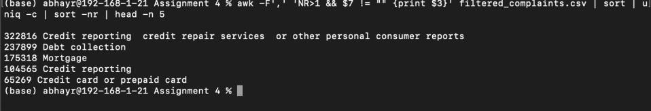

Explanation:
To determine which products were most frequently discussed by consumers in written narratives, we filtered the cleaned dataset (filtered_complaints.csv) to include only rows with non-empty Consumer complaint narrative fields. We then extracted the corresponding Product values and calculated their frequencies. Sorting these counts in descending order allowed us to identify the top 5 products with the highest number of narrative-based complaints i.e., the largest number of paragraphs.

Objective 5: Analyse complaint narratives using text matching

Objective 5.1 Identify fraud-related credit card complaints

Code:
awk -F',' 'NR>1 && tolower($7) ~ /fraud/ && tolower($3) ~ /credit[ -]?card/ {count++} END{print count}' filtered_complaints.csv

Output:

Explanation:
This step counts complaints where the consumer narrative mentions fraud and the associated product category relates to credit cards. Case-insensitive matching was used to capture variations such as “creditcard”, “credit-card”, and “credit card”. This links fraud-related complaint text with credit-card product records.

Objective 5.2 Identify complaints involving long wait times

Code:
awk -F',' 'NR>1 && tolower($7) ~ /(wait|waiting|waited|on hold)/ && tolower($7) ~ /[0-9]+
*(min|minute|hour|hr)/ {count++} END{print count}' filtered_complaints.csv

Output:
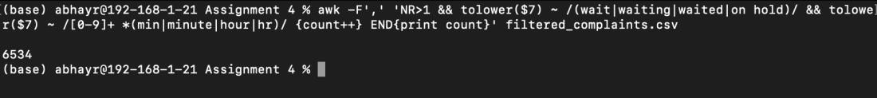

Explanation:
To estimate the number of complaints related to long wait times, we searched the Consumer complaint narrative column for variations of the word "wait" (e.g., "waiting", "on hold", "waited") in combination with expressions of time (e.g., "30 minutes", "2 hours"). The search was performed in a case-insensitive manner to ensure completeness. Only complaints that included both a wait-related phrase and a numerical time reference were counted.

Skills Demonstrated
- Shell scripting
- Data cleaning
- Regular expressions
- Text pattern matching
- CSV filtering
- Frequency analysis
- Command-line data exploration

Limitations

This analysis uses comma-based parsing with shell tools such as awk and cut. While this approach demonstrates command-line data wrangling skills, some CSV files may contain commas inside quoted text fields. A production-level workflow would use a CSV-aware parser for more robust processing.

