Efficient Image Processing Based Liver Cancer Detection Method

Efficient Image Processing Based Liver Cancer Detection Method

Namrata Ghuse^{1*}, Yogita Deore², Amol Potgantwar³

^{1*}Professor, Computer Engineering Department, SITRC, Pune University, Nashik, India
²Student, Computer Engineering Department, SITRC, Pune University, Nashik, India
³HOD, Computer Engineering Department, SITRC, Pune University, Nashik, India

*Corresponding Author: yogitadeore111@gmail.com, Tel.: +91-8087610215
Received 17th May 2017, Revised 30th May 2017, Accepted 20th Jun 2017, Online 30th Jun 2017
Abstract— Cancer treatment has a great significance due to the prevalent episodes of the diseases, very high death rate and reappearance after treatment. In the large world scale, cancer stands in the fifth position which causes death. Among the various cancers, liver cancer stands in the third position. Liver cancer is generally diagnosed by three different test like blood test, image test and biopsy. To make the different task of detecting the liver cancer simpler, less time consuming, an effective and efficient approach is adopted for the same. In this research an Image processing system for detecting liver cancer is put forward. The proposed detection methodology makes use of MRI and CT. Region growing technique is adopted so as to segment the images in order to capture the region of interest. Later, wavelet transform is considered to compute the threshold values for the region of interest. After processing and measuring it gives the correct result with in the efficient time period.

Keywords— Image; Region Growing; CT Image; Image processing; Segmentation

Introduction
Twenty-five years ago clinicians and researchers were poised to make major advancements in Liver cancer. Liver cancer is one of the broad death factors in the world and also known as hepatic cancer. There are different cancers which start from somewhere else and end up in the liver those are not primary liver cancers.

Cancers that create in the liver are known as primary liver cancers. The most common type of liver cancer is heptagon cellular carcinoma and it bearings to affect males more than females. A significant issue in practical radiology is soon detection and accurate presentation of liver cancer. Liver lesions refer to that weird tissue cell that is found in the liver. Liver lesions are an injury in the tissue areas of the body due to harm by a disease. Lesions can be identified in CT scan by a difference in pixel intensity from other regions of the liver. For clinical treat, manual segmentation of this CT scan is flinty and materially time consuming task. Lesion of liver tumors is a sense prerequisite tasks onwards any medical mediation.

Precise and perfect examination of the segmentation allows for sure staging and valuation of the available therapies that can be provided to the patient. In Beyond years invasive methods are used for diagnosis any disease, like cancer. Sundry types of imaging technologies based on non-invasive approach are CT scan, MRI, X-Ray, Ultrasound and liver scans.

Liver is the biggest glandular organ in the body and performs many important functions to keep the body pure of toxins and dangerous substances. It is an important organ that supports nearly every organ in the body in some facet. The liver receives about 1.5 quarts of blood every minute via the hepatic artery and portal vein.

Liver Tumor is a weird mass found in the liver. Simply segmentation techniques are applied on images of liver then classification techniques are applied on category images to classify tissue into two types normal and abnormal this tissues image is further investigated for extracting useful information from segmented image with the presence of some noises volume calculation is carried out to identify its size. [7] CT is most commonly used imaging modalities in the diagnosis of liver Tumor.

LITERATURE SURVEY

H. B. Kekre et al designed vector quantization segmentation techniques to detect cancerous mass from MRI images. In order to increase radiologist's diagnostic performance, computer-aided diagnosis (CAD) scheme have been developed to improve the detection of primary signatures of this disease: masses and micro calcifications.

Nelofar Kureshi suggests that the combination of patient clinical and genetic data significantly improves the model’s predictive performance for tumor response than clinical data alone. The decision model is driven by real-world patient data and is a promising step in fostering personalized medical decision-making for patients with advanced NSCLC.

A. J. Stephenson et al. discussed many factors are likely involved, however they believe that part of this improvement was the result of clinical trials which investigated and subsequently defined chemo radiotherapy as the standard of care. In order to continue to improve clinical outcomes, clinical trials investigating new treatment paradigms are needed.

Marco A. Pierotti et al. analyze the activation of the downstream RTK effectors as targets for therapies in colorectal cancer. Finally, they highlight how a novel multidimensional approach which adds an in silico dimensions to the in vitro and in vivo approach, can predict clinical results.

Movsas et al. represents the results of a different Patterns of Care Study (PCS) investigating the treatment patterns for patients with lung cancer in 1998. While 42,335 patient records were reviewed, this study included only 72 patients with LS-SCLC. It is important to note in this study that less than 5% of the patients did not receive both radiotherapy and chemotherapy. While they cannot state that every patient within their analysis treated with radiotherapy also received chemotherapy in the later years, their assumption that such is did occur would appear valid. Furthermore, PCS does not report survival analysis which is contained in their analysis of the SEER database.

Chung-Ming Wu, et al. shows a Multiresolution Fractal (MF) feature to differentiate normal, hepatoma and cirrhosis liver using ultrasonic liver images with an accuracy of 90%.

Yasser M. Kadah, et al. represented Gray level parameters like mean and first percentile and second order Gray level parameters like Contrast, Angular Second Moment, Entropy and Correlation, and trained the Functional Link Neural Network for diagnosis of diffused liver diseases like fatty and cirrhosis using ultrasonic images and showed that very good diagnostic rates can be obtained using unconventional classifiers trained on actual patient data.

M V Sudhamani, G T Raju proposed that segmentation of CT liver images helps to analyze the occurrence of hepatic tumor and classify the tumor from images. To examine the neighboring pixels of initial seed points and determine whether the pixel neighbors should be added to the region or not they used the region growing technique. The procedure is iterative and seed point is selected interactively in the suspected region. The watershed segmentation method is used to segment the contour, which is generated by the region growing. The texture features for the segmented region are extracted through Gray Level Co-occurrence Matrix (GLCM). These features are used to classify the tumor as benign or malignant using Support Vector Machine (SVM) approach. In this paper, a semi-Automated system has been presented which is robust, allows radiologist and surgeons to have easy and convenient access to organ measurements and visualization. Experimental results shows that liver segmentation errors are reduced significantly and all tumors are segmented from liver and are classified as benign or malignant.

PROPOSED SYSTEM

In these approach MRI, CT images are taken as input to do the further analyses. First step is the noise removal. After that region growing segmentation technique is applied. Region based segmentation is classified into different parts. There are primarily four types of segmentation techniques: thresholding, boundary-based, region-based, and hybrid techniques. Thresholding is based on the assumption that clusters in the histogram correspond to either background or objects of interest that can be extracted by separating these histogram clusters. Boundary-based techniques assume that the pixel properties, such as intensity, color, and texture, should change abruptly between different regions. Region-based methods assume that neighboring pixels within the same region should have similar values. Hybrid methods tend to combine boundary detection and region growing together to achieve better segmentation.
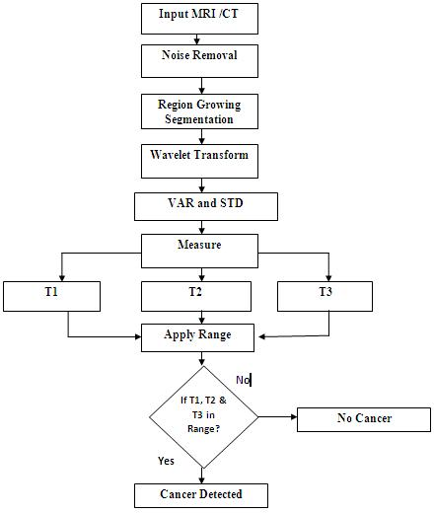
- Proposed System

WORKING OF MODULES

CT scan image
The CT image is sufficient for analysis for this proposed method. The CT scan images are used to identify and design normal and abnormal structures in the body and/or assist in procedures by helping to precisely guide the placement of instruments or treatments. Moreover MRI Scan is very costly and the tissues can’t able to view clearly. But the CT is not so costly but also the tissues can be clearly visible in CT scan.

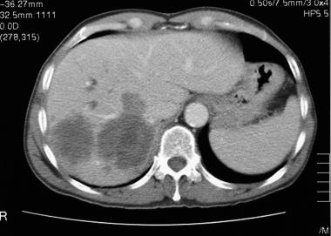
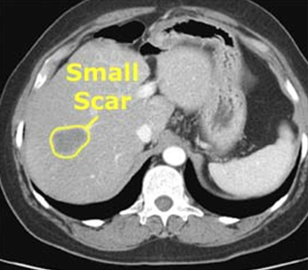
- Sample CT scan images of Liver Cancer

Noise Removal Process
Noise removal process is nothing but it removes the unwanted pixels and improves the clarity of the object given in the CT images.

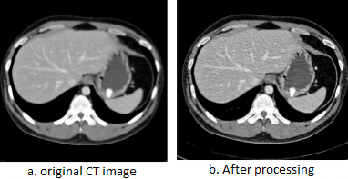
- Noise removal process

Region Based Growing Segmentation
Image segmentation is a process of pixel classification. An CT scan image is segmented into the new subsets by assigning individual pixels to classes. It is an important step towards pattern detection and recognition. Pal provided a review on various segmentation techniques. It should be noted that there is no single standard approach to segmentation. Many different types of scene parts can serve as the segments on which descriptions are based, and there are many different ways in which one can attempt to extract these parts from the image. Selection of an appropriate segmentation technique depends on the type of images and applications. There are primarily four types of segmentation techniques: thresholding, boundary-based, region-based, and hybrid techniques. Thresholding is based on the assumption that clusters in the histogram correspond to either background or objects of interest that can be extracted by separating these histogram clusters. Boundary-based methods assume that the pixel properties, such as intensity, color, and texture, should change abruptly between different regions. Region-based methods assume that neighboring pixels within the same region should have similar values. Hybrid methods tend to combine boundary detection and region growing together to achieve better segmentation.

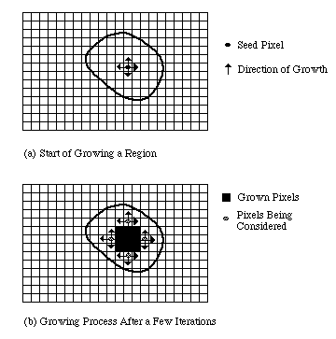
- Region growing segmentation process

Wavelet Transform
The wavelet transform plays an important role in image compression. For image compression applications, wavelet transform is a more suitable technique compared to the Fourier transform. Fourier transform is not practical for computing spectral information because it requires all previous and future information about the signal over the entire time domain and it cannot observe frequencies varying with time because the resulting function after Fourier transform is a function independent of time. On the other hand, wavelet transforms are based on wavelets which are varying frequency in limited duration. Due to the practicality of the wavelet transforms, this research paper is written to investigate the properties and the improvements that can be made to enhance the performance of the wavelet transforms.

Wavelet Function
The wavelet function is analogous to the scaling function expression. Both integer translation and binary scaling are incorporated

- The Discrete Wavelet Transform
It is necessary to express the continuous dilation and translation parameters a & b in terms of discrete values. A popular way to discretize a and b is expressing the parameters as
a = a₀^{j}
b = kb₀a₀ ^{j}

Where, the parameter j affect the scaling of the wavelet transform and k is related to the translation of the wavelet function.

RESULT ANALYASIS
As per the experimental result analysis some sample images are tested in the system. It gives the excellent response. Accuracy graph distinguishes between the existing system and implemented system by the percentage. Every sample CT image test accuracy of result is improved compared to existing systems.
- Accuracy Analysis
Number of Test | Accuracy In Percentage (%)
Number of Test | Existing | Proposed
10 | 67.3 | 70.1
20 | 69.5 | 74.5
30 | 75.9 | 79.5
40 | 82.5 | 86.5

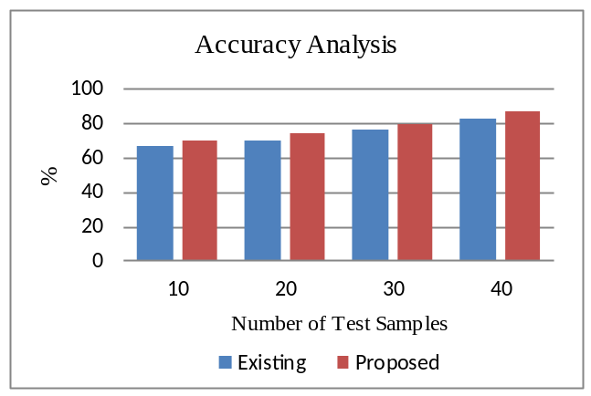
- Accuracy Graph
Processing time details are shown in the time analysis figure. It simply shows the increased efficiency of the processing time.
- Time Analysis
CT Image Test | Time In Seconds
CT Image Test | Existing | Proposed
Image 1 | 3.5 | 2.1
Image 2 | 3.89 | 2.4
Image 3 | 3.39 | 2.1
Image 4 | 4.25 | 2.22
Image 5 | 3.92 | 2.43
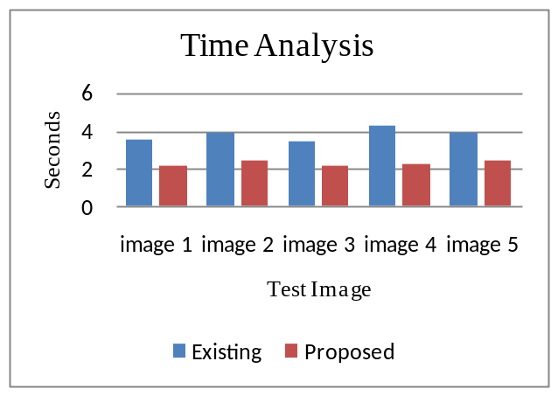
- Time analysis

CONCLUSION
The implemented image processing based liver cancer detection method works efficiently and gives the best accuracy. Here we have used two main techniques region growing and wavelet transform for the implementation of these systems. We are still working on this system to add any new technology to enhance the system progress.

REFERENCES

- Nelofar Kureshi, Syed Sibte Raza Abidi, “A Predictive Model for Personalized Therapeutic Interventions in Non-small Cell Lung Cancer”, IEEE Journal of Health Informatics Vol. 20, No.1, pp. 424-431, 2016.
- PR Anisha, CKK Reddy, LVN Prasad, "A pragmatic approach for detecting liver cancer using image processing and data mining techniques", International Conference on Signal Processing And Communication Engineering Systems (SPACES), India, pp.1-6, 2015.
- F. J. Kaye, N. Lindeman, T. J. Boggon, K. Naoki, H. Sasaki, Y. Fujii, M. J., W. R. Sellers, B. E. Johnson, M. Meyerson, “EGFR mutations in lung cancer: Correlation with clinical response to gefitinib therapy”, Science, vol. 304, no. 5676, pp. 1497-1500, Jun. 2004.
- F. G. Haluska, D. N. Louis, D. C. Christiani, J. Settleman, D. A. Haber, “Activating mutations in the epidermal growth factor receptor underlying responsiveness of non-small-cell lung cancer to gefitinib”, New England J. Med., vol. 350, no. 21, pp. 2129-2139, 2004.
- H. B. Kekre, A. Bild, E. S. Iversen, A. T. Huang, J. R. Nevins, M.West, “Integrated modeling of clinical and gene expression information for personalized prediction of disease outcomes”, Proc. Nat. Acad. Sci. vol. 101, no. 22, pp. 8431-8436, 2004.
- Nelofar Kureshi, L. X. Li, “Survival prediction of diffuse large-B-cell lymphoma based on both clinical and gene expression information”, Bioinformatics, vol. 22, no. 4, pp. 466-471, 2006.
- A. J. Stephenson, A. Smith, M. W. Kattan, J. Satagopan, V. E. Reuter, P. T. Scardino, W.L. Gerald, “Integration of gene expression profiling and clinical variables to predict prostate carcinoma recurrence after radical prostatectomy”, Cancer, vol. 104, no. 2, pp. 290-298, 2005.
- C. C. Bennett, T. W. Doub, R. Selove, “EHRs connect research and practice: Where predictive modeling, artificial intelligence, and clinical decision support intersect”, Health Policy Technol., vol. 1, no. 2, pp. 105-114, 2012.
- L. Chouchane, R. Mamtani, A. Dallol, J. I. Sheikh, “Personalized medicine: a patient-centered paradigm”, J. Trans. Med., vol. 9, Issue.1, pp.201-206, 2011.
- S. Navada, P. Lai, A. G. Schwartz, G.P. Kalemkerian, “Temporal trends in small cell lung cancer: Analysis of the national surveillance epidemiology and end-results (SEER) database”, J. Clin. Oncol., vol. 24, no. 18, p. 70-82, 2006.
- R. S. Herbst, M. Fukuoka, J. Baselga, “Gefitinib-A novel targeted approach to treating cancer”, Nature Rev. Cancer, vol. 4, no. 12, pp. 956-965, 2004.
- Movsas, A.L. Stiegler, T.J. Boggon, S. Kobayashi, B. Halmos, “EGFR-mutated lung cancer: A paradigm of molecular oncology”, Oncotarget, vol. 1, no. 7, pp. 497-514, 2010.
- Yasser M. Kadah, Einhorn LH, Bond WH, Hornback N, Joe BT, “Long-term results in combinedmodality treatment of small cell carcinoma of the lung”, Semin Oncol, Vol. 5, No. 3, pp. 309-313, 1978
- Govindan R, Page N, Morgensztern D, Read W, Tierney R, Vlahiotis A, “Changing epidemiology of small-cell lung cancer in the United States over the last 30 years: analysis of the surveillance, epidemiologic, and end results database”, J Clin Oncol, Vol.24, Issue.28, pp.4539-4544, 2006.
- Murray N, Turrisi AT, “A review of first-line treatment for small-cell lung cancer”, J Thorac Oncol, Vol.1, Issue.3, pp.270278, 2006.
- Ravdin PM, Cronin KA, Howlader N, Berg CD, Chlebowski RT, Feuer EJ, Edwards BK, Berry DA., “The decrease in breast-cancer incidence in 2003 in the United States”, New England Journal of Medicine, Vol.356, Issue.16, pp.1670-1674, 2007.
- Green RA, Humphrey E, Close H, Patno ME, “Alkylating agents in bronchogenic carcinoma”, Am J Med, Vol.46, Issue.4, pp.516-525, 1969.
- Chung-Ming Wu, Weiss RB, “Small-cell carcinoma of the lung: therapeutic management”, Ann Intern Med, Vol.88, Issue.4, pp.522–31, 1978.
- Nelofar Kureshi, Syed Sibte Raza Abidi, “A Predictive Model for Personalized Therapeutic Interventions in Non-small Cell Lung Cancer”, IEEE Journal of Health Informatics Vol. 20, No.1, pp. 424-431, 2016.
- J.G. Paez, P.A. Janne, J.C. Lee, S. Tracy, H. Greulich, S. Gabriel, P. Herman, F.J. Kaye, N. Lindeman, T.J. Boggon, K. Naoki, H. Sasaki, Y. Fujii, M.J., W.R. Sellers, B.E. Johnson, M. Meyerson, “EGFR mutations in lung cancer: Correlation with clinical response to gefitinib therapy”, Science, vol. 304, no. 5676, pp. 1497-1500, 2004.
- D.C. Christiani, J. Settleman, D.A. Haber, “Activating mutations in the epidermal growth factor receptor underlying responsiveness of non-small-cell lung cancer to gefitinib”, New England J. Med., vol.350, no.21, pp.2129-2139, 2004.
- C.M. Chen, A. Bild, E.S. Iversen, A.T. Huang, J.R. Nevins, M. West, “Integrated modeling of clinical and gene expression information for personalized prediction of disease outcomes”, Proc. Nat. Acad. Sci., vol.101, no.22, pp. 8431-8436, 2004.
- L. X. Li, “Survival prediction of diffuse large-B-cell lymphoma based on both clinical and gene expression information”, Bioinformatics, vol. 22, no. 4, pp. 466-471, 2006.
- A.J. Stephenson, A. Smith, M.W. Kattan, J. Satagopan, V.E. Reuter, P.T. Scardino, W.L. Gerald, “Integration of gene expression profiling and clinical variables to predict prostate carcinoma recurrence after radical prostatectomy”, Cancer, vol. 104, no. 2, pp. 290-298, 2005.
- C.C. Bennett, T.W. Doub, R. Selove, “EHRs connect research and practice: Where predictive modeling, artificial intelligence, and clinical decision support intersect”, Health Policy Technol., vol. 1, no. 2, pp. 105-114, 2012.
- L. Chouchane, R. Mamtani, A. Dallol, J.I. Sheikh, “Personalized medicine: a patient-centered paradigm”, J. Trans. Med., vol. 9, Issue.1, pp.201-206, 2011.
- S. Navada, P. Lai, A.G. Schwartz, G.P. Kalemkerian, “Temporal trends in small cell lung cancer: Analysis of the national surveillance epidemiology and end-results (SEER) database”, J. Clin. Oncol, vol.24, no.18, pp.70-82, 2006.
- R. S. Herbst, M. Fukuoka, J. Baselga, “Gefitinib—A novel targeted approach to treating cancer”, Nature Rev. Cancer, vol. 4, no. 12, pp. 956-965, 2004.
- Z. Zhang, A. L. Stiegler, T. J. Boggon, S. Kobayashi, B. Halmos, “EGFR-mutated lung cancer: A paradigm of molecular oncology”, Oncotarget, vol. 1, no. 7, pp. 497-514, 2010.
- Einhorn LH, Bond WH, Hornback N, Joe BT, “Long-term results in combinedmodality treatment of small cell carcinoma of the lung”, Semin Oncol, Vol.5, Issue.3, pp.309-313, 1978.
- Govindan R, Page N, Morgensztern D, Read W, Tierney R, Vlahiotis A, “Changing epidemiology of small-cell lung cancer in the United States over the last 30 years: analysis of the surveillance, epidemiologic, and end results database”, J Clin Oncol, Vol.24, Issue.28, pp.4539-44, 2006
- Murray N, Turrisi AT, “A review of first-line treatment for small-cell lung cancer”, J Thorac Oncol, Vol.1, Issue.3, pp.270-278, 2006
- Jemal A, Siegel R, Ward E, Murray T, Xu J, Thun MJ., “Cancer statistics”, CA Cancer J Clin, Vol.57, Issue.4, pp.43-66, 2007
- Green RA, Humphrey E, Close H, Patno ME, “Alkylating agents in bronchogenic carcinoma”, Am J Med, Vol.12, Issue.6, pp.516-525, 2007.

Author Profile


Prof. Namrata. D. Ghuse pursed Master of Engineering from Prof. Ram Meghe Institute of Engineering & Management, Badnera, Amravati in 2014. She is currently working as Assistant Professor in Department of Computer Engineering of Sandip Institute of Technology & Research Centre, Nashik. She is a member of ISTE i.e. International Society for Technology in Education. She has published more than 10 research papers in reputed international journals and it’s also available online.

