Project Report On
Indent Slip

Submitted By
Abhay Shihora
Seat No.:

Submitted for
Project Work
BCA Semester - IV (2023-24)

Submitted To


S.G.M. English Medium College of Commerce and Management (SEMCOM) CVM University

ACKNOWLEDGEMENT

- In completing this graduate project I have been fortunate to have help, support
and encouragement from many people. I would like to acknowledge them for their
cooperation.
- First, I would like to thank Ms. Ami Trivedi Ma’am, my project advisor, for
guiding me through each and every step of the process with knowledge and support.
Thank you for your advice, guidance and assistance.
- Finally, I would like to dedicate this project to my Teachers, my Friends and
for their love, encouragement and help throughout the Project. This project
has been a rewarding learning experience, and I feel deeply grateful for the
opportunity to contribute to it. Thank you once again to everyone who has been
a part of this journey.

Index

Sr.  No. | Description of Topic | Page  No.
1 | Title Page of Project
2 | College Certificate
3 | Acknowledgement
4 | Index
5 | Project Profile | 5
6 | An Existing System | 10
7 | Hardware and Software | 11
8 | Data Flow Diagram | 12
9 | Database Layout | 16
10 | Screens | 17
11 | Limitations | 21
12 | Conclusion | 22
13 | Bibliography | 23

Project Profile

As the modern organizations are automated and computers are working as per the instructions, it becomes essential for the coordination of human beings, commodity and computers in a modern organization. This System helps to Request for the Require Item In the Company.

Indent Slip Web is as Web-site used by Internet in local computer for Requesting The Needed Item .

This Web-site helps to Request Item Online And promote usage of digital technology in daily life.

According to the Modules the Employee and Manager(Admin) do their activities in easy manner.

The Indent Slip Web is a comprehensive Web solution designed to automate and streamline Request and Get Item. It enables efficient management of Required Item in The each Department.

The system facilitates easy tracking of Required Item resources and provides robust reporting capabilities for Managers.

The proposed system is for Making easier to manage Required Item in Each Department. So, this will be developed for Easy Managing for Employee’s Item Request. The overall system is control through the Home Page.

The project has Four modules namely-Login & Register, Create Indent, Indent Status, Indent Report, Admin Panel.

- Key Features

- Login & Register Module:

- Insert the Customers records.
- This Will Give Safe login And Register experience.

- Home Module:

- Best Designed Home page.
- Giving Info About Indent System.

- Easy Access to Indent.

- Details About System Modules (Create Indent, Indent Status, Indent Report).

- Create Indent:

- Giving Indent Form

- Using This form Request the Manager for The Indent.

- Simple And Easy Fill up the form.

- Redirecting to Indent Status Page.

- Indent Status:

- Status of the User Indent.

- Details of Indent or their Status.

- Easy to Update and Delete the selected Indent

- Easy Access To Indent Details.

- Report:

- Display Data of Indent.

- Display Only Accepted Indent Data.

- Give the Report of Indent.
- Admin Panel:

- Getting Details About User Indent.

- Filtering the data as per status.

- Divide Status in to three category(Accepted, Declain, Pending).

Features
  - Login, Register & Forget / Logout.
  - Easy to Create Indent.
  - Easy to Request of Manager for Required Item.
  - You want to see the Status of Indent Then You Also see.
  - You also see your accepted Indent Report.
  - User Landing Page with Unique Design.
  - Home Page With Vertical Navbar for Easy Access of all Features.
  - Details & History About All Indent.
  - All Departments Employee can Request for the Indent.
  - Every Type of Employee can Have their own Indent Request.
  - Employee Can Add Quantity of Each Item.
  - Employee can update or Delete the Indent also.
  - All The Indent Can be watch which is they Request.

Languages Used

Front End:
    - HTML
    - CSS(Cascading Style Sheet)
    - JavaScript

Back End:
    - PHP
    - MyPhpAdmin
    - MYSQL
(Local Database)
SQL is used for database management and interactions. PHP Web often interact with databases (such as Microsoft SQL Server or MySQL) to store and retrieve
data related to Indent, User and other Web records.

Editor:
    - Visual Studio Code Editor

Existing System

- Request Submission: Employees or departments within the organization submit requests for goods or services that they require. This could include items such as office supplies, equipment, or services from other departments.
- Indent Slip Creation: Upon receiving a request, the requester fills out an indent slip, providing details such as the requested item(s), quantity, purpose, and any specific requirements. The indent slip may also include fields for approval signatures or comments.
- Approval Process: The indent slip is typically routed through an approval process, where designated personnel review and approve the request. Depending on the organization's policies, this may involve multiple levels of approval based on factors such as cost, budget allocation, or departmental authority.
- Documentation and Tracking: Once approved, the indent slip serves as an official document for tracking the request throughout the procurement process. It may be logged into a central system or database for documentation and record-keeping purposes.
- Procurement and Fulfillment: After approval, the procurement team or responsible personnel take action to fulfill the request. This may involve purchasing the requested items, coordinating with vendors, or arranging for the provision of services.

Hardware and Software

Hardware Requirements:
The following is a list of minimum requirements of hardware,
    - Laptop/Desktop
    - Memory : Minimum 8GB RAM
    - Hard Disk : Minimum 256GB Hard disk
    - Interface : Mouse, Keyboard

Software Requirements:
This system requires the following software
- OS: Windows 10 and above or macOS
- Visual Studio Code Editor
- Microsoft Word
- Microsoft PowerPoint

Data Flow Diagram

Process Hierarchy

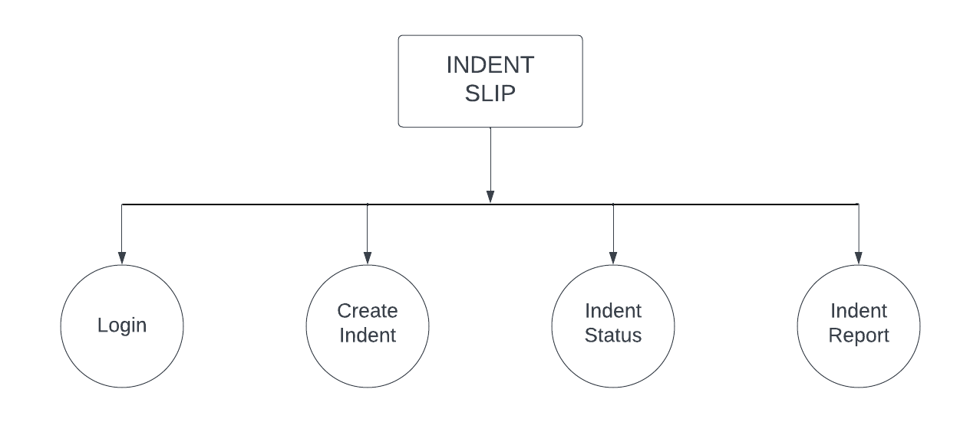

Process Hierarchy
- Process hierarchy is a framework that represents processes in a hierarchical structure. It helps in visualizing the relationships between different forms.
- In Indent Slip the flow of system shows that information about employee’s Indent Request, Status and Report also Have a Admin Panel for Manager.

DFD Symbol Table

 | Symbols | Functions
`External Entity |  | A rectangle represents a Entity Decision
Process |  | The activities within a system that use or generate data
Flow |  | A line is a connector that shows relationships between the representative shapes
Data Store |  | Electronic data storage

- Context-Level DFD

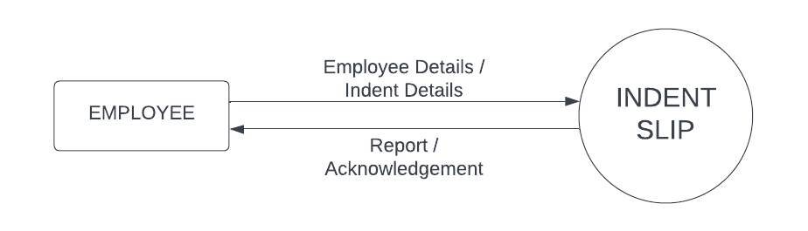

Context-Level DFD
- The Context Level DFD for the Indent Slip System illustrates the system's relationship with external entities.
- At this high level of abstraction, the focus is on depicting the system as a single process, interacting with entities external to the system.
- In this context, the primary external entities are Employee and Manager.
- The flow of the DFD is the Employee, Item and many more entries enter in the database.
- For next, Acknowledgement is returned.

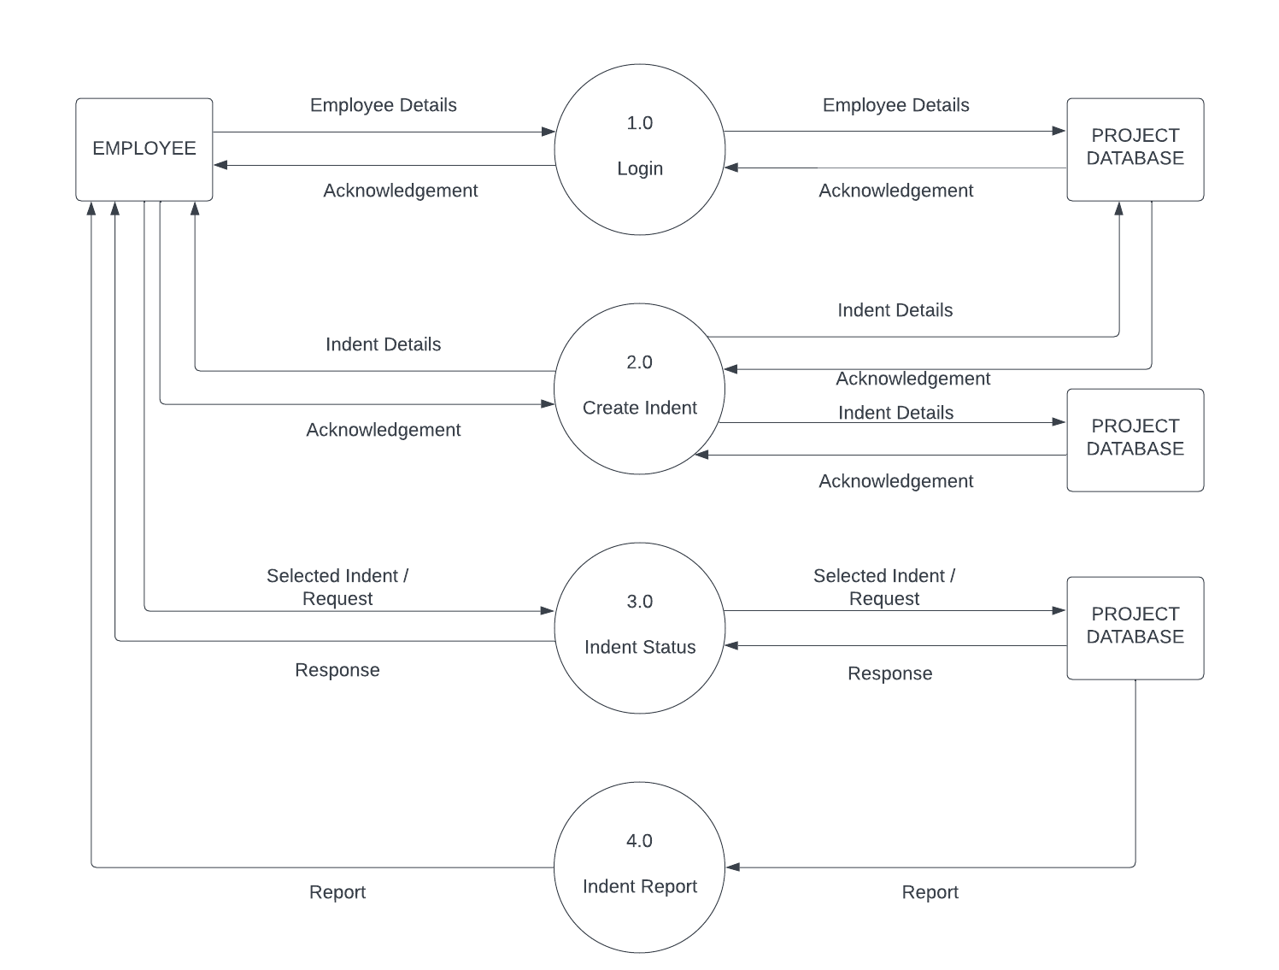
Zero-Level DFD

Zero-Level DFD
- In the Zero Level DFD for the Indent Slip System, the system is depicted as for process box, representing the entire system.
- The diagram illustrates the primary processes that occur within the system and how they interact with external entities to manage the Item resources effectively.
- At this level, the focus is on representing major processes and data flows without diving into the finer details.
- In this DFD there are four main modules (Login, Create Indent, Indent Status and Indent Report).

Database Layout

emp

Sr. No. | Name | Type | Size | Constraint
1 | id | int | 3 | Auto Increment
2 | empno | int | 4 | Not Null
3 | ename | Varchar | 20 | Not Null
4 | mo | Decimal | 10 | Not Null
5 | email | text | 20 | Not Null
6 | deptno | Int | 2 | Not Null
7 | psw | Varchar | 16 | Not Null

- item

Sr. No. | Name | Type | Size | Constraint
1 | id | int | 100 | Not Null(AI)
2 | empno | int | 4 | Not Null
3 | ename | varchar | 30 | Not Null
4 | deptno | int | 2 | Not Null
5 | dname | varchar | 20 | Not Null
6 | mo | decimal | 10,0 | Not Null
7 | iname | varchar | 30 | Not Null
8 | quantity | int | 3 | Not Null
9 | uom | varchar | 15 | Not Null
10 | rate | int | 5 | Not Null
11 | rdate | date |  | Not Null
12 | pursupplier | varchar | 30 | Not Null
13 | purpose | varchar | 50 | Not Null
14 | status | varchar | 10 | Not Null

Screens

Create Indent Page

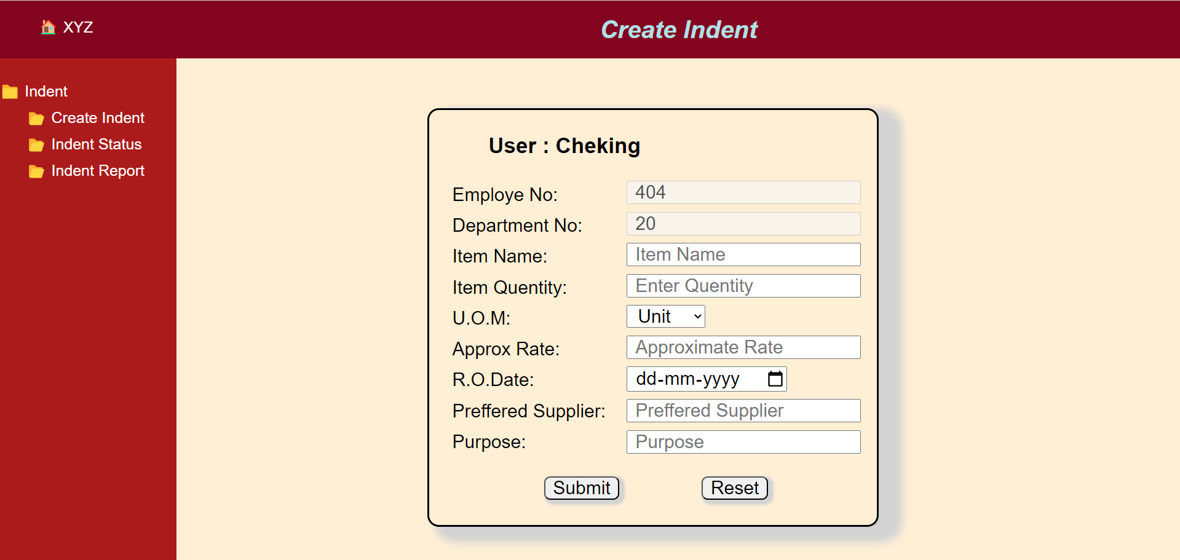

- A Create Indent form, also known as a Home screen, is a user interface element designed to provide feedback to users when the system is in the process of loading or performing a time-consuming operation.
- It is a crucial component of user experience design, and its primary purpose is to enhance the user experience by giving clear visual indications of Create Indent Page.
- This Indent Slip starts with Create Indent page with the interactive interface.

Indent Status

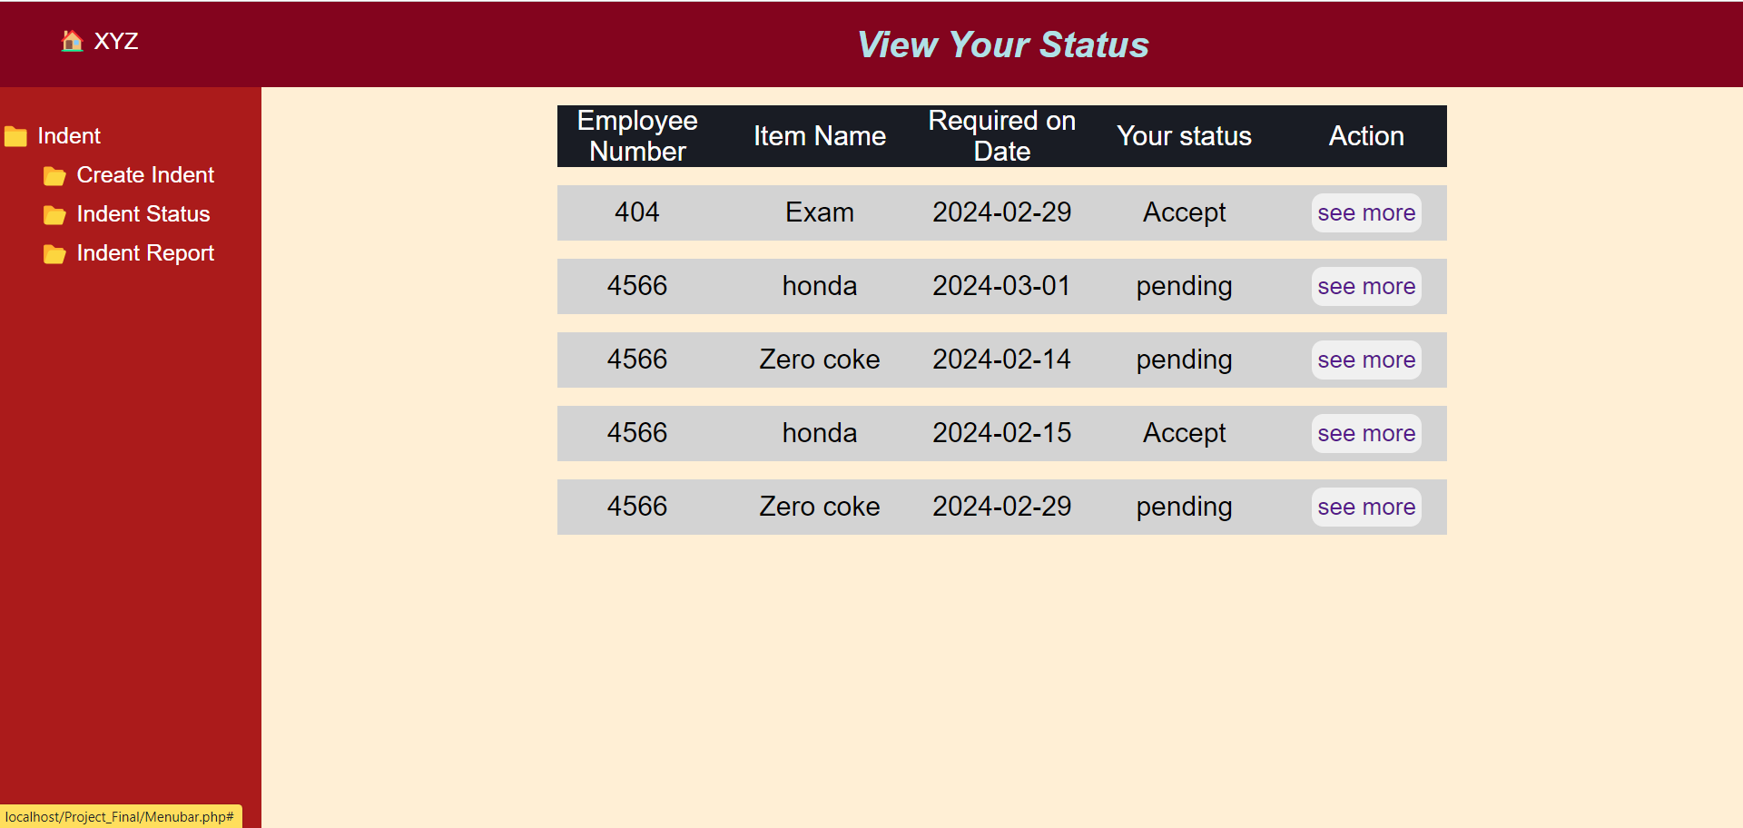

- This Page are designed to present complex information in a clear and user-friendly manner.
- Here we can see our inserted Record means about our indent Detail.
- We can click on see more button then Display that particular Indent Details in detail.
- This Page is User-friendly.

Selected Indent Detail

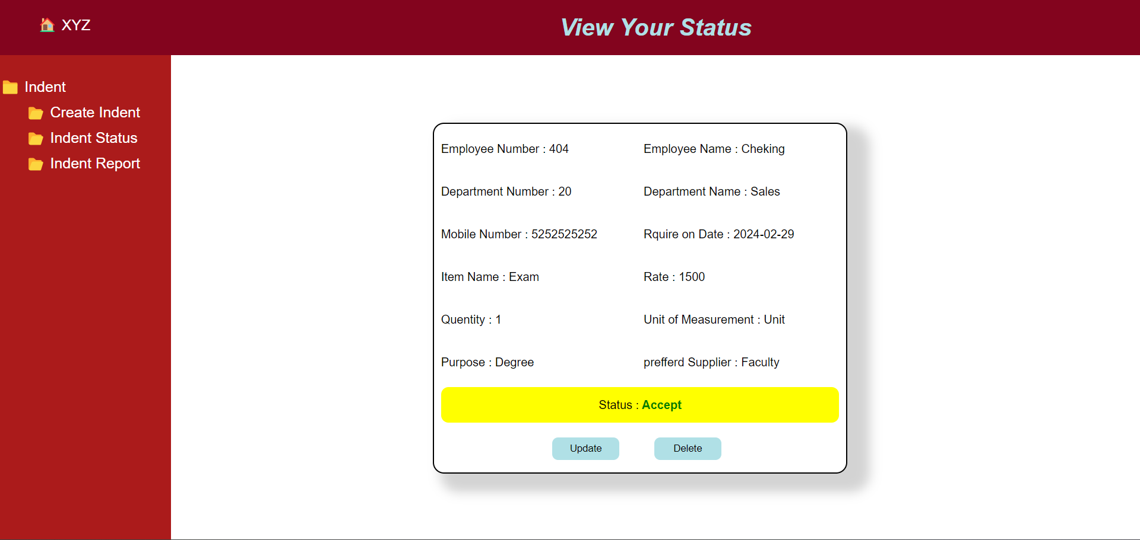

Indent Update

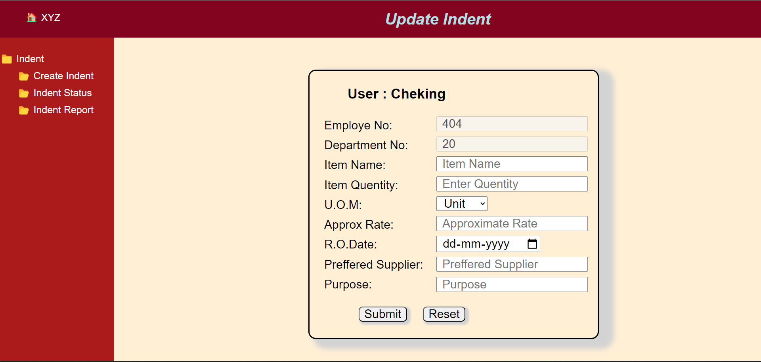

Indent Report

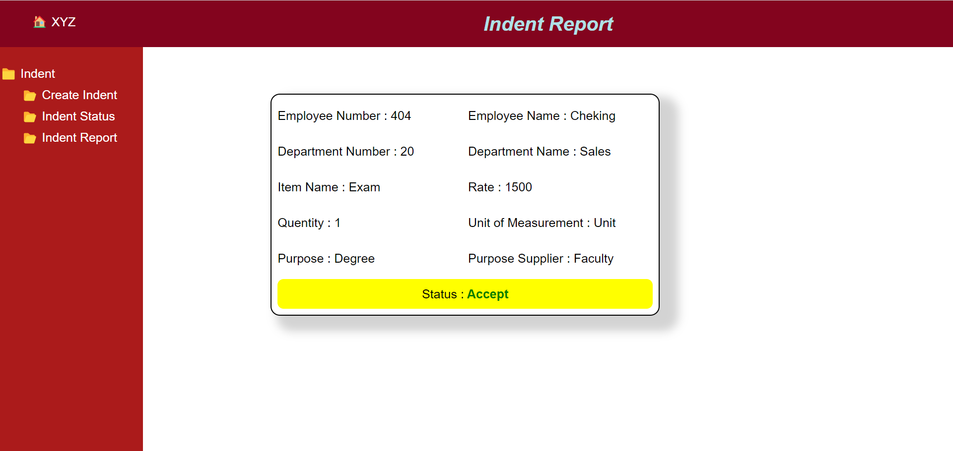

Limitations

Manual Processing: In a manual indent slip system, everything from creating the slip to processing the order is done manually. This can be time-consuming and error-prone.
Potential for Errors: Manual entry increases the likelihood of errors in transcription, leading to mistakes in orders or requisitions.
Limited Traceability: Without a robust digital system in place, tracking orders and their statuses can be challenging. It may be difficult to trace who requested what and when.
Delayed Processing: Manual processing can lead to delays in fulfilling orders, particularly if there's a backlog or if slips get lost in the process.
Lack of Real-Time Information: Traditional indent slip systems may not provide real-time insights into inventory levels or order statuses, making it harder to manage inventory efficiently.
Storage and Retrieval Challenges: Maintaining physical indent slips requires space and organization. Retrieving specific slips can be time-consuming if they're not stored properly.
Scalability Issues: Manual systems may struggle to cope with increasing volumes of orders or requisitions, leading to inefficiencies as the workload grows.

Conclusions

in conclusion, while the indent slip system has been a traditional method for managing procurement and inventory, it comes with several limitations. These include manual processing, potential for errors, limited traceability, delayed processing, lack of real-time information, storage and retrieval challenges, dependency on paper, scalability issues, difficulty in collaboration, and security risks.
Despite these drawbacks, the indent slip system has been used effectively in many organizations, particularly those with simpler procurement needs or smaller inventory management requirements. However, as businesses evolve and demand more efficient and streamlined processes, many are transitioning to digital procurement and inventory management systems.
Digital systems offer automation, real-time tracking, improved efficiency, and enhanced collaboration capabilities. They mitigate the shortcomings of manual indent slip systems by providing better accuracy, scalability, and security. Ultimately, the conclusion is that while the indent slip system has served its purpose in the past, the future of procurement and inventory management lies in embracing digital solutions to drive efficiency, accuracy, and competitiveness.

Bibliography

  - lucid For DFD’s
  - Google

