- Create a table called “Clients” from the “Client_Master” table.
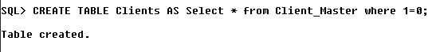
- Insert all records of “Client_Master” into “Clients”
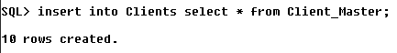
- Create table “Products” from “Product_master”
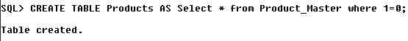
- Copy only selected Product’s information into “Products” table.
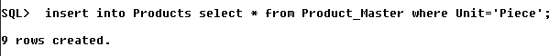
- Create table “Salesman” from Salesman_Master” where “Salesman” table contains Fields: Salesman number, Name, Address1, City, Target, Sales

- Insert all records for the fields in new table from “Salesman_Master” table
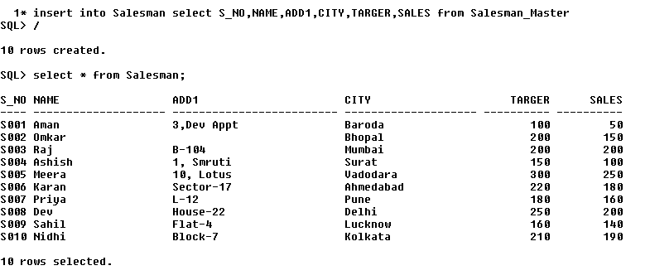
- Create an “Order_Master” table form “Sales_Order” Table

- Insert appropriate records in “Order_Master” from Sales_Order” table
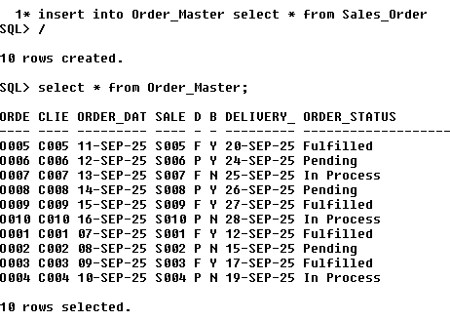
- Create “Order_Detail” table from “Sales_Order_Detail” table.
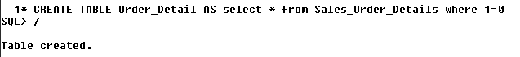
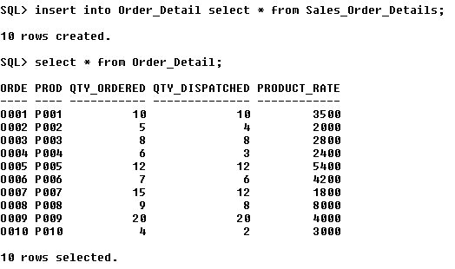
- Insert few selected records in “Order_Detail” from Sales_Order_ Detail” table.
11. Destroy tables: Client_Master, Product_Master and Salesman_Master table using Truncate
12. Destroy tables: “Sales_Order” and Sales_Order_Details using drop operation.
14. Copy only the structure of Applicant Table into Applicant_Master
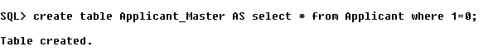
15. Create a new table called Course_Master having same fields as Enterance_Test table but change the column name as Course_Code, Course_Name and Course_Credit
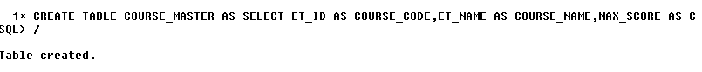
16. Insert new data in Course_Master table.
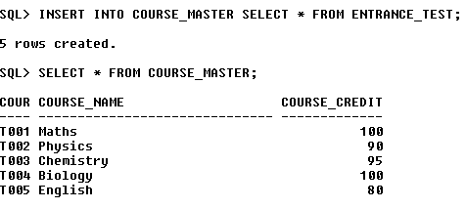
17. Create a view of Entrance_Test_Details table having only 2 columns
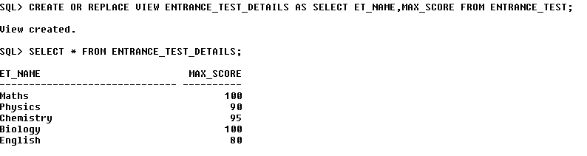18. Create a view of Applicant Table
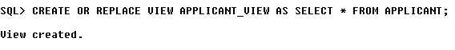
19. Change the record (Column values) in the view table.
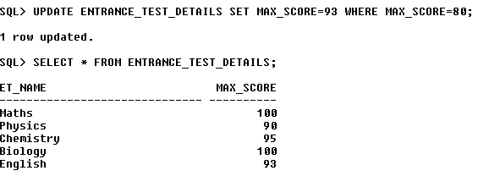
20 Remove the view.
