- Remove all Sales_Orders whose QtyOrdered = 1 in “Sales_Order_Detail” table
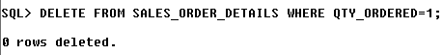
- Modify the OrderStatus to “Fulfilled” where the OrderStatus is “In Process” in Sales_Order Table
- SQL> UPDATE SALES_ORDER SET ORDER_STATUS='Fulfilled' WHERE ORDER_STATUS='In Process';

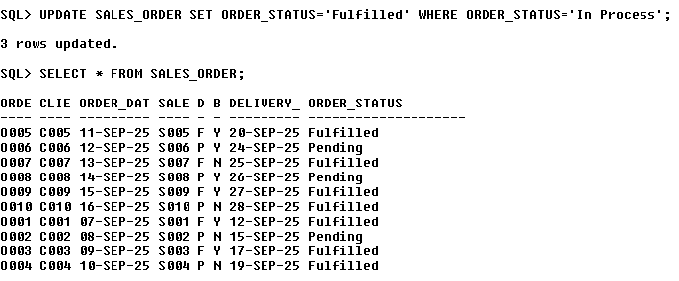
- Increase the sell price of saree by Rs. 20
- update Product_Master set SELL_P=SELL_P+20 WHERE DESCR='Saree';
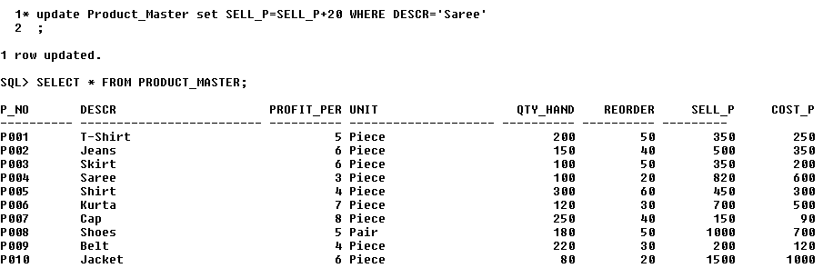
- Delete all Salesman from Salesman_Master table whose salary is more than 3500
- delete from Salesman_master where salary>3500;
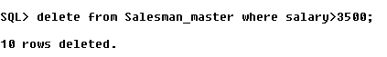
- Delete all Products from Product_master where Quantity on Hand (Qty_Hand) is less than 50
- delete from Product_Master where QTY_HAND<50
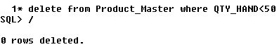
- Change the details of the Client ‘C003’ as pincode to 387903 and Occupation is ‘Manager’
- UPDATE CLIENT_MASTER SET OCCUPATION='Manager' WHERE C_NO='C003' AND PINCODE=387903
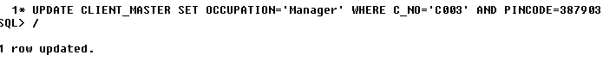
- Remove the product details column from Product_Master Table
- ALTER TABLE PRODUCT_MASTER DROP COLUMN DESCR
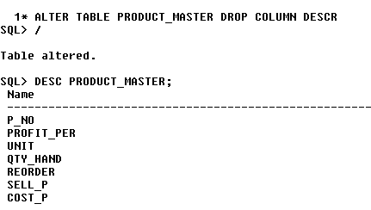
- Add column City and State in Client_Master table
- alter table Client_Master ADD (City varchar2(15),State varchar2(15));

- Increase the size of the Price Column
- ALTER TABLE ITEM MODIFY PRICE NUMBER(9,3)
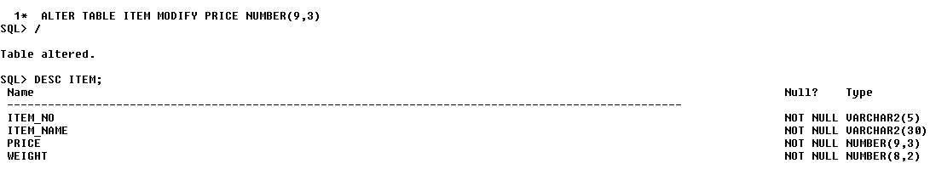
- Add a column Mobile_No of type Number, in the Client_Master Table
- ALTER TABLE CLIENT_MASTER ADD MOBILE_NO NUMBER(10) CHECK(LENGTH(MOBILE_NO)=(10));

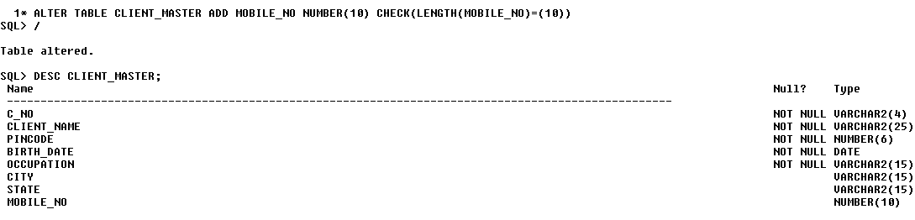
- Add constraint to the Mobile_No column

- ALTER TABLE CLIENT_MASTER ADD MOBILE_NO NUMBER(10) CHECK(LENGTH(MOBILE_NO)=(10));


- Change the name of Salesman_Master table to “SMan_Mst”
- RENAME SALESMAN_MASTER TO SMAN_MST;
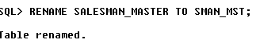
13. Add a column of Experience in the Faculty_Master Table
- ALTER TABLE FACULTY_MASTER ADD EXPERIENCE VARCHAR2(20);
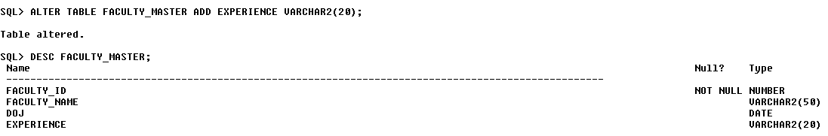
- Change the name of the column Address to Area in Faculty_Master Table
- ALTER TABLE FACULTY_MASTER RENAME COLUMN ADDRESS TO AREA
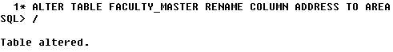
- Modify the Applicant Table name to Applicant_Master
- RENAME APPLICANT TO APPLICANT_MASTER;
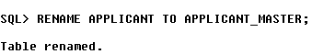
- Add a column “Hobby” in Applicant_Master table.
- ALTER TABLE APPLICANT_MASTER ADD HOBBY VARCHAR2(10);
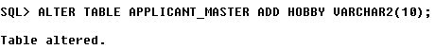
17. Add a column “Location” in the “ETest_Detail” table. Keep it varchar(10)
18. Modify the column “Location” and increase the size upto 25 characters.
19. Change the field “Address” to “City” in Applicant_Master Table
20. Change the name of the Item table to “Item_Master”

