Detailed scheduled
Topics:- | Logical operators like: AND, OR, Combining the AND and OR operator, Not Operator  Aggregate, Math and String functions: MIN, COUNT, MAX, AVG, SUM, ABS, POWER, ROUND, SQRT, EXP, MOD, TRUNC, FLOOR, CEIL, LOWER, INITCAP, UPPER, SUBSTR, ASCII, COMPOSE, TRANSLATE, LENGTH, LTRIM, RTRIM, TRIM, LPAD, RPAD, SYSDATE , EXTRACT (), DATE FORMAT functions TO_DATE (), TO_CHAR ()

- Display all the clients whose age is more than 25 years but less than 50 years
- select client_name,(extract(year from sysdate))-(extract(year from birth_date)) from Client_Master where ((extract(year from sysdate))-(extract(year from birth_date))) between 25 and 50
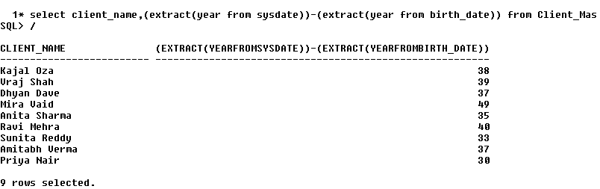

- Display all the Salesman from Salesman_Master table where “Sale” is more than his “Target” and “Target” is more than 100
- select * from salesman_master where sales>target and target>100;

- Find the Salesman who are neither from Baroda nor from Surat.
- select * from salesman_master where city not in('Surat','Baroda');
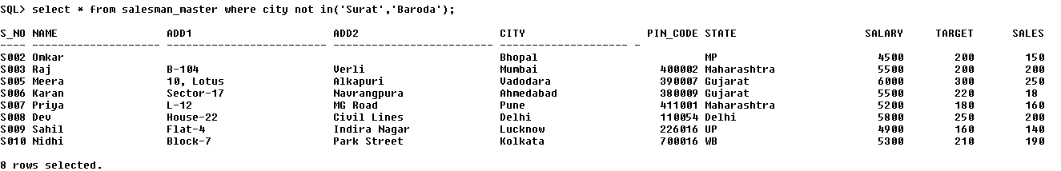
- Display total number of clients using Client_Master Table.
- select count(*) from Client_master;
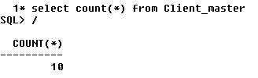
- Display the highest salary a salesman is getting.
- select max(salary) from salesman_master;
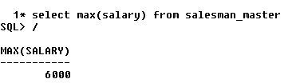
- Display all item names in upper case letters only
- select upper(item_name) from item;
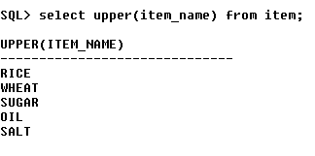
- Display current date and time
- select to_char(sysdate,'dd-mm-yy hh:mm:ss') from dual
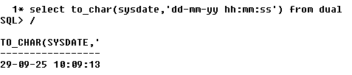
- Display average target given to the salesman.
- select avg(target) from salesman_master;

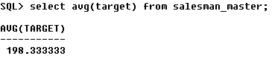
- Display the Birth Date (DOB in Student_Master Table) in a new format. (Eg. February 12, 1998)
- select to_char(DOB,'Month DD, YYYY') from Student_Master;

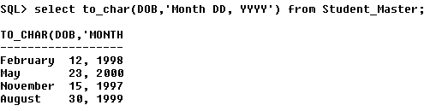

- Display Date of Joining (DOJ, Faculty_Master) of all faculties in DD/MM/YY format
- select to_char(DOJ, 'DD/MM/YY') from faculty_master;
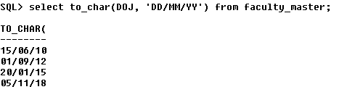
- Display Only Birth Date and Month of all the students from Student_Master Table
- select to_char(DOB, 'DD Month') from student_master;
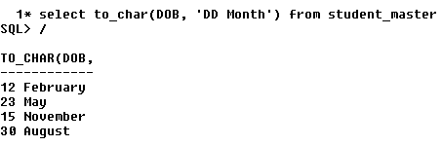
- Count the total number of employees.
- select count(*) from emp;
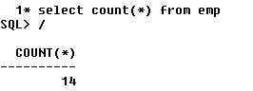
- Calculate the average salary of all the employees.
- select avg(sal) from emp;

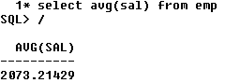
- Determine the maximum and minimum salary. Rename the output as max_salary and min_salary respectively.
- select max(sal) as Max_Sal,min(sal) as Min_Sal from emp;
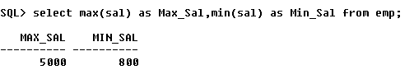
- Count the number of employees having salary less than or equal to 15000.
- select count(sal) from emp where sal<=15000;
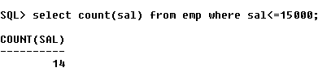
- List the details of Employee month wise in DD/MM/YY format.
- select empno,ename,job,mgr,to_char(hiredate,'DD/MM/YY'),sal,comm,deptno from emp order by to_char(hiredate,'MM');
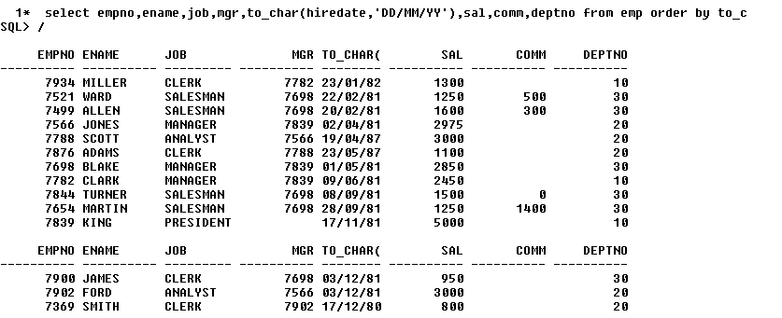
- List the DOB in the format ‘DD-Month-YY’ eg. 12-February-91
- select to_char(DOB,'DD-Month-YY') from student_master;
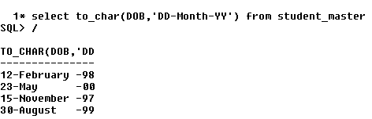
Use below given tables to solve queries based on it:
Distributor (Dno, DName, City, Phone)
Item (Item_No, Item_Name, Price, Weight)
Dist_Item (Dno, Item_No, Qty, Date)
- Count total distributors
- SELECT COUNT(*) FROM DISTRIBUTOR;
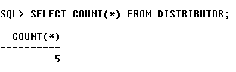
- Find the total price of all items
- select sum(price) from item;
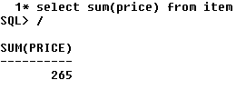
- Find the item wise total quantity of each item
- SELECT ITEM_NO,SUM(QTY) FROM DIST_ITEM GROUP BY ITEM_NO
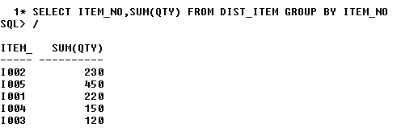

- Display all items whose name starts with “S”
- select * from item where item_name like 'S%';
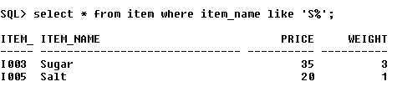
- Display Distribution details of all items with month (from the date) only.
- SELECT DNO,ITEM_NO,QTY,TO_CHAR(ORDER_DATE,'MONTH') FROM DIST_ITEM;

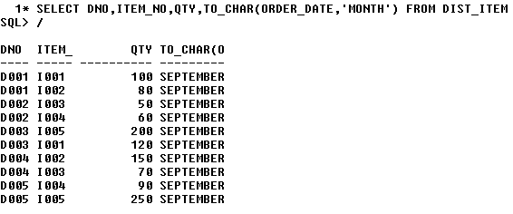
- Display the distributors whose city name starts with “B”
- SELECT * FROM DISTRIBUTOR WHERE CITY LIKE 'B%';
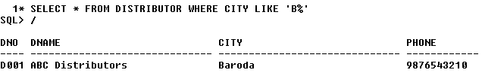
- Find the highest weight of an item
- SELECT MAX(WEIGHT) FROM ITEM;
