Detailed Schedule
Topics:- | Select data using: Order By, Group by and Having clause

1. Use following tables and solve given queries below it.
APPLICANT (AID, A_Name, City, B_Date)
ENTRANCE_TEST (ET_ID, ET_Name, Max_Score)
ETEST_DETAILS (AID, ETID, ETest_Date, Score)

- How many applicants have appeared for each test?
- select etid,count(*) from etest_details group by etid;
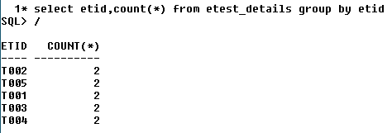
- Display highest score for each test
- select etid,max(score) from etest_details group by etid

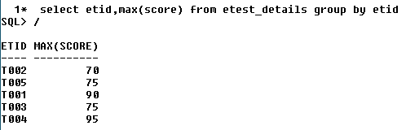
- Display applicant’s ID who appeared for more than 3 tests
- select aid,count(etid)from etest_details group by aid having count(etid)>3;
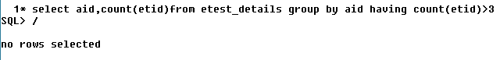
- Calculate applicant’s average score across all test they have appeared in
- select aid,avg(score) from etest_details group by aid
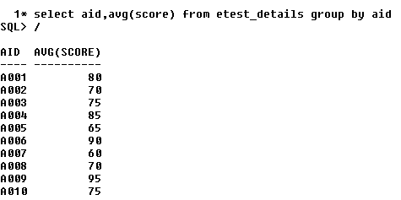
- Display number of applicants by city
- select address,count(address) as City from applicant group by address;
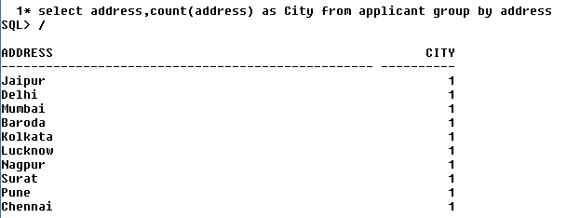
- Display ETID and Average score where average score is more than 50.
- select etid,avg(score) from etest_details group by etid having avg(score)>50
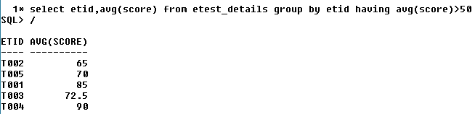
- Count date wise total entrance test to be held.
- select etest_date,count(etid) from etest_details group by etest_date;
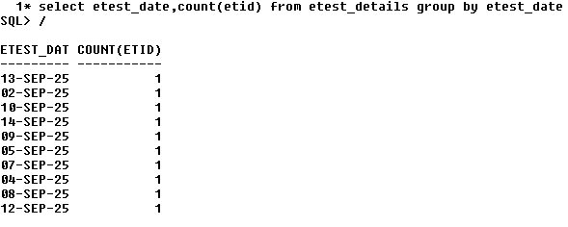

2. Use the following tables and solve below given queries.

Distributor (Dno, DName, City, Phone)
Item (Item_No, Item_Name, Price, Weight)
Dist_Item (Dno, Item_No, Qty, D_Date)

1. Display city wise total number of distributors
2. List the distributors by who distributed more than 50 items in month of July
3. List Item wise total quantity delivered and display items having more than 5000 Qty delivered
4. List Dno who delivered more than 50 items for each month
5. Display item details in descensding order of price and ascending order of weight
6. Show all distributors in alphabetical order of City and DName
7. Calculate average quantity of items distributed on each day.
8. Find the weight wise average price of items

3. Use the following tables and solve below given queries.
Worker (Id, Name, Wages_Per_Hr) Job (Job_Id, Job_Type) Assigned (W_Id, J_Id, Start_Date, Status, Total_Hrs)

1. Display all workers in descending order of their Wages_Per_Hr
2. Count workers in each J_Id
3. List all the W_Id who has worked for more than 100 hrs
4. Count total jobs which are pending till date .
5. Display all Job_Id according to alphabetical order of their type

