Detailed Scheduled
Topics:- | Subqueries  • Using sub-query in the FROM clause  • Using co-related sub-queries  • Using multi-column sub-queries  • Using sub-query in an Order-By clause  • Using Exits and Not Exists operator

Use Following Tables and solve given queries:

STUDENT (rollno, fname, lname, dob)
Course(C_No, coursename, fees, Credit)
Enroll (rollno, courseno, Earn_Credit)
- Display the name of students who have enrolled for course ‘C101’.
- select fname from student where rollno IN(select rollno from enroll where COURSENO='C101');
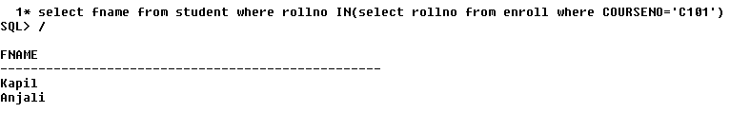
- Display the name of the courses in which rollno 11 is enrolled.
- select coursename from course where C_NO in(select courseno from enroll where rollno=11);
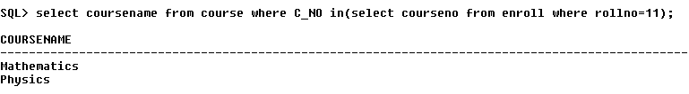
- Display the name of the student who have earned maximum credit.
- select fname from student where rollno in(select rollno from enroll where earn_credit in(select max(earn_credit) from enroll));
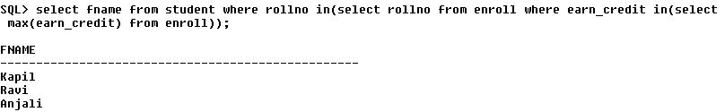
- Display details of students who have enrolled in any course.
- select * from student where rollno in( select rollno from enroll);
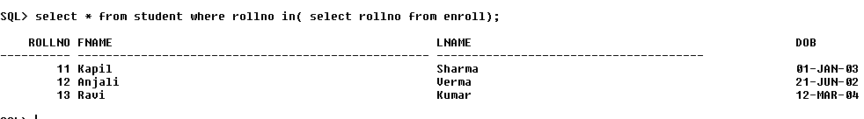
- Display details of students who have not enrolled in any course.
- select * from student where rollno not in( select rollno from enroll);

- Display details of students who have enrolled in all courses.
- Give the name of the course in which maximum number of students are enrolled.
- Give the name of the course in which no student has enrolled
- select coursename from course where C_NO not in(select courseno from enroll);

- Find all students whose credit earned is higher than the average credit of the students in their course.(using corelate sub query)
- List the student detail whose total credit is same as that of ‘Kapil’.

Employee (emp_no, fname, lname, dob,address) Company(comp_id,emp_no,company_name,salary,department,designation) Customer(cust_no,fname,lname,address)
- Find all employee whose salary is higher than the average salary of the employees in their departments.
- select * from employee where emp_no in(select emp_no from company where salary>(select avg(salary) from company));
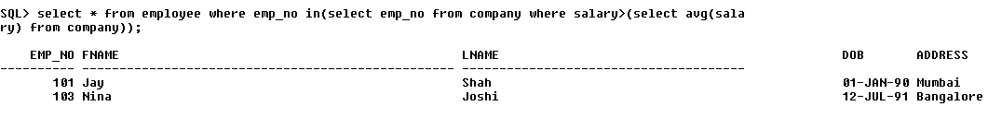
- List the employee detail whose salary is same as “Jay”.
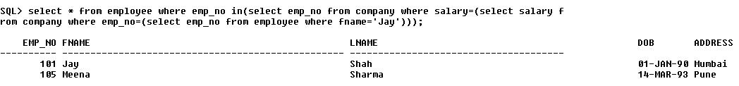
- select * from employee where emp_no in(select emp_no from company where salary=(select salary from company where emp_no=(select emp_no from employee where fname='Jay')));

3. Display the name of employees who work in ‘mrkt’ department.
- select * from employee where emp_no in(select emp_no from company where department='mrkt');
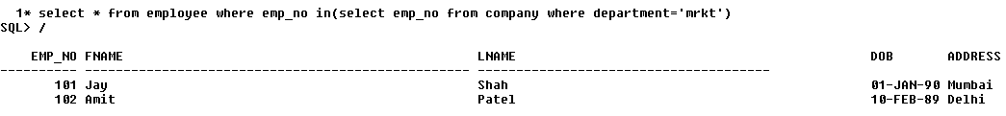
4. Display details of employees not belong to any department.
5. Find out all the customers having same name as the employees. (Using multi column subquery).
- select fname from customer where fname in(select fname from employee);
