Detailed Scheduled
Topics:- | What is Join?  Explain types of Join.  Understand Equi Join with examples  Inner Join, Outer Join, Cross Join

Use the tables Client_master, Prod_Master, Salesman_master, Sales_Order and Sales_order_Details and solve following queries:

- Display the salesman name who have processed Order_No 1
- Display datewise (dates in descending order) order details with salesman name and product name.
- Display the unique product names, whose order status is still pending
- Display the Client_name who has made order on 15th Aug, 2025
- Display the salesman_no and his order_no where quantity ordered and quantity dispatched are not equal

(I) Use following tables and solve given queries below it.
APPLICANT (AID, A_Name, City, B_Date)
ENTRANCE_TEST (ET_ID, ET_Name, Max_Score)
ETEST_DETAILS (AID, ETID, ETest_Date, Score)
1. Display Entrance Test ID (ETID) Wise highest marks scored by any applicant.
2. Count ETID wise total number of applicants appeared for the test
3. Find the minimum number of applicants in the entrance test.
4. Count city wise number of applicants registered
5. Display all the entrance test details for which the applicant “Ohm Patel” appeared
**********************************************************************
(II) Use the following tables and solve below given queries.
Distributor (Dno, DName, City, Phone)
Item (Item_No, Item_Name, Price, Weight)
Dist_Item (Dno, Item_No, Qty, Date)
1. Display all the distributor’s name who supplies Item_No 5
2. Display the item which is distributed maximum time
3. Display all the items that are distributed by the distributor “Dev Shah”
4. Display the Item_Name and Quantity that are received in month of July in 2021
5. Display all the items whose price is less than 1000 and received Qty =10

Use the following tables (can use the script given in the assignment folder) and solve below given queries.
Worker (Id, Name, Wages_Per_Hr)
Job (Job_Id, Job_Type)/
Assigned (W_Id, J_Id, Start_Date, Status, Total_Hrs)
- Display all the workers assigned for Job “Assemble”
- select w.id,w.name,j.job_id,a.status from worker w JOIN assigned a ON w.id=a.w_id JOIN job j ON j.job_id=a.j_id where job_type='Assemble';
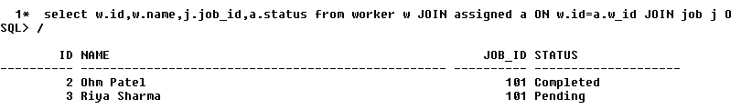
- Display total hours of the worker “Deep Jha” spent on Job “Packing”
- select name,job_type,total_hrs from worker w JOIN assigned a ON w.id=a.w_id JOIN job j ON j.job_id=a.j_id where name='Deep Jha' and job_type='Packing';
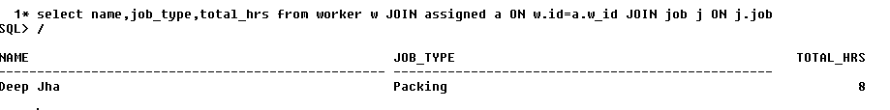
- Display all the job types that are starting from Sept-2021.
- SELECT * FROM JOB J JOIN ASSIGNED A ON J.JOB_ID=A.J_ID WHERE START_DATE LIKE('%-SEP-21');
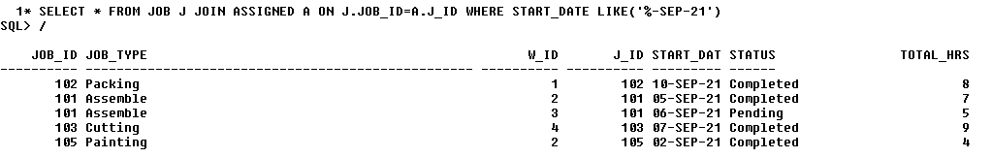
- What are the total hours allocated for Job “Cutting”
- SELECT JOB_TYPE,SUM(TOTAL_HRS) FROM JOB J JOIN ASSIGNED A ON J.JOB_ID=A.J_ID WHERE JOB_TYPE='Cutting' GROUP BY J.JOB_TYPE;
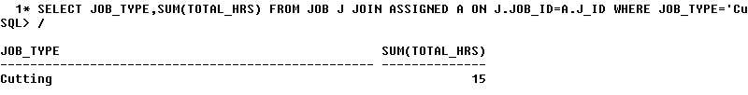
- Display all the jobs that are still pending
- SELECT JOB_ID,JOB_TYPE,STATUS FROM JOB J JOIN ASSIGNED A ON J.JOB_ID=A.J_ID WHERE STATUS='Pending';
